**Expiriment NO: 13**

**Aim : Familiarisation of linux commands.**

**CO2 : Perform system administration tasks.**

procedure :

**1)sudo apt update**

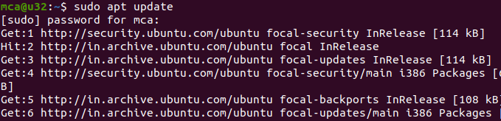

**2) sudo apt install net-tools**

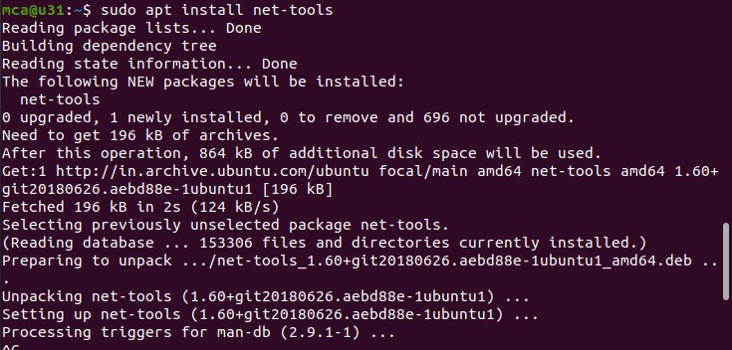

**3)ifconfig**

used to find out network interface,ip address and mac address

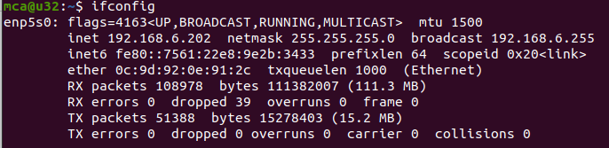

**4)sudo ifconfig enp5s0 down**

used to down the network interface



**4.1)sudo ifconfig enp5s0 up**

used to activate network interface



**5)ping address**

Used to detect the connectivity between the host and the server

Used for detecting devices on a network and for troubleshooting problems

**$ping google.com**

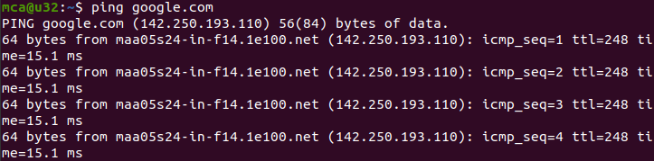

**5.1)Ping -c 2 google.com**

only send 2 packets and stop.

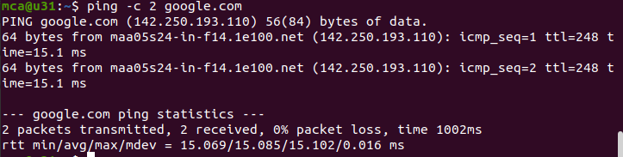

**6)traceroute google.com**

Used to identify the route taken by the packet to reach the destination

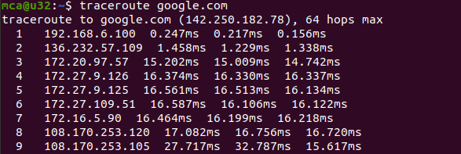

**7) whois google.com**

Used to find all information about a particular domain.

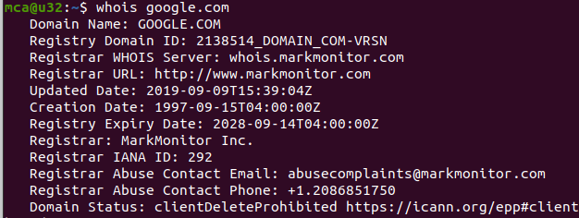

**8)nslookup domain name**

used to lookup the corresponding domain

**$nslookup ajce.in**

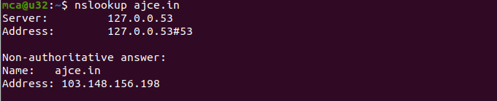

**9) wget url**

used to download files from a url

**$wget https://.us.archive.org/13/items/TheAlchemist/_OceanofPDF.com_The_Alchemist.pdf**



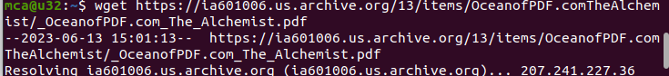



**10)sudo tcpdump**

to capture the packets of current network interface along with time.

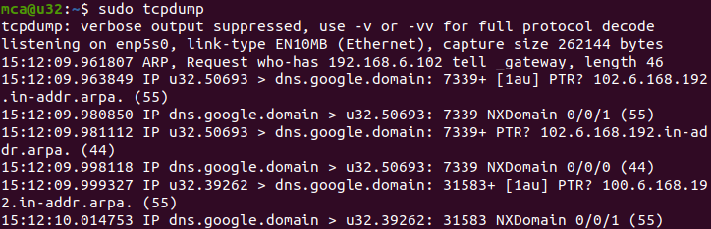

**10.1)sudo tcpdump -D**

To show all the available network interface.

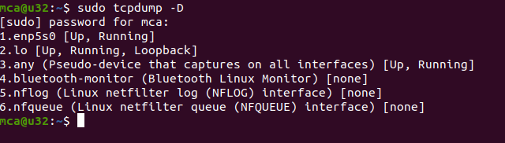

**10.2)sudo tcpdump -c 5 -i enp5s0**

To capture particular number of packets from network interface.

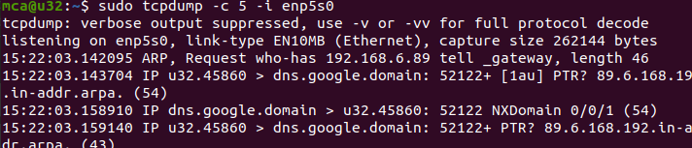

**10.3)sudo tcpdump -i enp5s0**

To capture packets from one interface..

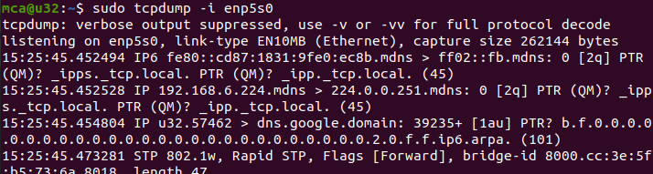

**10.4)sudo tcpdump -A -i enp5s0**

To capture packets in ASCII format

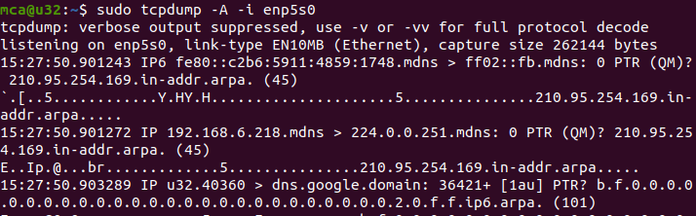

**10.5)sudo tcpdump -xx -i enp5s0**

To capture packets in Hexadecimal format

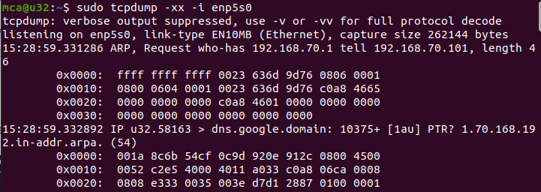

**10.6)sudo tcpdump -w filename.txt -i enp5s0**

To save the packets into a particular file.

**$sudo tcpdump -w filename.txt -i enp5s0**

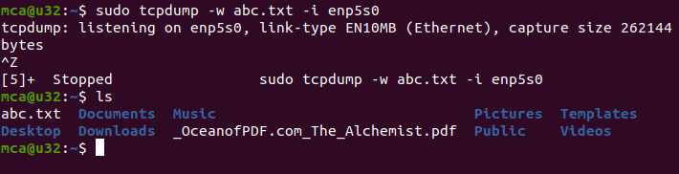

**10.7)sudo tcpdump -r filename.txt**

To read the saved file.

**$sudo tcpdump -r abc.txt**

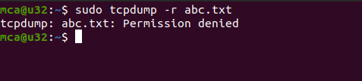

**11)sudo wireshark**

