1. Define a class ‘product’ with data members pcode, pname and price. Create 3 objects of

the class and find the product having the lowest price.

Program

import java.util.Scanner;

public class Product {

int productId;

String pname;

int price;

public void ask() {

Scanner cin = new Scanner(System.in);

System.out.println("Enter product code: ");

productId = cin.nextInt();

System.out.println("Enter product name: ");

pname = cin.next();

System.out.println("Enter product price: ");

price = cin.nextInt();

}

public void display() {

System.out.println("Product code is: " + productId);

System.out.println("Product name is: " + pname);

System.out.println("Product price is: " + price);

}

public static void main(String[] args) {

Product ob1 = new Product();

Product ob2 = new Product();

Product ob3 = new Product();

ob1.ask();

ob1.display();

ob2.ask();

ob2.display();

ob3.ask();

ob3.display();

if(ob1.price<ob2.price && ob1.price<ob3.price)

{

System.out.println("first product has lowest price");

}

else if(ob2.price<ob1.price && ob2.price<ob3.price)

{

System.out.println("second product has lowest price");

}

else

{

System.out.println("Third product has lowest price");

}

}

}

Output:

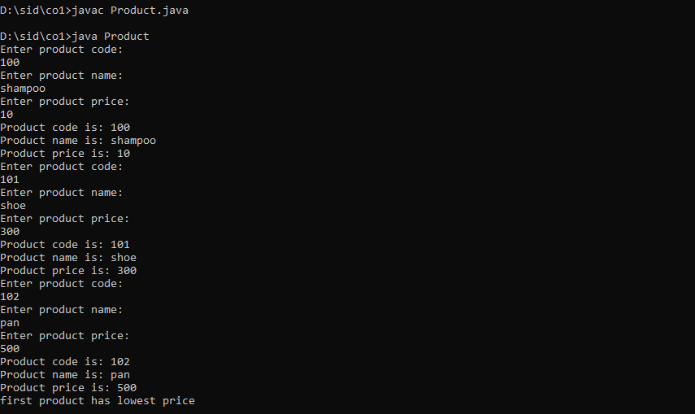

2. Read 2 matrices from the console and perform matrix addition.

import java.util.Scanner;

public class Matadd

{

public static void main(String[] args)

{

Scanner obj=new Scanner(System.in);

System.out.println("Enter the row and col of first matrix");

Integer r1=obj.nextInt();

Integer c1=obj.nextInt();

System.out.println("Enter the row and col of second matrix");

Integer r2=obj.nextInt();

Integer c2=obj.nextInt();

int a[][]=new int[r1][c1];

int c[][]=new int[r1][c1];

int b[][]=new int[r2][c2];

int i,j;

System.out.println("enter elements to first array");

for(i=0;i<r1;i++)

{

for(j=0;j<c1;j++)

{

a[i][j]=obj.nextInt();

}

}

System.out.println("enter elements to second array");

for(i=0;i<r2;i++)

{

for(j=0;j<c2;j++)

{

b[i][j]=obj.nextInt();

}

}

System.out.println("Printing 2d first Matrix");

for(i=0;i<r1;i++)

{

for(j=0;j<c1;j++)

{

System.out.print(a[i][j]+" ");

}

System.out.println();

}

System.out.println("Printing 2d second Matrix");

for(i=0;i<r2;i++)

{

for(j=0;j<c2;j++)

{

System.out.print(b[i][j]+" ");

}

System.out.println();

}

if(r1==r2 && c1==c2)

{

for(i=0;i<r1;i++)

{

for(j=0;j<r1;j++)

{

c[i][j]=a[i][j]+b[i][j];

}

}

System.out.println("Printing ADDED MATRIX");

for(i=0;i<r1;i++)

{

for(j=0;j<c1;j++)

{

System.out.print(c[i][j]+" ");

}

System.out.println();

}

}

else

{

System.out.println("NOT COMBATIBLE");

}

}

}

Output:

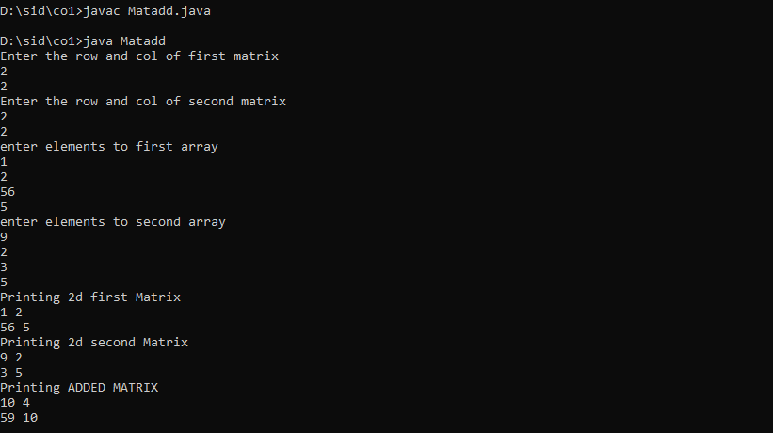

3.Add two complex numbers.

import java.util.Scanner;

public class Addcomplex

{

public static void main(String[] args)

{

Scanner obj=new Scanner(System.in);

System.out.println("Enter real and imaginary part of first");

Integer fr=obj.nextInt();

Integer fi=obj.nextInt();

System.out.println("Enter real and imaginary part of second");

Integer sr=obj.nextInt();

Integer si=obj.nextInt();

Integer resultr=fr+sr;

Integer resulti=fi+si;

System.out.println("Sum of complex nos is is "+resultr+ " " +resulti+"i");

}

}

Output:

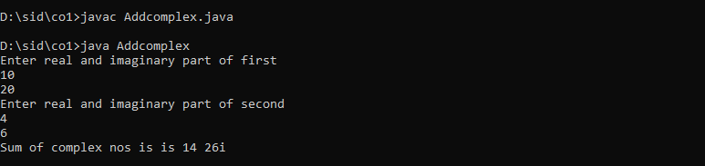

4. Read a matrix from the console and check whether it is symmetric or not.

import java.util.Scanner;

public class Matsym

{

public static void main(String[] args)

{

Scanner obj=new Scanner(System.in);

System.out.println("Enter the row and col of first matrix");

Integer r1=obj.nextInt();

Integer c1=obj.nextInt();

int a[][]=new int[r1][c1];

int c[][]=new int[r1][c1];

int i,j;

System.out.println("enter elements to first array");

for(i=0;i<r1;i++)

{

for(j=0;j<c1;j++)

{

a[i][j]=obj.nextInt();

}

}

System.out.println("Printing 2d first Matrix");

for(i=0;i<r1;i++)

{

for(j=0;j<c1;j++)

{

System.out.print(a[i][j]+" ");

}

System.out.println();

}

int flag=1;

for(i=0;i<r1;i++)

{

for(j=0;j<c1;j++)

{

c[i][j]=a[j][i];

if(c[i][j]!=a[i][j])

{

flag=0;

}

}

}

if(flag==1)

{

System.out.println("The matrix is a Symmetric Matrix");

}

else

{

System.out.println("The matrix is a Not a Symmetric Matrix");

}

}

}

Output:

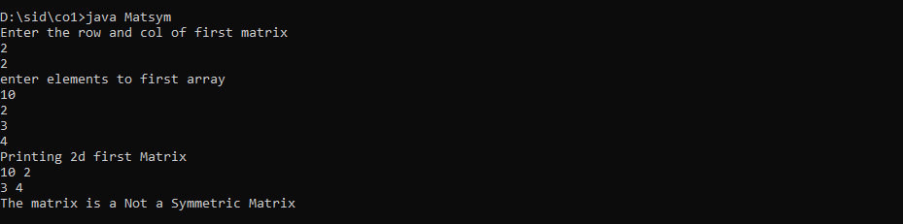

5. Create CPU with attribute price. Create inner class Processor (no. of cores, manufacturer)

and static nested class RAM (memory, manufacturer). Create an object of CPU and print

information of Processor and RAM..

import java.util.\*;

class CPU

{

int price;

CPU()

{

Scanner obj=new Scanner(System.in);

System.out.println("Enter the price:");

price=obj.nextInt();

}

public void display()

{

System.out.println("Price :"+price);

}

class Processor

{

int core;

String manufature;

Processor()

{

Scanner obj1=new Scanner(System.in);

System.out.println("Enter the core:");

core=obj1.nextInt();

System.out.println("Enter the Manufature:");

manufature=obj1.next();

}

public void display1()

{

System.out.println("Core :"+core);

System.out.println("Manufature :"+manufature);

}

}

static class Ram

{

int memory;

String manufature1;

Ram()

{

Scanner obj2=new Scanner(System.in);

System.out.println("Enter the Memory:");

memory=obj2.nextInt();

System.out.println("Enter the Manufature:");

manufature1=obj2.next();

}

public void display2()

{

System.out.println("Memory :"+memory);

System.out.println("Manufature :"+manufature1);

}

}

}

public class CpuDetails

{

public static void main(String args[])

{

CPU c=new CPU();

c.display();

CPU.Processor s= c.new Processor();

s.display1();

CPU.Ram p=new CPU.Ram();

p.display2();

}

}

Output:

