**CO2**

**Experiment No.: 1**

Program to Sort strings.

**Procedure:**

import java.util.Scanner;

public class Stringcmp

{

public static void main(String[] args)

{

Scanner obj=new Scanner(System.in);

System.out.println("Enter string array size");

Integer n=obj.nextInt();

String arr[]=new String[n];

System.out.println("Enter elements");

int i=0,j;

for(i=0;i<n;i++)

{

arr[i]=obj.next(); //because in string array

}

System.out.println("Printing original");

for(i=0;i<n;i++)

{

System.out.println(arr[i]);

}

String temp;

for(i=0;i<n;i++)

{

for(j=i+1;j<n;j++)

{

if(arr[i].compareTo(arr[j])>0)

{

temp=arr[i];

arr[i]=arr[j];

arr[j]=temp;

}

}

}

System.out.println("Printing sorted array");

for(i=0;i<n;i++)

{

System.out.println(arr[i]);

}

}

}

**Output:**

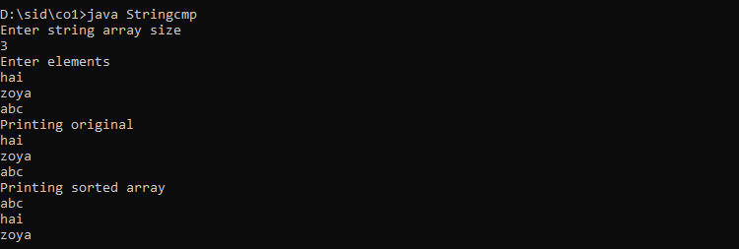

**Experiment No.: 2**

Search an element in an array.

**Procedure:**

import java.util.Scanner;

public class Arraysearch

{

public static void main(String[] args)

{

Scanner obj=new Scanner(System.in);

System.out.println("Enter the size of array");

Integer n=obj.nextInt();

int arr[]=new int[n];

int i,flag=0;

System.out.println("Enter the elements of array");

for(i=0;i<arr.length;i++)

{

arr[i]=obj.nextInt();

}

System.out.println("Enter item to be searched");

Integer item=obj.nextInt();

System.out.println("searching");

for(i=0;i<arr.length;i++)

{

if(item==arr[i])

{

System.out.println("Value found at loc "+i);

flag=1;

}

}

if(flag==0)

{

System.out.println("item not found");

}

}

}

**Output:**

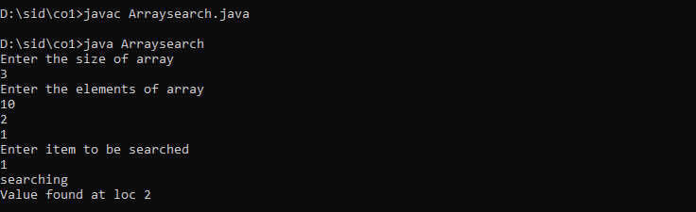

**Experiment No.: 3**

Perform string manipulations

**Procedure:**

import java.util.Scanner;

public class Stringmani

{

public static void main(String[] args)

{

Scanner obj=new Scanner(System.in);

System.out.println("Enter two strings");

String str1=obj.nextLine();

String str2=obj.nextLine();

System.out.println("string concat is "+str1.concat(str2)); //concat

if(str1.equals(str2)) //string compare

{

System.out.println("Both string are same");

}

else

{

System.out.println("Both string are not same");

}

System.out.println("string to upper caseis "+str1.toUpperCase()); //uppercase

System.out.println("string to lower caseis "+str2.toLowerCase()); //lowercase

System.out.println("substring is "+str1.substring(1,3));

System.out.println("Trim function is "+str1.trim()); //front space removal eg " hai"

System.out.println("Length of first string is "+str1.length()); //string length

}

}

**Output:**

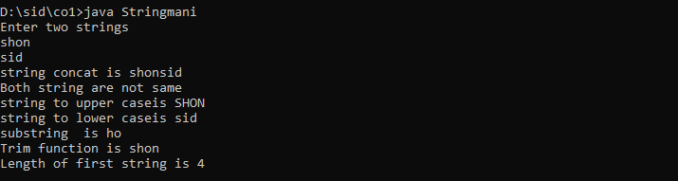

**Experiment No.: 4**

Program to create a class for Employee having attributes eNo, eName eSalary. Read n

employ information and Search for an employee given eNo, using the concept of Array of

Objects.

**Procedure:**

import java.util.Scanner;

public class Emp

{

int eno;

String ename;

int esalary;

public void get()

{

Scanner cin=new Scanner(System.in);

System.out.println("Enter employee number: ");

eno=cin.nextInt();

System.out.println("Enter employee name: ");

ename=cin.next();

System.out.println("Enter salary of employee: ");

esalary=cin.nextInt();

}

public void display()

{

System.out.println("employee number is "+eno);

System.out.println("employee name is "+ename);

System.out.println("Salary is "+esalary);

}

public static void main(String[] args)

{

int i;

Scanner cin=new Scanner(System.in);

System.out.println("Enter the limit of array");

int n=cin.nextInt();

Emp e[]=new Emp[n];

for(i=0;i<n;i++)

{

e[i]=new Emp();

e[i].get();

}

for(i=0;i<n;i++)

{

e[i].display();

}

System.out.println("Enter the eno:");

int val=cin.nextInt();

int flag=0;

for(i=0;i<n;i++)

{

if(e[i].eno==val)

{

e[i].display();

flag=1;

}

}

if(flag==0)

{

System.out.println("Not found");

}

}

}

**Output:**

