Calc

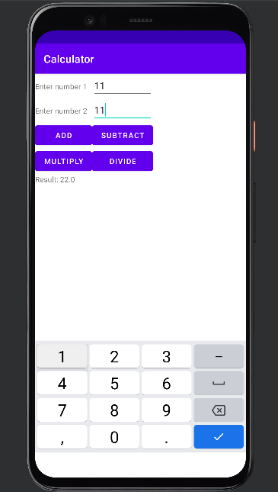

Strings

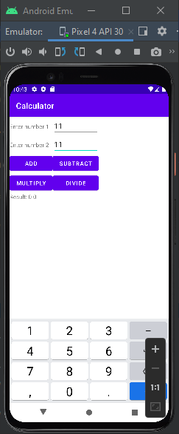

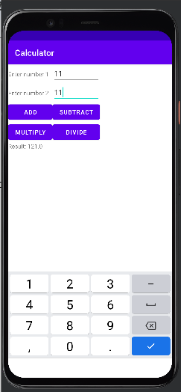

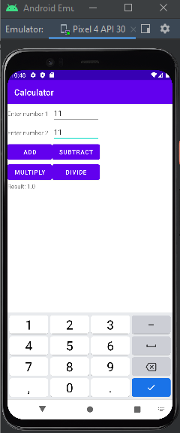

Activity main

<?xml version="1.0" encoding="utf-8"?>

<TableLayout xmlns:android="http://schemas.android.com/apk/res/android"

xmlns:app="http://schemas.android.com/apk/res-auto"

xmlns:tools="http://schemas.android.com/tools"

android:layout_width="match_parent"

android:layout_height="match_parent"

android:orientation="vertical"

tools:context=".MainActivity">

<TableRow android:layout_height="wrap_content" android:layout_width="wrap_content">

<TextView

android:layout_height="wrap_content"

android:layout_width="wrap_content"

android:text="@string/no1"

/>

<EditText

android:id="@+id/t1"

android:layout_height="wrap_content"

android:layout_width="wrap_content"

android:inputType="number" />

</TableRow>

<TableRow android:layout_height="wrap_content" android:layout_width="wrap_content">

<TextView

android:layout_height="wrap_content"

android:layout_width="wrap_content"

android:text="@string/no2"

/>

<EditText

android:id="@+id/t2"

android:layout_height="wrap_content"

android:layout_width="wrap_content"

android:inputType="number" />

</TableRow>

<TableRow android:layout_height="wrap_content" android:layout_width="wrap_content">

<Button

android:id="@+id/add"

android:layout_width="wrap_content"

android:layout_height="wrap_content"

android:text="Add" />

<Button

android:id="@+id/subtract"

android:layout_width="wrap_content"

android:layout_height="wrap_content"

android:text="Subtract" />

</TableRow>

<TableRow android:layout_height="wrap_content" android:layout_width="wrap_content">

<Button

android:id="@+id/multiply"

android:layout_width="wrap_content"

android:layout_height="wrap_content"

android:text="Multiply" />

<Button

android:id="@+id/divide"

android:layout_width="wrap_content"

android:layout_height="wrap_content"

android:text="Divide" />

</TableRow>

<TableRow android:layout_height="wrap_content" android:layout_width="wrap_content">

<TextView

android:id="@+id/resid"

android:layout_height="wrap_content"

android:layout_width="wrap_content"

android:text="@string/no3" />

</TableRow>

</TableLayout>

Strings

<resources>

<string name="app_name">Calculator</string>

<string name="t1">Enter number 1</string>

<string name="t2">Enter number 2</string>

<string name="b1">Calculate</string>

<string name="no1">Enter number 1</string>

<string name="no2">Enter number 2</string>

<string name="no3">Result</string>

<string name="resid">Result: %s</string>

</resources>

Mainactivity.java

package com.example.calc;

import androidx.appcompat.app.AppCompatActivity;

import android.os.Bundle;

import android.view.View;

import android.widget.Button;

import android.widget.EditText;

import android.widget.TextView;

import android.widget.Toast;

public class MainActivity extends AppCompatActivity {

Button add, subtract, multiply, divide;

EditText e1, e2;

TextView txtv1;

@Override

protected void onCreate(Bundle savedInstanceState) {

super.onCreate(savedInstanceState);

setContentView(R.layout.activity_main);

e1 = findViewById(R.id.t1);

e2 = findViewById(R.id.t2);

txtv1 = findViewById(R.id.resid);

add = findViewById(R.id.add);

subtract = findViewById(R.id.subtract);

multiply = findViewById(R.id.multiply);

divide = findViewById(R.id.divide);

add.setOnClickListener(new View.OnClickListener() {

@Override

public void onClick(View view) {

performOperation("+");

}

});

subtract.setOnClickListener(new View.OnClickListener() {

@Override

public void onClick(View view) {

performOperation("-");

}

});

multiply.setOnClickListener(new View.OnClickListener() {

@Override

public void onClick(View view) {

performOperation("*");

}

});

divide.setOnClickListener(new View.OnClickListener() {

@Override

public void onClick(View view) {

performOperation("/");

}

});

}

private void performOperation(String operator) {

String val1 = e1.getText().toString();

String val2 = e2.getText().toString();

if (val1.isEmpty() || val2.isEmpty()) {

txtv1.setText("Enter Both Nos.");

return;

}

double a = Double.parseDouble(val1);

double b = Double.parseDouble(val2);

double result = 0;

if (operator.equals("+")) {

result = a + b;

} else if (operator.equals("-")) {

result = a - b;

} else if (operator.equals("*")) {

result = a * b;

} else if (operator.equals("/")) {

if (b != 0) {

result = a / b;

} else {

Toast.makeText(MainActivity.this, "Division by zero is not allowed", Toast.LENGTH_SHORT).show();

return;

}

}

String c = String.valueOf(result);

txtv1.setText("Result: " + c);

}

}