Database System Engineering and Distributed Backend Development(25CS1302E)
Practical Week-2

Name: Siddina Pujith Pavan Kumar
Roll No.: 2520030029
SEC: 7
Step 1: Create Database
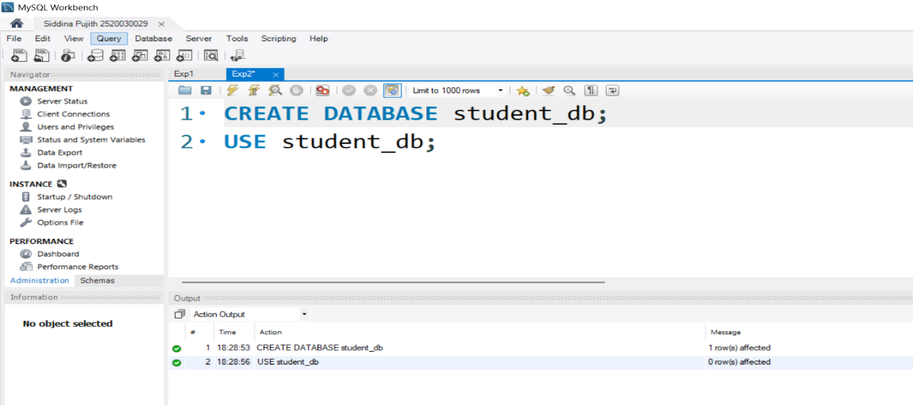

Step 2: Create Books Table
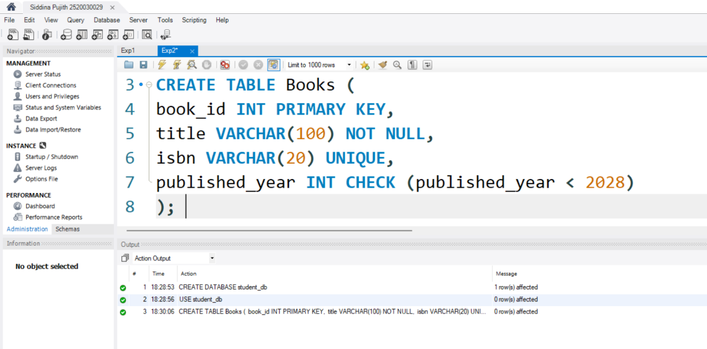

Step 3 & 4: Insert Books and Display
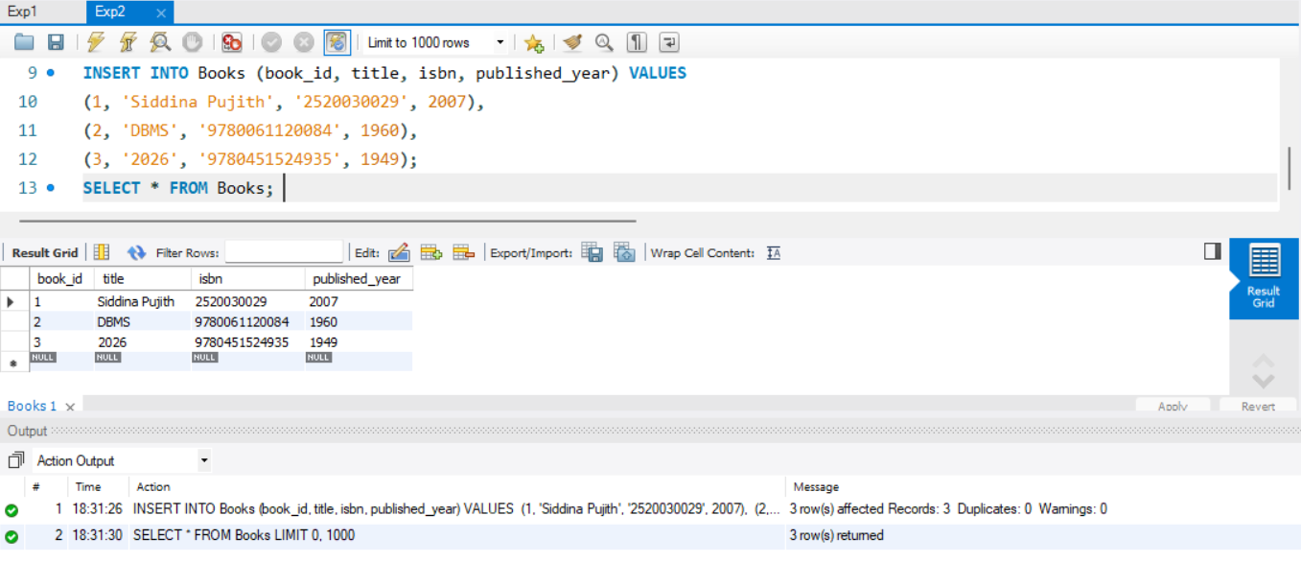

Step 5: Members Table: Create
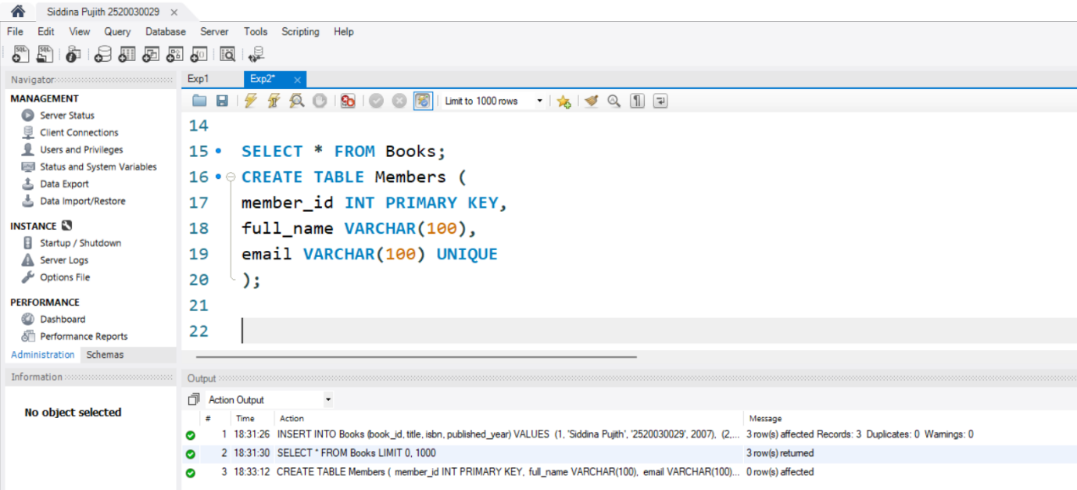

Step 6 & 7: Members Table: Insert, Display
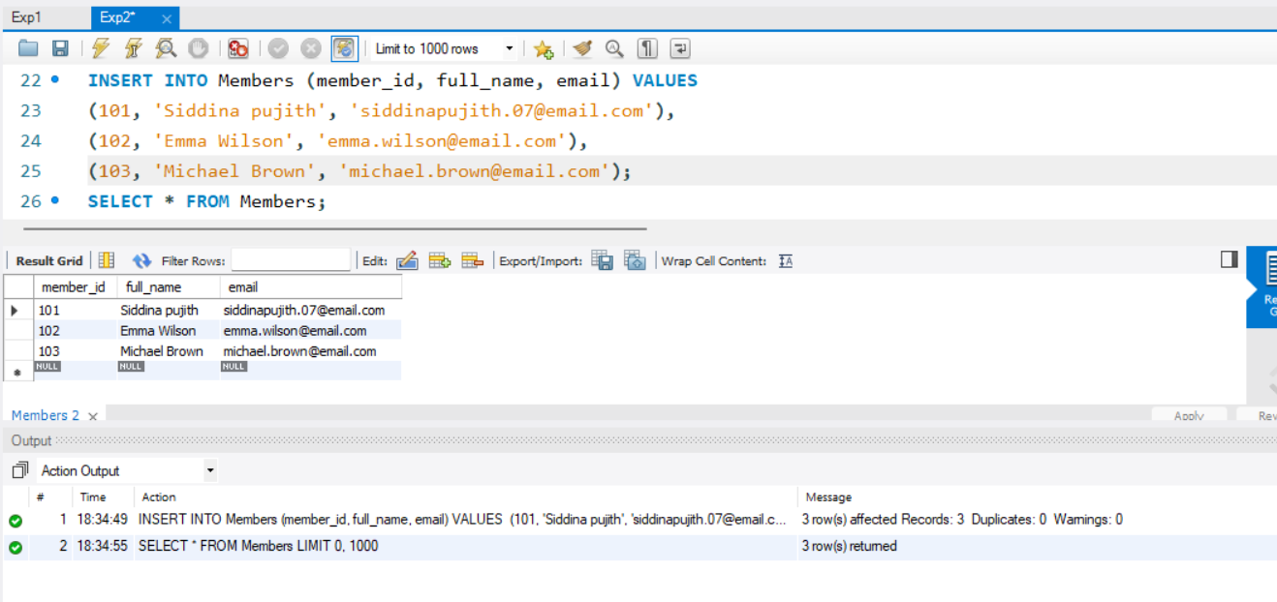

Step 8: Create Loans Table
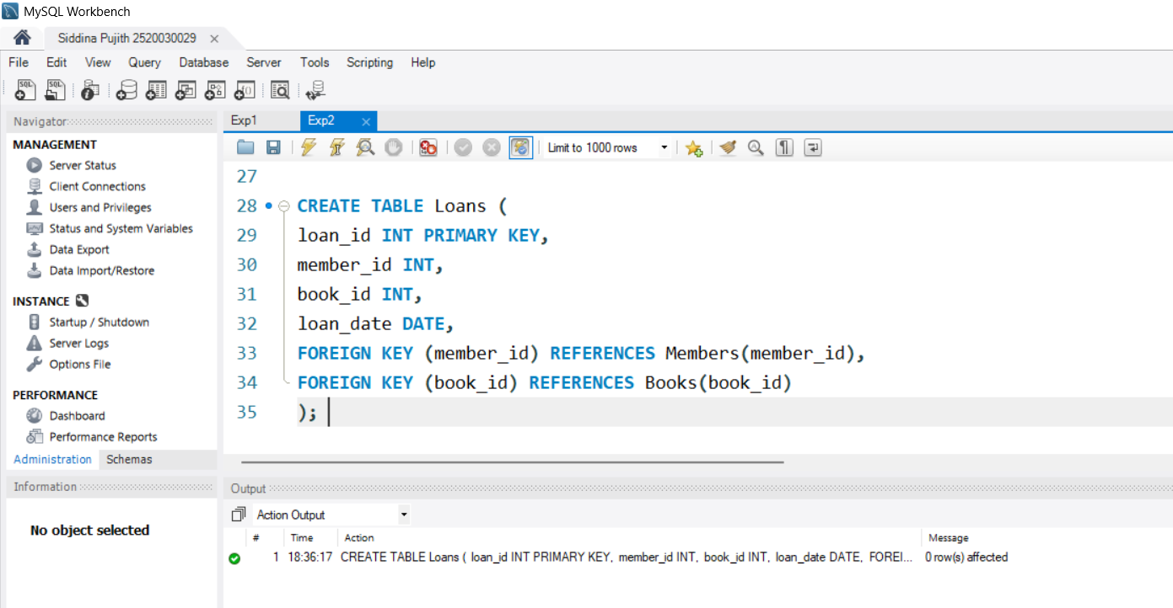

Step 9 & 10: Insert 10 Loans and Display
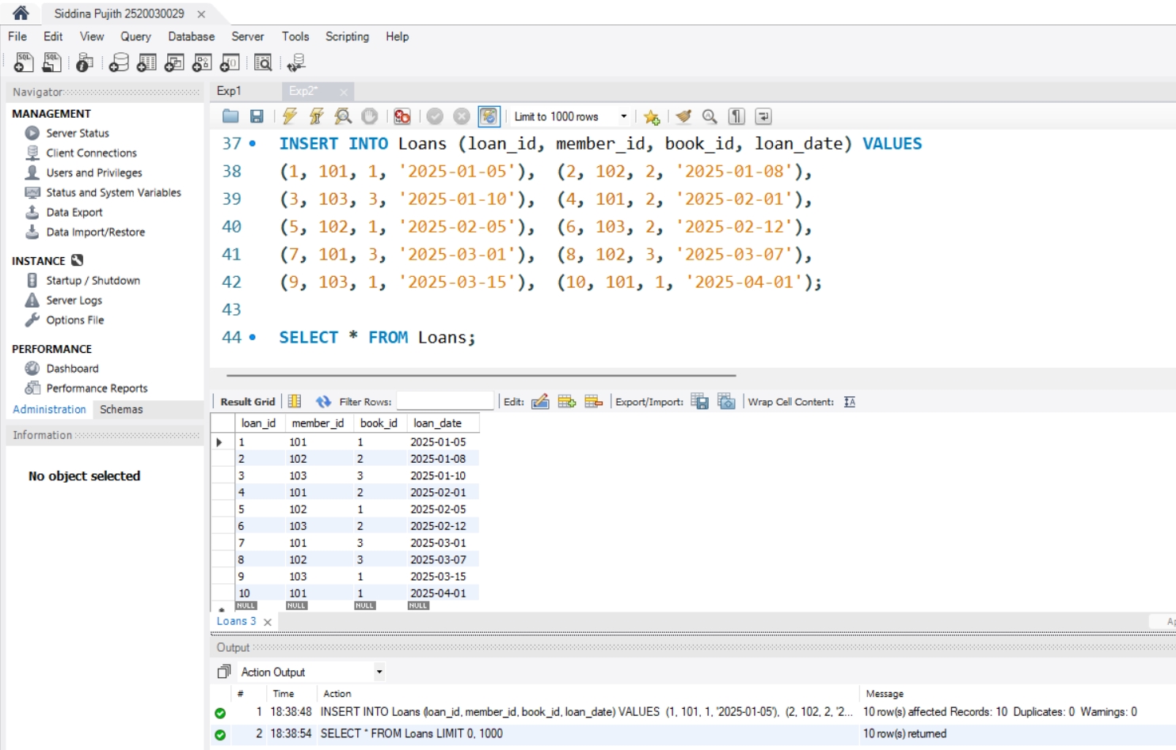

Step 11: JOIN Query
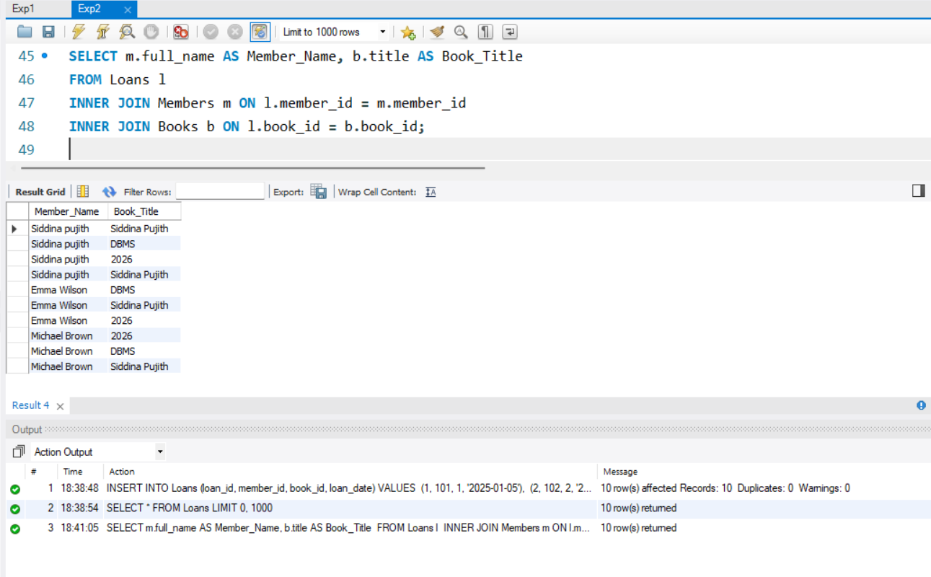

Step 12: GROUP BY Query
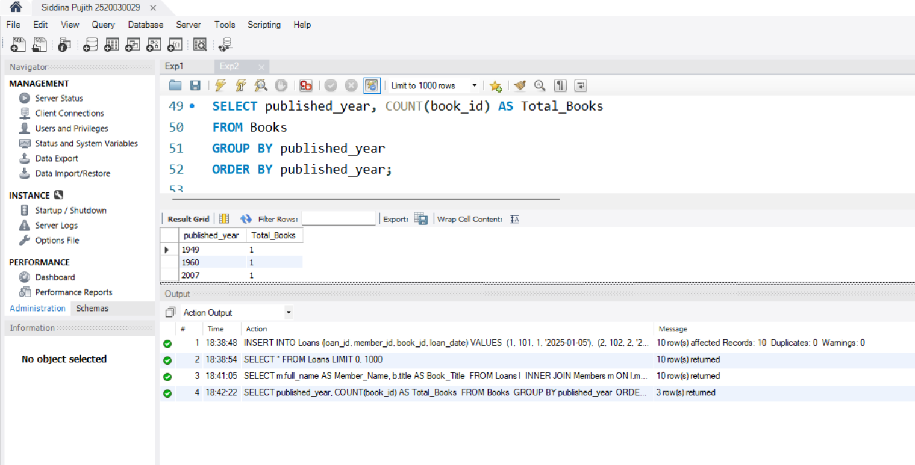

Step 13–16: Donation via TRANSACTION
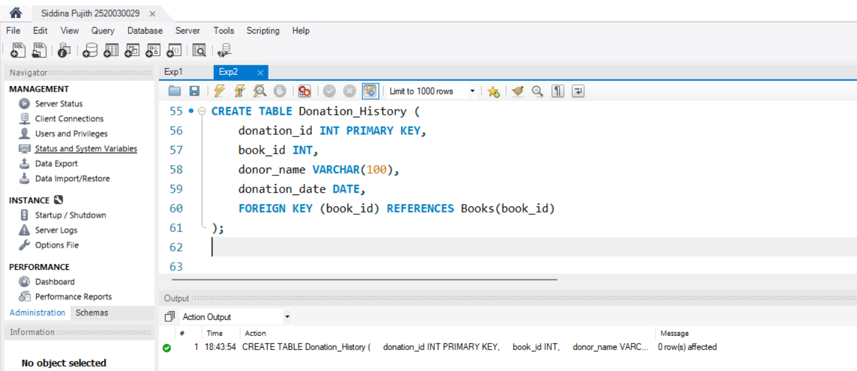
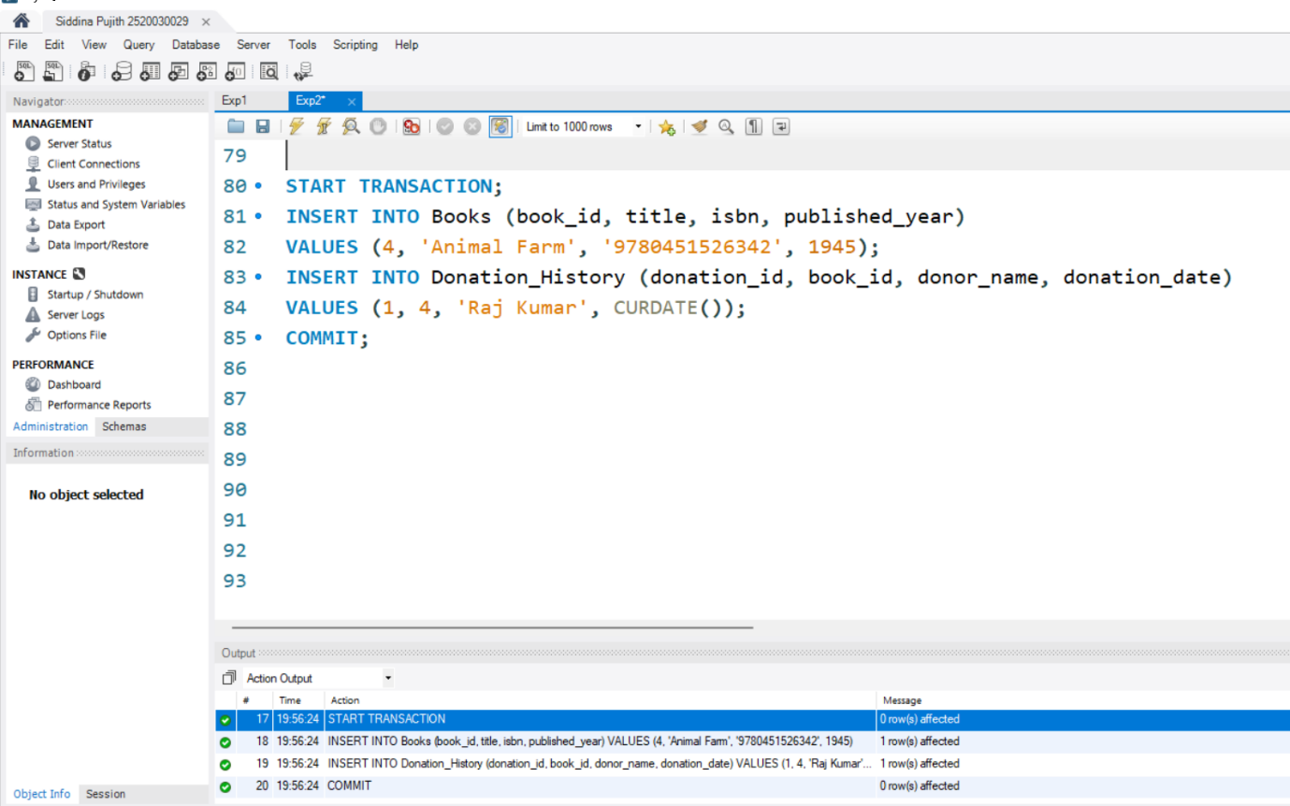

Step 17 & 18: Index on ISBN + Fast Search
