Database System Engineering and Distributed Backend Development(25CS1302E)
Practical Week-1

Name: Siddina Pujith Pavan Kumar
Roll NO: 2520030029
Sec: 7

Step 1: Database Setup
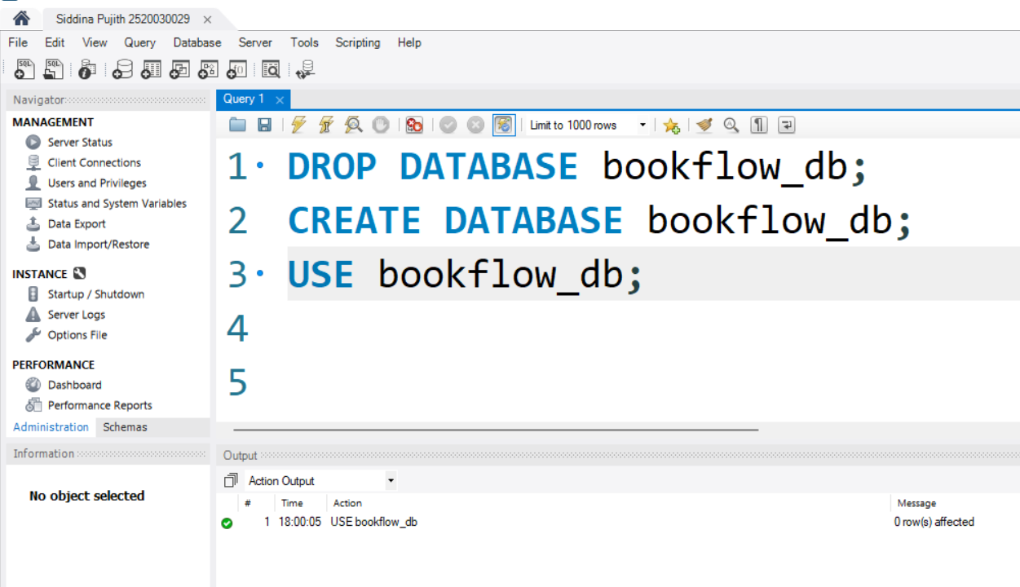

Step 2 : Table Creation
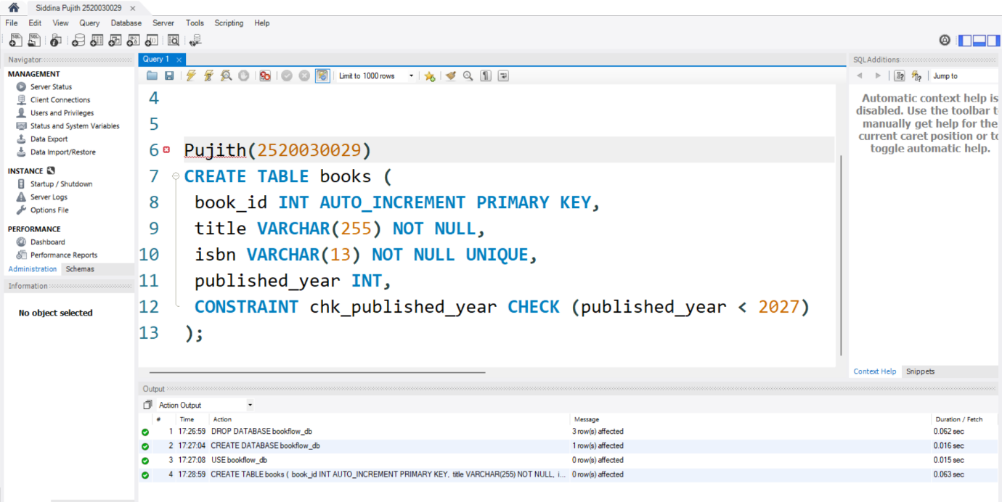
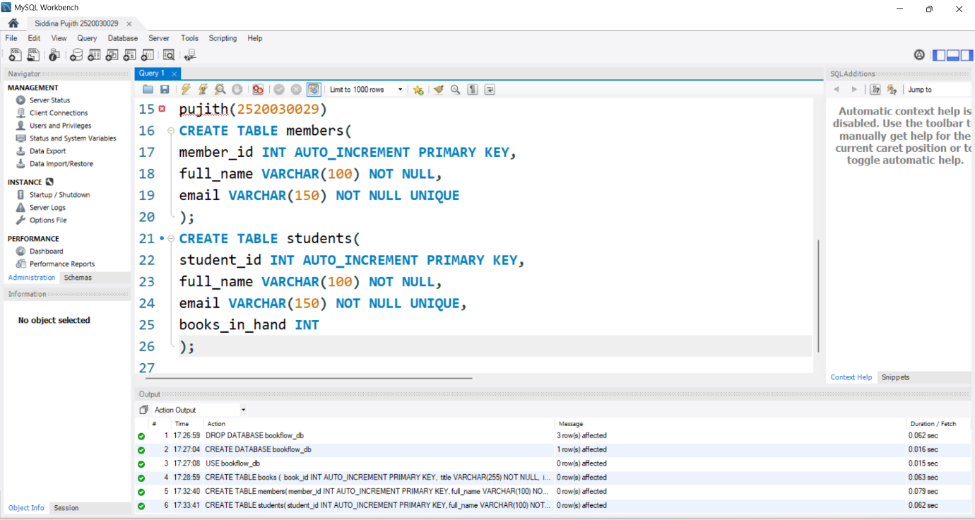
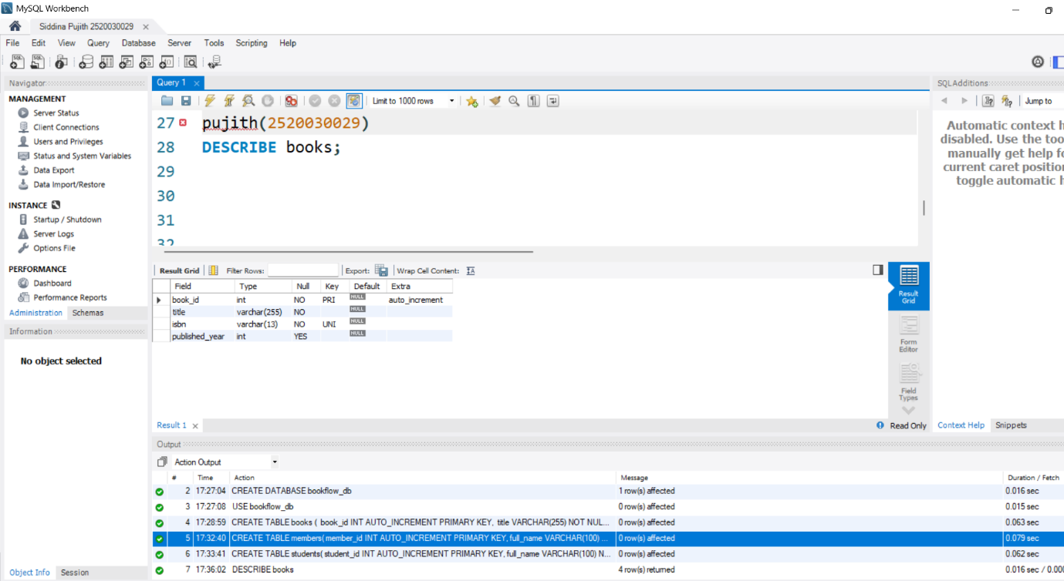

Step 3: Initial Seeding
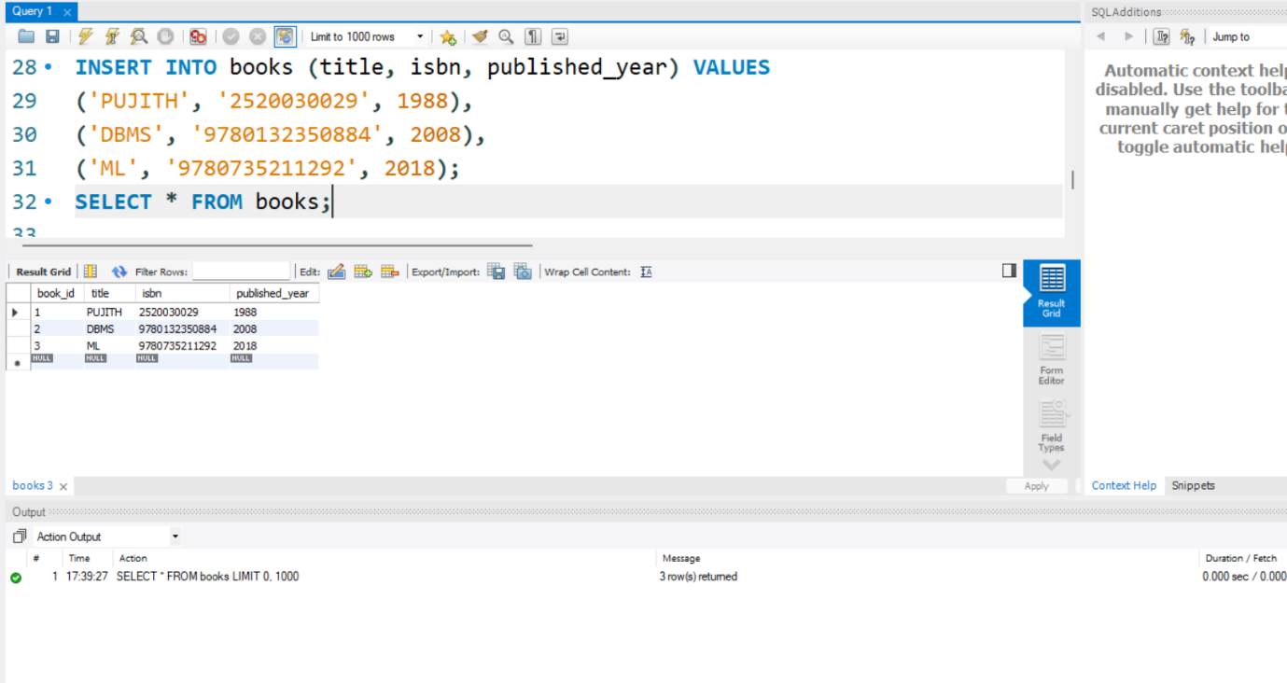
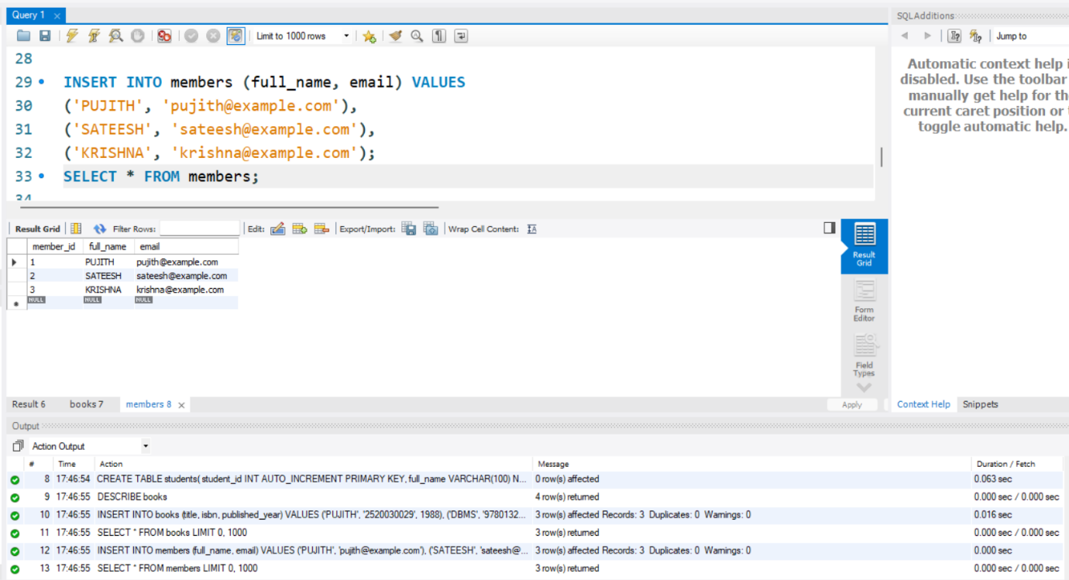

Step 4: Constraint Tests
