MULTI-CLASS MATCH RESULT PREDICTION
USING MULTINOMIAL LOGISTIC REGRESSION
Project Report submitted for the partial fulfilment of grade for the course
MACHINE LEARNING (25SC2107E)
A.Y. 2026–2027 | Trimester 4
Submitted by
Vinay Bandla (2520030437)
S. Pujith Pavan Kumar (2520030029)
Team Number: 21 | Section: 09
Under the guidance of
M. Rani
Professor

K L (Deemed to be) University
Bachupally, Hyderabad, Telangana, India

K L (DEEMED TO BE) UNIVERSITY
DEPARTMENT OF COMPUTER SCIENCE ENGINEERING
DECLARATION
The project report entitled “Multi-Class Match Result Prediction Using Multinomial Logistic Regression” is a record of bonafide work carried out by Vinay Bandla (2520030437) and S. Pujith Pavan Kumar (2520030029) in partial fulfilment of the requirements for the course Machine Learning (25SC2107E) at K L (Deemed to be) University during the academic year 2026–2027. The project uses historical Indian Premier League (IPL) data to build an interpretable model for estimating match-outcome probabilities. The work and results presented here are based on the implementation and project materials identified in the accompanying repository.
Vinay Bandla – 2520030437
S. Pujith Pavan Kumar – 2520030029
Signature of the Supervisor: ______________________________
Signature of the HOD: ____________________ External Examiner: ____________________

ACKNOWLEDGEMENT
We express our sincere gratitude to our faculty guide and the Department of Computer Science Engineering at K L (Deemed to be) University for the support and academic environment provided during this Machine Learning project. We also acknowledge the guidance and learning resources that helped us apply statistical learning techniques to a practical prediction task.
We thank our classmates, friends, and family for their encouragement and support throughout the development and documentation of the project. We are grateful to the maintainers of the public Python, NumPy, Pandas, scikit-learn, Flask, and SQLite documentation, which supported our understanding of the tools used in the system.
Project team
Vinay Bandla (2520030437)
S. Pujith Pavan Kumar (2520030029)

TABLE OF CONTENTS
S. No. | Contents | Page
1 | 1. Abstract | 5
2 | 2. Introduction | 6
3 | 3. Literature Survey | 7
4 | 4. Problem Statement and Objectives | 8
5 | 5. Hardware and Software Requirements | 9
6 | 6. Implementation | 10
7 | 7. Results and Discussion | 12
8 | 8. Conclusion and Future Scope | 13
9 | 9. References | 14

Note: Page numbers are indicative and may shift slightly after editing or opening in another word processor.

1. ABSTRACT
MatchState is a web-based machine-learning application for estimating the outcome probabilities of Indian Premier League (IPL) cricket fixtures. The project frames match prediction as a three-class classification problem rather than a strictly binary win/loss task. Its Multinomial Logistic Regression model estimates probabilities for Team 1 victory, Team 2 victory, and tie/no-result outcomes. The training pipeline uses historical match records and constructs nine input features: each team’s historical win rate, recent form over the last five matches, Team 1’s head-to-head win ratio, home-ground indicators for both teams, whether Team 1 won the toss, and whether the toss winner chose to bat. Team names are normalised across historical franchise aliases, matches are ordered chronologically, and rolling statistics are computed before updating records for each match to reduce look-ahead leakage. A Flask application provides an interactive interface where users select the teams, venue city, toss winner, and toss decision. The prediction view presents the model’s three outcome probabilities and a verdict, while a simulation page exposes feature extraction, linear logits, softmax probabilities, and feature contributions. Exploratory analysis documented in the repository covers 1,095 match records from IPL seasons 2008–2024 and 260,920 ball-by-ball delivery records. The project demonstrates an interpretable end-to-end application of supervised learning, data preparation, probabilistic classification, and web-based presentation; the probabilities should be understood as model estimates, not guarantees of actual match results.
Team Name: MatchState
Team Number: 21 | Section: 09
Team Members:
• Vinay Bandla — 2520030437
• S. Pujith Pavan Kumar — 2520030029
Project repository: https://github.com/venkataramavinaybandla-crypto/MV_MLR_ML

2. INTRODUCTION
Sports outcome prediction combines historical evidence with uncertainty. In cricket, match outcomes are affected by team performance, recent form, venue conditions, toss decisions, and matchup history. An approach that reports only one winner can conceal uncertainty and cannot naturally represent tied or abandoned fixtures. MatchState explores a probabilistic alternative using Multinomial Logistic Regression to estimate a distribution over three mutually exclusive result classes.
2.1 Project Overview
The system ingests historical IPL match data, standardises franchise names, orders fixtures by date, constructs sequential team and head-to-head statistics, and fits a scikit-learn LogisticRegression classifier. The resulting model is exposed through a Flask web application. Users provide the fixture context through dropdown controls; the application returns estimated probabilities for Team 1 win, Team 2 win, and draw/no result. A separate simulation interface allows users to inspect the nine-feature vector and the softmax transformation that converts model scores to probabilities.
2.2 Motivation
A three-class model is useful because sports data includes ties, Super Overs, abandoned matches, and no-result outcomes. The project also aims to make the prediction process more understandable by showing how historical rates, recent form, head-to-head information, venue indicators, and toss inputs are used, instead of presenting a prediction without context.
2.3 Scope
• Historical analysis focuses on IPL match records from 2008 through 2024.
• The prediction task includes Team 1 win, Team 2 win, and tie/no-result classes.
• The web application supports fixture selection and a mathematical simulation view.
• The model is an analytical aid; it does not account for every real-time factor such as player availability or live in-game events.
3. LITERATURE SURVEY
Sports prediction research has explored statistical classification, team-strength ratings, historical form, and venue effects. The following related methods and tools provide context for this implementation. These summaries describe the general approach of each resource and do not claim a measured head-to-head benchmark against MatchState.
3.1 Logistic Regression and Multiclass Classification
Logistic regression estimates class membership from a weighted combination of input features. Its multinomial form applies a softmax transformation across classes, making it suitable when outcomes are mutually exclusive and more than two classes must be represented. Its coefficients are relatively interpretable compared with many complex models, although good probability calibration still depends on data quality and validation.
3.2 Machine Learning Tools for Structured Data
Pandas and NumPy support data cleaning, feature construction, and numerical computation, while scikit-learn provides a mature implementation of Logistic Regression. These tools are used in the project to create a repeatable workflow from historical CSV records to a trained estimator.
3.3 Web Interfaces for Data Products
Flask is a lightweight Python web framework suitable for connecting model logic to HTTP routes and user-facing pages. MatchState uses form selections to prepare a feature vector and presents class probabilities in an interactive browser interface. Its simulation page adds an educational layer by exposing the model’s intermediate calculations.
3.4 Historical Sports Data and Feature Engineering
Historical match datasets enable the extraction of team win rates, rolling form, toss context, venue indicators, and head-to-head records. Chronological feature construction is important: statistics for a fixture must be derived only from matches that occurred earlier, otherwise the model can benefit from future information that would not have been available at prediction time.
3.5 Related Resources Reviewed
• Scikit-learn Logistic Regression documentation — model behaviour, solver options, and multiclass classification.
• Scikit-learn model evaluation documentation — principles for evaluating classification models.
• Flask documentation — routing, request handling, and HTML response generation.
• Pandas documentation — CSV ingestion, date parsing, and tabular data processing.
• NumPy documentation — numerical arrays and mathematical operations.
• SQLite documentation — relational database concepts and SQL data storage.
• Kaggle IPL dataset listings — examples of historical match and delivery data used for sports analysis.
4. PROBLEM STATEMENT AND OBJECTIVES
Problem Statement: Develop an interpretable machine-learning web application that estimates IPL match-result probabilities across win, loss, and tie/no-result classes from historical team and fixture features.
Problem Description: Historical match information contains multiple interacting signals, while a binary prediction can omit ties and no-result outcomes. The project builds a data-processing pipeline, trains a multinomial classifier, and provides a browser interface for exploring the resulting probabilities.
4.1 Objectives
• Prepare historical IPL data by parsing dates, normalising franchise aliases, and handling missing or no-result outcomes.
• Construct nine explanatory features based on historical performance, recent form, head-to-head history, venue/home indicators, and toss context.
• Train a Multinomial Logistic Regression classifier to estimate probabilities for three outcome classes.
• Expose the trained estimator through a Flask-powered web interface.
• Display outcome probabilities and a human-readable prediction verdict for a selected fixture.
• Provide a simulation page that explains feature extraction, logits, softmax probabilities, learned weights, and feature impact.
• Use chronological feature construction to reduce look-ahead leakage in derived historical statistics.
4.2 Expected Outcome
The expected deliverable is a runnable prototype that connects data preparation, model fitting, probability generation, and a browser-based workflow. The repository includes the Python application, data files, an exploratory analysis report, and dependency declarations.
5. HARDWARE AND SOFTWARE REQUIREMENTS
5.1 Hardware Requirements
• Computer or laptop capable of running Python 3.10 or later.
• Recommended: 4 GB RAM or more; additional memory may be useful when processing the ball-by-ball CSV file.
• Sufficient local storage for the Python environment and IPL datasets.
• Display and keyboard/mouse for interacting with the local web application.
5.2 Software Requirements
Component | Use in the project
Python 3.10+ | Application language and model pipeline
NumPy | Numerical computation
Pandas | CSV loading, cleaning, sorting, and feature engineering
scikit-learn | Multinomial Logistic Regression estimator
Flask | Web routes, prediction endpoint, and HTML rendering
Gunicorn | WSGI server dependency for deployment environments
Browser | Access the MatchState web interface
Git and GitHub | Source-code version control and repository hosting
SQLite (documented project context) | Relational data technology referenced in the project README

The repository requirements file lists NumPy, Pandas, Flask, Gunicorn, and scikit-learn. The deployed application shown in the submitted screenshot demonstrates the web interface, but the screenshot alone does not establish the hosting provider or runtime environment.
6. IMPLEMENTATION
The implementation is organised as a single Python application with the principal modelling logic in MV_MLR_ML.py. The workflow below summarises the main modules visible in the repository.
6.1 Module 1 — Data Ingestion and Franchise Normalisation
The application reads matches.csv using Pandas, parses the match date, sorts records chronologically, and standardises older team names such as Delhi Daredevils to Delhi Capitals and Kings XI Punjab to Punjab Kings. Home-ground city mappings are maintained for known franchises to derive home indicators.
6.2 Module 2 — Sequential Feature Engineering
For each fixture, the pipeline derives Team 1 and Team 2 historical win rates, each team’s recent form over up to the last five matches, Team 1’s head-to-head win ratio, home-ground flags, whether Team 1 won the toss, and whether the toss decision was to bat. Defaults of 0.5 are used when a team or pairing has no prior history. Importantly, the current fixture’s statistics are recorded before its result updates the historical state.
Feature | Meaning
t1_wr | Historical win rate for Team 1 before the fixture
t2_wr | Historical win rate for Team 2 before the fixture
t1_form | Team 1 win proportion across its last five prior matches
t2_form | Team 2 win proportion across its last five prior matches
t1_h2h | Team 1’s historical win ratio against Team 2
t1_home | 1 when the venue city is mapped as Team 1’s home city; otherwise 0
t2_home | 1 when the venue city is mapped as Team 2’s home city; otherwise 0
toss_t1 | 1 when Team 1 won the toss; otherwise 0
toss_bat | 1 when the toss decision is bat; otherwise 0

6.3 Module 3 — Multinomial Logistic Regression
The nine features form an input vector x. The scikit-learn LogisticRegression estimator is fitted with max_iter=1000. For each class k, the linear score is z_k = w_kᵀx + b_k. The softmax transformation converts these scores to a probability distribution:
P(Y = k | x) = exp(z_k) / Σⱼ exp(zⱼ), for k ∈ {Team 1 win, Team 2 win, tie/no result}.
The winning verdict displayed in the interface follows the strongest predicted class; probabilities should be interpreted as estimates rather than certainty.
6.4 Module 4 — Flask Application and User Interface
The Flask app serves the home page, an About Us page, and a Simulation page. The home form collects Team One, Team Two, venue city, toss winner, and toss decision. Its JavaScript sends the selected values to the /predict route, which returns probability values used to populate the probability bars and verdict. The simulation view supports fixture mode and a sandbox mode where users can adjust the nine input features and observe the linear scores, softmax outputs, and feature contributions.
6.5 Core Logic Excerpt
MODEL = LogisticRegression(max_iter=1000)
MODEL.fit(X, y)
# For an input feature vector x:
probabilities = MODEL.predict_proba(x)
predicted_class = MODEL.predict(x)
7. RESULTS AND DISCUSSION
The submitted screenshots document the MatchState interface and the project’s field presentation during a demonstration. The accompanying repository EDA report provides dataset-level descriptive statistics. No independently measured held-out accuracy, precision, recall, F1 score, or calibration score was found in the project materials examined; such metrics are therefore not claimed here.
7.1 Application Screenshot — Fixture Input
Figure 7.1 shows the MatchState home page with the fixture selection panel. The user selects two teams, a venue city, the toss winner, and the toss decision, then activates Predict to request the model’s outcome probabilities.
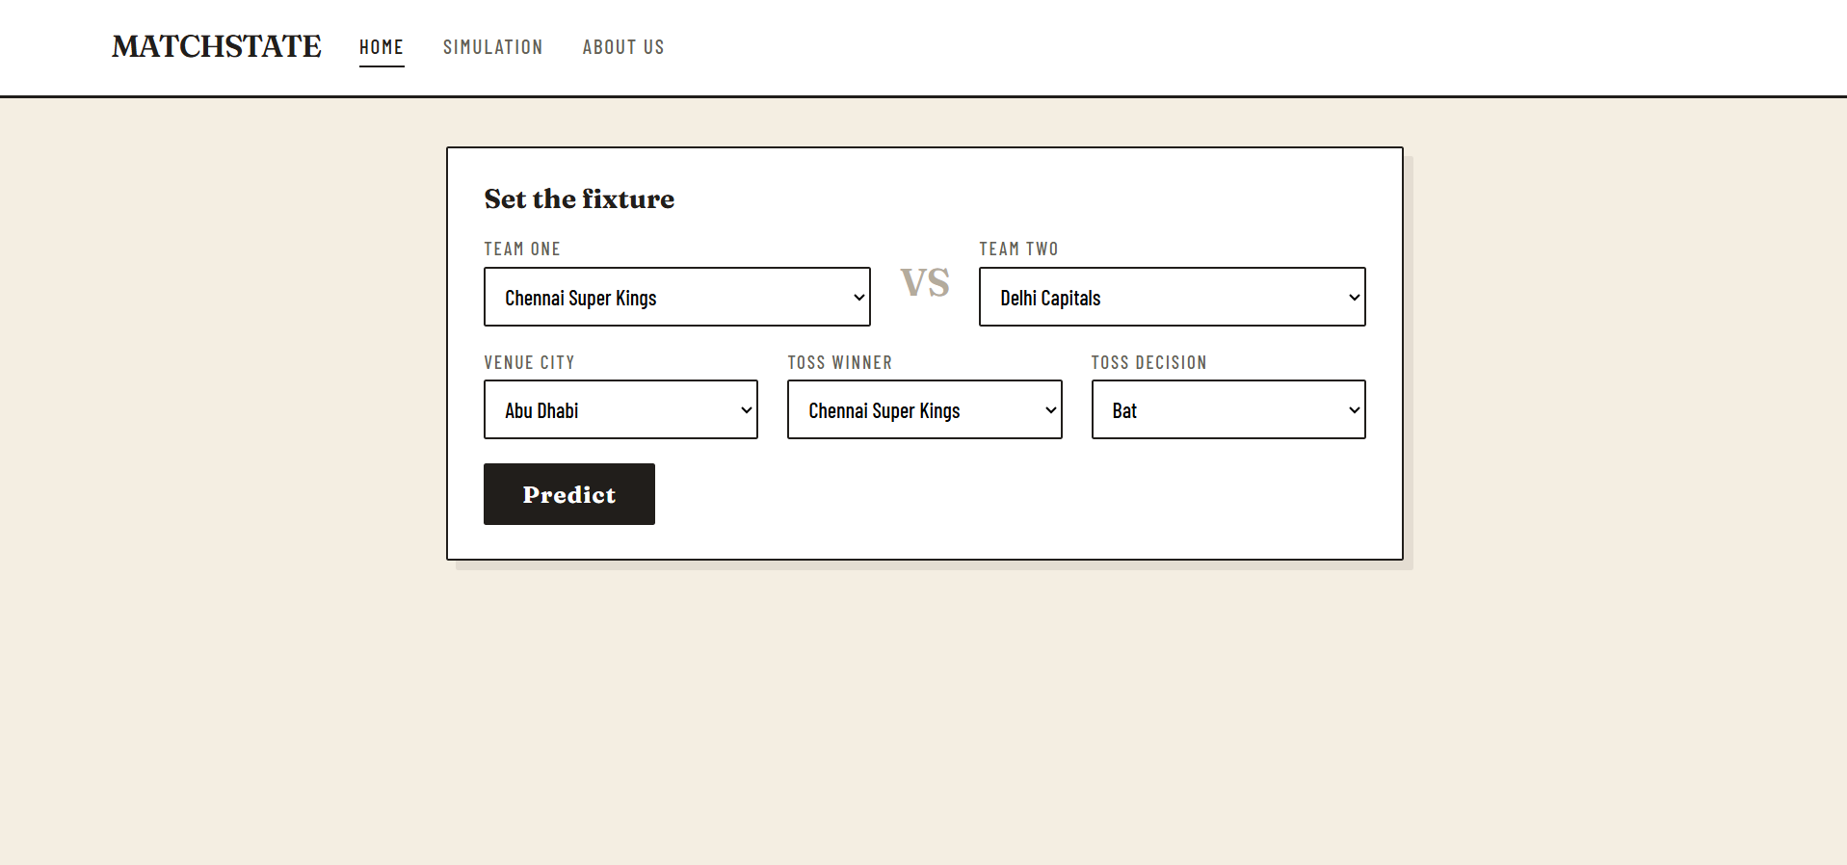
Figure 7.1: MatchState web interface showing fixture inputs (submitted application screenshot).
7.2 Geotagged Project Demonstration
Figure 7.2 records a project demonstration in a computer laboratory in Hyderabad, Telangana, with the geotag overlay preserved from the original image. The screenshot provides contextual evidence of the project presentation; it is not used as a model-performance result.
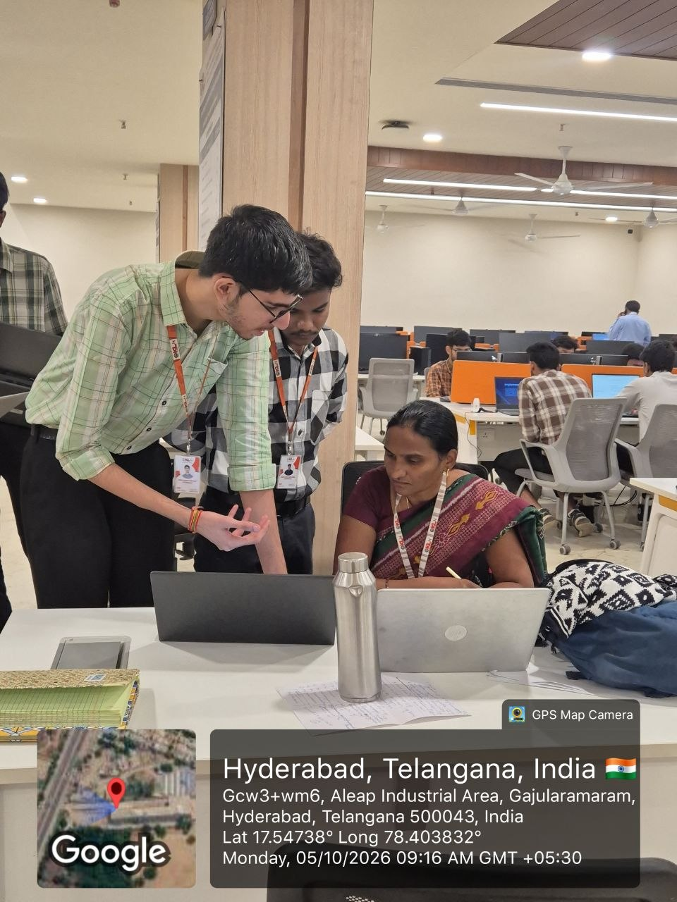
Figure 7.2: Geotagged photograph of the project demonstration, Hyderabad, Telangana (as provided).
7.3 Exploratory Data Analysis Summary
EDA item | Repository-reported observation
Historical coverage | IPL seasons 2008–2024 (17 seasons)
Match dataset | 1,095 rows × 20 columns
Ball-by-ball dataset | 260,920 rows × 17 columns
Team 1 wins | 536 matches (48.95%)
Team 2 wins | 540 matches (49.32%)
Tie / no result class | 19 matches (1.74%)
Toss winner also won match | 50.59% across the reported matches
Model features | 9 engineered features

Discussion: The EDA report indicates that win outcomes are distributed almost evenly according to the arbitrary Team 1/Team 2 ordering, while the tie/no-result class is rare. That class imbalance is an important modelling limitation and motivates evaluation with class-aware metrics and calibration checks. The EDA report also notes a 52.8% chasing win share in the analysed historical data; this is descriptive and should not be treated as proof that choosing to field causes better outcomes.
8. CONCLUSION AND FUTURE SCOPE
8.1 Conclusion
MatchState demonstrates an end-to-end machine-learning workflow for historical IPL match outcome estimation. It integrates data cleaning, franchise-name consolidation, chronological feature construction, Multinomial Logistic Regression, a Flask prediction interface, and an educational simulation view that exposes the mathematical steps behind the output. Modelling three result classes is a deliberate choice that keeps tie and no-result fixtures within the task. The project provides a practical illustration of probabilistic classification and interpretable feature engineering. However, a production-quality assessment requires a separate chronological hold-out test and published class-wise metrics; this report therefore avoids claiming a particular predictive accuracy.
8.2 Future Scope
• Evaluation: add chronological train/validation/test splits and report accuracy, macro-F1, per-class precision/recall, confusion matrix, log loss, and calibration.
• Rare outcomes: investigate class weighting or suitable resampling/regularisation methods for the tie/no-result class without overstating the available evidence.
• Feature expansion: consider venue-specific scoring and chasing statistics, player availability, squad strength, weather, and pitch conditions when reliable datasets are available.
• Temporal modelling: test recency-weighted form and compare the current model with well-defined baselines and alternative classifiers.
• Data handling: use a documented database layer or repeatable data-refresh pipeline, validate missing values, and track dataset versions.
• Deployment: add input validation, error handling, automated tests, logging, and deployment monitoring.
• Explainability: expose probability calibration and clearer feature-contribution explanations while communicating model uncertainty to users.
9. REFERENCES
1. Project repository: MV_MLR_ML — source code, dataset notes, and project materials. https://github.com/venkataramavinaybandla-crypto/MV_MLR_ML
2. Scikit-learn, LogisticRegression API documentation. https://scikit-learn.org/stable/modules/generated/sklearn.linear_model.LogisticRegression.html
3. Scikit-learn, Probability calibration. https://scikit-learn.org/stable/modules/calibration.html
4. Scikit-learn, Model evaluation: quantifying the quality of predictions. https://scikit-learn.org/stable/modules/model_evaluation.html
5. Flask documentation. https://flask.palletsprojects.com/
6. Pandas documentation. https://pandas.pydata.org/docs/
7. NumPy documentation. https://numpy.org/doc/
8. SQLite documentation. https://www.sqlite.org/docs.html
9. Python documentation. https://docs.python.org/3/
10. Kaggle datasets — IPL historical match data discovery page. https://www.kaggle.com/datasets?search=IPL+matches

