**The Global Business of Football Ownership.**

**Data Visualization**

Muhammad Siddiq

**Abstract:**

The football transfer market plays a pivotal and dynamic role in the sport, acting as the arena where clubs strategically reshape their squads to achieve success both domestically and internationally. With designated transfer windows, particularly during the summer and winter periods, the market sparks a flurry of activity as clubs engage in intricate negotiations to secure new talent or offload existing players.

At its core, the transfer market revolves around player transactions, involving financial dealings that dictate the movement of athletes between clubs. While high-profile transfers often grab headlines, the market also sees numerous loan deals and free transfers, enabling clubs to secure players temporarily or acquire free agents whose contracts have expired. Player valuation stands as a central aspect of these transactions- a complicated process influenced by factors such as a player's skill level, age, on-field performance, and market demand.

Operating within a regulatory framework established by football governing bodies like FIFA, the transfer market strives to maintain fairness, transparency, and financial stability in the sport. Despite its inherent complexities, the football transfer market reverberates globally, captivating audiences worldwide, instilling excitement, and nurturing anticipation among fans.

Beyond the financial intricacies, the market's significance lies in its ability to reshape football's competitive landscape. The addition of new talents, the departure of established players, and the constant flux of squad dynamics contribute to the ever-evolving narratives that define each football season. Essentially, the football transfer market transcends mere economic transactions; it is a dynamic force that molds the very essence of the beautiful game.

In this extensive project, our primary focus is on conducting a comprehensive analysis of the football transfer market, particularly within the context of the top 5 global leagues. Over the span of the last decade, we meticulously examine the financial intricacies, strategic decisions, and evolving trends that have shaped the transfer market. Our investigation encompasses an in-depth exploration of the spending behaviors exhibited by the most influential clubs, unraveling the strategic considerations and patterns that underpin their player acquisition strategies.

Furthermore, we shift our attention to individual player transfers, scrutinizing the record-breaking fees associated with these transactions. This involves an examination of the multifaceted factors that drive these deals, including player performance, market demand, and the financial standing of the involved clubs. Our analysis extends to the last 10 years, allowing us to trace the trajectories of financial investments and identify key influencers, such as economic shifts, regulatory changes, and global events.

Diving into the granular details, we explore player values and transfer fees based on various parameters, including position and age. This analysis provides nuanced insights into the market's valuation criteria, shedding light on how these factors influence the financial dynamics of player transfers. The project also concludes with an intriguing investigation into the correlation between financial investments in transfers and on-field success. By examining how money spent translates into competitive achievements, we offer a holistic perspective on the football transfer market's economic, strategic, and competitive dimensions.

**Motivation:**

Undertaking this Football TransferMarket Data Visualization project is a passionate journey fueled by the transformative events and monumental changes that have recently reshaped the footballing landscape. As a devoted football fan since childhood, the recent surge in interest surrounding high-profile transfers has ignited a deep curiosity to delve into the intricate world of football transactions and club takeovers.

The awe-inspiring transfers of Neymar, Kylian Mbappe, Dembele, Griezmann, Bale, Ronaldo, Coutinho, and others have not only captured headlines but have marked a paradigm shift in the sport. Witnessing the takeovers of iconic clubs by wealthy oligarchs, such as Sheikh Mansour's Manchester City acquisition and the Qatari and Saudi investment fund takeovers of PSG and Newcastle United, respectively, has been nothing short of fascinating.

These pivotal moments extend beyond the pitch, influencing media rights revenues, infrastructure development in nations like Greece and Egypt, and even contributing to significant global events like the hosting of the World Cup. The narrative of football legends transitioning from European powerhouses to playing in Saudi Arabia is a testament to the evolving dynamics of the beautiful game, where passion, finance, and strategic decisions intersect in unprecedented ways.

This project aims to visualize the data behind these captivating stories, offering a unique perspective on the correlation between financial investments and on-field success. It's a journey through the last decade of football, exploring how these monumental transfers and takeovers have not only reshaped individual clubs but have had a profound impact on the global footballing ecosystem. By undertaking this project, we seek to unravel the intricate threads that tie together the passion for football and the contemporary, ever-evolving narrative of the sport millions of people around the globe hold dear.

**Data:**

The dataset for this project is sourced from the Transfermarkt website, a renowned platform that serves as a comprehensive repository for football-related data, including player transfers, market values, and club information. Transfermarkt has established itself as a reliable and widely-used resource in the football analytics community, providing enthusiasts and analysts with detailed insights into the dynamic world of player movements and financial transactions within the sport.

The focus of this data exploration centers on the transfer data of football players within the top 5 European leagues, namely the Premier League (England), La Liga (Spain), Bundesliga (Germany), Serie A (Italy), and Ligue 1 (France). These leagues represent the pinnacle of European football and are home to some of the most prestigious clubs and talented players globally.

The dataset encompasses a range of crucial columns that capture essential information about each transfer. The key variables include:

* Club: The football club involved in the transfer.
* Name: The name of the player undergoing the transfer.
* Age: The age of the player at the time of the transfer.
* Nationality: The player's nationality.
* Position: The playing position of the player.
* Short_Pos: Abbreviated playing position.
* Market_Value: The estimated market value of the player.
* Dealing_Club: The club involved in the transfer deal.
* Dealing_Country: The country of the dealing club.
* Fee: The transfer fee associated with the transaction.
* Movement: Indicates whether the transfer is an incoming or outgoing movement.
* Window: Specifies the transfer window during which the deal took place.
* League: The football league to which the clubs belong.
* Season: The season in which the transfer occurred.

These columns collectively provide a comprehensive view of the transfer activities within the top European leagues, allowing for detailed analyses and data visualizations to uncover patterns, trends, and insights into the dynamics of player movements in the world of football.

**Background:**

In the background of this report, we delve into the intricate landscape of the football transfer market, tracing its evolution over the years and examining its profound impact on the sport. The football transfer market has undergone significant transformations, influenced by historical events, regulatory interventions, and the ever-growing financial dimensions of the beautiful game.

Historically, player transfers have been a fundamental aspect of football, allowing clubs to bolster their squads and adapt to changing competitive landscapes. However, the contemporary transfer market has transcended its traditional role, becoming a multi-billion-dollar industry with global implications.

Over the years, the transfer market has witnessed watershed moments, from landmark transfers that shattered records to regulatory changes implemented by football governing bodies like FIFA. The advent of influential investors, including wealthy oligarchs and investment funds, has injected unprecedented capital into the market, redefining the financial dynamics of player acquisitions. As we explore the data visualization aspects in this project, this background provides the necessary foundation to understand the complexities in the modern football transfer ecosystem.

**Related Work:**

**Title of the work: Visualization Transfers 2000-2018**

**Link:** <https://www.kaggle.com/code/maximilianschrder2/part-2-visualization-transfers-2000-2018>

**Screenshots:**

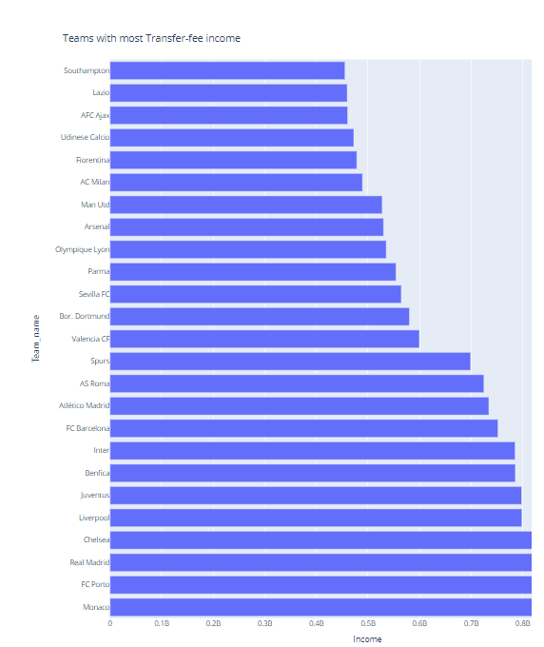

**Critique and compare:**

The original graph might lack detailed information and labels, making it challenging to interpret spending patterns. The recommendation is to create an individual bar plot that explicitly shows the transfer-fee income for each team. Each bar in the plot represents a team, and the height of the bar corresponds to the total transfer-fee income for that team. This provides a more detailed and explicit view of the spending pattern for each team. Labeling the bars with exact values further enhances precision, allowing for easy comparison between teams.

**Title of the work: Football transfers between 2000-2018**

**Link:**

<https://www.kaggle.com/code/yahyarashwan/football-transfers-between-2000-2018-eda>

**Screenshots:**

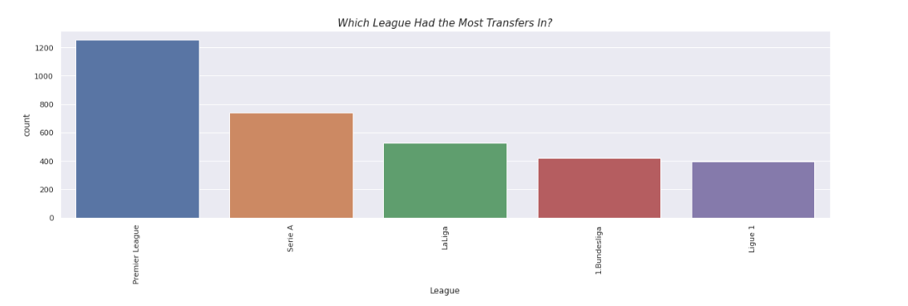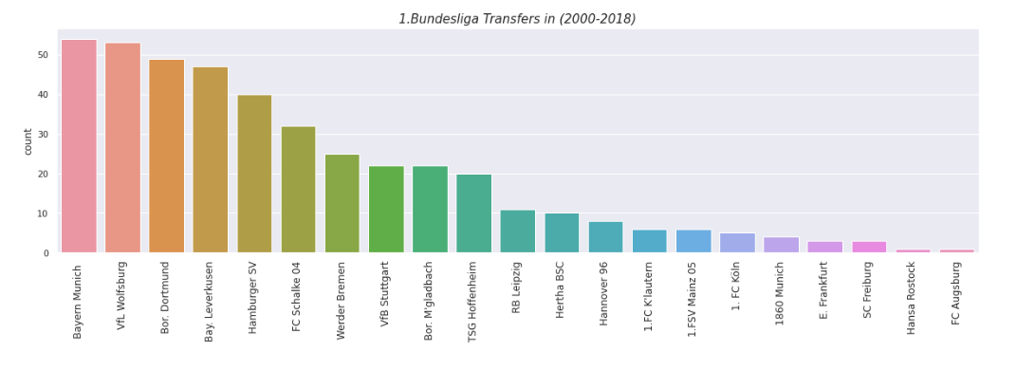**Critique and compare:**

Instead of plotting the number of transfers for different leagues and then creating individual plots for transfer counts for each team within a league, a treemap can efficiently display all this information in a single graph. Treemaps use nested rectangles to represent hierarchical data structures, allowing for a clear visualization of the relationship between leagues and teams. Each rectangle in the treemap represents a league, and nested within it are rectangles representing individual teams. The size of each rectangle corresponds to the number of transfers. Hovering over a specific section of the treemap provides detailed information about that league and team, reducing the need for separate plots and streamlining the analysis process.

**Title of the work: Visualization Transfers 2000-2018**

**Link:**

<https://www.kaggle.com/code/maximilianschrder2/part-2-visualization-transfers-2000-2018>

**Screenshots:**

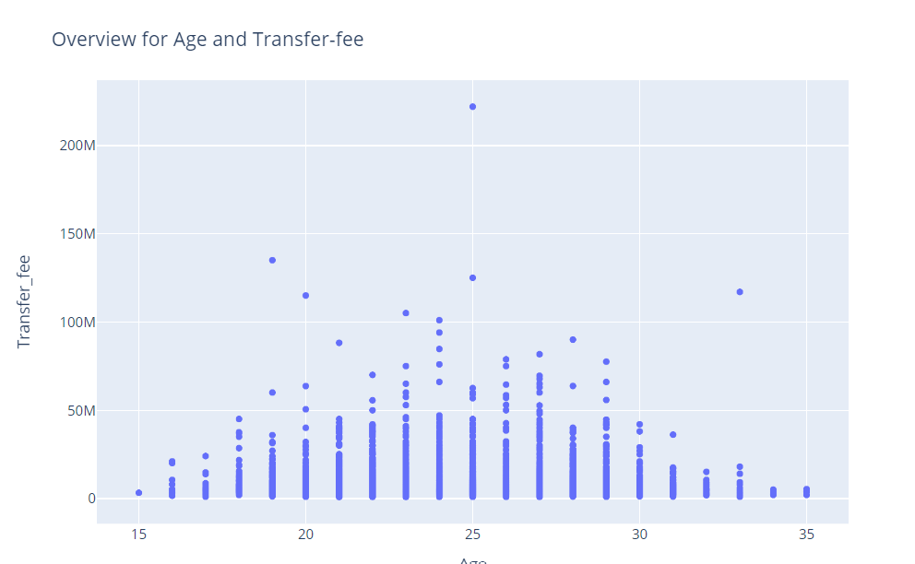

**Critique and compare:**

While scatterplots are useful for visualizing individual data points, they may become cluttered and less informative when dealing with many overlapping points, especially in the context of age distribution. The recommendation is to use a histogram with Kernel Density Estimation (KDE). This approach provides a smoother and continuous representation of the age distribution, offering insights into the overall shape and concentration of ages. The KDE curve helps identify peaks and valleys in the distribution, making it easier to understand the underlying pattern. This visualization choice is particularly beneficial when exploring the broader trends in age distribution across the dataset.

**Title of the work: Analyzing Soccer’s transfers and Predicting footballer’s transfer price.**

**Link:**

https://www.researchgate.net/publication/342347848_Analyzing_soccer's_transfers_and_predicting_footballers'_transfer_price

**Screenshots:**

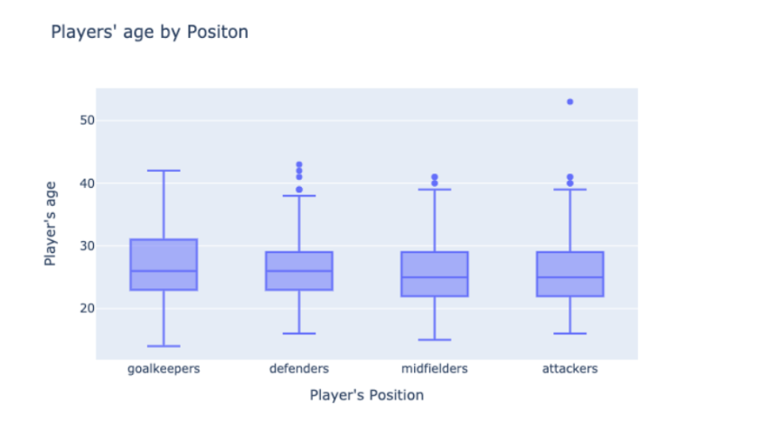

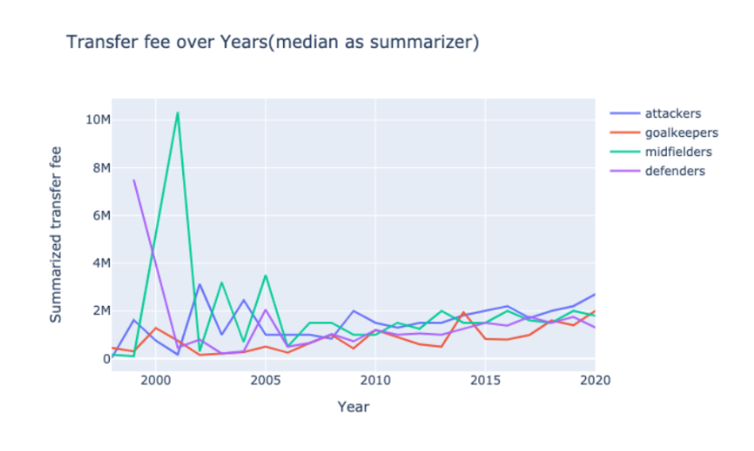

**Critique and compare:**

Several critiques and considerations have been observed in the above research paper. The analysis relies on correlations, and caution is needed in inferring causation. Additionally, the study acknowledges that some performance metrics may not be equally applicable to all positions. One notable limitation is the potential oversimplification of the analysis by relying on summarizers like mean, median, and maximum, which might not fully capture the nuances of the data. Additionally, the analysis does not delve deeply into the specific factors contributing to the fluctuations in market values and transfer fees, such as player performance metrics, team dynamics, or economic factors. A more granular examination of these variables could enhance the depth of the analysis. Furthermore, while the correlation between market values and cumulative market values is explored, a more comprehensive investigation into the evolving factors affecting player valuations over time could provide a more nuanced understanding of the market dynamics.

**Objectives:**

The objectives of this Football TransferMarket Data Visualization project are designed to provide some meaningful insights into the dynamic realm of football transfers within the top 5 European leagues. The key goals include:

* Explore Spending Patterns: Analyze and visualize the spending behaviors of football clubs within the specified leagues over the last decade, identifying trends, outliers, and shifts in financial strategies.
* Long-Term Financial Trajectories: Trace the financial investments in player transfers over the last 10 years, mapping the trajectories of spending and identifying influential factors such as economic shifts, regulatory changes, and global events.
* League Spendings Overview: Provide an overview of spending activities by football leagues, highlighting patterns and variations in financial investments across the Premier League, La Liga, Bundesliga, Serie A, and Ligue 1. Explore how different leagues contribute to the overall dynamics of the football transfer market.
* Position/Club-wise Spending Activities: Delve into specific spending activities by league, offering insights into how each league contributes to the broader landscape of football transfers. Analyze league-specific trends, showcasing the unique characteristics that define spending behaviors within the leagues.
* Individual Player Transfers Analysis: Scrutinize individual player transfers, focusing on record-breaking fees, and investigate the driving factors behind these transactions, considering player performance, market demand, and the financial standing of clubs.
* Correlation Between Spending and Success: Investigate the correlation between financial investments in player transfers and on-field success, examining how money spent translates into competitive achievements, and contributing to a deeper understanding of the economic, strategic, and competitive dimensions of the football transfer market.

**Process:**

**Data Preprocessing:**

Data is loaded using the Pandas library’s **pd.read_csv** function to import datasets for each football league. This initial step is crucial as it establishes the foundation for subsequent data manipulations and analyses.

To comprehensively address missing values, exploratory insights are gained using **info()** and **describe()** functions. Focusing on the ‘market_value,’ ‘fee,’ and ‘loan_status’ columns, the **fillna** method is applied. The mean values of ‘market_value’ and ‘fee’ columns are used for filling, while ‘loan_status’ is assigned the string “Not Applicable.” to ensure a comprehensive strategy for handling missing data.

After that we converted the ‘season’ column into ‘category’ data type to use the values of ‘season’ as labels instead of taking numerical values. Then duplicate rows are eliminated using the **drop_duplicates** method. Because it is crucial for maintaining data integrity, preventing skewed analyses, and ensuring accuracy in subsequent statistical summaries.

Following duplicate removal, the index of the DataFrame is reset through **reset_index(drop=True)** to establish a consistent and sequential index, aiding data integrity maintenance and facilitating subsequent analyses.

Casting the ‘fee’ column to integer using **astype(int)** ensures that ‘fee’ values are treated as numerical, supporting mathematical operations and analyses. Dropping null values in critical columns such as ‘dealing_country’ and ‘dealing_club’ are removed using dropna(subset=[‘dealing_country’, ‘dealing_club’]) to ensure the availability of essential information. Filtering out loan transactions, corresponding to loan transactions (where ‘is_loan’ is True) are excluded using [dataframe_name][‘is_loan’] == False. This refines the dataset to focus solely on permanent transfers for cleaner analysis.

The cleaned datasets for each league are stored as new CSV files (e.g., ‘premier-league-cleaned.csv’, ‘laliga_cleaned.csv’, etc.) using the **to_csv** method. Saving cleaned datasets is essential for preserving data integrity and allowing future analyses without repeating the preprocessing steps. The final step involved merging cleaned datasets from different leagues into a single DataFrame, ‘merged_cleaned_data,’ utilizing **pd.concat**. This comprehensive dataset enables cross-league analyses, offering a holistic view of player transactions across multiple leagues for more extensive and insightful analyses.

**Methods: ideas, sketches, prototypes:**

Initially, we opted to eliminate outliers from our dataset, believing it would enhance the quality of our visualizations and yield more accurate insights. However, upon further examination, we discovered that this approach significantly altered the visual representations and led to potentially inaccurate results. Consequently, we decided to retain all data points to ensure a comprehensive and reliable analysis.

In our exploration of transfer patterns, we initially employed a bar graph to illustrate the number of transfers occurring in both the summer and winter transfer windows over the years. However, recognizing the need for a more nuanced representation of trends, we transitioned to a line chart. This adjustment allowed us to better capture and convey the evolving patterns and fluctuations in transfer activities over time.

Considering the possibility of creating a cartogram based on nationality, we encountered a limitation in the available location information. Without sufficient details about the geographical locations associated with each nationality, we recognized the potential for misleading visualizations. Consequently, we made the decision to drop the idea of constructing a cartogram based on nationality, prioritizing accuracy and relevance in our visualizations.

Exploring the age distribution of players, we experimented with various bin sizes for histograms to derive an optimal representation. This involved testing different bin configurations to achieve a histogram that accurately and effectively conveyed the distribution of player ages. By iteratively adjusting bin sizes, we aimed to produce a histogram that offered meaningful insights into the age demographics within the dataset.

**Data visualization methods selection:** We have listed out potential visualization methods and discussed in detail the pros and cons of particular visualizations.

1. Lineplots for Transfer Activity Over Seasons and Spending Across Leagues:

* Line plots effectively depict trends over time for different leagues.
* Consistent use of legends and labels improves clarity.
* Communicates seasonal trends, transfer counts, and spending amounts effectively.
* The color palette and markers enhance visual appeal.

2. Bar Plots for Transfer Windows and Top Spending Clubs:

* Easily identifies peak transfer activity during specific windows.
* Seasonal breakdown aids in understanding transfer trends over time.
* Provides a clear ranking of clubs based on spending.
* Annotations enhance data comprehension.
* Effective use of color, legends, and annotations.

3. Choropleth Plots for Player Distribution and Transfer Fees by Country:

* Highlights regions with a high concentration of football players.
* Offers an intuitive overview of global player distribution.
* Provides insights into global financial aspects of football transfers.
* Choropleth maps effectively visualize spatial distributions and variations.
* Color scales aid in identifying trends and patterns.

4. Treemaps for Top Dealing Clubs and Spending Distribution:

* Provides a clear and hierarchical representation of transfer counts and spending distribution.
* Hover data enhances interaction.
* Treemaps are effective for conveying hierarchical data structures.
* Size and color intensity provide dual encoding for enhanced interpretability.

5. Radar Charts for Positional Spending Across Leagues:

* Easily identifies positions with the highest total fees spent.
* Circular layout allows quick comparison across positions.
* Effective for displaying multivariate data in a circular layout.
* Polar coordinates enable easy comparison along different axes.
* Suitable for analyzing and comparing spending patterns by position.

6. Interactive Bar Chart for Transfer Fees by Position and League:

* Interactivity through dropdown menus for selecting the year and position.
* The horizontal bar chart represents total transfer fees for each league.
* Color-coded bars add an extra dimension to the visualization.
* User-friendly interface for exploring and understanding transfer fee distributions.

7. Sunburst Chart for Top Transfer Fees Distribution:

* Represents hierarchical data of top transfer fees by league, club, and player.
* The color of each segment provides a visual cue for different categories.
* Communicates the distribution of top transfer fees in an appealing and intuitive manner.
* Suitable for exploring key players, clubs, and leagues in terms of transfer fees.

This comprehensive set of visualizations caters to different aspects of football transfer analysis, enabling diverse stakeholders to gain valuable insights.

**Visualization Results Insights and Details:**

Exploring Transfer and Spending Patterns:

Transfer Patterns:

We started our analysis with a couple of line charts illustrating the transfer dynamics across the top five football leagues. Serie A emerges as the frontrunner, dominating both incoming and outgoing transfers. Over the past decade, the Premier League initially held the second position in transfer activities. However, in recent years, there has been a noticeable decline in both inbound and outbound transfers.

La Liga and Ligue 1 exhibit relative consistency, experiencing occasional fluctuations. Notably, Ligue 1 has witnessed a slight increase in both incoming and outgoing transfers in recent years. Bundesliga stands out with the least transfer activity among the leagues. The zenith of transfer activities occurred between 2013 and 2016, coinciding with significant takeovers and the restructuring of several clubs.

Examining the charts for all leagues, a conspicuous dip in transfer numbers is evident from 2020 onwards. This decline is primarily attributed to the global impact of the COVID-19 pandemic. The pause in league football, travel restrictions affecting foreign players, and domestic limitations resulted in a substantial reduction in transfer activities. The closure of stadiums further resulted in financial losses for major clubs, contributing significantly to the diminished number of transfers.

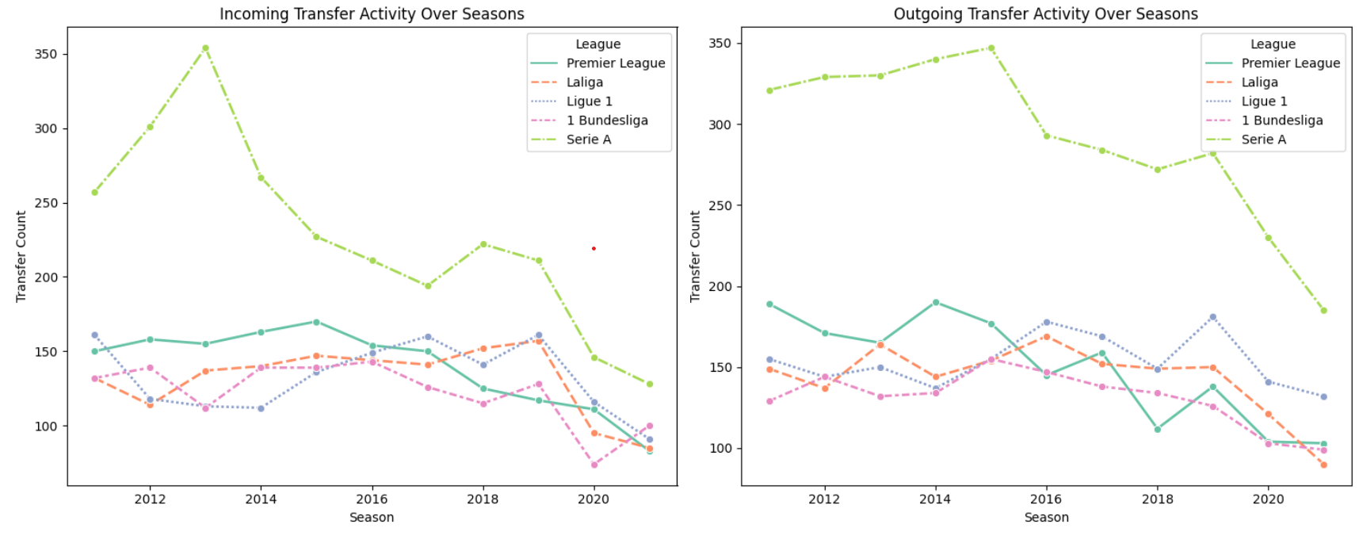

**Spending Patterns by league over the years:**

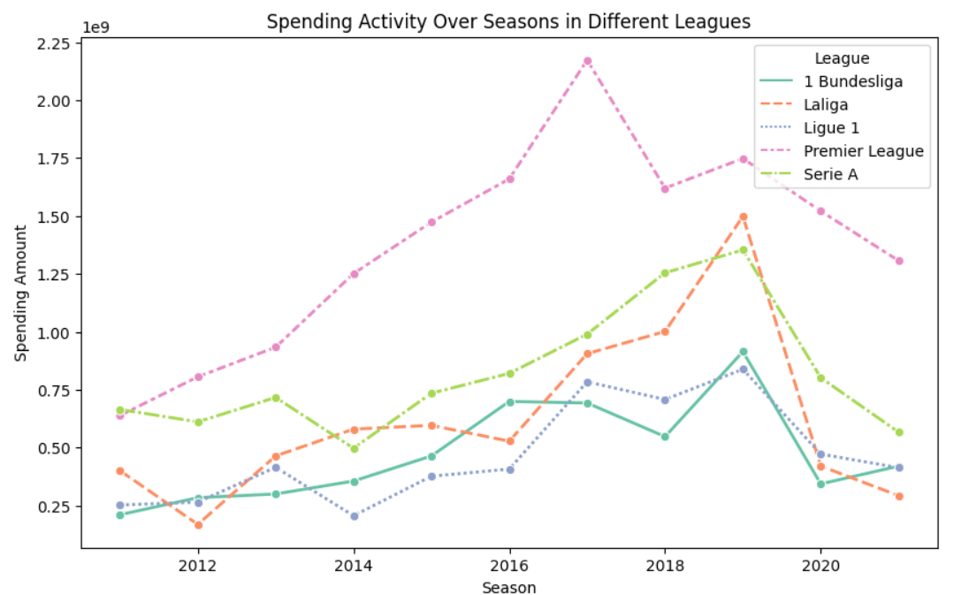

In the Premier League, aggregate spending has witnessed a significant upward trajectory over the past decade. The league commenced the period as the highest spender and has since experienced a remarkable surge, surpassing other leagues. Notable takeovers, such as Manchester City by a UAE prince and Chelsea by a Russian oligarch (later sold to an American billionaire), along with influential clubs like Manchester United and Newcastle United, Everton, Tottenham Liverpool and Arsenal have contributed to this surge. The Premier League's global viewership and substantial revenue streams from sponsorships and broadcasting further amplify its financial prowess.

Serie A, while commencing the decade with spending levels comparable to the Premier League, has struggled to keep pace. The league faces challenges, including outdated stadiums and declining attendances, with most teams, excluding Juventus, playing in facilities they do not own. This situation, coupled with poor performances from major clubs, has led to plummeting attendances and a decline in matchday revenues. The need for new ticket-pricing strategies, improved corporate facilities, and broader commercial approaches is crucial for Serie A's financial revival.

La Liga has witnessed a consistent upward trend in spending, surpassing Serie A before the impact of COVID-19. The league's international appeal, particularly through clubs like Barcelona and Real Madrid, which attract significant Asian and global viewership, and modern stadiums with capacities exceeding 50,000, contribute to its financial strength.

Bundesliga, with limited international viewership except for clubs like Dortmund and FC Bayern, has been dominated by FC Bayern over the last decade. While the league has found success in the Champions League, its international reach is comparatively modest. Ligue 1, particularly after the Qatar takeover of PSG in 2011, has become a league dominated by a single club. PSG's significant investments have attracted star players, international viewership, and lucrative sponsorships, transforming the league's financial landscape.

Exploring the Long-Term financial investments in player transfers over the last decade:

**Time Series Analysis for Spending against the Market Values of transfers for different leagues.**

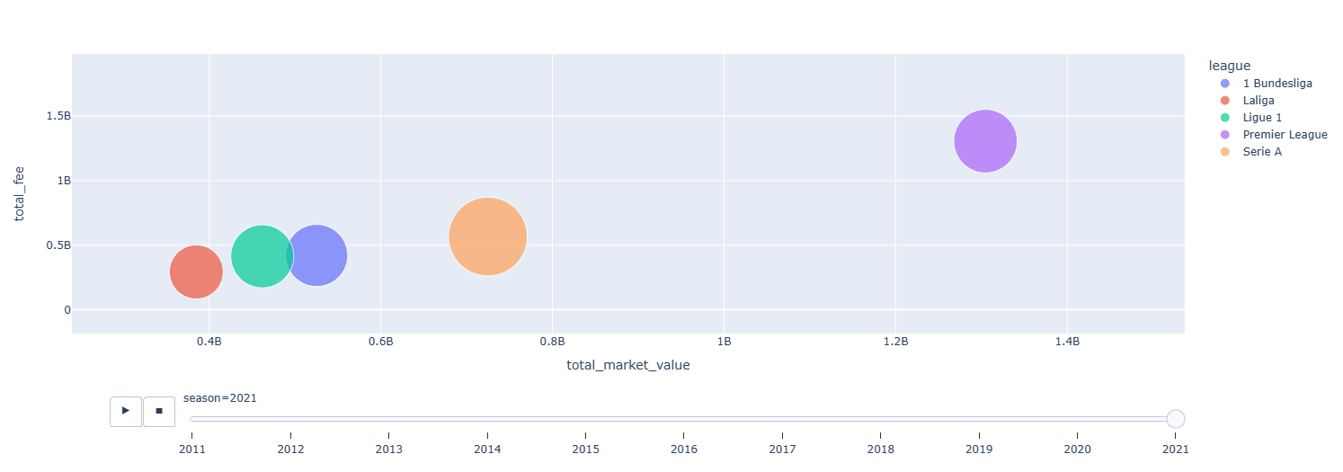

This dynamic animated scatter plot serves as a comprehensive visual representation of the intricate transfer activities within the realm of football across diverse leagues and numerous seasons. Each precise point on the graph corresponds to a specific combination of league and season. The horizontal axis (X-Axis) portrays the cumulative market value of players engaged in incoming transfers, offering insights into the financial dimensions of these acquisitions. Conversely, the vertical axis (Y-Axis) illustrates the total transfer fees expended on incoming players, providing a glimpse into the economic aspects of the transfer market. The size of each point reflects the total count of incoming transfers during a given season and league, with larger points denoting heightened transfer activity. Furthermore, distinct color codes distinguish each league, such as the Premier League, La Liga, Bundesliga, Serie A, and Ligue 1, facilitating a clear identification of data points. The animation gracefully progresses through different seasons, enabling a dynamic observation of how transfer activities evolve across leagues over time. This visualization offers valuable insights into trends and patterns, allowing viewers to discern fluctuations in market value, transfer fees, and the volume of player transfers across various football leagues throughout the years which combines the line plots and confirms the facts and information.

**Pie Chart for visualizing the proportions in spending across the leagues.**

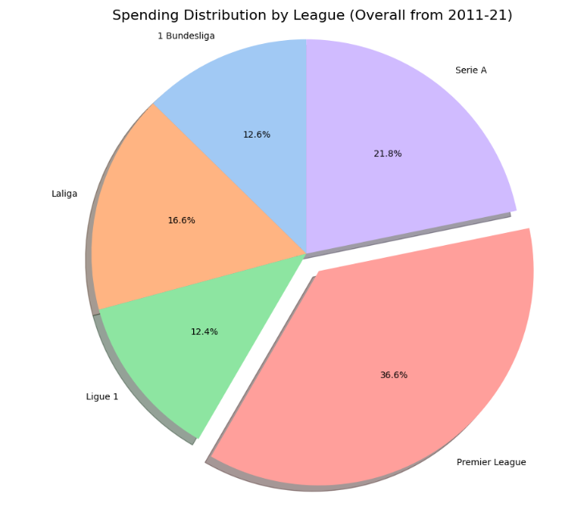

The pie chart illustrates the proportional distribution of football transfer spending among the top European leagues from 2011 to 2021. The Premier League emerges as the leading spender, commanding an impressive 36.6% share, a testament to its global appeal and lucrative broadcasting deals. Serie A follows closely with a 21.8% share, while La Liga, shares 16.6%, Bundesliga, contributing 12.6%, emphasizes its significance while Ligue 1 has the lowest share share of in the market with 12.4%.

**Visualizing the impact of Age on Football Transfers:**

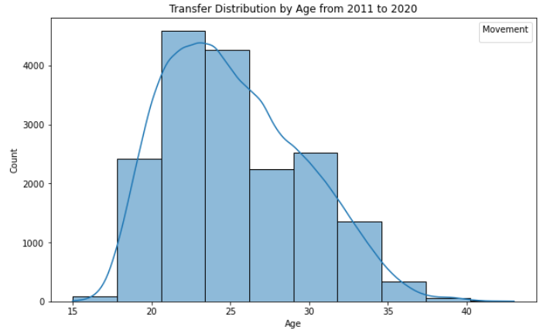

The histogram presents a distribution of football transfers based on players' ages from 2011 to 2020. It reveals a right-skewed pattern, indicating that the majority of transfers involve players in the age range of 22-25, peaking during this period. Transfers involving younger players (15-20) are relatively low, gradually increasing, while those involving older players (above 30) decrease. This skew suggests a preference for players in their prime years, likely due to their peak performance levels.

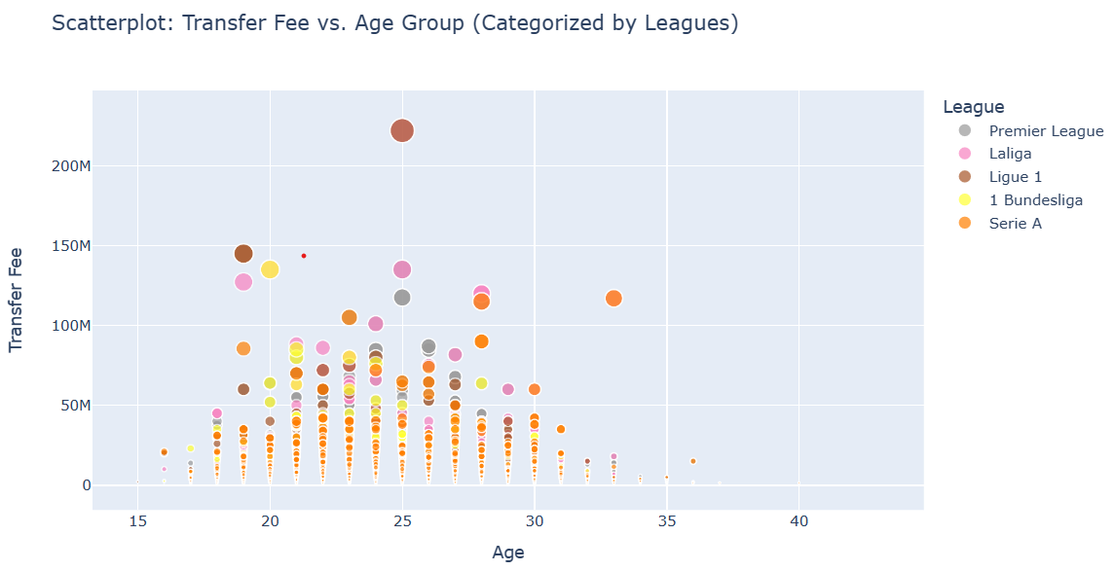

The scatterplot explores the relationship between transfer fees and player age categorized by leagues. The bell-curve-like trend indicates that the majority of transfer fees peak in the age range of 22-25 and decline as players get older. However, the presence of outliers signifies exceptions to this trend. These outliers often include players with substantial social media followings and lucrative sponsorship deals, turning them into celebrities in addition to athletes. These outliers contribute to the dispersion in transfer fees, highlighting the multifaceted factors influencing football transfers, beyond just on-field performance.

**Navigating the Field: Analyzing Transfer Fees by Position and Season Across Football Leagues**

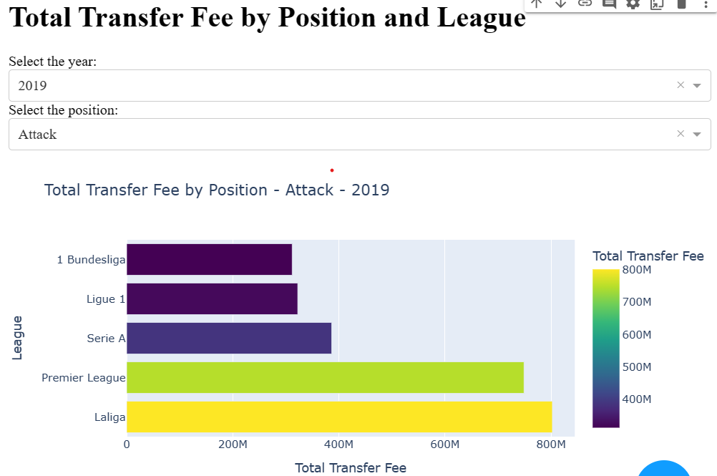

This dynamic visualization offers a detailed exploration of transfer fees based on player positions across different football leagues and seasons. The interactive dashboard allows users to select specific years and player positions, providing valuable insights into the financial dynamics of each league.

Defensive Transfers:

Starting with defenders, Serie A led the decade tactically renowned for its defensive prowess. However, since 2013, the Premier League has dominated defensive transfers, consistently surpassing La Liga and Serie A. Notably, Serie A's defensive spending remained significant throughout the years.

Midfield Dominance:

In the midfield category, the Premier League emerged as the top spender, with Serie A and La Liga closely vying for the second spot. La Liga briefly overtook Serie A in 2015 and 2017, showcasing the competitive nature of spending in these positions.

Attacking Frontiers:

For attacking transfers, the Premier League initially held the lead until 2017. However, Serie A claimed the top spot in 2018 with high-profile acquisitions like Ronaldo to Juventus and Lukaku to Inter Milan. La Liga took the lead in 2019, fueled by notable transfers such as Griezmann to Barcelona and Jao Felix to Atletico Madrid. The Premier League regained its dominance post-COVID, securing the highest spending in the attacking department.

Goalkeeping Excellence:

In the realm of goalkeepers, Serie A initially led for two years and reclaimed the top position in 2021 post-COVID. The Premier League consistently topped the chart in the remaining years, emphasizing its prowess in securing elite goalkeeping talent. La Liga surpassed the Premier League in 2015, marked by significant acquisitions by Atletico Madrid and Barcelona.

**Radar Chart Analysis:**

Radar chart not only unveils overarching spending trends across different player positions but also provides nuanced insights into specific pivotal years, such as 2017, marked by historic transfers.

**Total Transfer Fees by Position Across Leagues**

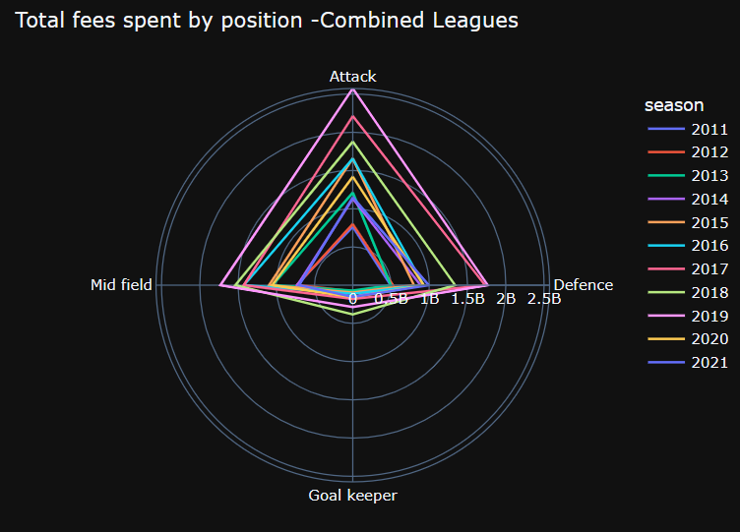

**Positional Spending Patterns:**

The radar chart vividly illustrates that attacking players consistently command the highest transfer fees, reflecting the premium placed on goal-scoring talents. The significant expenditure on attackers is a common trend across all leagues, showcasing the emphasis on offensive prowess.

Midfield vs. Defense Dynamics:

Midfield and defensive positions emerge as contenders for the second-highest spending category, demonstrating the strategic balance clubs seek between solidifying their defense and bolstering their midfield. The competition between these two positions is a recurrent theme across different seasons and leagues.

Goalkeeper Spending:

Goalkeeper transfers, represented by the innermost layer of the radar, consistently reflect the lowest expenditure. This is attributed to the unique nature of the goalkeeper position, where teams typically have only one star goalkeeper, leading to fewer transfers compared to other positions.

2017/2019 - A Notable and the Pinnacle Year:

In 2017, the chart echoes the resonance of monumental transfers, headlined by Neymar's groundbreaking move to PSG for £222 million, complemented by Mbappe's £180 million transfer, and high-profile deals for Dembele and Lukaku, each exceeding £100 million. Fast forward to 2019, and the radar lines trace a trajectory of escalating spending across all positions. This pinnacle year witnessed a cascade of major transfers, featuring stars like Aaron Wan-Bissaka, Harry Maguire, Rodri, Bruno Fernandes, Romelu Lukaku, Nicolas Pepe, Joao Cancelo, Joao Felix, Antoine Griezmann, Eden Hazard, Matthijs De Ligt, Lucas Hernández, and Frenkie De Jong. Collectively, these high-profile moves elevated 2019 to a landmark year, surpassing even the remarkable spending witnessed in the notable 2017 transfers.

**Transfer Distribution Across Leagues by positions:**

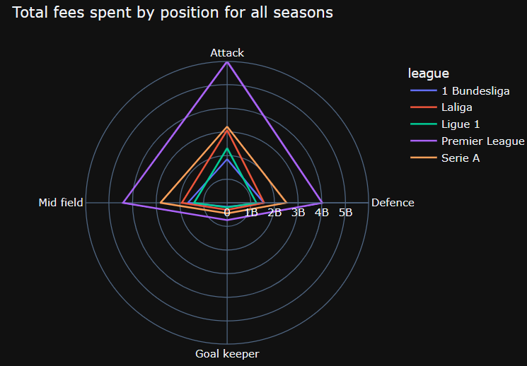

This visualization effectively reinforces a key observation derived from our project objectives—namely, the substantial spending disparity between the Premier League and other top football leagues. The chart vividly illustrates the Premier League's dominance in spending across all positions, outpacing its counterparts from France, Spain, Italy, and Germany. This financial supremacy is attributed to the Premier League's lucrative TV deals, enabling even lower-tier teams within the league to outspend top clubs from other European leagues. Notably, Premier League consistently leads the charts in all positions, with Serie A emerging as the second-highest spender, particularly in attacking positions. La Liga closely competes with Serie A in attacking expenditures, both nearing the 3 billion mark, followed by Ligue 1 with over 2 billion in spending. Bundesliga trails behind with approximately 1.8 billion in total spending, making it the league with the least financial outlay across all positions. The data affirms a consistent trend where the second-highest expenditure occurs in the midfield, followed by defense, while the least spending is observed in the goalkeeper position across all leagues.

**League Leaders:**

**Unveiling the Top 3 Football Clubs across the leagues in Transfer Spending Across the Decade**

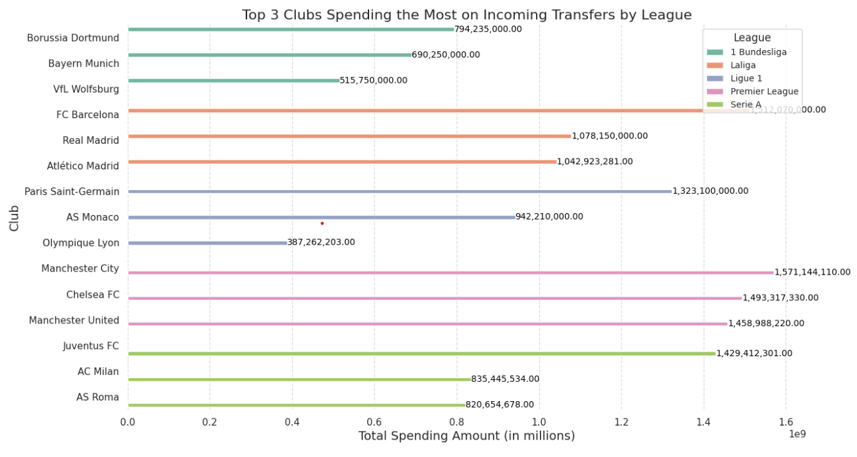

This visual representation through a bar plot effectively encapsulates the top 3 clubs spending the most on incoming transfers within each football league over the last decade. Barcelona emerges as the highest spender, leading the charts across all leagues, a testament to their global stature and significant revenue generation. Manchester City, under the ownership of a UAE prince, follows closely, showcasing a determined effort to reshape the team and the league. Chelsea, backed by a Russian oligarch, secures its position among the top spenders, while Manchester United, with the Glazer family at the helm, maintains its international prominence and financial clout. In Italy, Juventus dominates as the highest spender, reflecting its status as the premier club in the country. Paris Saint-Germain (PSG), fueled by the Qatar takeover, has become a major player in the transfer market, asserting itself as one of the top spenders.

**Overall spending summary**

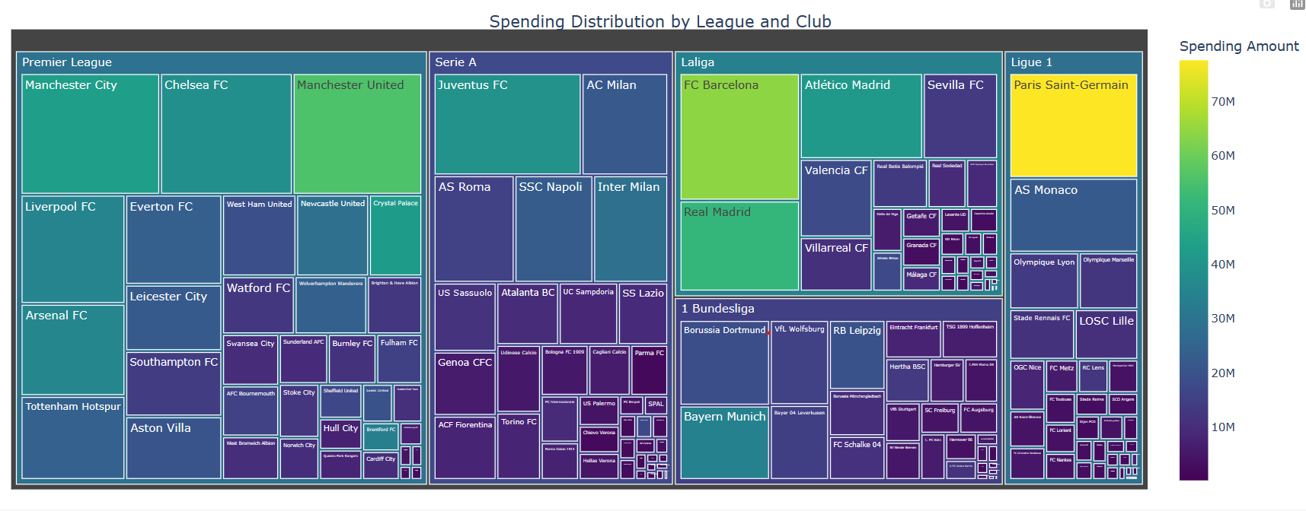

The tree map showcases the spending distribution across various leagues and clubs, Premier League giants dominate the spending panorama, with even mid-tier clubs outspending some of their European counterparts. Serie A and Barcelona emerge as strong contenders, while Germany and France witness comparatively conservative spending.

**Financial Powerhouses: Top 10 Clubs Dominating the Transfer Market**

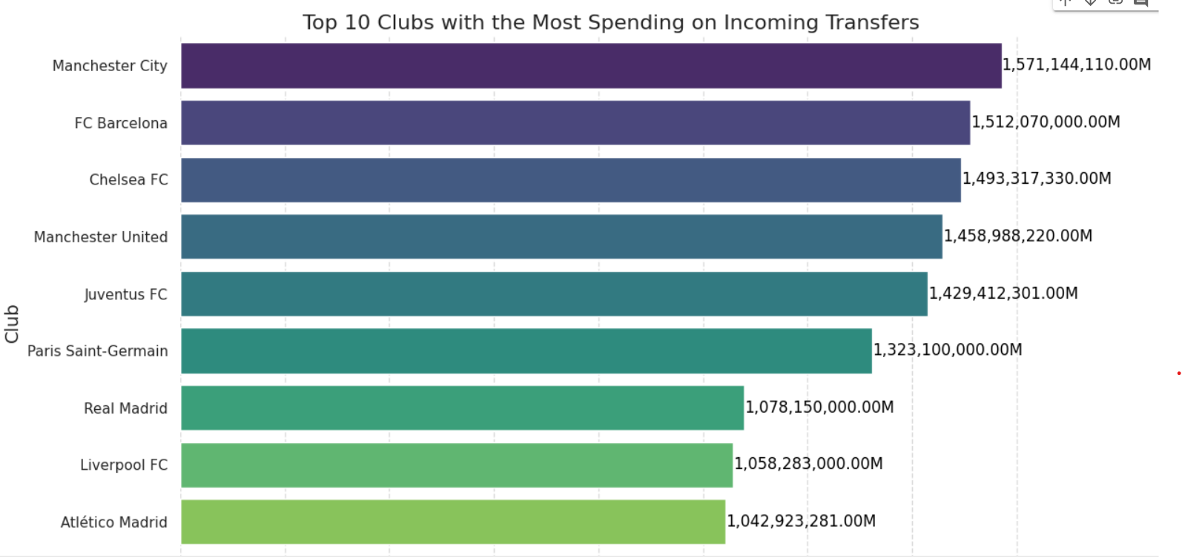

Manchester City emerges as the frontrunner, investing a staggering £1.57 billion, a testament to the transformative impact of their wealthy ownership. Barcelona and Chelsea closely trail, with £1.51 billion and £1.49 billion respectively, underlining the financial might of these European giants. Manchester United follows suit, having spent £1.45 billion, reflecting their commitment to securing top talent on the pitch. Juventus, Real Madrid, Liverpool, and Atletico Madrid complete the top ranks, each surpassing the billion-pound mark in transfer expenditure.

**Football's Mega Transfers:**

**Costliest Player Moves of the Decade**

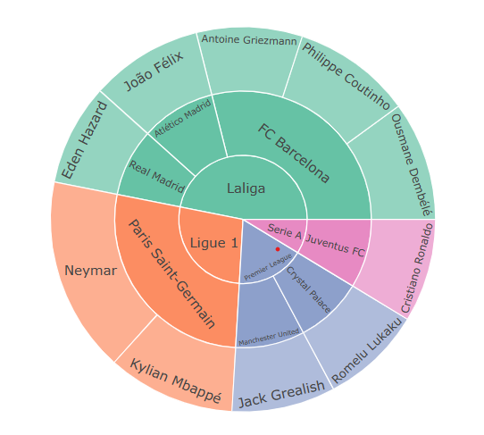

The sunburst analysis unveils the costliest 15 transfers of the past decade, The hierarchical structure of the sunburst begins with league distinctions, delving into specific clubs followed by individual player names. Each segment's color indicates the league, we have also included a hoverboard feature in the code which enhances interactivity, providing precise cost information for each player. Neymar emerges as the decade's priciest acquisition at £222 million, closely trailed by Mbappe at £145 million. Notable transfers to Barcelona include Dembele and Coutinho, while Griezman's move to the same club also features prominently. Other luminaries like Joao Felix, Cristiano Ronaldo, Eden Hazard, and Romelu Lukaku round out the chart, all commanding transfer fees exceeding £110 million.

**Players with the Highest Accumulated Transfer Fees**

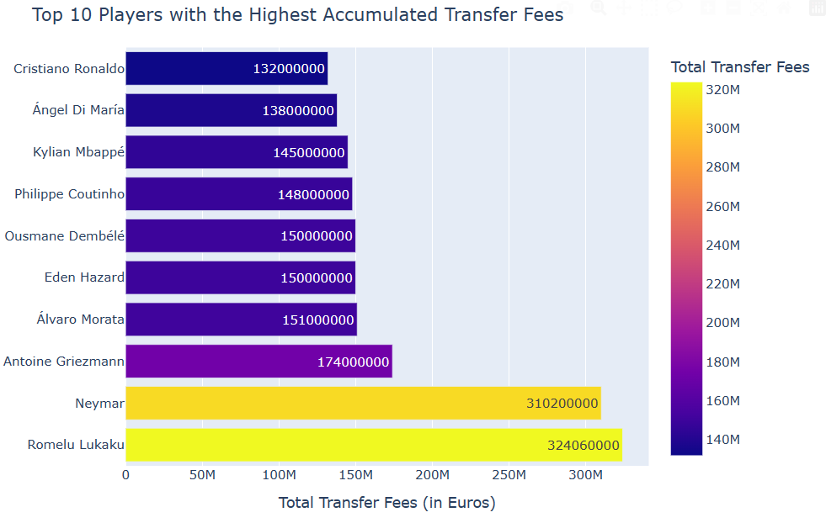

This bar chart spotlights the players who have commanded the highest accumulated transfer fees throughout the past decade. Romelu Lukaku emerges as the leader, having navigated three monumental transfers, twice to Inter and once to Manchester United, each exceeding €90 million. Following closely is Neymar, the record-breaker who traversed from Santos to Barcelona and then to PSG, accumulating substantial fees. Griezmann's journey from Real Valladolid to Atletico Madrid, then Barcelona, and back to Atletico secures him a spot, also another big name making this list is the iconic Cristiano Ronaldo, known for his impactful moves from Sporting to Manchester United, Real Madrid, Juventus, and back to Manchester United.

**Conclusion:**

**Concentration of Power: Dominant Clubs in European Football Leagues**

The existence of a limited number of powerhouse clubs in the premier European leagues, wielding influence over both transfer activities and competitive dynamics, sparks an investigation into the overall level of competitiveness within these football leagues.

**English Premier League's Dominance:**

The English Premier League stands out in the transfer market, with its teams chipping in more than 36% of the total transfer fees paid in the last ten years. This financial strength comes from big TV deals, profitable sponsorships, and the global fan following of the Big 6 clubs. The Premier League's widespread popularity pulls in fans from all around the world, boosting its financial power in the world of football transfers. Interestingly, even mid-table clubs in the Premier League sometimes have the financial muscle to spend generously, surpassing some of the top clubs in Europe.

**Positional Spending Trends:**

When it comes to spending on different positions, attackers get the highest fees underscoring the value placed on goal-scoring prowess. Midfielders and defenders are next, spending a lot but not as much as attackers. Goalkeepers spend the least because teams rely on a singular star goalkeeper.

**Astronomical Price Tags:**

Individual player transfers, such as Neymar's £222 million and Mbappe's £145 million deals, are influenced by various factors. The urgent need of clubs, like Barcelona after Neymar's departure, and the financial strength of teams, especially after takeovers like PSG's by Qatar, are key players in these expensive transactions. This shows how a player's performance, the club's needs, and financial strength all come together in shaping major transfers in football today.

**Player Performance vs. Transfer Fee:**

Not all expensive player transfers lead to success on the field. Players like Kepa at Chelsea and Nicolas Pépé at Arsenal were bought for a lot of money, but they didn't perform as well as expected during matches. Even Neymar was bought by PSG with the goal of attaining champions league success, but his stint was highlighted by injuries and was eventually sold to a Saudi Club last summer. This shows that we need to look at how well players play, not just how much they cost, to judge if a transfer was a good move.

**Club Spending vs. Success:**

The analysis highlights cases where club spending doesn't always guarantee on-field success. For instance, Manchester United witnessed a spike in spending post-Sir Alex Ferguson's retirement but hasn't secured a league title since then. Conversely, Tottenham's historic 2018 season, without new signings, led them to the Champions League final. However, the landscape is diverse; clubs like Manchester City, with substantial spending, have dominated the Premier League in the last six years and clinched a Champions League title. Similarly, Barcelona, Real Madrid, PSG, and Juventus, despite being top spenders, have enjoyed both domestic and international success, challenging the conventional correlation between spending and success.

**Future work:**

For future advancements in the transfer market data visualization project, enhancing interactivity stands as a key objective. Developing an interactive dashboard with filters for clubs, players, and seasons will empower users to dynamically explore and analyze transfer data, fostering a more engaging and personalized experience. Furthermore, the integration of real-time data represents a cutting-edge future scope. Establishing a framework for real-time data integration and potentially collaborating with platforms offering live transfer updates will ensure that the visualizations reflect the latest transfer activities.

The application of linear regression models to predict transfer fees in soccer can lay the foundation for future advancements and enhancements in the project. Incorporating market value and league as predictors signifies the importance of league dynamics in fee determination. Furthermore, the model can be refined by introducing additional league-specific features, such as team performance and regional economic indicators, to capture a more comprehensive picture of market variations. Additionally, exploring advanced regression techniques, ensemble methods, or machine learning algorithms could enhance the predictive capabilities of the models and contribute to a more robust understanding of the intricate factors influencing soccer transfer fees.

**References:**

[**Chart of the Week: Visualize the Transfer Spending and Earning among the Football League Clubs Using WPF Scatter Chart (syncfusion.com)**](https://www.syncfusion.com/blogs/post/visualize-transfer-spending-earning-wpf-scatter-chart.aspx)

[**Monthly Report 77 (football-observatory.com)**](https://football-observatory.com/IMG/sites/mr/mr77/en/)

[**Sample visualizations of European soccer transfers - Eric M. Ordoñez (ericmordonez.com)**](https://ericmordonez.com/blog/sample-visualizations-of-european-soccer-transfers/)

[**Data visualization shows Premier League transfer spending spree | Yellowfin BI**](https://www.yellowfinbi.com/blog/data-visualization-shows-premier-league-transfer-spending-spree)

[**Data Visualization: Football Transfer 2000–2019 Part 1 “Premier League is an Outstanding League” | by Wigardi Maswiguno | Medium**](https://maswigunowigardi.medium.com/data-visualization-football-transfer-2000-2019-part-1-premier-league-is-an-outstanding-league-353239df0c11)

[The best stats you've ever seen | Hans Rosling](https://www.youtube.com/watch?v=hVimVzgtD6w)