# Name: Jawwad Shadman Siddique
# Module 1
The Steps are provided below:
1. Create a new file in Spyder and name the file as YourName_Module1.py. Save the file.
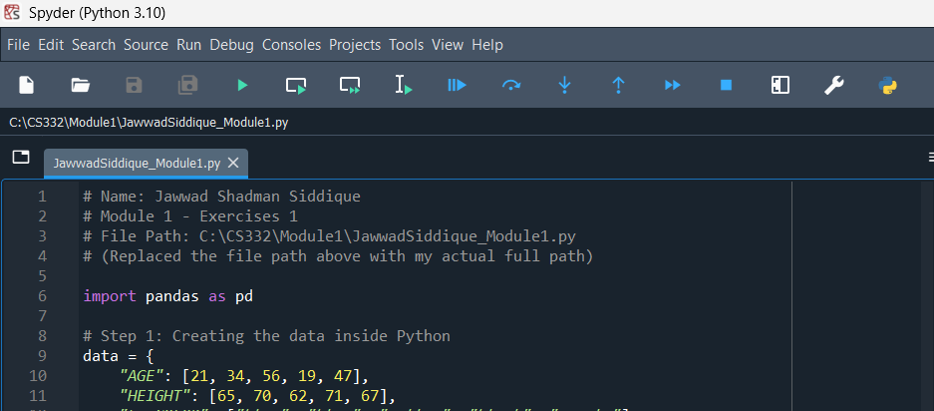

2. Into the new file, create a few comments that include your name, Module 1, "Exercises 1". Always save as you go.
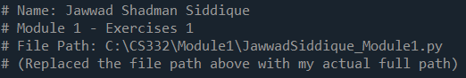

# Name: Jawwad Shadman Siddique
# Module 1 - Exercises 1
# File Path: C:\CS332\Module1\JawwadSiddique_Module1.py
# (Replaced the file path above with my actual full path)

3. Take note of where you saved the file. Copy the complete path to the file you just into the file as a comment.
Here, I recommend choosing a location on your computer where you plan to keep your Python files. Then, you can use that location, can create folders inside that location, etc.
For example, on my computer, I keep my OSU CS 332 Python files here:
C:\Users\profa\Desktop\C_O\OSU\CS332\PythonFiles
Your path will look different because you have folders on your computer with different names than I do :)
However, you can see in this example that this is a "complete path" to the folder called PythonFiles because it starts from the C drive and contains all folders from C to PythonFiles.

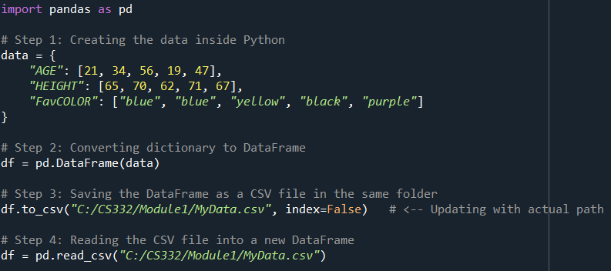

4. Into the same folder that you choose to place you Python files, create a new .csv file called MyData.csv. Into this new .csv file, type the following:
AGE | HEIGHT | FavCOLOR
21 | 65 | blue
34 | 70 | blue
56 | 62 | yellow
19 | 71 | black
47 | 67 | purple

Save the file and again, be sure that you know the complete path to this file.

import pandas as pd

# Step 1: Creating the data inside Python
data = {
"AGE": [21, 34, 56, 19, 47],
"HEIGHT": [65, 70, 62, 71, 67],
"FavCOLOR": ["blue", "blue", "yellow", "black", "purple"]
}

# Step 2: Converting dictionary to DataFrame
df = pd.DataFrame(data)

# Step 3: Saving the DataFrame as a CSV file in the same folder
df.to_csv("C:/CS332/Module1/MyData.csv", index=False) # <-- Updating with actual path

# Step 4: Reading the CSV file into a new DataFrame
df = pd.read_csv("C:/CS332/Module1/MyData.csv")

5. Next, your first goal is to use pandas to read this file into Python as a dataframe and print the dataframe. Use the web, any resources on my site (see resources below) etc. to discover how to do this.
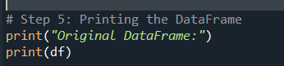
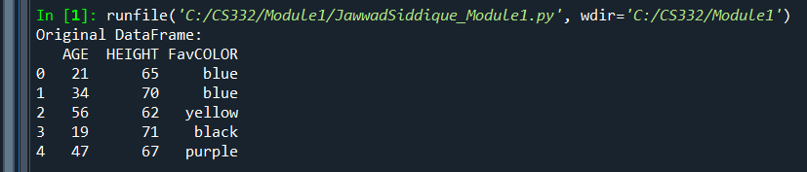
# Step 5: Printing the DataFrame
print("Original DataFrame:")
print(df)

6. Then, write Python code that prints a list of the names of the dataframe columns.
# Step 6: Printing the list of column names
col_names = list(df.columns)
print("\nColumn Names:")
print(col_names)
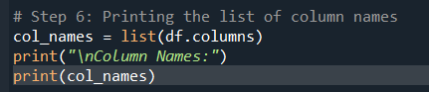
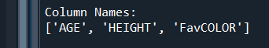

7. Finally, use a loop to look through the list of column names. Have the code delete the column (from the dataframe) whose column name is more than 6 characters. You will use the list to loop through and will make the deletion in the dataframe.

# Step 7: Deleting columns whose names are longer than 6 characters
for col in col_names:
if len(col) > 6:
df = df.drop(columns=[col])

# Step 8: Print the modified DataFrame
print("\nModified DataFrame:")
print(df)

