Bank Customer Churn Analysis Report

1. Objective
To analyze customer churn behavior and identify key factors influencing customer attrition using SQL-based analysis.

2. Dataset Overview
The dataset contains customer demographics, transaction behavior, credit usage, and churn status.

3. DATABASE & TABLE SETUP
We begin by creating a database in MySQL. Next, the dataset is imported using the Import Wizard, which automatically generates the table with appropriate columns and data types. Each row corresponds to an individual customer.
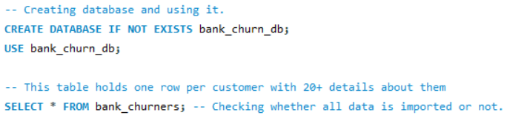

4. DATA CLEANING
Before doing any analysis, I checked if the data is clean. I looked for duplicates, missing values, wrong labels, and numbers that don't make sense.
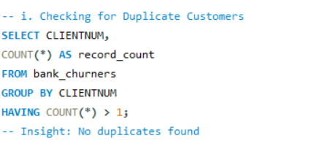
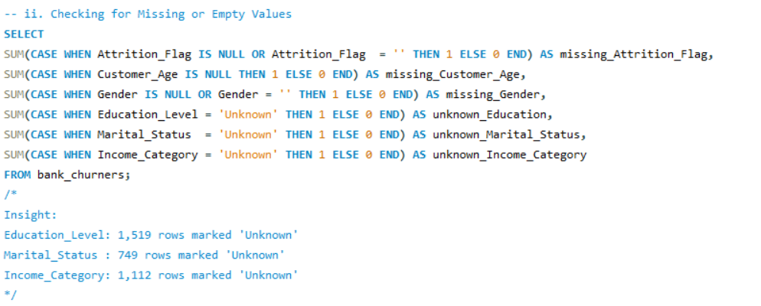
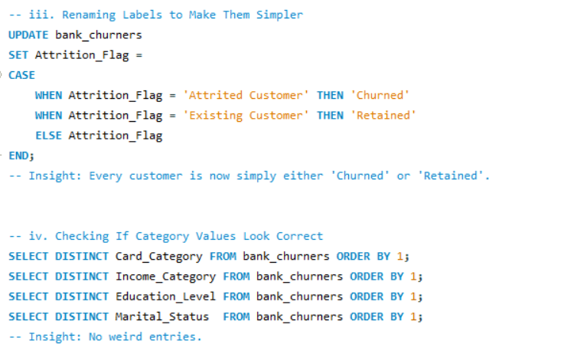
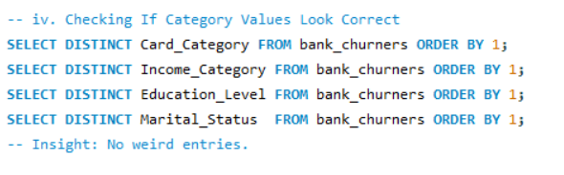
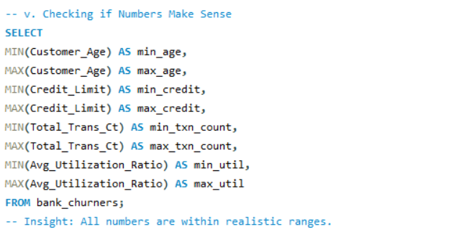

5. SQL Analysis

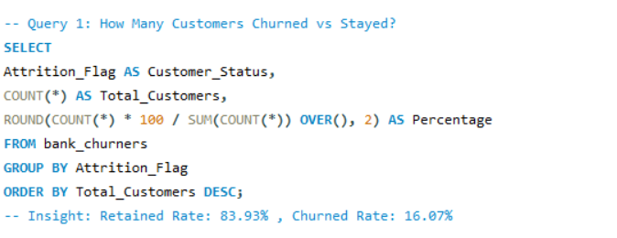

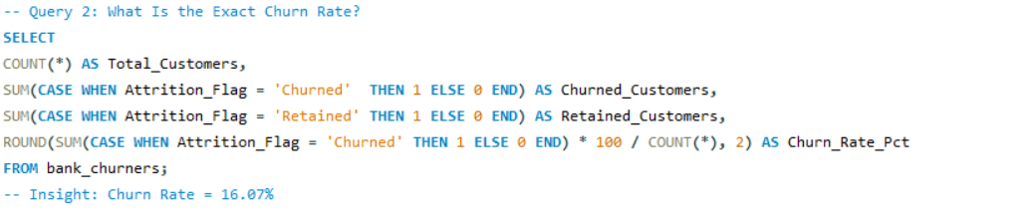
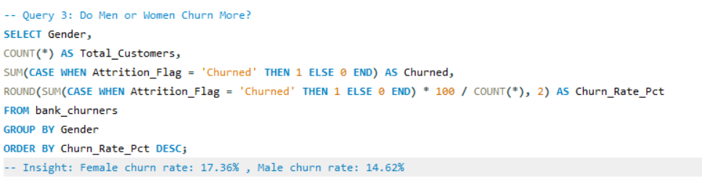
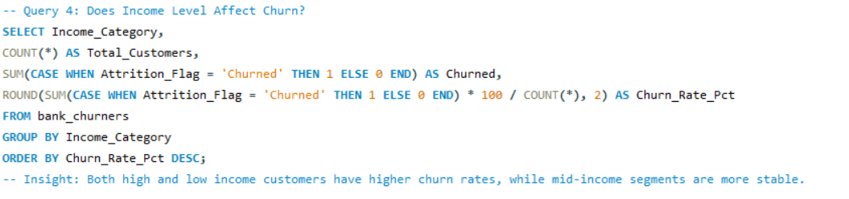
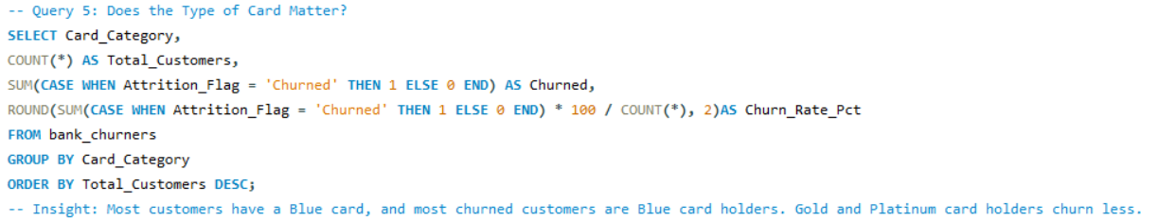
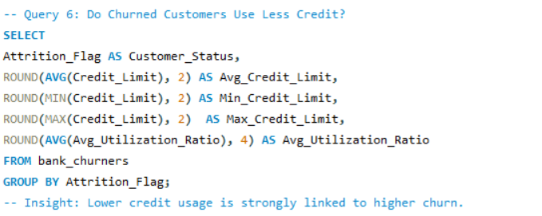
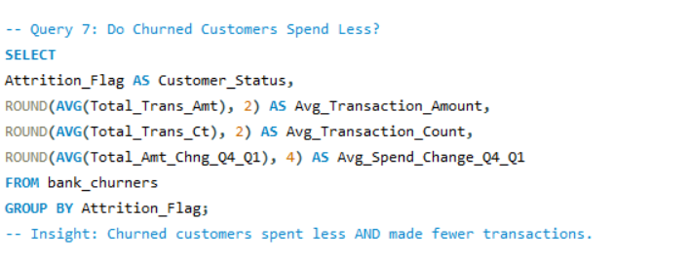
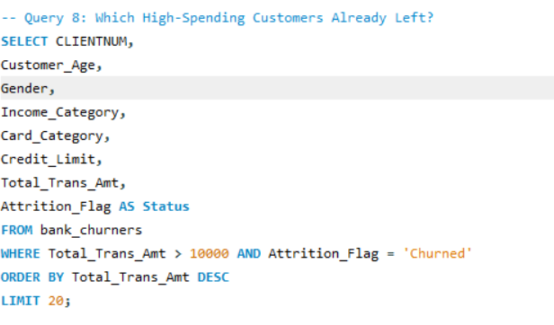
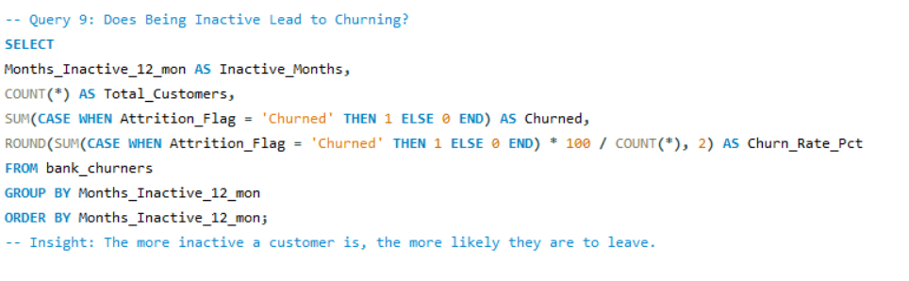
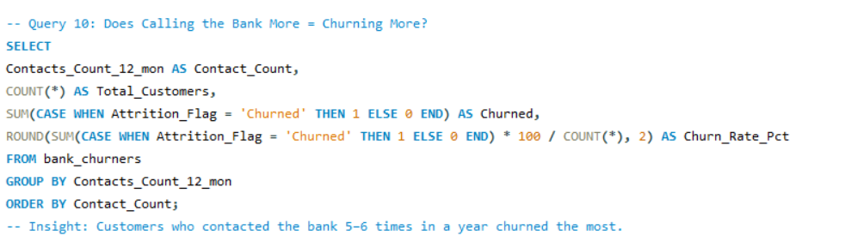
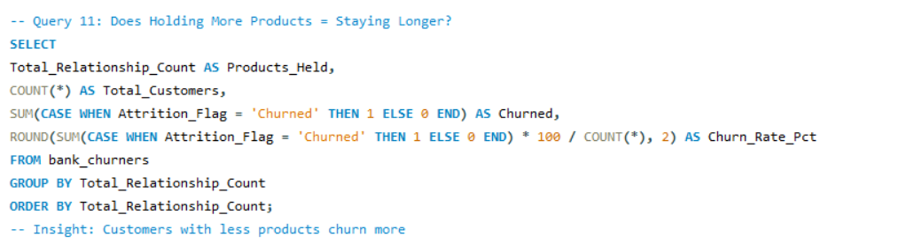
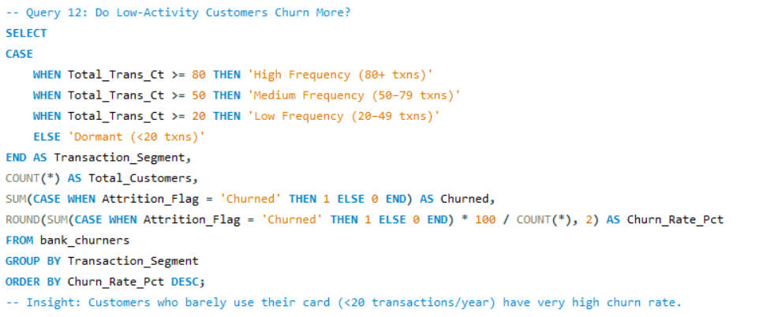
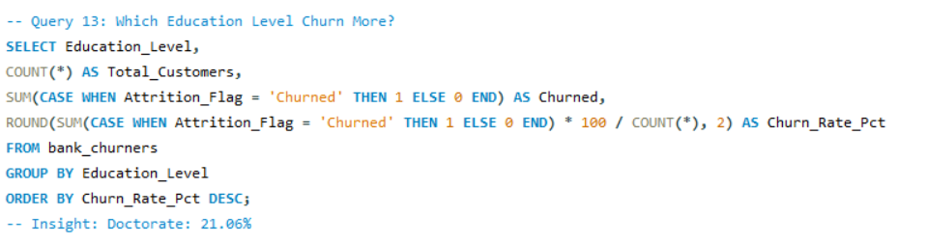
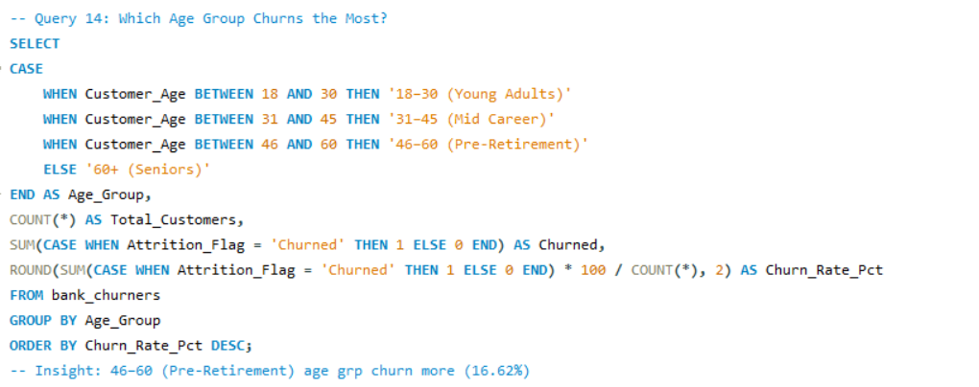
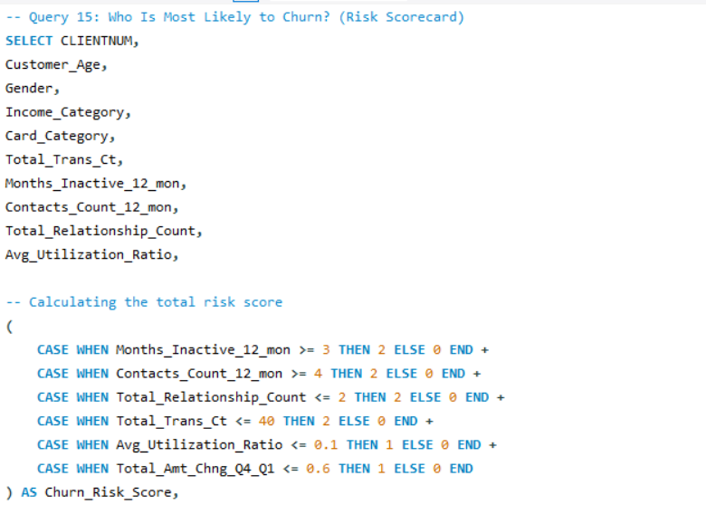
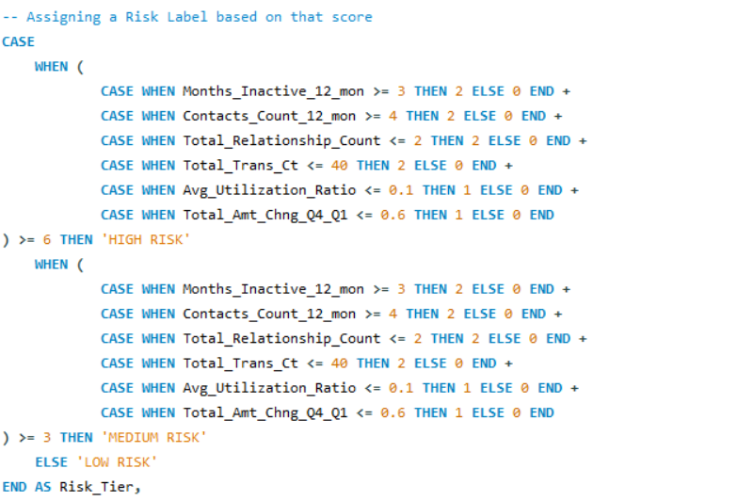
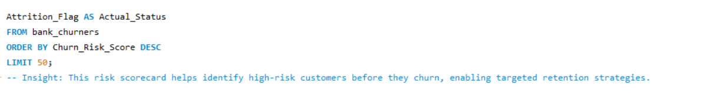

6. Key Findings
- Overall churn rate is approximately 16%, indicating moderate churn.
- High- and low-income customers show higher churn (U-shaped pattern).
- Customers with lower credit utilization are more likely to churn.
- Lower transaction activity and spending are strong indicators of churn.
- Customers aged 46–60 show the highest churn rate.
- Low engagement (inactivity, fewer products, low transactions) strongly predicts churn.

7. Risk Score Model
A rule-based churn risk scoring model was developed using behavioral indicators such as inactivity, transaction count, and credit usage. Customers were classified into High, Medium, and Low risk categories.

8. CONCLUSION
From this analysis, it's clear that customers don't leave suddenly — there are clear warning signs before they go:
They become less active → they transact less → they eventually leave.

9. Tools Used
MySQL

10. Project Outcome
Demonstrates SQL skills including data cleaning, aggregation, and insight generation.

