Blinkit Sales Analysis Report

1. Introduction
This project analyzes Blinkit sales data using SQL to extract meaningful insights such as total sales, customer behavior, and outlet performance.

2. Objective
- Analyze sales performance
- Compare outlet types
- Understand customer preferences
- Generate business insights

3. Dataset Description
The dataset includes item details, outlet details, sales, and ratings.

4. DATABASE & TABLE SETUP
We start by creating the database and a table to hold all customer data. Each row = 1 customer.
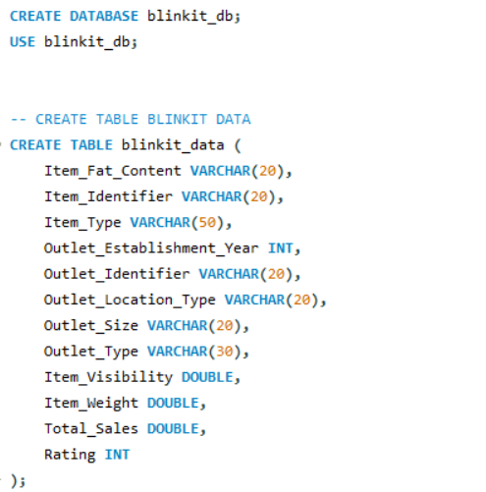

5. Data Cleaning
Standardized inconsistent values such as 'LF' and 'low fat' to 'Low Fat', and 'reg' to 'Regular'.
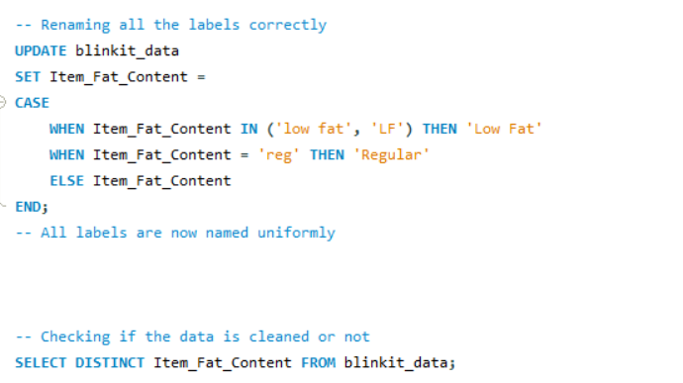

6. KPIs
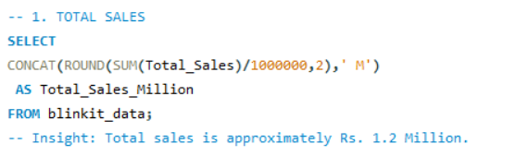
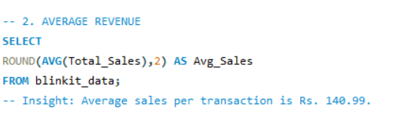
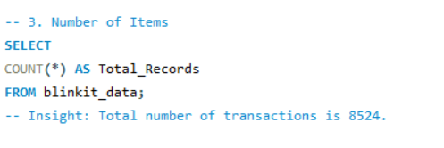
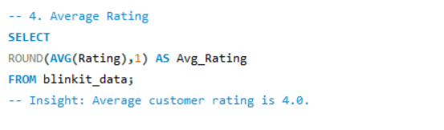

7. SQL Analysis
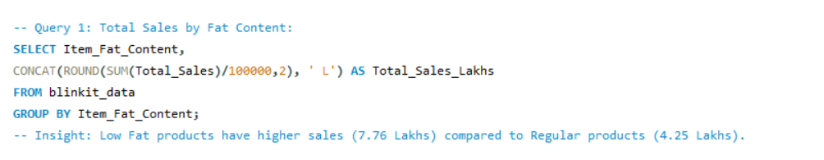
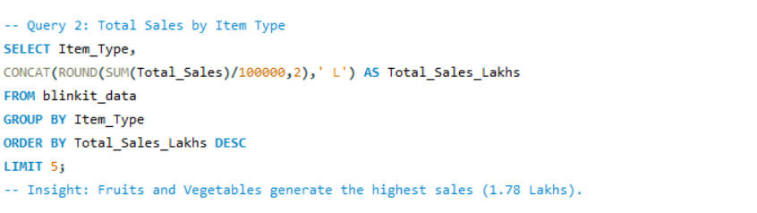
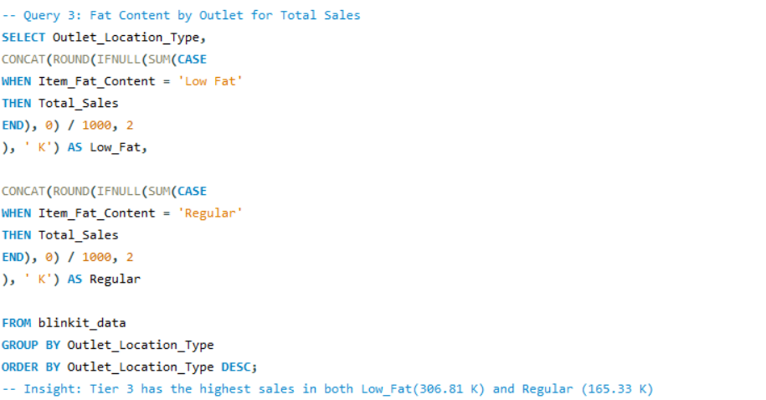
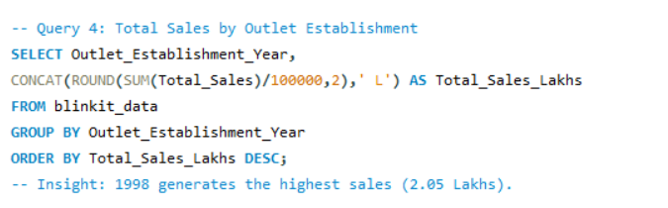
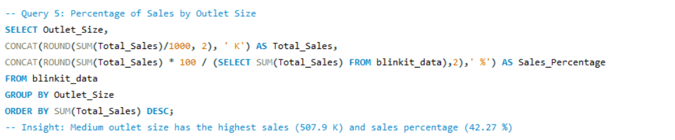
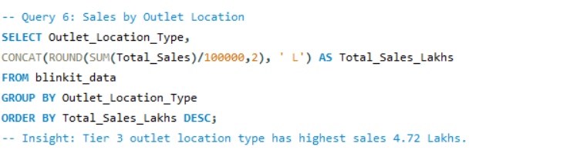
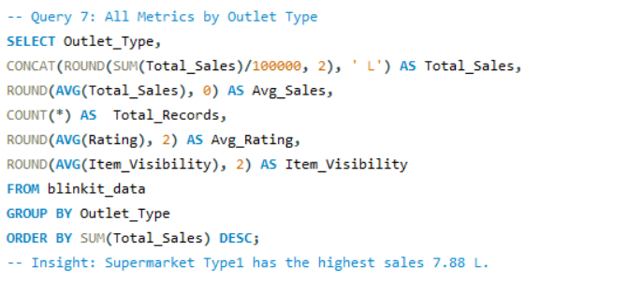

8. Conclusion
Tier 3 and medium outlets perform best. Low Fat products are in demand.

9. Tools Used
MySQL

10. Project Outcome
Demonstrates SQL skills including data cleaning, aggregation, and insight generation.

