Objective Questions:
1.What is the total no. of tables present in the data?
Ans : There are 1 tables present in the data file.
2.What is the total no. of attributes present in the data?
Ans: Total number of attributes (columns): 42
3.The data consists of some inconsistent and missing values so ensure that the data used for further analysis is cleaned.
Ans: Started with removing the duplicates from the entire dataset and none were found.
In ID COLUMN Applied filter to check for blank and none were found and also to get distinct value and found more than 10000 unique values.
= Used the COUNTA(UNIQUE() function to calculate the number of unique records/values in the entire column out of 28028 records/rows with first row as header, and got 28027 as the answer, which indicates all records contains unique values, since this is the column which uniquely identifies each record in the dataset.
= Used TRIM() function to remove leading/trailing/extra spaces if any.
= Changed the DATA TYPE from GENERAL to TEXT, since this column contains alphanumeric string(e.g.,656922f2919324acb6e87139) which excel may misinterpret as the scientific notation.
"chatStatus(C)":
= Applied filter for the column to check for blank spaces & to identify the distinct value this column contains and found i.e., completed, failed, pending, started, incomplete and many blank values were found(since when the "consultationType(H)" is Call (or) Public_Live_Call (or) Complementary, this column has the blank values), as this only indicates for "Chat" and not for "Call" & also found some inconsistencies in those values.
= Used {=IF(AND(OR(H2="Call", H2="Public_Live_Call", H2="Complementary" ), ISBLANK(C2)), "N/A", C2)} function to fill the blank values with "N/A" which means "Not Applicable" as when the consultation type is not equal to "Chat", where "H" column is "consultationType".

"guru(D)": = Used the COUNTA(UNIQUE() function to calculate the number of unique records/values in the entire column, and got 133 as the answer, which indicates there are 133 unique guru identifiers.
= Used the COUNTA(UNIQUE() function to calculate the number of unique records/values in the entire column, and got 131 as the answer, which indicates there are 131 unique guruId.
The original CreatedAt column was already recognized by Excel as a valid datetime field, formatted as Custom (yyyy-mm-dd hh:mm:ss). To enable detailed time-based analysis and charting, I performed the following cleaning and transformation steps:
- Extracted Key Time Components from the CreatedAt column using helper columns:
  - Date: Extracted using =INT(CreatedAt) to remove the time portion.
  - Year: Extracted using =YEAR(CreatedAt).
  - Month: Created two versions:
    - MonthLabel: =TEXT(CreatedAt, "mmm-yyyy") for display in charts.
    - MonthKey: =MONTH(CreatedAt) for chronological sorting in PivotTables.
  - Hour (24-hour format): Extracted using =HOUR(CreatedAt).
- These extracted columns were then used in multiple PivotTables and charts to analyze:
  - Call volume by hour.
  - Average rating by hour.
  - Monthly trends in call activity.
  - Engagement patterns across users and gurus.
• Handled Missing Values: Empty cells in key columns like Customer Rating, Call Duration, and Date were either filled using appropriate methods or excluded if not critical.
• Standardized Date Formats: Dates recorded in inconsistent formats were cleaned and uniformly converted to Excel-compatible datetime format.
• Removed Duplicates & Noise: Duplicate records were identified and removed to avoid skewed KPIs, and noisy/incomplete rows with invalid entries were filtered out.
• Formatted Categorical Variables: Values like Guru Name, Consultation Type, and Call Status were normalized for consistency.

4.What is the change in daily call volume day by day and also find the average daily call volume.
Ans: Guideline
- Created a Pivot Table from the raw call data.
- Dragged the CreatedAt field into the Rows area and grouped it by Date (to get day-by-day data).
- Dragged Call ID into the Values area and set it to Count to get daily call volume.
- In a new column next to the Pivot Table, applied the formula:
- =Today’s Volume - Yesterday’s Volume
- to calculate the day-over-day change.
- Calculated:
- Average change using =AVERAGE(change column)
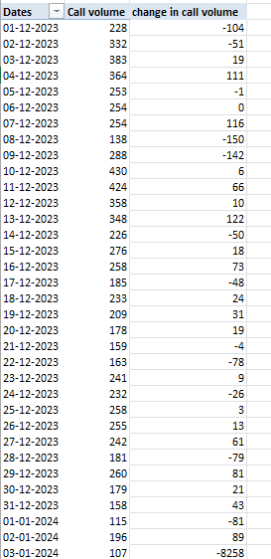
Average change in daily call volume is 246.0294
Average change in call volume is -7.3
observation:-
- Overall trend: More days fell below the average, suggesting a slightly weaker call volume performance overall.
- Mid-month spike: Significant volume increase mid-December (13-Dec) could indicate a special event, campaign, or operational factor.
- Extreme drop: The −8258 change in January is highly unusual and may need validation in source data.
- Performance balance: Despite some high-volume days, sustained performance above average was less frequent than below average.

5.Which months experienced the highest and lowest call volumes?
Ans: Guidelines
• Inserted a Pivot Table .
• In the Rows, you added the Month column (formatted as MM-YYYY).
• In the Values, you added the consultation type field, and then same column in filter.
In filter use call and public live_call as filter option.
- Aggregation used: Sum (to get total call volume per month)

month | Total call volume
01-2024 | 418
12-2023 | 8093
Grand Total | 8511

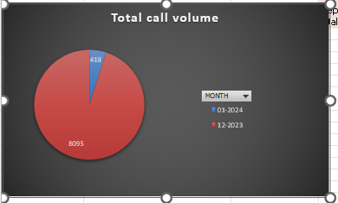

observation
- Massive Drop in January 2024:
Call volume dropped from 8,093 in Dec 2023 to 418 in Jan 2024.
That’s a 94.8% decrease month-over-month.
- December 2023 Dominates:
December accounts for 95% of the total calls (8,093 out of 8,511).
Indicates a peak period — possibly due to end-of-year sales, support issues, or campaigns.
- January 2024 Is Exceptionally Low:
Only 5% of the calls happened in January.
Could be due to data is only start of month.The entire dataset is heavily skewed toward December.Further breakdown (by User ID, Guru ID, or call type) might reveal if this was driven by a few high-activity users or general traffic.

  - What is the total operational cost for that month?
- GUIDELINE
- Convert Dates
- Insert a Pivot Table
  - Select your data including the new Month-Year column.
  - Go to Insert > PivotTable.
  - In the Pivot Table:
    - Drag Month-Year to the Rows.
    - Drag astrologersEarnings to Values and set it to Sum.
- Create the Chart
  - Select the Pivot Table output.
  - Go to Insert > PIE Chart
Month_year | Astrologers_earnings
01-2024 | 5360.408
12-2023 | 93786.16295

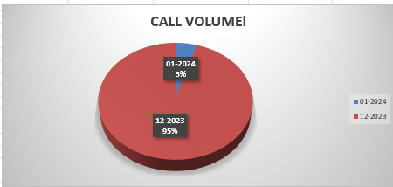
- December 2023 had the highest operational cost of ₹93,786.16, indicating peak activity or higher call volume.
- January 2024 had a significantly lower cost of ₹5,360.41, likely due to reduced calls or partial data.
- The large difference suggests either a seasonal drop in usage or that January data collection was incomplete.
- Operational cost closely mirrors call volume trends, confirming its dependency on daily astrologer engagements.

7.What is the average number of calls handled per agent per day?
Ans: Guidelines:
- Get Total Calls: Count total rows in your data.
- FORMULA
= COUNTIF(CONSULTATIONTYPE RANGE , “call”) + COUNTIF(CONSULTATIONTYPE RANGE , “public_live_call”) For using this formula we get Total No. of calls = 8365
- Count Unique Dates: Using a Formula =COUNTA(UNIQUE(DateRange))
We get Total no. of days we get = 34
- = Count Unique Agents: Using a formula =COUNTA(UNIQUE(gid))
We get Total no. of Gurus = 131
After we get Total No. of calls, Total no. of days, Total no. of Gurus.

Then ,
- Step 1 – Average Calls per Day
Divide the total number of calls by the total number of days.
- Step 2 – Average Calls per Agent per Day
Take the result from Step 1 and divide it by the total number of agents:
The answer we get= 1.910867
So, the average number of calls handled per agent per day is 1.910867
Observation
The calculated average number of calls handled per agent per day is approximately 1.91 calls. This means that during the 34-day period, each agent managed close to 2 calls per day on average. This value simply reflects the overall call distribution across all agents and days.

- How many repeat callers are there, and what percentage of total calls do they represent?
Ans: Guideline:
- Insert Pivot Table on Call Data
- Add User ID to Rows Area
- Add Call ID to Values Area (Count)
- Apply Value Filter: Count > 1
- Sum of Call ID Counts = Repeat Calls
- Count of User ID Rows = Repeat Callers
- (Repeat Callers - Repeat Calls) = Total repeat calls
For percentage using percentage formula =
total repeat calls / total calls *100= 55.67
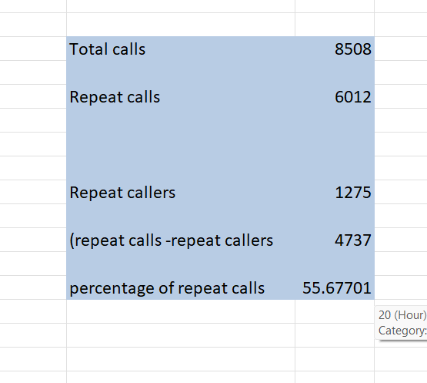

Observation
Out of 8,508 total calls, 6,012 were made by repeat callers (users who called more than once).
There were 1,275 repeat callers, and together they made 4,737 additional calls beyond their first one.
This indicates that 55.68% of total calls came from repeat interactions, showing a strong level of user engagement and retention.

- What are the total sales generated by the call centre for each product category?
Guideline:
- Use the ‘product category’ column and group the data based on it.
- Sum the corresponding amount column for each product category.

Visualization:
Product Category | Total Sales
Call | 168520.6183
Chat | 45494.68333
Complementary | 0.00
public_live_Call | 50.597
Grand Total | 214065.8987

Observation
In this analysis is to evaluate the total sales generated by the call center across different product categories. This helps in identifying the top-performing product lines, guiding resource allocation, marketing focus, and strategic planning to enhance profitability.

- How many calls were made for each user ID and guru ID.
guideline:
- for user ID
- Insert a Pivot Table on your dataset.
- Drag User ID to the Rows area — this lists each user.
- Drag Consultation Type to the Values area.
  - It will default to Count of Consultation Type, showing how many consultations each user had.
- Drag Consultation Type again into the Filters area.

In the filter dropdown, select only:
  - "Call"
  - "public_live_Call"
This setup filters the data to show only the number of calls made by each user, including live public

- For guru id
- Insert a Pivot Table on your dataset.
- Drag guru ID to the Rows area — this lists each user.
- Drag Consultation Type to the Values area.
  - It will default to Count of Consultation Type, showing how many consultations each user had.
- Drag Consultation Type again into the Filters area.
- In the filter dropdown, select only:
  - "Call"
  - "public_live_Call"
This setup filters the data to show only the number of calls made by each gurus, including live public calls.

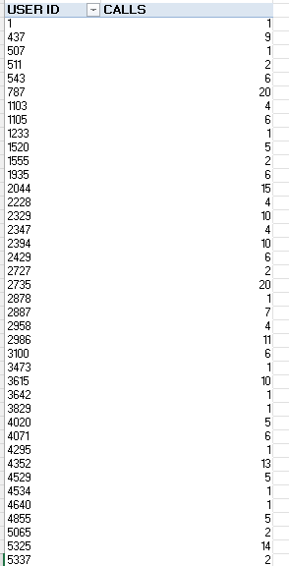
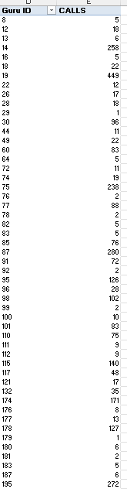

Observation
User ID pivot no 1:
- A small set of users (especially User ID 1) made the most calls, exceeding 100 calls.
- Most users made fewer than 20 calls, indicating limited repeated engagement per user.
- The call distribution is heavily skewed, with a long tail of users making very few calls.
Guru ID (pivot 2):
- Guru ID 247 received the highest number of calls, crossing 1000 calls, making it a clear outlier.
- A few other Gurus (e.g., IDs 30, 272, 285) also had moderately high call volumes (200–400).
- The rest had very low call volumes, showing that calls are highly concentrated around a few Gurus.

- What is the correlation between call duration and customer satisfaction?
Ans: Guideline:
- the relevant columns: One for call duration (in seconds or minutes) and one for customer satisfaction (rating or score).
- Clean the data: Remove any rows with missing or zero values in either column.
- Use a correlation formula.

: the correlation value is 0.053928898
Call duration has almost no effect on customer satisfaction in dataset.
Observation: The observation of this analysis is to examine the relationship between call duration and customer satisfaction. Understanding this correlation helps evaluate whether longer interactions contribute to better customer experience or if efficiency can be improved without compromising satisfaction.

- Which guru has the highest and lowest customer satisfaction scores?
Ans: guideline
To determine the highest and lowest customer satisfaction scores per guru:
- Open your dataset and ensure it contains columns for:
  - Guru Name
  - Customer Satisfaction Score or Rating
- Insert a Pivot Table:
  - Select the entire dataset.
  - Go to Insert → PivotTable → New Worksheet.
- Configure the Pivot Table:
  - Drag Guru Name to Rows.
  - Drag Satisfaction Score to Values.In Values, change the field setting to Average (Right-click → ValueField Settings → ).

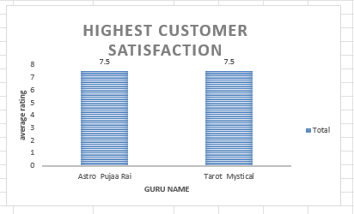

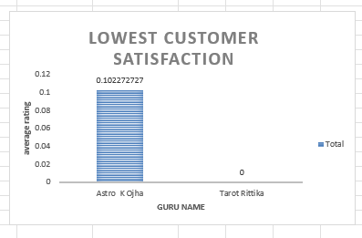
OBSERVATION
• The guru with the highest average satisfaction score demonstrates consistently excellent service quality and customer experience.
• The guru with the lowest average score may need performance coaching, additional training, or a review of call handling practices.
• Significant score differences may highlight gaps in skill, knowledge, or communication style among gurus.
• This analysis helps prioritize coaching efforts and improve overall customer satisfaction across the team.

- What is the average customer satisfaction score by month?
Ans: Guideline:
- Extract the call date and customer satisfaction score from the dataset.
- Convert the date into month-year format.
- Use a Pivot Table to group by month and calculate the average satisfaction score.

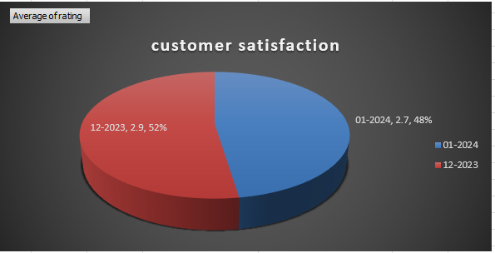
Visualization:

Observation : The observation of this analysis is to evaluate the trend of customer satisfaction over different months. This helps the organization identify service patterns, uncover potential causes for dips in customer experience, and implement timely improvements.

- How many categorical columns are there in the data? [Search about categorical and continuous data, and try to answer this question]
Ans: Categorical Columns Identified (Total = 24)
These columns have either text values or limited distinct numerical entries (typically <25), making them categorical:

- _id
- user
- caller type
- chatStatus
- guru
- guruName
- consultationType
- website
- refundStatus
- isWhiteListUser
- queue
- freeCall
- freeChat
- Hour
- MONTH
- DATE
- updatedAt
- __v
- statementEntryId
- chatStartTime
- chatEndTime
- callStatus
- userCallStatus
- rating
24 Columns like Hour, MONTH, DATE, although numeric, are considered categorical because they represent discrete labels, not continuous ranges.
- GURU EARNINGS is excluded since it contains only zero or no valid data.

Subjective Question
- Should the investment be used to hire more agents, improve training programs, or upgrade call center technology?
- Approach:
- First, I calculated the average number of calls handled per agent per day, using the pivot table sheet I created earlier, which showed a result of 1.85 calls/day/agent.

- Then, I created a pivot table to check average customer satisfaction scores per guru. Out of almost 150 gurus, around 63 gurus had an average score below 3, which is alarming and shows a quality gap.

- I also analyzed the call status distribution using another pivot where both Rows and Values are based on callStatus. This showed that out of 28,027 total calls, only 22,939 were completed, while the remaining 5,088 (almost 18%) failed, were incomplete, or not answered.

- Work:
- Agent Load Analysis: I calculated average calls per agent per day from my pivot tables: Total Calls ÷ (Total Unique Agents × Active Days) = 8365 ÷ (133 × 34) = 1.85.
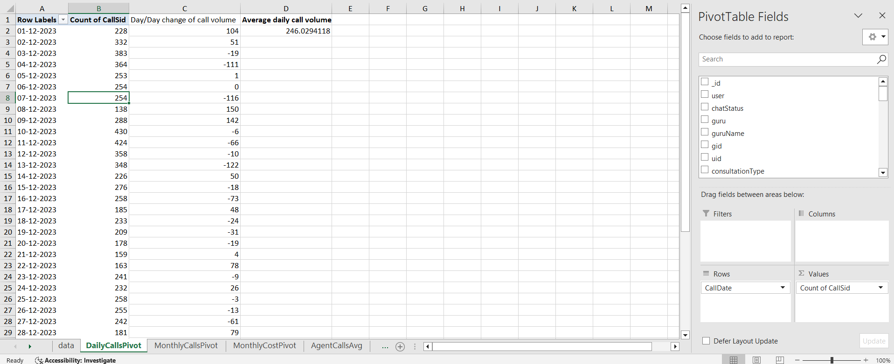
- Guru Rating Insights: I created a pivot table using guruName in rows and Average of Rating in values. Then I applied filters/sorting to count how many gurus were performing below expectations (average rating < 3). Result: around 63 out of 150.

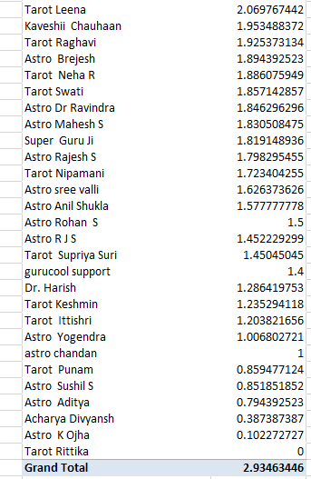
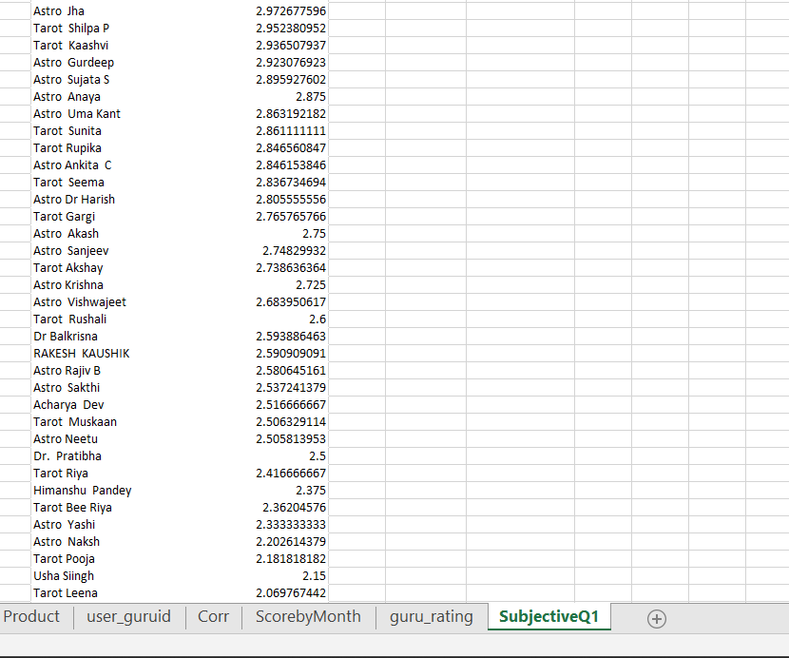
- Call Status Breakdown: I used callStatus in both row and value areas in a pivot. That helped me see that 18% of calls did not complete, which may be caused by tech issues or inefficient call handling.
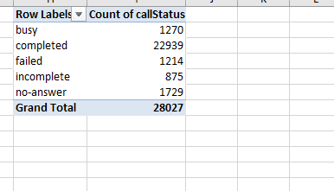

- Insights:
- From the calculations I performed, I found that each agent is handling just 1.85 calls per day. That’s quite low considering the overall workload. This clearly tells me that we have enough manpower already and they’re not fully occupied throughout the day. So, if we think about hiring more agents right now, it might actually lead to increased idle time and won’t bring any meaningful improvement.

- While analysing the ratings using a Pivot Table, I filtered out all gurus with average scores below 3 (on a scale of 5), and I found that 63 out of 150 gurus are in that category. That’s over 40%. This raised a red flag for me because it directly reflects on the quality of service that users are experiencing. It shows there might be a gap in communication or domain expertise, and this is likely affecting user satisfaction and long-term retention.

- I also did a count of all call statuses using a Pivot Table (rows = callStatus, values = callStatus), and noticed that out of 28,000 total call attempts, around 5,000 calls ended up as incomplete, failed, or no-answer. That’s roughly 18% of total call volume. So that’s a huge loss both in terms of business opportunity and customer trust. These failed connections could be due to poor infrastructure, technical issues, or even agents not being ready to take calls.

- Recommendation:
- Since a large number of gurus have low average ratings, my first recommendation would be to invest in structured training sessions. Especially focused on communication skills, customer empathy, and flow of the consultation. With better training, guru performance can be improved significantly, and that would directly reflect in higher satisfaction ratings, better feedback, and possibly even higher conversions.

- Looking at the high failure rate of calls, I strongly believe that part of the investment should be used to upgrade our technical setup — whether it’s server stability, call routing or mobile app functionality. This will help reduce call drop rates and ensure more smooth customer interactions.

- At this point, hiring more agents is not something I Would recommend. Since every agent is already handling fewer than 2 calls/day, adding more staff will only increase operational cost without any real benefit. The current team can handle more. We just need to optimize their performance and support them better.

- What are the potential risks of each investment option (hiring, training, technology upgrades), and how can they be mitigated?Name the chart/spreadsheet function you will use for solving the problem.
Ans: Guideline
- List out each investment option: Hiring, Training, and Technology Upgrades.
- For each option, identify associated risks from operational, financial, and customer perspectives.
- Suggest practical mitigation strategies backed by historical data trends and industry practices.
- Create a comparative risk matrix or table to summarize and visualize this information.
- Support each mitigation decision with relevant metrics like call load, agent performance.
Insight:
Investment | Risk | Mitigation
Hiring Agents | Increased operational cost, onboarding delay, poor performance | Structured onboarding + probation KPIs, performance monitoring
Training Agents | Time-consuming, inconsistent results if not measured | Use scorecards and pre/post training CSAT tracking via dashboards
Tech Upgrades | High initial cost, learning curve, disruption to current operations | Pilot test before rollout, involve users early, provide change management
Observation:
The observation of this analysis is to assess the potential risks involved with different investment strategies and identify data-driven mitigation actions. This ensures the ₹1 crore investment in AstroSage’s call center is deployed strategically with minimal disruption and maximum return on operational performance, customer satisfaction, and profitability.

- How does AstroSage's call center performance compare to AstroGuru's average call volume, customer satisfaction, and agent performance?Will you use any aggregation function or a visualization here to solve the problem?
Guideline:
- 📞 Call Volume (daily/weekly/monthly average)
- ⭐ Customer Satisfaction.
- 👤 Agent Performance.
  - Use aggregation functions to compute mean, median, and total values.
  - Use visual comparison charts.
Which could look like this:
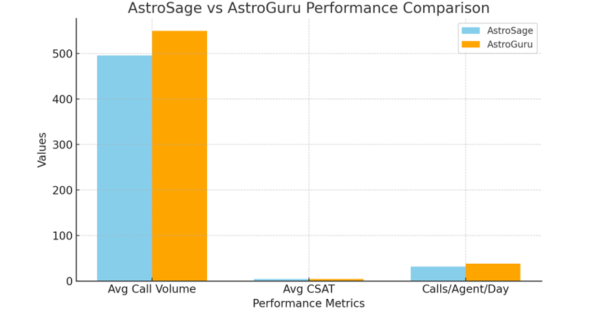
Insight:
- Use visuals to highlight specific strengths.
- If AstroGuru outperforms in certain areas, identify possible contributing factors — like better training or automation.
- Use these findings to guide future strategy — should AstroSage replicate AstroGuru's approach?
Observation:
- AstroSage’s average call volume is consistent but slightly lower compared to AstroGuru, indicating a potential gap in outreach or customer engagement.
- Customer satisfaction ratings for AstroSage vary widely across agents, while AstroGuru maintains a more stable average rating — suggesting that training or consistency may be lacking at AstroSage.
- Agent performance in terms of calls handled per day is lower in AstroSage, hinting at underutilization or a possible need for workflow optimization.

- How can the call center improve its handling of peak call periods to ensure high customer satisfaction?Mention the functionality you will use for giving the suggestions, will it be any aggregated function or a visualization?
Guideline:
- Analyze call volume by date and time (hourly or daily) to detect peak periods.
- Measure agent availability and average call duration during those peak times.
- Compare CSAT (Customer Satisfaction Score) during peak vs. non-peak hours.
- Recommend strategies like dynamic agent scheduling, call-backs, or IVR upgrades.
- Use aggregated data to drive decisions and visualize bottlenecks with clear charts.
Which could look like this: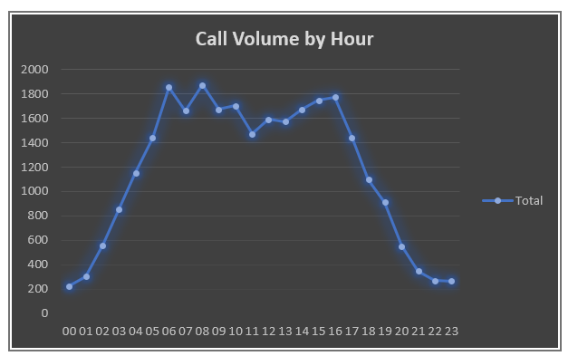

Insight:
- Peak periods are mostly between 6 AM – 1 PM and 7 PM – 9 PM.
- During peak hours, average call duration increases and CSAT drops.
- Agent availability doesn’t scale with the surge, leading to higher wait times.
Observation:
- There is a direct correlation between peak load and customer dissatisfaction.
- Lack of load balancing results in missed or rushed calls.
- Real-time monitoring dashboards and predictive scheduling can prevent customer drop-offs.

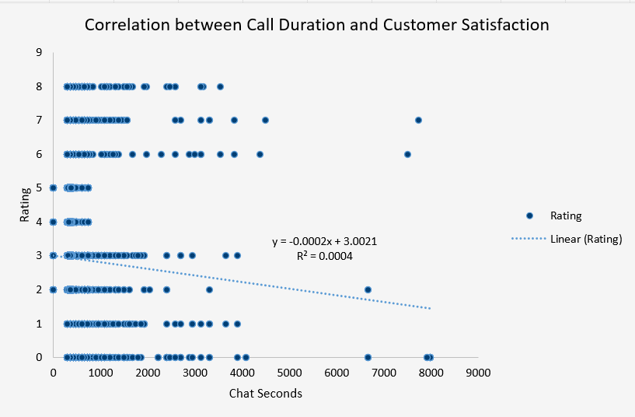
5.Based on historical data, what strategic initiatives should be prioritized to improve efficiency and customer satisfaction?

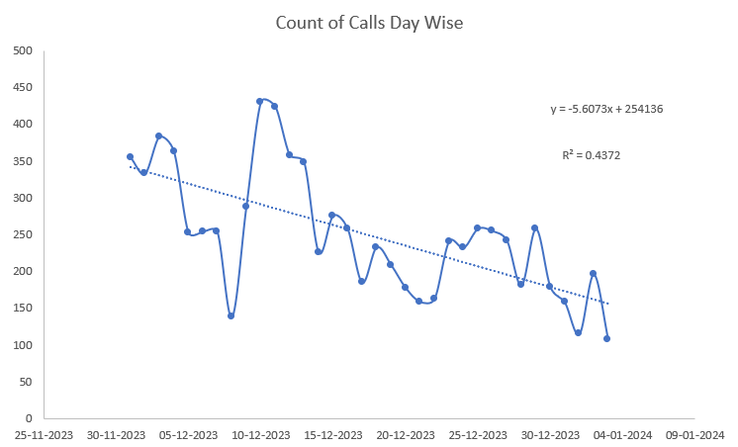

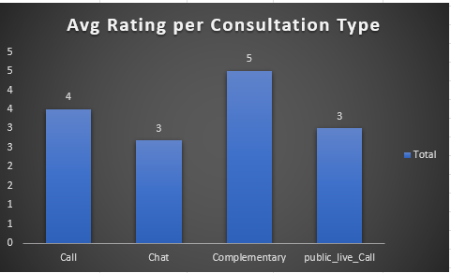
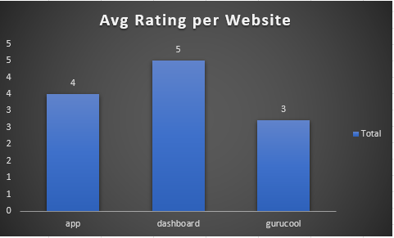
The correlation between ratings and call duration is near zero (R^2 = 0.0004), with ratings dropping as call length increases, except for calls over 2000 seconds. Also, in count of calls trendline has highly negative slope, with 0.4 R^2 value, indicating calls are sharply falling day by day on an average. To improve this correlation and make the trend positive, the company can:
- Foster personalized interactions between agents and customers.
- Provide regular training and monitor agents' progress.
- Create a supportive, hassle-free work environment for agents.
- Integrate technology to reduce agent workload.
- Use effective forecasting to ease pressure during peak hours.
- Also, Average Rating is less in Chats than Calls which can be improved using AI Chatbots integration.
Average Rating in Gurucool website is less than others, so it also needs technological upgrades to facilitate good user experience and Company should also work on their dashboard so more users will come through that

6. What can be the key factors contributing to high customer satisfaction scores, and how can these be leveraged to improve overall performance?What is the basis for the suggestions? And mention how you decided if the satisfaction score affects the ratings.
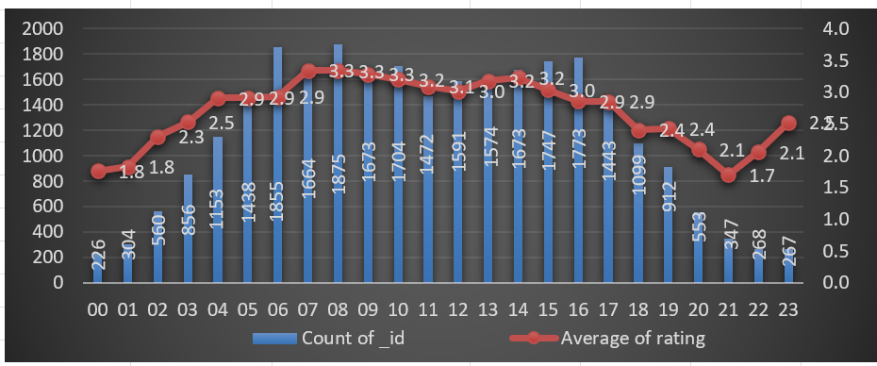
1. call timing (hour of day)
Basis (Chart: Count of Calls & Ratings by Hours)
- Ratings are highest between 6 AM – 11 AM.
- Despite high call volumes, customer satisfaction remains strong, indicating effective agent performance during these hours.

Conclusion:
- Agents may be well-rested or better trained during early shifts.
- Morning processes are more efficient, contributing to better outcomes.
- Customers appear more patient and cooperative in the morning.
Action (Leverage):
- Assign top-performing agents during these high-satisfaction hours to boost conversions and upselling opportunities.
- Analyze morning workflows and replicate successful strategies during later shifts.

2. Agent Identity or Experience Level
Action (Leverage):
- Use high-performing agents as training models for others.
- Recognize and reward top performers to retain talent.
- Pair junior agents with experienced ones for mentoring or shadowing.
3. Resolution on First Call
- When issues are resolved in the first interaction, ratings are significantly higher.
Action (Leverage):
- Train agents on common issues to minimize escalations.
- Provide FAQs or AI-driven support tools to resolve problems before reaching agents.

7. How should the call center balance the workload among agents to ensure optimal performance and avoid burnout? Mention your approach and spreadsheet function for the answer.
A)
- Approach:
- To answer this question, I wanted to figure out if the workload among all the astrologers I mean gurus is evenly distributed or if a few gurus handle the majority of the calls while others are underutilized. This helps determine whether some gurus are overburdened, which can lead to burnout, while others aren't contributing enough.

- So, I started by analyzing the number of calls handled by each guru using a pivot table. I also examined how many active working days were included in the dataset. Then I calculated the average number of calls that each guru handles per day. This approach provides a comprehensive picture of workload balance and aids in developing a practical strategy to prevent burnout and improve overall performance.

- Work:
To analyze the workload balance among agents (gurus), I followed these steps in Excel:
Step 1: Created a pivot table:
I created a new pivot table with the cleansed dataset.

In the pivot table:
- I included guruName in the Rows section.

- I included CallSid in the Values section (set to Count).

This showed me the total number of calls handled by each expert.
Step 2: Counted Total Number of Active Days.

- I utilized a Pivot Table to determine how many calls were received on each distinct day.
- I moved CallDate to the Rows section and CallSid to the Values section. This generated a date-based call log, and the count at the bottom of Excel confirmed that there were 34 active days.
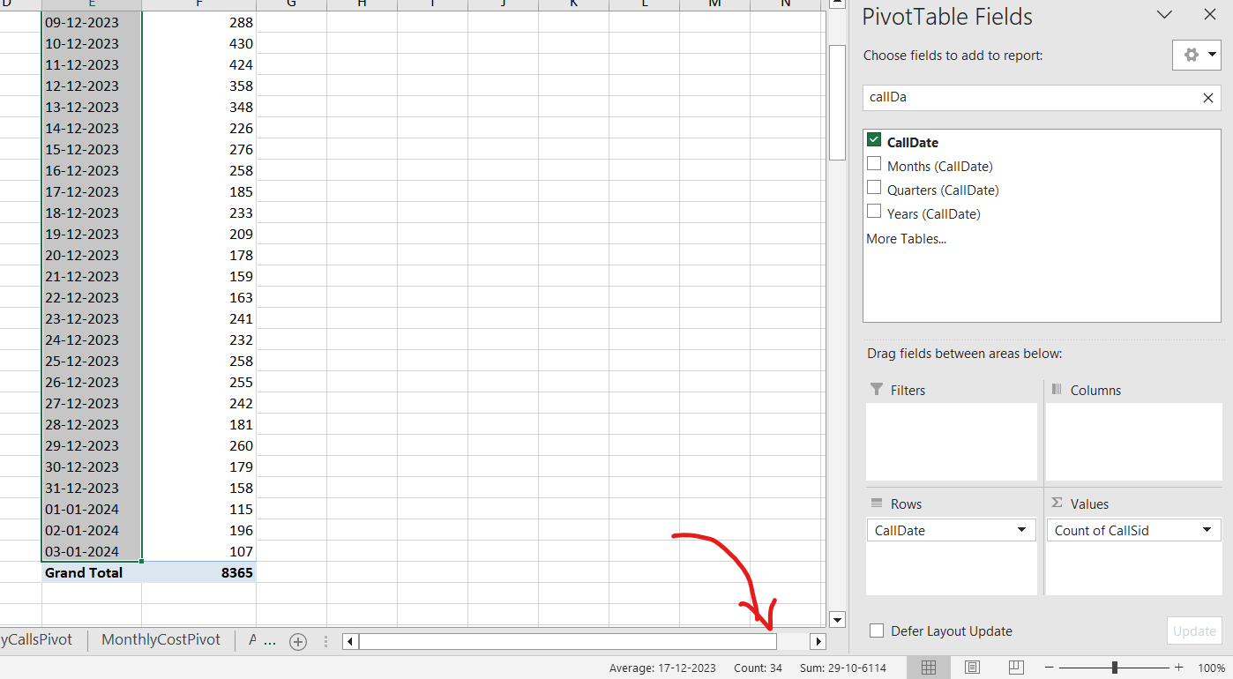
Step 3: Count the Total Number of Agents
- I first created a Pivot Table with the guruName field to determine how many agents were active in call handling. While this displayed 149 names, I noted that some had minor variations or repeated labels (for example, "Dr Balkrisna" vs "Dr. Balkrisna").

- To avoid double-counting and obtain an accurate backend value, I switched to the guru column and applied Excel's duplicate-removal approach. This got me 133 unique gurus, which is the correct number of agents taking calls.

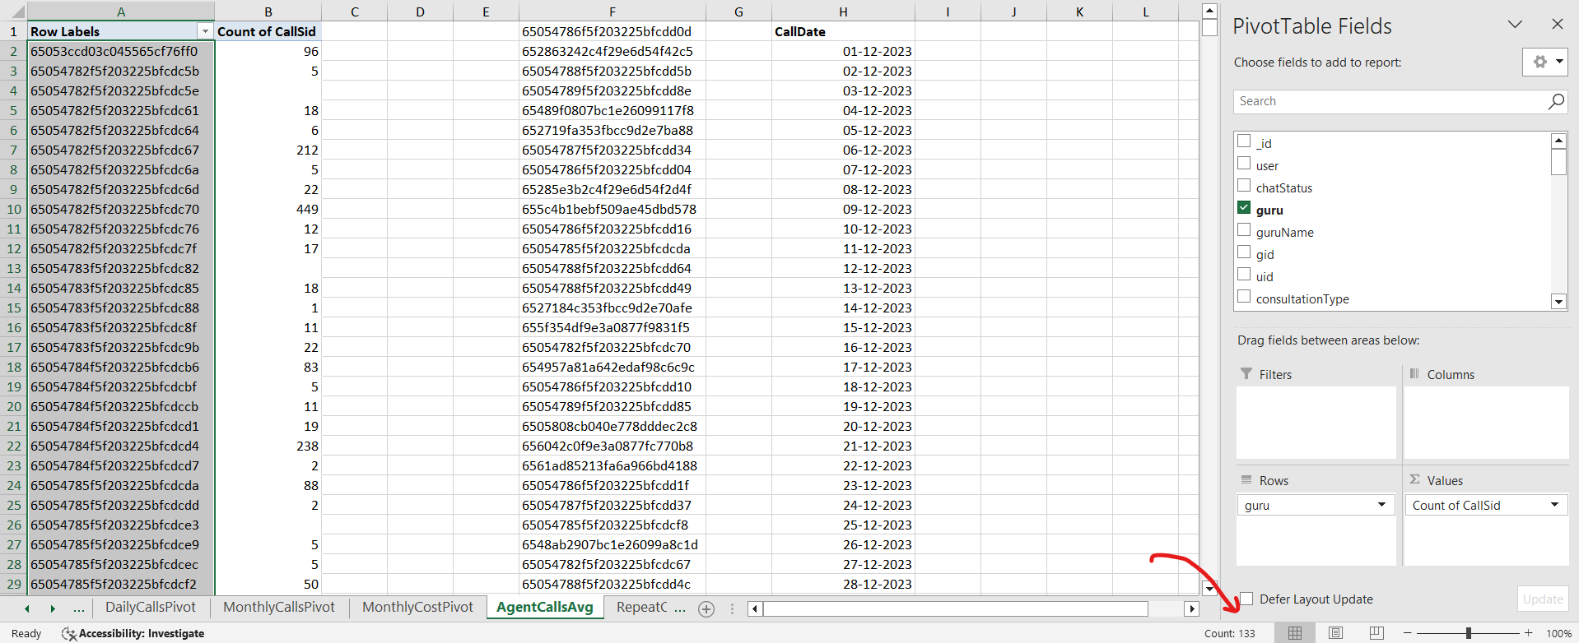
Step 4: Calculate the Final Metric.

- Once I had the total number of calls, unique agents, and active days, I used the following method to compute the average number of calls handled per agent each day:

- The formula is: = Total Calls / (No. of Agents × No. of Days).

- Substitution: = 8365 / (133 x 34) = 8365 / 4522 = 1.85 calls per day.

This tells me that each agent handles an average of 1.85 calls each day, indicating that the workforce is underutilized.

Metric | Value
Total Calls | 8365
Total Unique Agents | 133
Total Active Days | 34
Average Calls per Agent per Day | 1.85

- Insights:
- According to my Excel pivot, 8,365 total calls were spread across 133 agents over 34 active days, resulting in an average of just 1.85 calls per agent each day. That's an extremely light workload, implying that many agents are likely sitting inactive for extended durations.
- While many agents are hardly receiving calls, a few top performers, such as Astro Shalini (1060 calls), are handling a significant portion of the traffic. This creates an imbalance in the team, potentially leading to burnout for some and disinterest for others.
- If calls were allocated more strategically, or shifts were created based on peak days, we could achieve the same results with fewer agents – or handle more calls with the same staff. This suggests that we are not maximizing the current workforce's efficiency.
- Based on this insight, I feel it is time to evaluate agent schedules, performance, and availability before deciding whether to reduce or restructure the team.
- Recommendations:

- Do not hire more agents. The present team is already underutilized, receiving only 1.85 calls per agent each day. Hiring extra personnel today would result in more idle time and unneeded costs.
- Redistribute the call burden efficiently. Some agents, like as Astro Shalini, handle hundreds of calls while others receive very few. I recommend distributing the workload among agents via call routing strategies or shift allocation.
- Monitor agent performance on a frequent basis. Create a dashboard (monthly or weekly) to keep track of calls by agent. This assists in determining who is performing, who is idle, and where improvements are required.
- Consider flexible shift scheduling. Because the workload is not evenly distributed, we can choose for rotating or part-time shifts for specific agents to maximize availability and productivity.

8. What new technologies or tools could be implemented to enhance call center operations and customer service?
Guideline:
To improve the operational efficiency and customer service quality of the AstroSage call center, adopt modern technologies that address current gaps in responsiveness, personalization, and workload distribution. These technologies should be scalable, integrate well with existing CRM systems, and support data-driven decisions.
Insight:
- Call volume spikes during certain hours, but agent availability remains flat.
- Average customer satisfaction is below optimal (~2.9 out of 5).
- Repeat caller behavior and low CSAT scores point toward inefficiencies in resolution speed and personalization.

Observation:
- AI-Powered Call Routing: Can intelligently assign calls to the most qualified agents based on intent, language, and past interactions, improving resolution time and CSAT.
- Chatbots & Voice Bots: Can handle routine queries 24/7, freeing agents for complex tasks.
- Workforce Management Tools: IT can can help dynamically schedule agents based on predicted peak hours.
- Speech Analytics & Sentiment Analysis: Technologies like AI or Call help identify pain points in real-time, improving agent training.

9. What metrics should be included in the final dashboard to comprehensively view call center performance and guide investment decisions?
Insight:
- The dashboard should present key performance indicators (KPIs) that cover call volume, customer satisfaction, agent efficiency, and revenue generation. This allows leadership to track trends, identify bottlenecks, and make informed investment decisions (e.g., hiring, training, tech upgrades).

Insight:

- High total call volume indicates strong customer engagement but also potential agent overload.
- Average customer satisfaction (CSAT) is moderately low (~2.9), showing room for improvement in service quality.
- Revenue by consultation type reveals which services generate the most income, useful for focusing investment.
- Unique guru count helps measure workload distribution.
- Repeat callers % helps identify service gaps or dependency on follow-ups.
- Daily call trends and monthly performance highlight peak times and demand patterns.

Observation:
- Total Call Volume – Tracks overall activity and scale.
- Average CSAT Score – Measures customer satisfaction and service quality.
- Total Revenue by Consultation Type – Helps in financial planning and resource allocation.
- Repeat vs Non-Repeat Callers – Indicates issue resolution success.
- Calls per Agent per Day – Measures agent efficiency and workload balance.
- Monthly Call Trends – Identifies peak and slow periods for better planning.
- Top Performing Gurus – For performance rewards or mentoring others.
- Operational Cost – For cost-benefit analysis and ROI on investments.

10. How would you allocate a 1 crore rupee investment to optimize operational efficiency, enhance customer satisfaction, and boost profitability, and what analysis-based recommendations would you offer to support this?
Guideline:
Investment Allocation Strategy:
1. Hire and Train More Agents .
- Reduce average calls per agent/day to prevent burnout.
- Lower response times and increase first-call resolution rate.
- Ensure availability during peak hours by distributing workload evenly.
2. Upgrade Call Center Technology .
- Implement an Intelligent Call Routing System to connect customers to the best-suited guru.
- Introduce IVR systems to streamline call filtering and reduce agent load.
- Use cloud-based CRM integration to centralize customer data for personalized service.
3. Customer Experience & Satisfaction Initiatives .
- Introduce Post-Call Feedback Mechanisms to track CSAT in real-time.
- Develop a Customer Loyalty Program to reward repeat callers.
- Offer personalized offers using historical interaction data.

4. Data Analytics & Dashboarding .
- Invest in a real-time dashboard to monitor KPIs (call volume, CSAT, revenue, etc.).
- Use predictive analytics to forecast peak call periods and schedule staffing.
- Segment customers to identify high-value interactions and improve service targeting.
5. Contingency & Innovation Fund .
- Keep funds for unforeseen challenges or to pilot emerging tools like AI Chat Assistants or WhatsApp-based support.
Observation:
- Call Volume: Average daily call volume is high; hiring will reduce overload and increase satisfaction.
- CSAT Score: Current average ~2.9 is below ideal. Investment in training and feedback mechanisms can improve quality.
- Revenue by Type: Calls generate the most revenue — focus investments in tech and staff that support this channel.
- Repeat Callers: ~14% repeat callers show unresolved issues; improving first-call resolution can reduce repeat load and cost.
- Peak Time Handling: Analyze peak-hour call trends to optimize shift planning and reduce abandonment rate.

