WEEK 3 TASK
Advanced Data Visualization and Statistical Analysis
Business Analytics Report
Python-Based Visualization, Statistical Analysis and Business Interpretation

Dataset: Sample Superstore retail transaction data
Analysis period in supplied data: 03 January 2023 – 30 December 2026
Rows analysed: 10,194
Prepared from the supplied Jupyter Notebook and project dataset
Report date: 02 October 2026

1. Executive Summary
This report documents an end-to-end advanced data visualization and statistical analysis project performed in Python on a supplied Superstore-style retail transaction dataset. The submitted notebook loads an Excel Superstore file, validates the structure, checks for missing values and duplicates, converts date and numeric fields, creates shipping and time features, calculates profit margin, and then applies a series of business visualizations and statistical methods. The final analytical dataset contains 10,194 rows and 27 columns after feature engineering.
The analysis reports total sales of $2,326,534.35, total profit of $292,296.81, 5,111 unique orders, total quantity of 38,654 units, an average order value of $455.20, an overall profit margin of 12.56%, and an average shipping time of 3.96 days. Technology generates the highest category sales and profit in this dataset, while West is the highest-sales region. The statistical analysis shows a moderate positive Pearson relationship between Sales and Profit (r = 0.481) and a negative relationship between Discount and Profit (r = -0.219, p < 0.001).
An OLS regression with heteroscedasticity-robust HC3 covariance explains approximately 27.5% of the variation in Profit using Sales, Quantity and Discount. Sales and Discount are statistically significant predictors in the fitted model, while Quantity is not statistically significant after controlling for the other variables. A one-way ANOVA indicates differences in mean Profit across categories, and the Kruskal-Wallis test provides a non-parametric confirmation. Because Levene's test indicates unequal variances, the Tukey post-hoc output is treated as exploratory and interpreted with caution.

2. Alignment with the Task Requirements
Task requirement | How the project addresses it
Advanced visualizations | Category, regional, time-series, scatter, correlation heatmap, boxplot, shipping and product visualizations.
Statistical relationships | Pearson and Spearman correlation matrices plus a specific Pearson test for Discount vs Profit.
Regression analysis | OLS regression with Sales, Quantity and Discount; an extended model adds Category and Region.
Hypothesis testing | One-way ANOVA, Levene variance test, Kruskal-Wallis non-parametric test and Tukey post-hoc comparisons.
Annotated code / methodology | The supplied notebook is organized into loading, validation, feature engineering, visualization, statistics, regression, hypothesis testing and final quality-check cells.
Business interpretation | Findings are linked to pricing/discount control, category strategy, regional focus, product mix and shipping operations.
Reproducibility | Python libraries, project-relative data/visualization paths, deterministic transformations and a final data-quality check are documented.
Detailed DOC report | This document consolidates the methodology, visual outputs, statistical results, interpretations, limitations and references.

3. Dataset Selection and Business Relevance
The supplied notebook identifies the input workbook as “sample_-_superstore(1).xls” and loads it as a Superstore-style retail dataset. Tableau describes Superstore as a sample business dataset containing products, sales and profits that can be used to identify areas for improvement in a fictitious company. Tableau also notes that Superstore contains dates, geographic fields, product hierarchies, positive and negative profit values, and multiple dimensions and measures, making it suitable for a broad range of visualization and business analysis tasks.
The supplied project data contains 10,194 transaction-line records and 21 original columns. The core business fields include Order ID, Order Date, Ship Date, Ship Mode, Customer, Segment, Region, Category, Sub-Category, Product Name, Sales, Quantity, Discount and Profit. This structure supports analysis of sales performance, profitability, product mix, regional performance, pricing/discount relationships and operational shipping performance.
The dataset is particularly suitable for this task because it supports both descriptive and inferential analysis. Sales and Profit are continuous measures; Category, Region and Ship Mode provide meaningful groups; Order Date supports time-series analysis; and Discount allows the study of a commercially important relationship with profitability.

4. Data Extraction and Preprocessing

4.1 Python tools
The notebook uses Pandas and NumPy for data handling and feature engineering, Matplotlib and Seaborn for visualization, SciPy for statistical tests, and Statsmodels for regression and post-hoc analysis. The notebook also uses pathlib for project-relative file management.

4.2 Extraction workflow
- Search project data folders for an Excel file using pathlib.
- Load .xls files with xlrd and .xlsx files with openpyxl.
- Confirm the number of rows and columns after loading.
- Inspect the first and last records and print all column names.
- Validate that the required business-analysis columns are present.

4.3 Data quality checks
Check | Result | Treatment
Rows before/after cleaning | 10,194 / 10,194 | No rows removed by required-field dropna.
Duplicate rows | 0 | No duplicate records detected.
Missing values | 0 | No missing values detected in the supplied cleaned dataset.
Negative Sales | 0 | No invalid negative sales values detected.
Quantity <= 0 | 0 | No invalid non-positive quantity values detected.
Discount outside 0–1 | 0 | No invalid discount values detected.
Order/Ship dates | Valid | Converted to datetime and used to calculate shipping days.

4.4 Feature engineering
- Shipping Days = Ship Date − Order Date.
- Year, Month and Month Name were extracted from Order Date.
- Year-Month was created for monthly aggregation and time-series visualization.
- Profit Margin (%) = Profit / Sales × 100, with zero-sales records protected using NaN.
The final dataset contains 27 columns: the 21 original fields plus six derived analytical fields. The final quality check confirms 10,194 rows, zero duplicates and zero missing values.

5. Key Business KPIs
KPI | Result | Business meaning
Total Sales | $2,326,534.35 | Overall revenue generated by the transactions.
Total Profit | $292,296.81 | Aggregate profit across all transaction lines.
Total Quantity | 38,654 | Total units sold.
Total Orders | 5,111 | Unique Order IDs in the dataset.
Average Order Value | $455.20 | Average sales value per unique order.
Overall Profit Margin | 12.56% | Profit as a percentage of total sales.
Average Shipping Days | 3.96 | Average elapsed time between order and shipment.

6. Advanced Data Visualization and Business Interpretation
The visual analysis is designed to move from high-level performance to relationships, distribution and operational detail. Each figure was regenerated from the supplied project dataset for inclusion in this report.
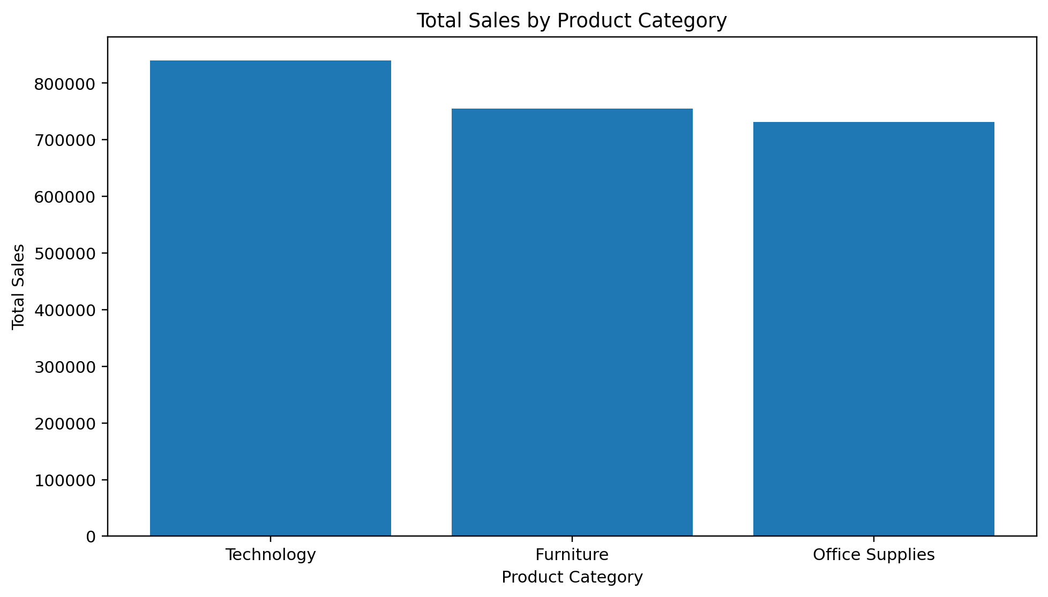
Figure 1. Total Sales by Product Category.
Technology has the largest category sales at $839,893.28. Furniture and Office Supplies follow at $754,747.76 and $731,893.31, respectively. This indicates that category-level sales concentration should be considered when allocating inventory, marketing and commercial attention.
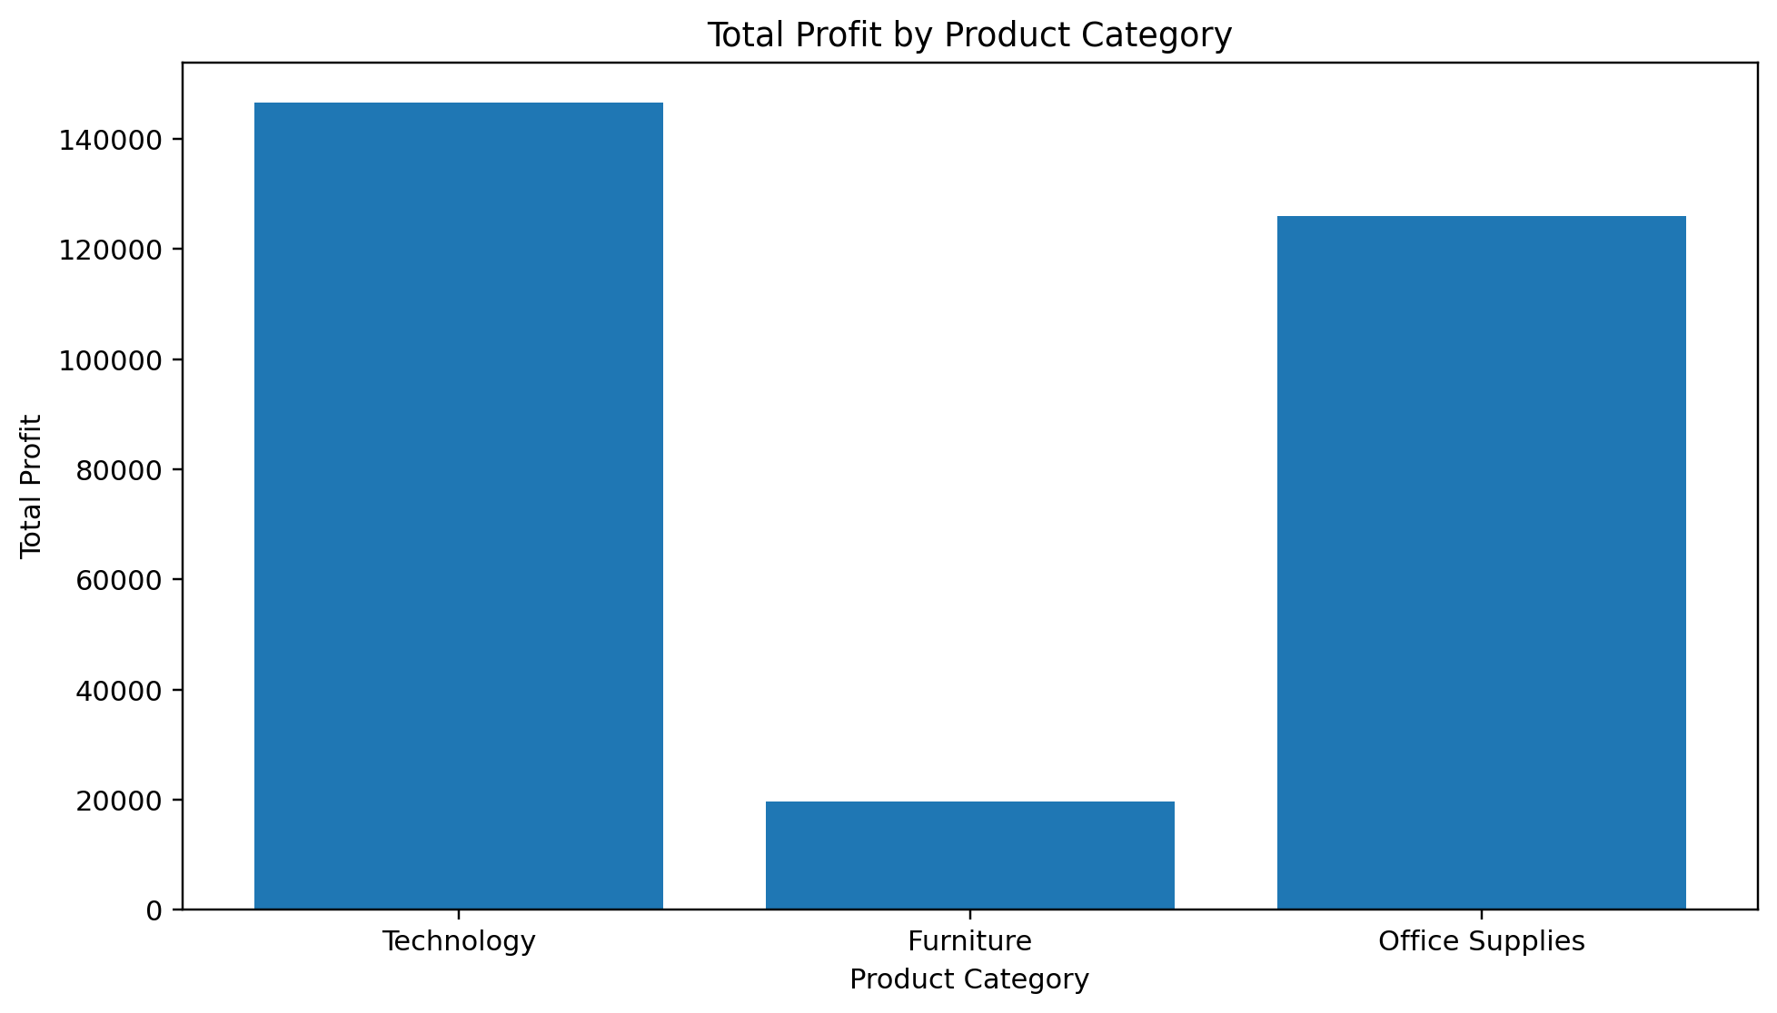
Figure 2. Total Profit by Product Category.
Technology contributes $146,543.38 in profit, while Office Supplies contributes $126,023.44. Furniture generates $19,730.00. The difference between sales and profit rankings highlights why revenue alone is not sufficient for performance management.
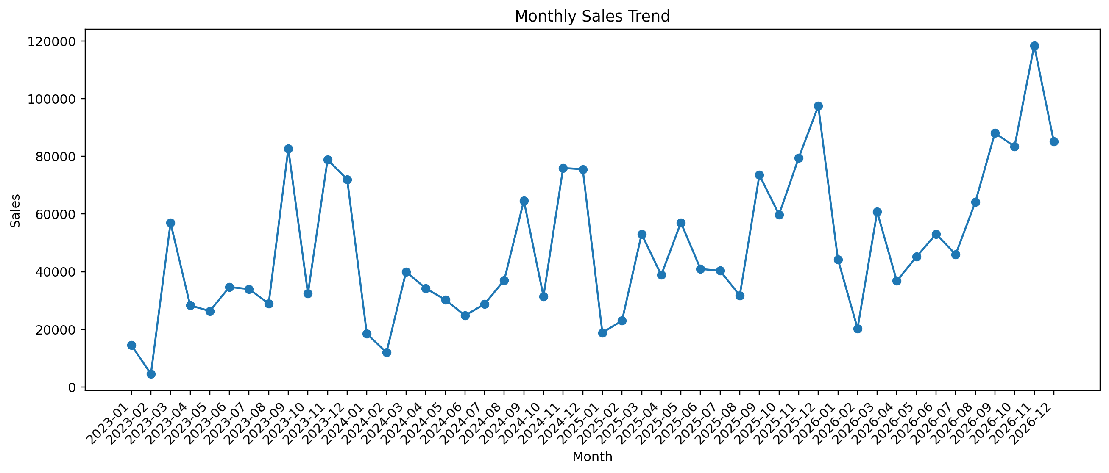
Figure 3. Monthly Sales Trend.
Monthly sales vary substantially across the observation period. The highest-sales month is 2026-11 with $118,454.51, while the lowest is 2023-02 with $4,519.89. The time series can therefore support seasonal planning, campaign evaluation and inventory preparation.
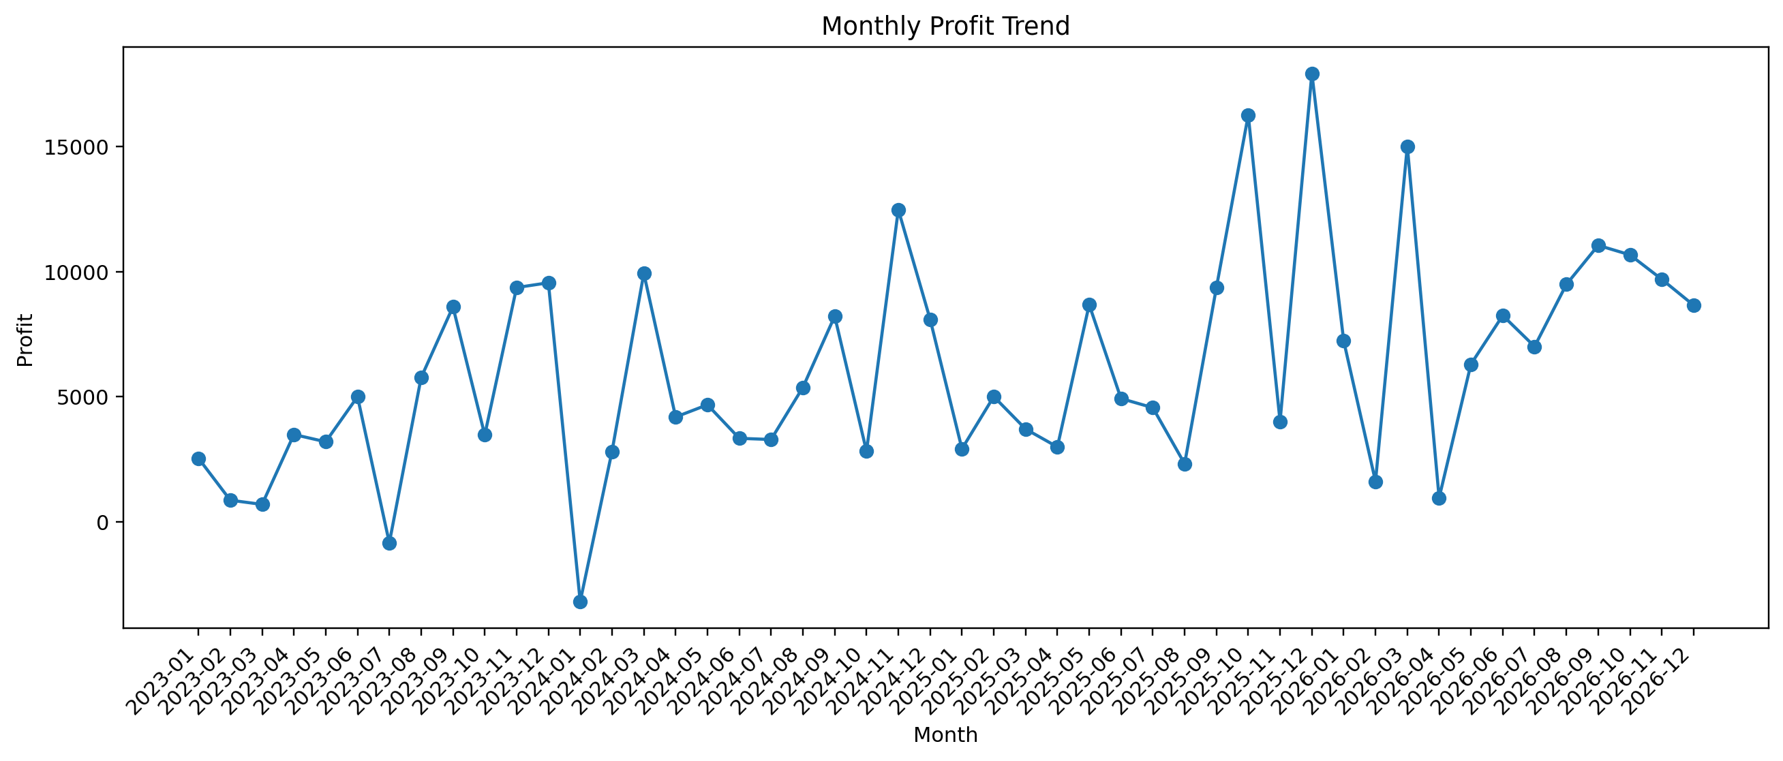
Figure 4. Monthly Profit Trend.
Monthly profitability is more volatile than a simple sales total might suggest. The highest monthly profit is 2025-12 at $17,926.30, while the lowest monthly profit is 2024-01 at $-3,189.80. The presence of negative monthly profit in some periods shows that sales growth should be evaluated alongside margins and costs.
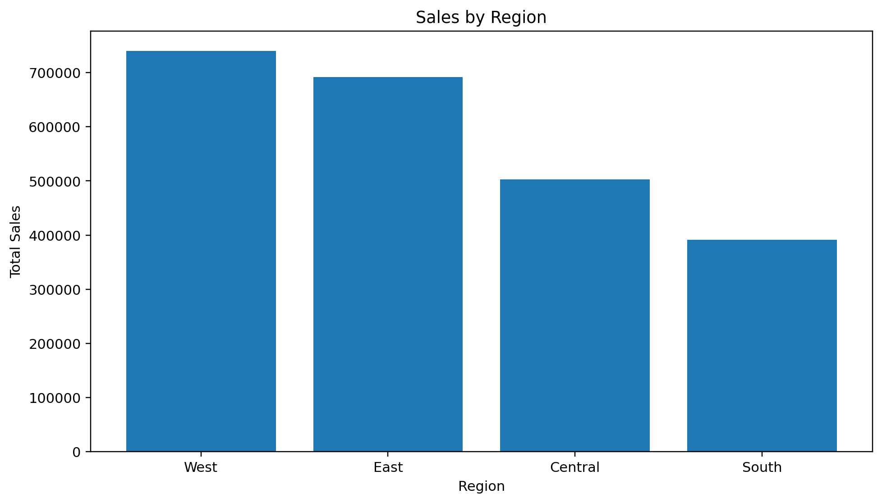
Figure 5. Sales by Region.
West has the highest sales at $739,813.61, followed by East, Central and South. Central also has the highest average discount among the four regions (0.24), which is relevant when examining regional profitability and discount policy.
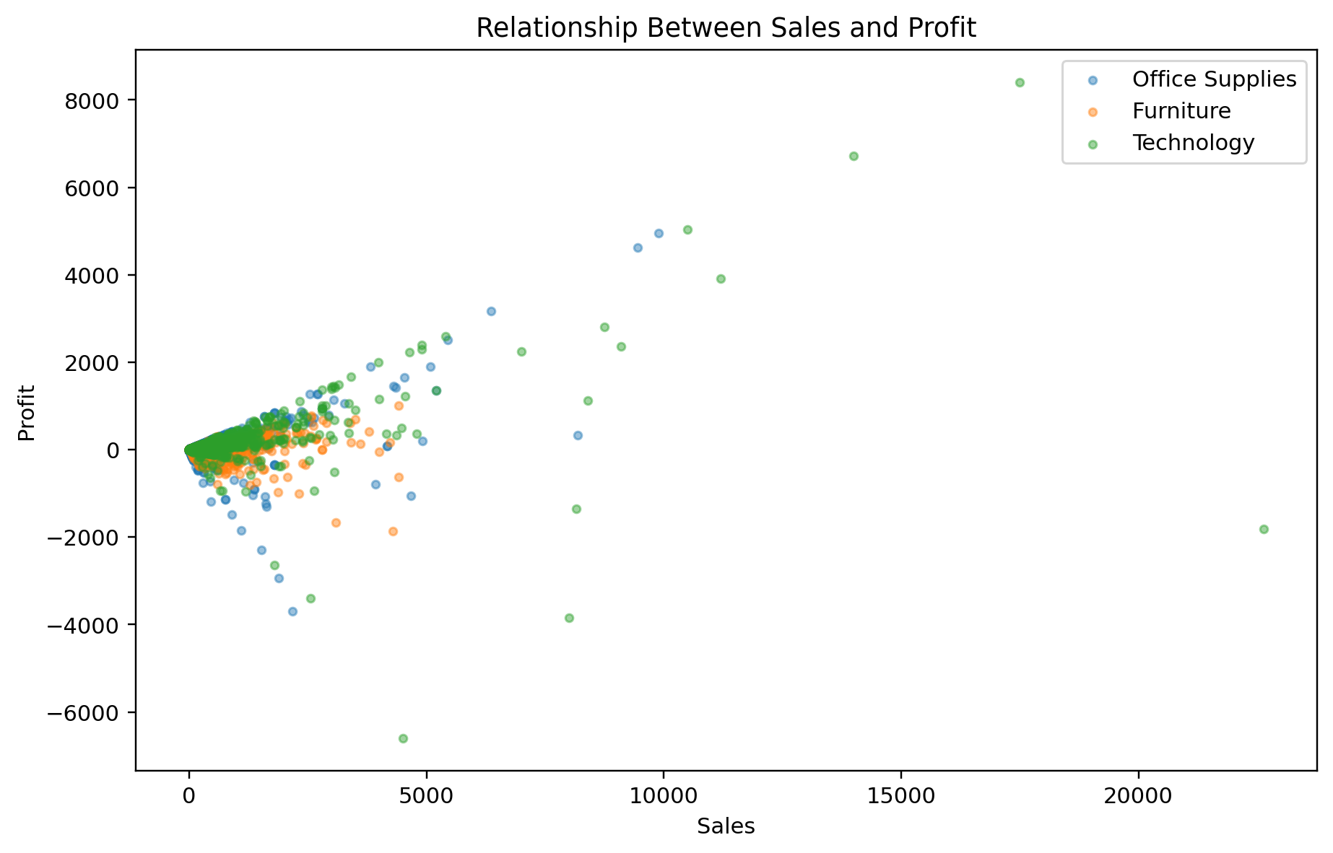
Figure 6. Relationship Between Sales and Profit.
The Pearson correlation between Sales and Profit is 0.481, indicating a moderate positive linear relationship. However, the scatter distribution also contains high-value and negative-profit observations, so the relationship should not be interpreted as a guarantee that higher sales always produce higher profit.
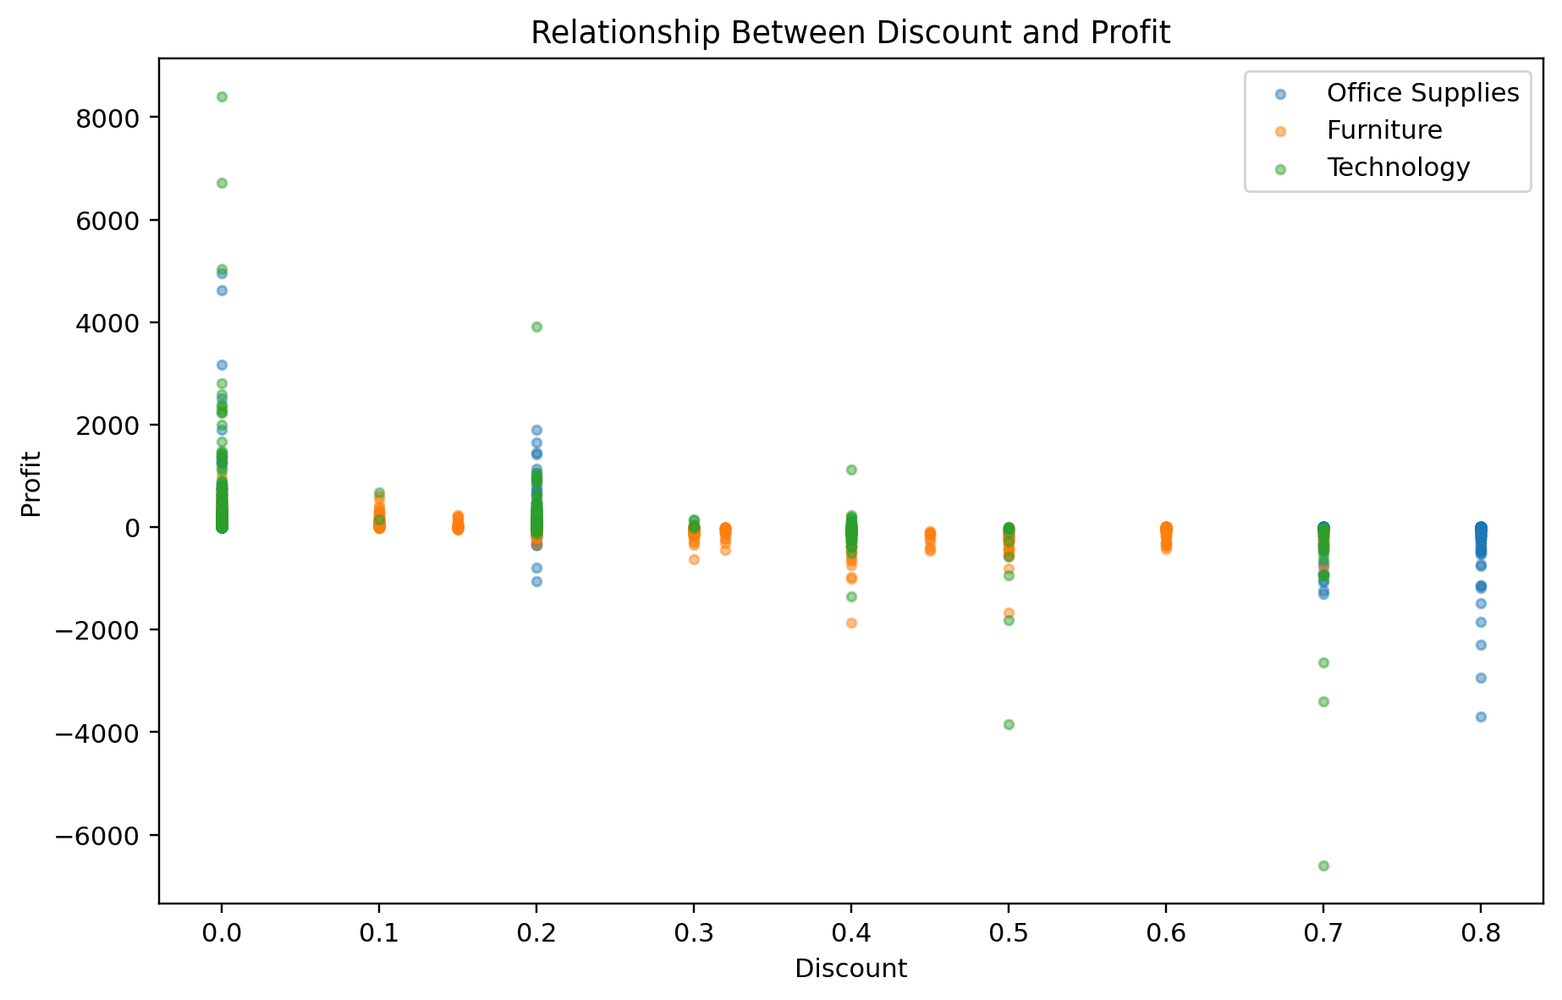
Figure 7. Relationship Between Discount and Profit.
Discount and Profit have a Pearson correlation of -0.219 with p < 0.001. The negative association is consistent with the business interpretation that heavier discounting can coincide with weaker profitability, although correlation does not by itself establish causation.
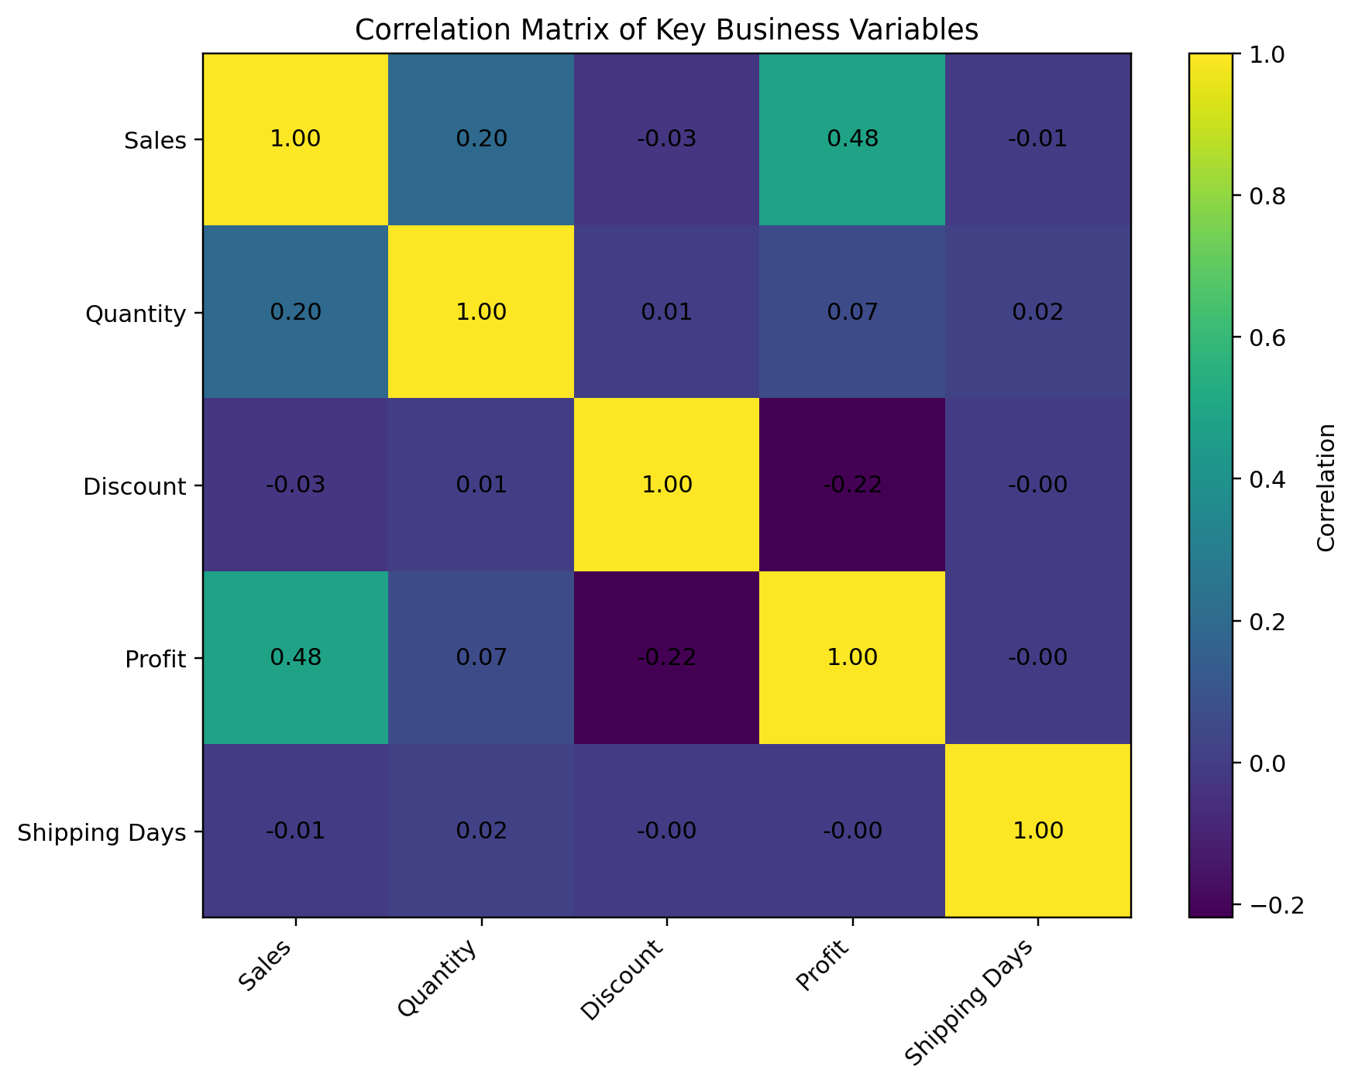
Figure 8. Correlation Matrix of Key Business Variables.
The strongest positive correlation among the selected variables is Sales–Profit (0.481); the strongest negative relationship is Discount–Profit (-0.219). Shipping Days is close to zero correlation with Profit (-0.004) in this dataset.
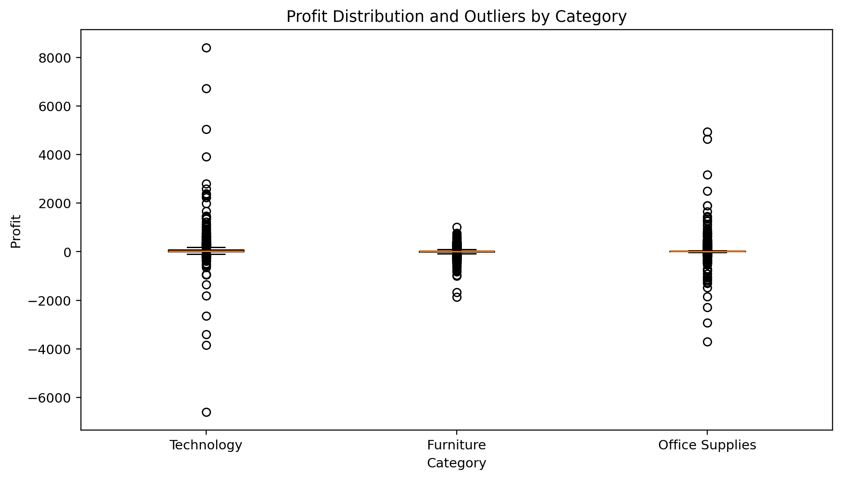
Figure 9. Profit Distribution and Outliers by Category.
The boxplot shows substantial spread and extreme profit observations within categories. This supports the use of distribution-aware and non-parametric statistical methods in addition to mean-based comparisons. Outliers should be investigated rather than automatically deleted because large retail transactions can be genuine business events.
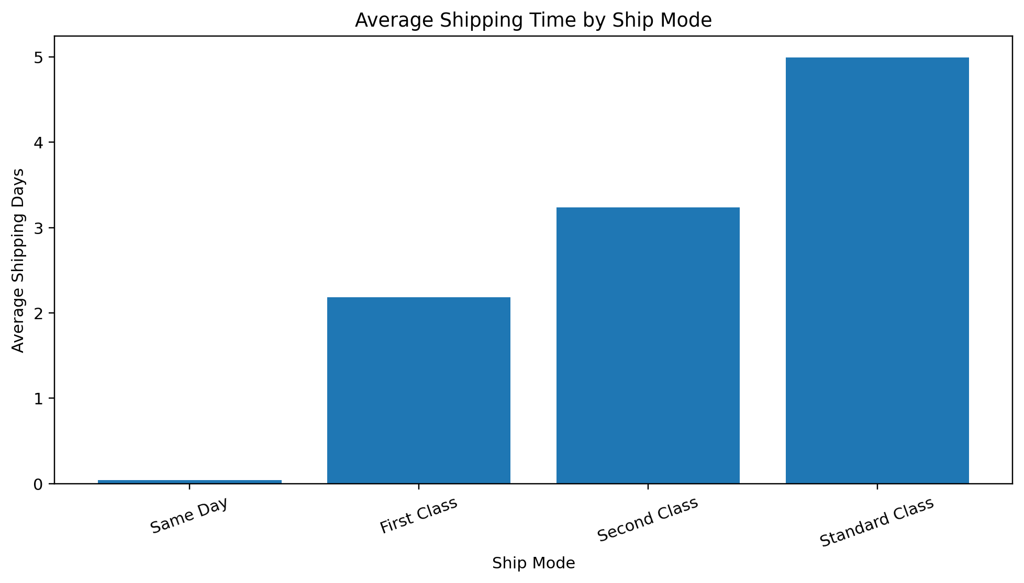
Figure 10. Average Shipping Time by Ship Mode.
Average shipping time is approximately 3.96 days overall. The comparison by Ship Mode helps identify operational differences between service levels and can be used to balance delivery speed against service configuration.
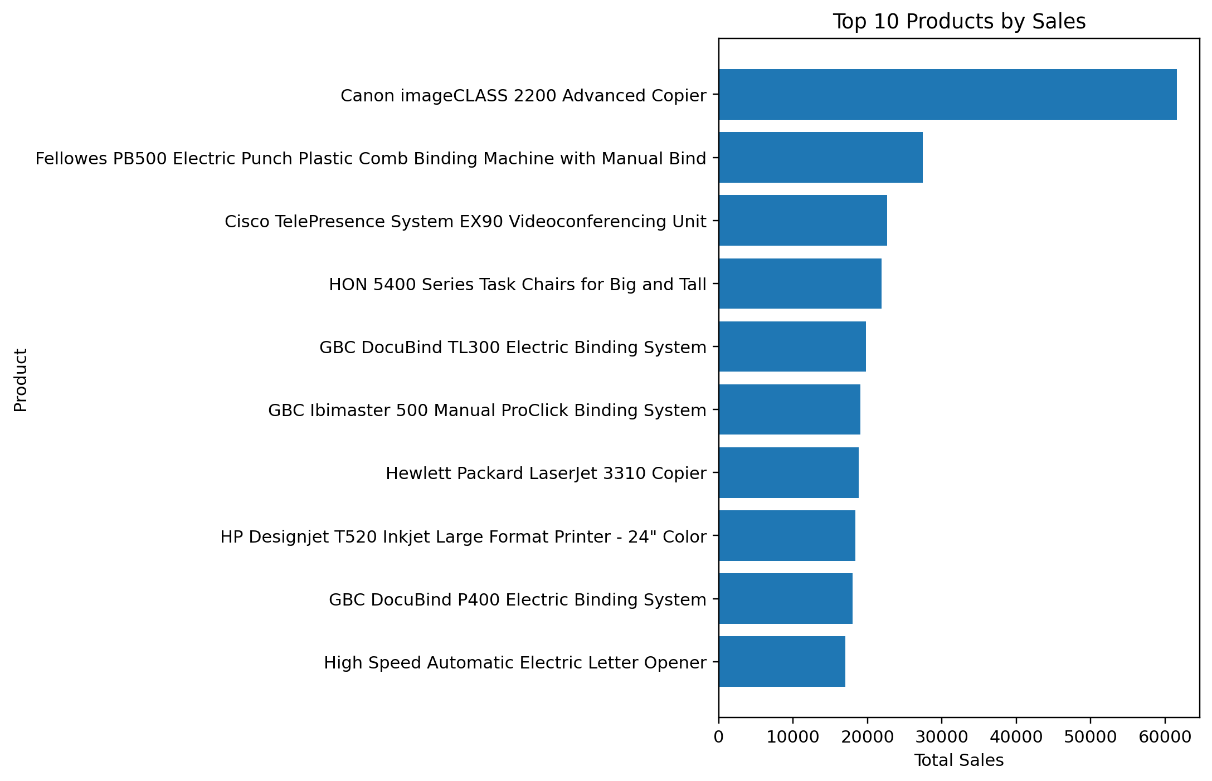
Figure 11. Top 10 Products by Sales.
The leading product by sales is “Canon imageCLASS 2200 Advanced Copier” with $61,599.82. Product-level concentration can help identify important revenue drivers and products that may deserve inventory, pricing or promotional monitoring.

7. Statistical Analysis

7.1 Descriptive statistics
Variable | Mean | Median | Std. dev. | Minimum | Maximum
Sales | 228.226 | 53.910 | 619.907 | 0.444 | 22638.480
Quantity | 3.792 | 3.000 | 2.228 | 1.000 | 14.000
Discount | 0.155 | 0.200 | 0.206 | 0.000 | 0.800
Profit | 28.673 | 8.690 | 232.465 | -6599.978 | 8399.976
Shipping Days | 3.961 | 4.000 | 1.743 | 0.000 | 11.000
Sales and Profit are strongly right-skewed in practical business terms, as shown by large differences between their medians and means and by their high maximum values. Profit also ranges from negative to positive values. These characteristics justify the use of scatterplots, boxplots, correlation measures and non-parametric tests rather than relying only on averages.

7.2 Pearson and Spearman correlation
Relationship | Pearson r
Sales vs Profit | 0.481
Discount vs Profit | -0.219
Sales vs Quantity | 0.198
Quantity vs Profit | 0.066
Shipping Days vs Profit | -0.004
The specific Pearson test for Discount versus Profit produced r = -0.2189 and p = 7.972e-111. At the 5% significance level, this provides strong statistical evidence of a non-zero linear association in the sample. The direction is negative. The result should be interpreted as an association, not proof that discounting alone causes lower profit.

7.3 OLS regression with HC3 robust covariance
The regression model estimates Profit as a function of Sales, Quantity and Discount. HC3 robust covariance was used to make coefficient inference less sensitive to heteroscedasticity. The model has R² = 0.2748 and adjusted R² = 0.2746. The overall F-test is 107.62 with p = 1.348e-68.
Term | Coefficient | P-value | 95% CI
Intercept | 34.4513 | 1.940e-10 | [23.8444, 45.0581]
Sales | 0.1805 | 1.091e-03 | [0.0722, 0.2888]
Quantity | -2.9037 | 2.914e-01 | [-8.2979, 2.4904]
Discount | -231.4131 | 2.847e-30 | [-271.0830, -191.7433]
Sales has a positive coefficient (0.1805) and a statistically significant p-value (1.091e-03). Discount has a negative coefficient (-231.4131) and is statistically significant. Quantity has a coefficient of -2.9037 but is not statistically significant at α = 0.05 (p = 0.2914) after controlling for the other predictors.
An extended model adding Category and Region increases R² from 0.2748 to 0.2824. This indicates that group-level information contributes additional explanatory power, although the model remains descriptive and should not be interpreted as a causal model.

7.4 One-way ANOVA
The one-way ANOVA tests whether mean Profit is equal across the three product categories. The result is F = 55.1895, p = 1.447e-24. At α = 0.05, the null hypothesis of equal category means is rejected for this sample, indicating evidence of differences in mean profit among the categories.

7.5 Levene's test and assumption check
Levene's test gives a statistic of 83.2650 with p = 1.351e-36. This provides evidence against the equal-variance assumption. Therefore, the ANOVA result should be treated as a mean-comparison finding with an assumption limitation rather than as the only basis for inference.

7.6 Kruskal-Wallis test
The Kruskal-Wallis test gives H = 450.7273 and p = 1.336e-98. This non-parametric result also indicates differences in the distributions of Profit across categories and provides a useful robustness check when the normality/equal-variance assumptions behind standard ANOVA are questionable.

7.7 Tukey post-hoc comparison
Comparison | Mean difference | Adjusted p-value | Significant at 0.05
Furniture vs Office Supplies | 11.6011 | 0.1077 | No
Furniture vs Technology | 69.6114 | <0.001 | Yes
Office Supplies vs Technology | 58.0104 | <0.001 | Yes
The Tukey output identifies statistically significant mean-profit differences for Furniture vs Technology and Office Supplies vs Technology, but not for Furniture vs Office Supplies. Because Levene's test indicates unequal variances, these Tukey results are reported as exploratory. For a production-grade unequal-variance post-hoc analysis, Games-Howell would be a more appropriate follow-up.

8. Integrated Business Findings
- Revenue and profit should be monitored together. Total sales are $2,326,534.35, while total profit is $292,296.81, producing an overall margin of 12.56%.
- Technology is the largest sales category and also contributes the highest total profit in the supplied data.
- West is the highest-sales region. Central has the highest average discount among regions, making discount policy an important regional profitability consideration.
- Sales and Profit show a moderate positive relationship, but the scatterplot demonstrates substantial variation and negative-profit transactions.
- Discount is negatively associated with Profit and is also a statistically significant negative predictor in the multivariable regression.
- Quantity alone has a weak correlation with Profit and is not statistically significant in the fitted regression after controlling for Sales and Discount.
- Profit differs across categories according to both ANOVA and Kruskal-Wallis testing; however, unequal variances require caution with classical post-hoc inference.
- Shipping Days has very little linear correlation with Profit in this dataset, suggesting that shipping duration is not a major direct numerical driver of profit in the selected variables.
- Product-level sales are concentrated among a relatively small number of high-value products, supporting targeted inventory and commercial monitoring.

9. Business Implications and Recommendations
- Track sales and profit as paired KPIs rather than using sales volume alone.
- Review high-discount transactions and categories to identify situations where discounting reduces margin without creating sufficient volume benefit.
- Use category-level profitability analysis to distinguish high-revenue categories from high-margin categories.
- Use regional dashboards to compare sales, profit and average discount simultaneously so that regional growth is not achieved at the expense of profitability.
- Monitor top-selling products for inventory availability and pricing stability because interruptions in key products can have an outsized effect on revenue.
- Use monthly sales and profit trends for demand planning, campaign timing and inventory preparation.
- For future statistical work, use a heteroscedasticity-aware post-hoc method such as Games-Howell after detecting unequal variances.
- For stronger causal conclusions, add variables such as cost, returns, promotions, customer characteristics or campaign information and use an appropriately designed longitudinal or experimental framework.

10. Reproducibility, Limitations and Quality Notes

10.1 Reproducibility
- The notebook uses Python and standard analytics libraries: pandas, numpy, matplotlib, seaborn, scipy and statsmodels.
- The dataset is discovered from project-relative data folders using pathlib, reducing dependence on a machine-specific absolute path.
- The analysis creates all derived fields programmatically and saves visualization outputs to a project-relative visualization folder.
- A final data-quality check reports row count, column count, duplicates, missing values, date range and numeric data types.
- The cleaned dataset is exported as a CSV from the notebook for downstream use.

10.2 Limitations
- The dataset is a sample/fictitious retail dataset, so findings should not be treated as evidence about a real company's performance.
- The observation period in the supplied data runs from 2023 to 2026; conclusions are specific to that supplied dataset and period.
- Correlation and regression associations do not establish causation.
- The Profit variable contains substantial dispersion and extreme values, so averages can be sensitive to outliers.
- Levene's test indicates unequal category variances; therefore, the classical ANOVA/Tukey combination requires caution.
- The notebook suppresses warnings, which can make debugging less transparent. In production code, warnings should normally be reviewed rather than globally hidden.
- The automatic first-match Excel-file discovery is convenient for a single-file project but should be replaced by an explicit input filename in a multi-file production environment.

11. Pseudocode / Analytical Workflow
START
1. Locate the Superstore Excel dataset.
2. Load the dataset into a Pandas DataFrame.
3. Inspect rows, columns, data types and sample records.
4. Validate required business columns.
5. Check duplicates, missing values and invalid numeric values.
6. Convert date and numeric fields to appropriate data types.
7. Create Shipping Days and calendar features.
8. Calculate Profit Margin.
9. Calculate business KPIs and descriptive statistics.
10. Create category, regional, monthly, product and shipping visualizations.
11. Create scatterplots and a correlation matrix.
12. Test Pearson/Spearman relationships.
13. Fit robust OLS regression models.
14. Test category differences using ANOVA and Kruskal-Wallis.
15. Check variance assumptions with Levene's test.
16. Run post-hoc comparisons and interpret them with assumption caveats.
17. Save visualizations and the cleaned dataset.
18. Perform final quality checks.
19. Document findings and business implications.
END

12. Key Code Excerpts

Data loading
if data_file.suffix.lower() == ".xls":
df = pd.read_excel(data_file, engine="xlrd")
else:
df = pd.read_excel(data_file, engine="openpyxl")

Feature engineering
df["Shipping Days"] = (
df["Ship Date"] - df["Order Date"]
).dt.days
df["Year"] = df["Order Date"].dt.year
df["Month"] = df["Order Date"].dt.month
df["Year-Month"] = (
df["Order Date"].dt.to_period("M").astype(str)
)
df["Profit Margin (%)"] = np.where(
df["Sales"] != 0,
(df["Profit"] / df["Sales"]) * 100,
np.nan
)

Correlation
numeric_data = df[
["Sales", "Quantity", "Discount", "Profit", "Shipping Days"]
]
pearson_correlation = numeric_data.corr(method="pearson")
spearman_correlation = numeric_data.corr(method="spearman")

Robust regression
regression_model = smf.ols(
"Profit ~ Sales + Quantity + Discount",
data=df
).fit(cov_type="HC3")

Hypothesis testing
anova_statistic, anova_p_value = stats.f_oneway(
*category_groups
)
levene_statistic, levene_p_value = stats.levene(
*category_groups, center="median"
)
kruskal_statistic, kruskal_p_value = stats.kruskal(
*category_groups
)
tukey_result = pairwise_tukeyhsd(
endog=df["Profit"],
groups=df["Category"],
alpha=0.05
)

13. Conclusion
The project demonstrates a complete Python-based workflow for advanced data visualization and statistical analysis. Starting from 10,194 transaction records, the analysis validates data quality, engineers business features, calculates KPIs, produces eleven business-focused visualizations, and applies correlation, regression and hypothesis-testing techniques. The findings show that sales, profit and discounting are closely connected business variables, while category and regional structure add useful context to profitability analysis.
The strongest methodological point is the combination of visualization with statistical testing. Visualizations reveal patterns and exceptions, while correlation, regression and group-comparison tests provide quantitative evidence for relationships and differences. The analysis also explicitly checks a variance assumption and supplements ANOVA with a non-parametric test, which strengthens the interpretation. Overall, the workflow satisfies the task's emphasis on advanced visualization, statistical commentary, business interpretation, documentation and reproducibility.

14. References
- Tableau. Sample Data – Superstore Sales. Tableau Public Sample Data. https://public.tableau.com/app/resources/sample-data
- Tableau Help. Step 1: Connect to a sample data source – Superstore. https://help.tableau.com/current/guides/get-started-tutorial/en-gb/get-started-tutorial-connect.htm
- Tableau Help. Find Good Data Sets – Superstore data characteristics and suitability. https://help.tableau.com/current/pro/desktop/en-gb/find_good_datasets.htm
- Pandas Documentation. GroupBy and descriptive statistics. https://pandas.pydata.org/docs/reference/groupby.html
- Pandas Documentation. Chart visualization. https://pandas.pydata.org/docs/user_guide/visualization.html
- Statsmodels Documentation. OLS results and HC3 heteroscedasticity-robust covariance. https://www.statsmodels.org/stable/generated/statsmodels.regression.linear_model.OLSResults.HC3_se.html
- Statsmodels Documentation. pairwise_tukeyhsd. https://www.statsmodels.org/dev/generated/statsmodels.stats.multicomp.pairwise_tukeyhsd.html

Appendix A. Final Data Profile
Profile item | Value
Rows analysed | 10,194
Original columns | 21
Final columns after feature engineering | 27
Date range | 03 January 2023 to 30 December 2026
Duplicate rows | 0
Total missing values | 0
Categories | 3
Regions | 4
Ship modes | 4
Unique customers | 804
Unique products | 1,862

Appendix B. Submission Description (200+ words)
This Week 3 project presents an end-to-end advanced data visualization and statistical analysis workflow using Python and a Superstore retail transaction dataset. The project begins with data extraction and validation using Pandas, followed by inspection of the dataset structure, data types, missing values, duplicate records and invalid numeric values. Date fields are converted to datetime format and additional analytical features are created, including shipping days, calendar fields and profit margin. Key business KPIs such as total sales, total profit, total quantity, unique orders, average order value and overall profit margin are then calculated.
The visualization stage includes category and regional comparisons, monthly sales and profit trends, sales-versus-profit and discount-versus-profit scatterplots, a correlation heatmap, profit distribution by category, shipping performance by ship mode and top-product analysis. These visualizations are interpreted in terms of business performance, profitability, discount management, regional performance, product concentration and operational planning.
The statistical component applies Pearson and Spearman correlation, a specific Pearson significance test for discount and profit, robust OLS regression using HC3 covariance, one-way ANOVA, Levene's variance test, Kruskal-Wallis testing and Tukey post-hoc comparisons. The analysis finds a positive relationship between sales and profit and a negative association between discount and profit. Regression results show that Sales and Discount are statistically significant predictors of Profit in the fitted model, while Quantity is not significant after controlling for the other variables. Category-level profit differences are supported by both parametric and non-parametric tests, while unequal variances are explicitly acknowledged as a limitation for classical post-hoc interpretation.
The final report documents the methodology, code excerpts, visual outputs, statistical results, business implications, limitations, reproducibility considerations and references. The project is designed to provide a complete and auditable workflow from raw business data through advanced analysis to decision-oriented insights.

