WEEK 1 TASK

Data Cleaning and
Preliminary Analysis with R
World Bank Fertility Rate Dataset

Prepared using R-focused data cleaning, transformation and exploratory analysis methods.

1. Executive Summary
This report presents a practical data-cleaning and preliminary analysis workflow using R. I selected the World Bank Fertility Rate dataset because it contains country-level categorical information, numerical yearly fertility values, and real missing values. The analysis focuses on the 2000–2011 period so the dataset is manageable and the results are easy to interpret.
The raw file contains 219 country/economy observations. During the initial inspection, the 2012 and 2013 columns were completely missing in the supplied dataset snapshot, so I removed those columns rather than trying to invent values. For the remaining 2000–2011 variables, missing values were identified and handled using median imputation. I used the IQR method to detect unusual 2010 fertility values, applied min-max normalization, and demonstrated categorical encoding with R factors and one-hot encoding.
The exploratory analysis shows a clear downward movement in the average fertility rate from about 3.25 births per woman in 2000 to about 2.88 in 2010 and 2.85 in 2011. The 2010 observed values have a mean of 2.88 and a median of 2.34, showing that the distribution is right-skewed. Four countries were flagged as high outliers in 2010: Niger, Somalia, Mali and Chad. The correlation between 2010 and 2011 is extremely strong (approximately 0.9995), which is consistent with the fact that fertility changes gradually rather than suddenly.

2. Task Requirements and How They Were Covered
Requirement | Implementation
Dataset selection | Public World Bank fertility-rate data with categorical country fields, numerical year fields and missing values.
Data inspection | Used structure, head and summary checks in R.
Missing values | Calculated missing counts and percentages, then used median imputation for numeric year fields.
Outlier detection | Applied the IQR rule to observed 2010 values and documented the flagged countries.
Normalization | Applied min-max normalization to the cleaned 2010 fertility rate.
Categorical encoding | Used factor encoding for Country Code and one-hot encoding for the derived fertility group.
Exploratory analysis | Calculated descriptive statistics, yearly means, rankings and correlations.
Visual evidence | Included six charts covering missingness, distribution, outliers, rankings and trend.
Documentation | Provided this DOCX report, the complete R script and supporting CSV/PNG outputs.

3. Dataset Overview
The dataset represents the World Bank indicator “Fertility rate, total (births per woman)”. The official documentation describes it as panel data in wide format with country names, country codes, an indicator description, an indicator code and yearly fertility rates. The statsmodels documentation identifies the source as the World Bank World Development Indicators, with the underlying statistics sourced from organisations including the United Nations Population Division.
- Rows: 219 countries/economies.
- Original columns: 58.
- Categorical/text fields: Country Name, Country Code, Indicator Name and Indicator Code.
- Numerical fields: yearly fertility-rate values.
- Working period: 2000–2011.
- Unit: births per woman.
Selected variables used in the working dataset:
Variable | Meaning | Type
Country Name | Country/economy name | Categorical
Country Code | Three-letter country code | Categorical
2000–2011 | Annual total fertility rate | Numerical
fertility_group | Low / Medium / High grouping based on 2010 | Categorical (derived)
fertility_2010_normalized | Min-max scaled 2010 value | Numerical (derived)

4. Initial Data Inspection
The first step was to understand the size, structure and quality of the raw file before changing anything. In R, I used read.csv(), str(), head() and summary(). I also checked each column for missing values.
data_raw <- read.csv("world_bank_fertility.csv", stringsAsFactors = FALSE, check.names = FALSE)
str(data_raw)
head(data_raw)
summary(data_raw)
The inspection showed that the 2012 and 2013 columns were entirely missing in the supplied snapshot. Removing a column that has 100% missing values is safer than filling it with artificial numbers.
all_missing_cols <- names(data_raw)[sapply(data_raw, function(x) all(is.na(x)))]
data <- data_raw[, !(names(data_raw) %in% all_missing_cols)]

5. Data Cleaning Process

5.1 Missing-value analysis
Variable | Missing Values | Missing %
Country Name | 0 | 0.000
Country Code | 0 | 0.000
2000 | 17 | 7.763
2001 | 18 | 8.219
2002 | 15 | 6.849
2003 | 17 | 7.763
2004 | 18 | 8.219
2005 | 16 | 7.306
2006 | 14 | 6.393
2007 | 13 | 5.936
2008 | 14 | 6.393
2009 | 14 | 6.393
2010 | 15 | 6.849
2011 | 17 | 7.763

The selected 2000–2011 variables contain missing observations. For example, the 2010 field has 15 missing values out of 219 rows (6.85%). The missingness is not treated as zero because a missing fertility value does not mean zero fertility.
missing_summary <- data.frame(
Variable = names(data),
Missing_Values = sapply(data, function(x) sum(is.na(x)))
)

5.2 Median imputation
For the numerical year columns, I used median imputation. The median is a reasonable simple choice for this preliminary analysis because the fertility-rate distribution is right-skewed and extreme values are present. This avoids allowing a few high-fertility countries to pull the replacement value upward.
for (col in year_cols) {
median_value <- median(data[[col]], na.rm = TRUE)
data[[col]][is.na(data[[col]])] <- median_value
}

5.3 Outlier detection
Outliers were checked before imputation using only the observed 2010 values. The IQR method was used: values below Q1 − 1.5×IQR or above Q3 + 1.5×IQR were flagged. The upper threshold was approximately 6.462 births per woman.
Statistic | Value
Observed Count | 204.000
Missing Count | 15.000
Mean (observed) | 2.876
Median | 2.344
Std. Deviation | 1.473
Minimum | 1.003
Maximum | 7.584
Q1 | 1.800
Q3 | 3.665
IQR | 1.865
Lower Bound | -0.997
Upper Bound | 6.462
Outliers | 4.000

Flagged 2010 outliers
Country Name | Country Code | 2010
Niger | NER | 7.584
Somalia | SOM | 6.869
Mali | MLI | 6.841
Chad | TCD | 6.596

5.4 Normalization
Min-max normalization converts the 2010 fertility rate to a 0–1 scale. The smallest value becomes 0 and the largest becomes 1. This is useful when variables with different scales need to be compared in later analytical work.
data$fertility_2010_normalized <-
(data$`2010` - min(data$`2010`)) /
(max(data$`2010`) - min(data$`2010`))

5.5 Categorical encoding
Country Code was converted to an R factor and then an integer code for demonstration. I also created a simple 2010 fertility group and one-hot encoded it. The encoded country number should not be interpreted as a meaningful ranking; it is only a data-processing representation of a categorical variable.
data$country_code_encoded <- as.integer(factor(data$`Country Code`))
data$fertility_group <- cut(data$`2010`,
breaks = c(-Inf, 2, 3, Inf),
labels = c("Low (<2)", "Medium (2-3)", "High (>3)"))
encoded_groups <- model.matrix(~ fertility_group - 1, data = data)

2010 fertility group counts
Group | Countries
Medium (2-3) | 77
Low (<2) | 72
High (>3) | 70

6. Exploratory Data Analysis and Visual Evidence
The charts below provide visual evidence for the cleaning and preliminary-analysis decisions. They are also saved as separate PNG files in the submission package.

Figure 1. Missing values by year
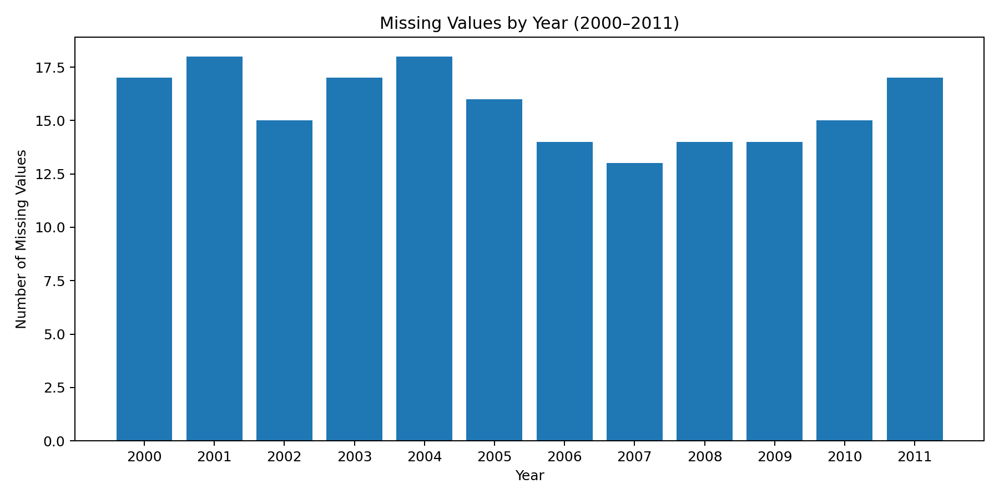
Missing observations are present throughout 2000–2011, which supports the need for an explicit missing-value treatment.

Figure 2. Distribution of 2010 fertility rates
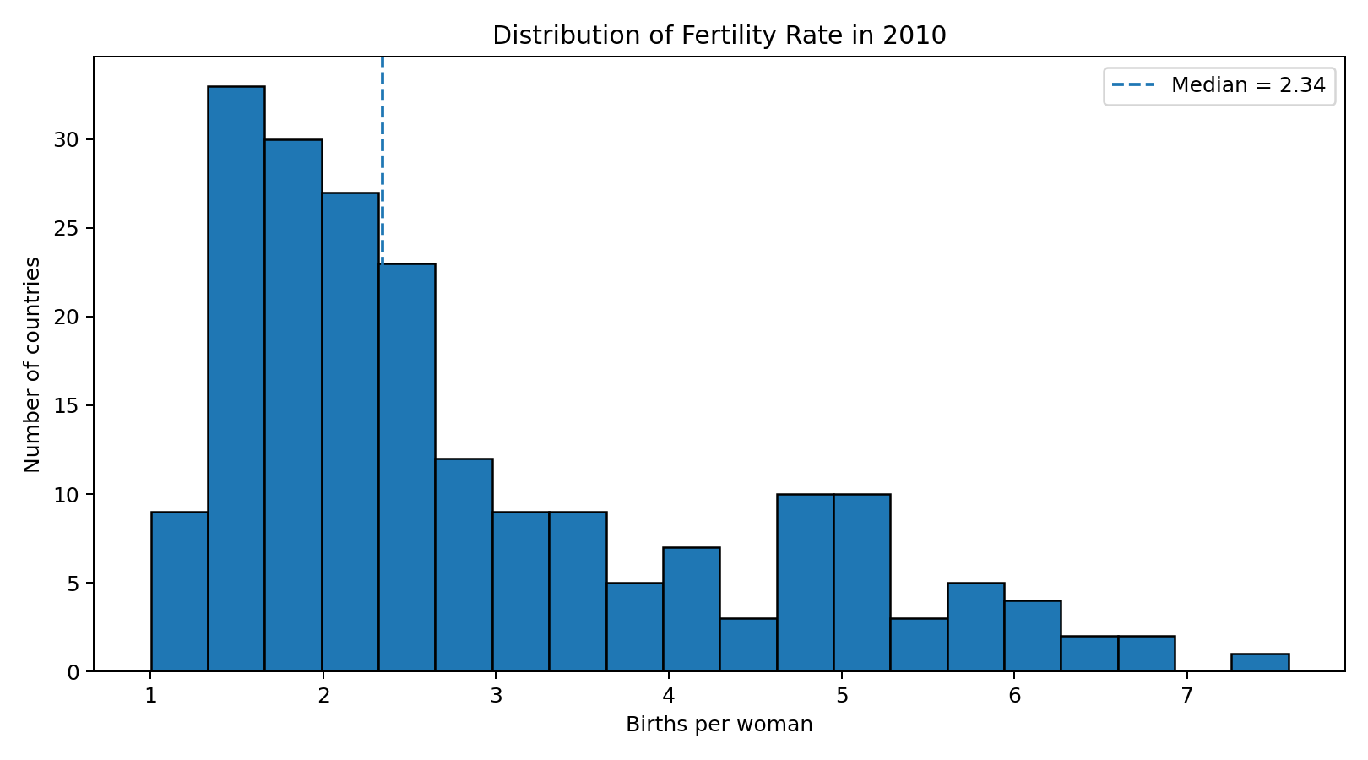
The distribution is right-skewed, with most countries below the high values seen in a small number of countries.

Figure 3. 2010 boxplot and outlier detection
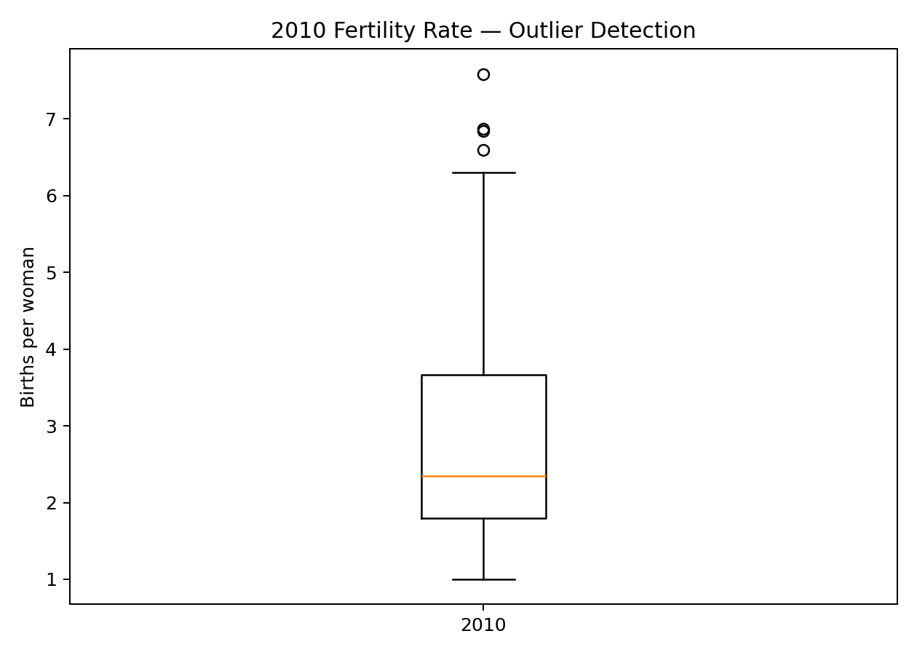
The boxplot highlights the unusually high 2010 values that were identified using the IQR rule.

Figure 4. Top 10 fertility rates in 2010
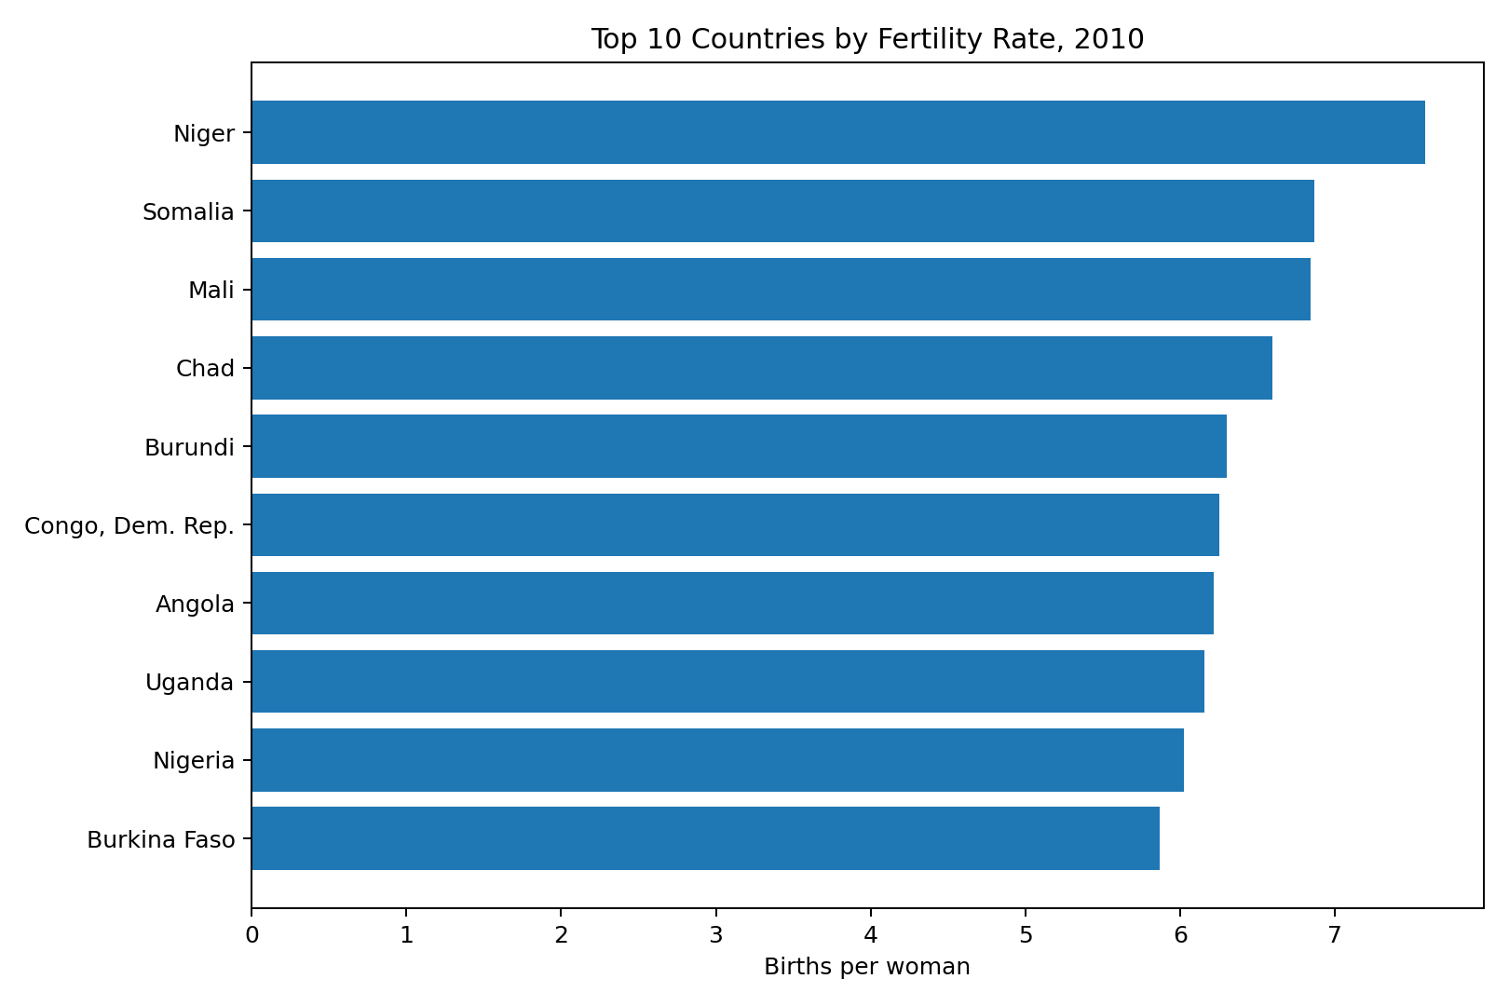
Niger has the highest observed 2010 fertility rate in the working data, followed by Somalia, Mali and Chad.

Figure 5. Average fertility-rate trend
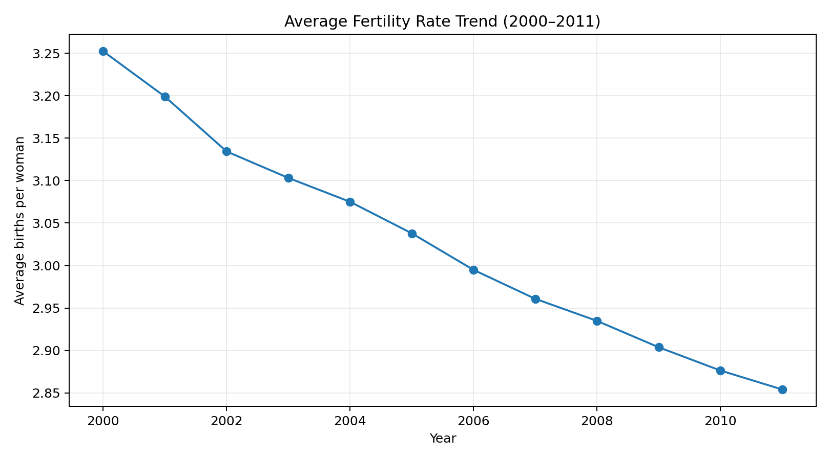
The average rate falls steadily from 2000 to 2011, showing a broad downward trend.

Figure 6. Lowest fertility rates in 2010
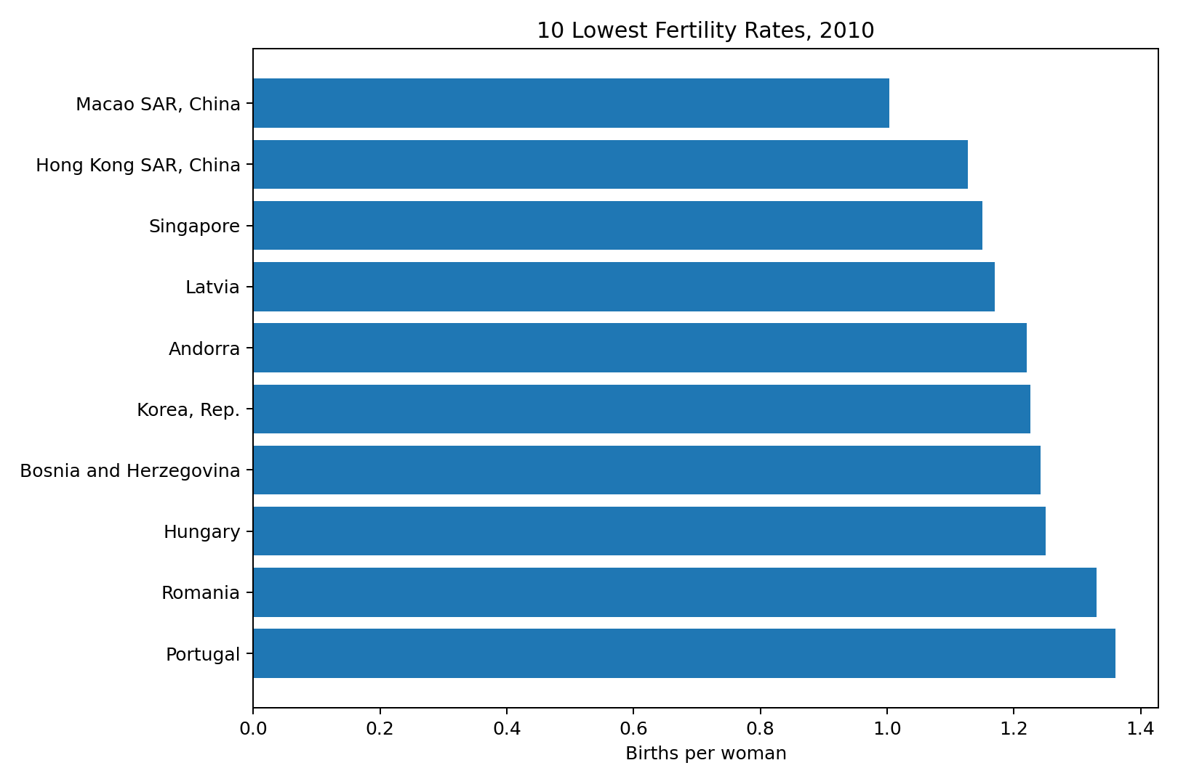
The lowest observed values are concentrated around or below 1.5 births per woman in several economies.

7. Descriptive Statistics and Initial Insights

7.1 2010 descriptive statistics
For the 204 countries/economies with observed 2010 values, the mean fertility rate was 2.876 births per woman and the median was 2.344. The difference between the mean and median is another sign that high-fertility observations create a right tail.

Top 10 countries/economies by observed 2010 fertility rate
Country Name | Country Code | 2010
Niger | NER | 7.584
Somalia | SOM | 6.869
Mali | MLI | 6.841
Chad | TCD | 6.596
Burundi | BDI | 6.304
Congo, Dem. Rep. | COD | 6.251
Angola | AGO | 6.218
Uganda | UGA | 6.155
Nigeria | NGA | 6.022
Burkina Faso | BFA | 5.869

Bottom 10 countries/economies by observed 2010 fertility rate
Country Name | Country Code | 2010
Macao SAR, China | MAC | 1.003
Hong Kong SAR, China | HKG | 1.127
Singapore | SGP | 1.150
Latvia | LVA | 1.170
Andorra | AND | 1.220
Korea, Rep. | KOR | 1.226
Bosnia and Herzegovina | BIH | 1.242
Hungary | HUN | 1.250
Romania | ROU | 1.330
Portugal | PRT | 1.360

7.2 Trend analysis
Year | Mean | Missing
2000.000 | 3.252 | 17.000
2001.000 | 3.199 | 18.000
2002.000 | 3.134 | 15.000
2003.000 | 3.103 | 17.000
2004.000 | 3.075 | 18.000
2005.000 | 3.038 | 16.000
2006.000 | 2.995 | 14.000
2007.000 | 2.961 | 13.000
2008.000 | 2.935 | 14.000
2009.000 | 2.904 | 14.000
2010.000 | 2.876 | 15.000
2011.000 | 2.854 | 17.000

The average fertility rate declined from 3.252 in 2000 to 2.876 in 2010 and 2.854 in 2011. Using the observed values, the 2000-to-2010 change in the country-level mean is about −0.376 births per woman. This is an initial descriptive result, not a causal conclusion.

7.3 Correlation
The correlation between 2010 and 2011 fertility rates is approximately 0.9995. This very high value indicates that countries with relatively high fertility in 2010 generally remained relatively high in 2011, while countries with lower values also tended to remain lower. Correlation does not prove causation, but it is useful evidence of short-term stability in the indicator.
cor(data[, c("2010", "2011")], use = "complete.obs")

8. Key Initial Insights
- The dataset needs cleaning before analysis because missing observations occur across multiple years.
- The 2010 fertility-rate distribution is right-skewed, so median-based missing-value replacement is more robust than simply using the mean.
- Four observed 2010 values were flagged as high outliers by the IQR method: Niger, Somalia, Mali and Chad.
- The average fertility rate shows a steady downward movement between 2000 and 2011 in this dataset snapshot.
- Low, medium and high fertility groups provide an easy categorical summary: 72 low, 77 medium and 70 high after the cleaning workflow.
- The strong 2010–2011 correlation suggests short-term persistence in country-level fertility patterns.
These are descriptive findings only. The task is focused on cleaning and preliminary analysis rather than advanced causal modelling, prediction or policy evaluation.

9. Data Quality and Methodological Decisions
- Completely empty columns were removed rather than fabricated.
- Numeric year columns were explicitly converted to numeric form before analysis.
- Missing numeric observations were filled using the median of the corresponding year.
- Outlier detection was performed before imputation so missing values did not create artificial outlier flags.
- Outliers were flagged, not automatically deleted, because unusually high fertility can represent genuine country-level conditions.
- Normalization was applied after cleaning to produce a comparable 0–1 measure.
- Categorical encoding was included to demonstrate an R-ready representation of categorical variables.

10. Limitations
- The dataset snapshot supplied through statsmodels contains 2012 and 2013 columns that are completely missing, so this report does not analyse those years.
- Median imputation is simple and useful for this assignment, but it can reduce natural variation and is not a substitute for a more advanced multiple-imputation approach.
- The analysis is descriptive and does not establish causal relationships between fertility and social or economic factors.
- Country Code integer encoding is only a representation of a category; the numeric code itself has no statistical meaning.
- The World Bank indicator is country-level and does not capture differences within countries or individual-level fertility behaviour.

11. Conclusion
This Week 1 task demonstrates a complete R-oriented workflow from raw data inspection to cleaning and preliminary analysis. The dataset was checked for structure and missingness, fully empty columns were removed, numeric missing values were handled with median imputation, outliers were identified with the IQR rule, 2010 values were normalized, and categorical variables were encoded. The exploratory analysis then used descriptive statistics, rankings, correlations and visualizations to produce initial insights.
Overall, the data shows a broad decline in average fertility rates between 2000 and 2011, while a small number of countries remain at much higher levels. The workflow creates a cleaner and more consistent dataset that can be used for deeper analysis in a later task.

12. References
1. World Bank. Fertility rate, total (births per woman), World Development Indicators. Indicator code: SP.DYN.TFRT.IN.
2. statsmodels documentation. World Bank Fertility Data. The documentation identifies the dataset as World Bank Fertility Rate data and describes its wide-format structure.
3. R Core Documentation. Base R functions used in this project include read.csv(), summary(), str(), median(), quantile(), IQR(), cut(), factor(), model.matrix(), cor(), hist(), boxplot(), plot() and write.csv().

13. Appendix – R Code and Output Evidence
The complete executable script is provided separately as Week1_Data_Cleaning_Preliminary_Analysis.R. The following snippets show the main methods used in the report.
raw <- read.csv("world_bank_fertility.csv", stringsAsFactors = FALSE, check.names = FALSE)
all_missing_cols <- names(raw)[sapply(raw, function(x) all(is.na(x)))]
data <- raw[, !(names(raw) %in% all_missing_cols)]
observed_2010 <- data$`2010`[!is.na(data$`2010`)]
Q1 <- quantile(observed_2010, .25)
Q3 <- quantile(observed_2010, .75)
IQR_value <- IQR(observed_2010)
lower_bound <- Q1 - 1.5 * IQR_value
upper_bound <- Q3 + 1.5 * IQR_value
for (col in year_cols) {
med <- median(data[[col]], na.rm = TRUE)
data[[col]][is.na(data[[col]])] <- med
}
data$fertility_2010_normalized <-
(data$`2010` - min(data$`2010`)) /
(max(data$`2010`) - min(data$`2010`))
data$fertility_group <- cut(data$`2010`,
breaks=c(-Inf,2,3,Inf),
labels=c("Low (<2)","Medium (2-3)","High (>3)"))
data$country_code_encoded <- as.integer(factor(data$`Country Code`))
Key output values:
- 2010 observed count = 204; missing count = 15.
- 2010 mean = 2.876; median = 2.344; standard deviation = 1.473.
- 2010 IQR = 1.865; upper outlier bound = 6.462; four high outliers were flagged.
- 2010–2011 correlation ≈ 0.9995.
- Average fertility declined from 3.252 in 2000 to 2.876 in 2010.
End of report.

