Predictive Modeling and Performance Evaluation
Predicting Online Shopper Purchase Intention using Python
Week 4 Task Report
Dataset: Online Shoppers Purchasing Intention | Tools: Python, pandas, scikit-learn

1. Introduction and Objective
This report documents the development and evaluation of a predictive model that estimates whether an online shopping session will end in a purchase. Predicting purchase intention is valuable for e-commerce businesses because it helps them target discounts, personalise content and allocate marketing spend to the sessions most likely to convert.
Problem type: binary classification. The target variable is Revenue (1 = the session ended in a purchase, 0 = it did not).

2. Dataset Selection and Description
The Online Shoppers Purchasing Intention dataset was selected because it is a public, real-world behavioural dataset with a clear business target and a mix of numeric and categorical features. It contains 12,330 sessions and 18 columns. Each row is one user session, and no user appears in more than one session. Of all sessions, 1,908 (15.47%) ended in a purchase, so the classes are imbalanced.
Feature group | Columns
Page-visit counts and durations | Administrative, Informational, ProductRelated and their *_Duration columns
Google Analytics metrics | BounceRates, ExitRates, PageValues
Calendar | SpecialDay, Month, Weekend
Visitor and technical info | VisitorType, OperatingSystems, Browser, Region, TrafficType
Target | Revenue (True/False)

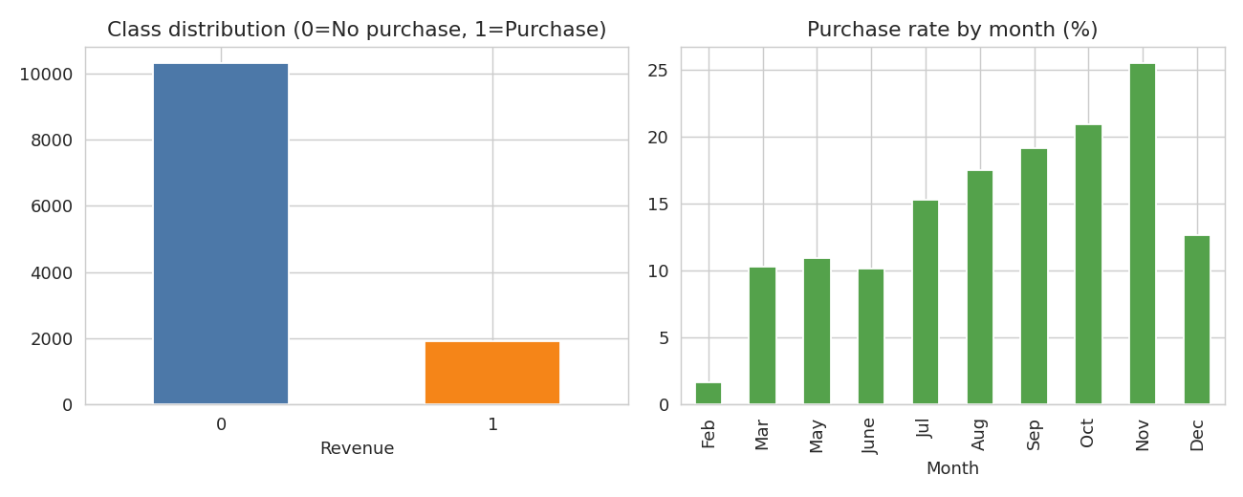
Figure 1: Class distribution and purchase rate by month
The left chart confirms the class imbalance. The right chart shows that purchase rates vary strongly by month, with November being the highest. The dataset has no sessions for January and April.
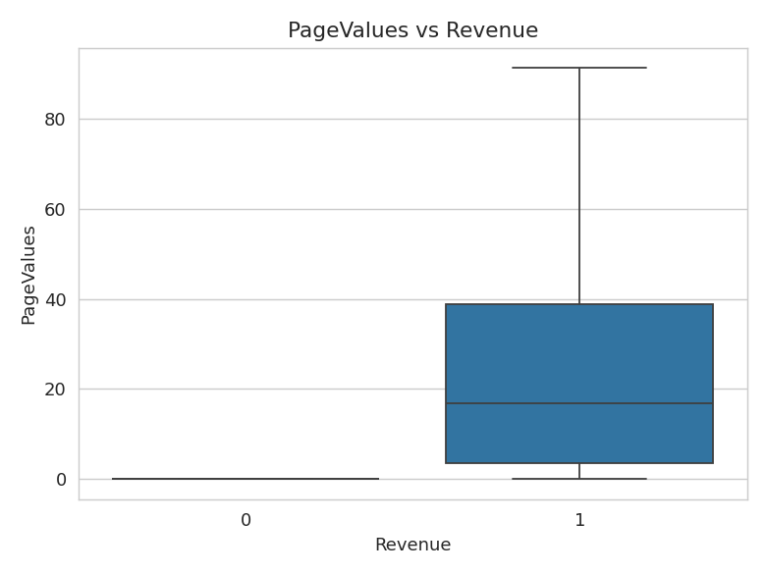
Figure 2: PageValues for purchasing and non-purchasing sessions
PageValues is clearly higher for sessions that ended in a purchase, which suggests it will be an influential predictor.

3. Data Preprocessing and Feature Engineering

3.1 Preprocessing steps
- Missing values: none were found in the dataset, so no imputation was required.
- Duplicates: 125 fully duplicated rows were removed, leaving 12,205 rows.
- Type conversion: Revenue and Weekend were converted from boolean to integer. OperatingSystems, Browser, Region and TrafficType are numeric codes with no order, so they were treated as categorical.
- Encoding: categorical columns (Month, VisitorType, OperatingSystems, Browser, Region, TrafficType) were one-hot encoded.
- Scaling: numeric columns were standardised with StandardScaler for Logistic Regression only. Tree-based models do not need scaling.
- Train/test split: 80/20 stratified split (random_state=42): 9,764 training and 2,441 test rows. Stratification keeps the purchase rate the same in both sets.

3.2 Feature engineering
Three new features were created to summarise overall session behaviour:
- TotalPages: Administrative + Informational + ProductRelated
- TotalDuration: sum of the three duration columns
- AvgTimePerPage: TotalDuration / TotalPages (set to 0 when a session has no pages)
df['TotalPages'] = df.Administrative + df.Informational + df.ProductRelated
df['TotalDuration'] = (df.Administrative_Duration + df.Informational_Duration
+ df.ProductRelated_Duration)
df['AvgTimePerPage'] = (df.TotalDuration / df.TotalPages.replace(0, np.nan)).fillna(0)

4. Methodology and Model Selection
Three classification models were trained and compared. They were chosen to cover a simple interpretable baseline and two stronger non-linear ensembles:
- Logistic Regression: a linear baseline that is fast and easy to interpret. It uses class_weight='balanced' to handle the imbalance.
- Random Forest: 300 trees, also with class_weight='balanced'. It captures non-linear interactions and is robust to outliers.
- Gradient Boosting: builds trees sequentially, each correcting the previous errors. It often gives the best accuracy on tabular data.
All preprocessing and modelling steps were wrapped in a scikit-learn Pipeline, so that scaling and encoding are fitted only on training data and no information leaks from the test set.
pre = ColumnTransformer([('n', StandardScaler(), num),
('c', OneHotEncoder(handle_unknown='ignore'), cat)])
model = Pipeline([('p', pre), ('m', GradientBoostingClassifier(random_state=42))])

X_tr, X_te, y_tr, y_te = train_test_split(X, y, test_size=0.2,
stratify=y, random_state=42)
cv = StratifiedKFold(5, shuffle=True, random_state=42)
cv_f1 = cross_val_score(model, X_tr, y_tr, cv=cv, scoring='f1').mean()
model.fit(X_tr, y_tr)
proba = model.predict_proba(X_te)[:, 1]

5. Training Process and Evaluation Metrics
Each model was trained on the training set and evaluated with 5-fold stratified cross-validation (F1) and on the held-out test set. Because only about 15% of sessions are purchases, accuracy alone is misleading: a model that always predicts "no purchase" would already score about 85%. The following metrics are therefore reported:
- Accuracy: share of all predictions that are correct.
- Precision: of the sessions predicted as purchases, how many really were.
- Recall: of the real purchases, how many the model found.
- F1-score: harmonic mean of precision and recall.
- ROC-AUC: how well the model ranks buyers above non-buyers across all thresholds.

6. Performance Summary
Model | Accuracy | Precision | Recall | F1 | ROC-AUC | CV F1 (5-fold)
Logistic Regression | 0.847 | 0.507 | 0.796 | 0.619 | 0.910 | 0.607
Random Forest | 0.897 | 0.748 | 0.513 | 0.609 | 0.922 | 0.601
Gradient Boosting | 0.903 | 0.711 | 0.639 | 0.673 | 0.936 | 0.652
Gradient Boosting (threshold 0.35) | 0.897 | 0.655 | 0.720 | 0.686 | 0.936 | -
Table 1: Test-set performance (default threshold 0.5 unless stated)
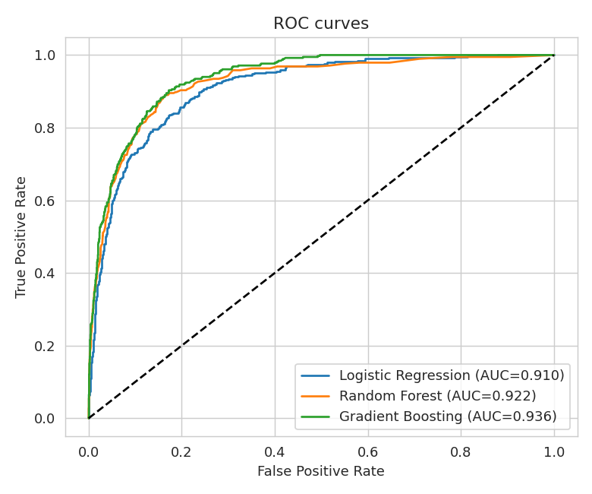
Figure 3: ROC curves of the three models

6.1 Threshold tuning for the best model
Gradient Boosting had the highest ROC-AUC (0.936) and cross-validated F1 (0.652), so it was selected as the final model. Its default decision threshold of 0.5 favours precision over recall. Since missing a real buyer is usually more costly than showing an offer to a non-buyer, the threshold was varied to find the best balance.
Threshold | Precision | Recall | F1
0.1 | 0.484 | 0.906 | 0.631
0.2 | 0.569 | 0.819 | 0.672
0.3 | 0.630 | 0.743 | 0.682
0.35 | 0.655 | 0.720 | 0.686
0.4 | 0.670 | 0.702 | 0.685
0.5 | 0.711 | 0.639 | 0.673
0.6 | 0.791 | 0.534 | 0.637
Table 2: Precision, recall and F1 at different thresholds (Gradient Boosting)
A threshold of 0.35 gave the highest F1 (0.686). At this threshold the model identifies 72.0% of real buyers with 65.5% precision, and accuracy is 89.7%.
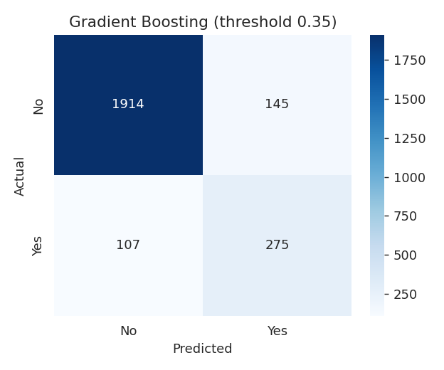
Figure 4: Confusion matrix of the final model on the test set
Of 382 real purchases in the test set, 275 were detected (true positives) and 107 were missed (false negatives). Of 2059 non-purchasing sessions, 1914 were correctly identified and 145 were wrongly flagged as purchases (false positives).

7. Results Discussion

7.1 Model comparison
- Logistic Regression has high recall (0.796) but low precision (0.507), because class balancing makes it flag many sessions as purchases. This also lowers its accuracy to 0.847.
- Random Forest has high precision (0.748) but misses almost half of the buyers (recall 0.513).
- Gradient Boosting gives the best overall balance and ranking quality, and its advantage is consistent in both the cross-validation and test results.

7.2 Important features
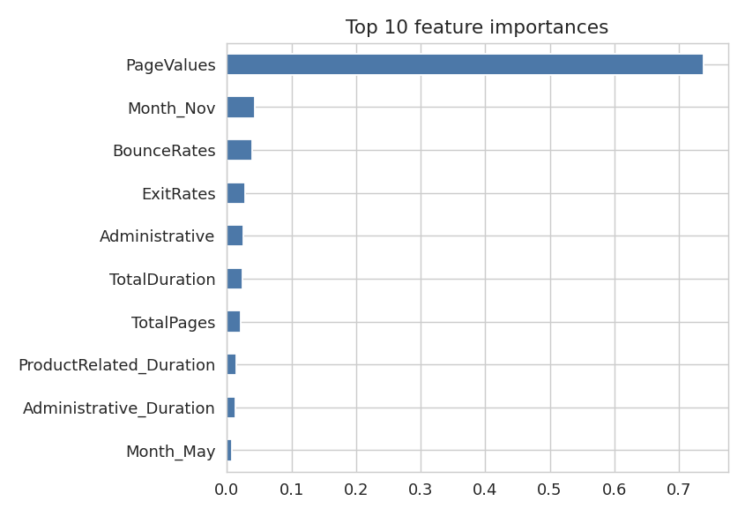
Figure 5: Top 10 feature importances (Gradient Boosting)
PageValues dominates the model with an importance of 0.74, far ahead of every other feature. This matches Figure 2: sessions that visit pages that typically precede a transaction are far more likely to convert. Other useful signals are the month (November), BounceRates, ExitRates and the overall amount of browsing (TotalDuration, TotalPages, Administrative). The engineered features TotalDuration and TotalPages both appear among the top features, which supports the feature-engineering step.

8. Limitations and Areas for Improvement
- Threshold chosen on the test set: the best threshold was picked using the test data, so the tuned numbers are slightly optimistic. A separate validation set, or choosing the threshold inside cross-validation, would give an unbiased estimate.
- No hyperparameter tuning: models used mostly default settings. GridSearchCV or RandomizedSearchCV on learning rate, depth and number of trees could improve F1.
- Class imbalance: techniques such as SMOTE, class weights for boosting, or cost-sensitive learning could improve recall.
- PageValues dependence: the model relies heavily on one feature. In a real deployment, PageValues may not be available early in a session, so a model without it should also be tested.
- Other models: XGBoost, LightGBM or a stacked ensemble could be compared.
- Limited calendar coverage: the data has no January or April sessions and covers a single period, so seasonal behaviour may not generalise.

9. Conclusion
A complete predictive pipeline was built for online shopper purchase intention, covering data cleaning, feature engineering, model comparison and evaluation. Gradient Boosting performed best with ROC-AUC 0.936. After threshold tuning it reached F1 0.686, recall 0.720, precision 0.655 and accuracy 0.897. The results show that session behaviour, especially PageValues, can predict purchases reliably, and the model can be improved further with tuning and imbalance handling.
The complete Python script used for this report is provided separately as week4_predictive_model.py.

