STATISTICAL ANALYSIS
AND PREDICTIVE MODELING
Using R | Week 3 Project

Predicting US Health Insurance Charges

Prepared as a practical statistical analysis and regression modeling project
Dataset: Medical Cost Personal Dataset (1,338 records)

Tools: R, ggplot2, dplyr, caret, broom

1. Executive Summary
This project analyses 1,338 health insurance records to understand how demographic and lifestyle-related variables are associated with billed insurance charges. The target variable is charges, while age, sex, body mass index (BMI), number of children, smoking status and region are used as predictors. The workflow includes data-quality checks, descriptive statistics, exploratory visualizations, a hypothesis test, correlation analysis, multiple linear regression, holdout evaluation, cross-validation and diagnostic review.
The average charge in the supplied dataset is $13,270.42, while the median is $9,382.03. Smokers have a mean charge of $32,050.23, compared with $8,434.27 for non-smokers. This difference is large in practical terms and is tested formally in the analysis. The regression model provides a baseline prediction, but the diagnostics and limitations must be considered before using it for any real-world decision.

2. Objectives
- Inspect the dataset structure, data types, missing values and duplicate records.
- Summarize the distributions of age, BMI, children and insurance charges.
- Explore relationships between insurance charges and the available predictors.
- Test whether average insurance charges differ between smokers and non-smokers.
- Build a multiple linear regression model to predict insurance charges.
- Evaluate predictive performance using a holdout test set and five-fold cross-validation.
- Review model diagnostics and identify practical limitations and improvements.

3. Dataset Identification and Rationale
The dataset is a publicly available health insurance cost dataset commonly distributed as the Medical Cost Personal Dataset. It contains 1,338 observations and seven columns. It is suitable for this task because the target variable, charges, is numeric and continuous, making regression an appropriate starting point. The predictor set includes both numeric and categorical variables, which also demonstrates how R handles factors in a regression model.
Variable | Type | Description
age | Numeric | Age of the primary beneficiary, in years
sex | Categorical | Recorded sex category
bmi | Numeric | Body mass index
children | Numeric integer | Number of dependent children covered
smoker | Categorical | Smoking status: yes or no
region | Categorical | US residential region
charges | Numeric target | Medical insurance charges billed, in USD
Public source: Kaggle, Medical Cost Personal Dataset. Dataset documentation also describes 1,338 observations and these seven variables.
Source link: https://www.kaggle.com/datasets/mirichoi0218/insurance

4. Data Quality and Preparation
The supplied file contains 1,338 rows and 7 columns. The initial check found 0 missing cells and 1 exact duplicate rows. Categorical fields are trimmed and converted to factors in R. Exact duplicate rows are removed only if found, and a cleaned CSV is saved. No artificial values are inserted into the data.
Data quality checks include: dataset dimensions, column types, summary statistics, missing-value counts, duplicate-row count and valid categorical levels. Since the supplied file has no missing values, imputation is not required.

5. Exploratory Statistical Analysis
The numeric summary shows a mean age of 39.21 years, mean BMI of 30.66, and mean insurance charge of $13,270.42. Charges vary from $1,121.87 to $63,770.43, indicating a wide range and a right-skewed distribution.
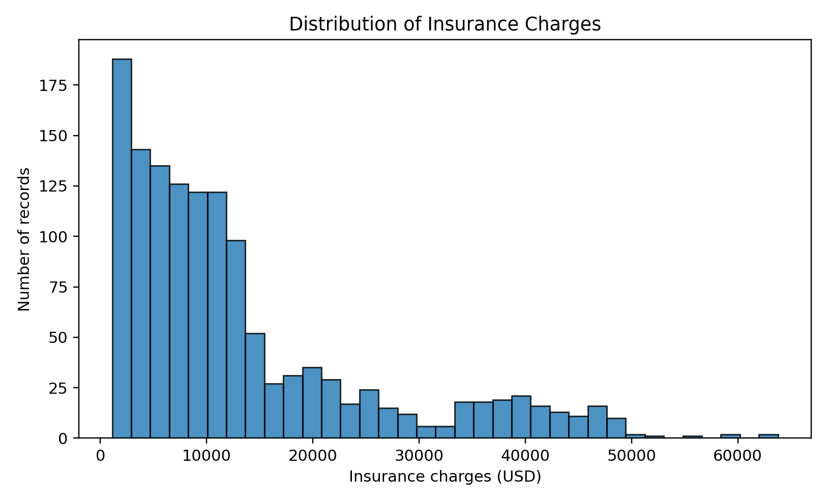
Figure 1. Distribution of billed insurance charges. The long upper tail indicates that a small number of records have very high charges.
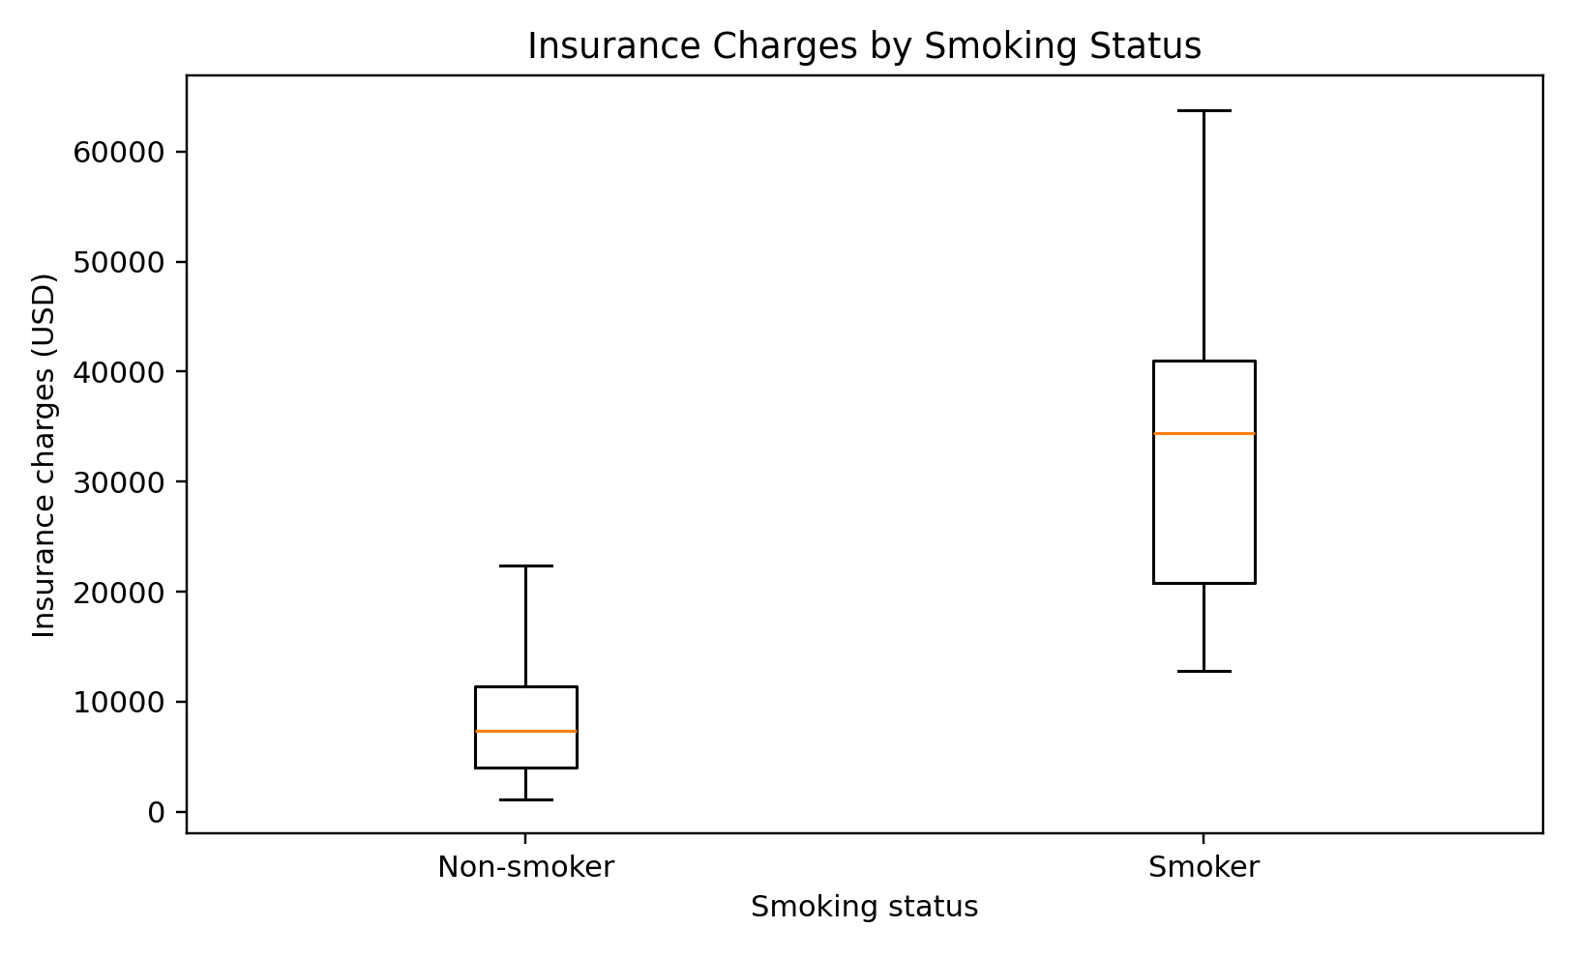
Figure 2. Charges by smoking status. The distribution for smokers is substantially higher than for non-smokers.
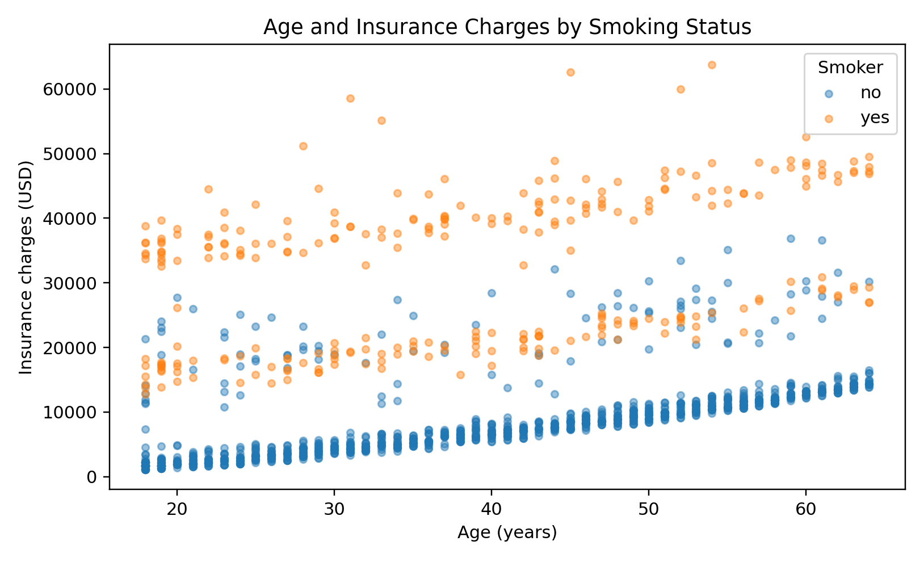
Figure 3. Age and charges, with smoking status indicated by point grouping.
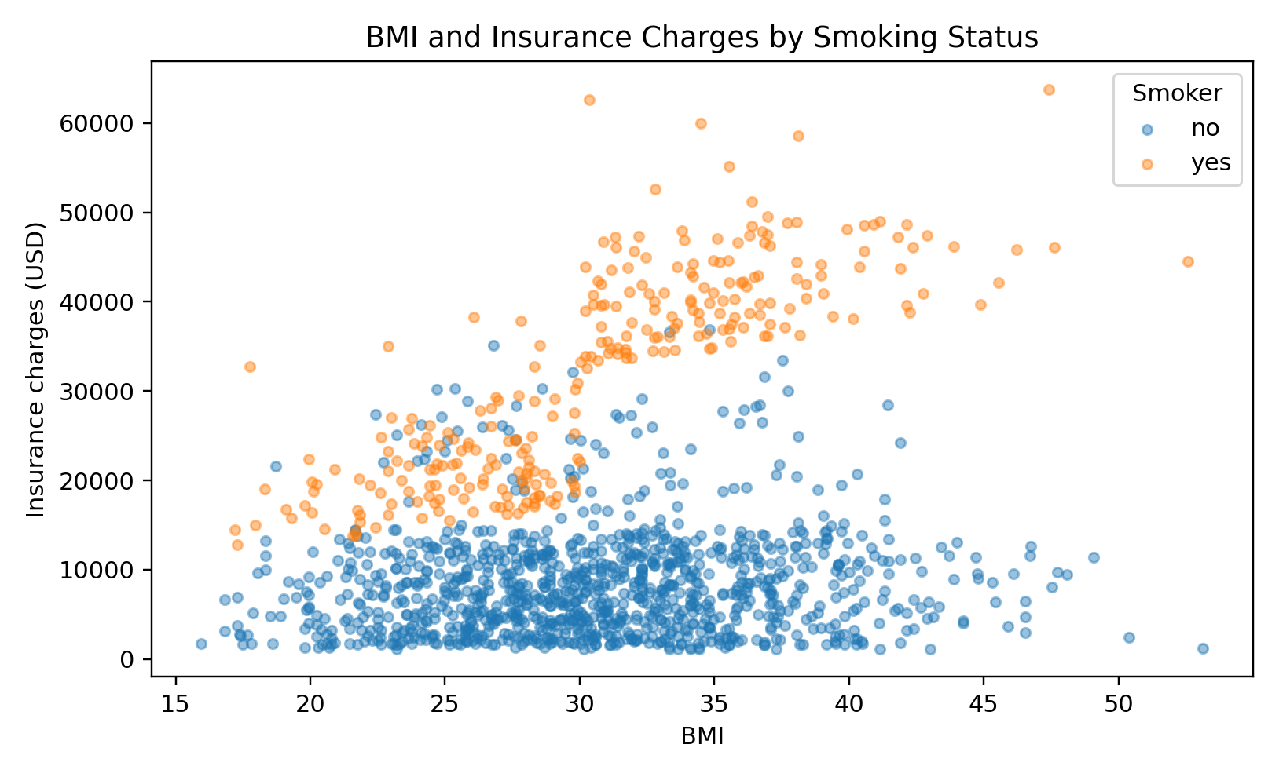
Figure 4. BMI and charges, separated visually by smoking status.
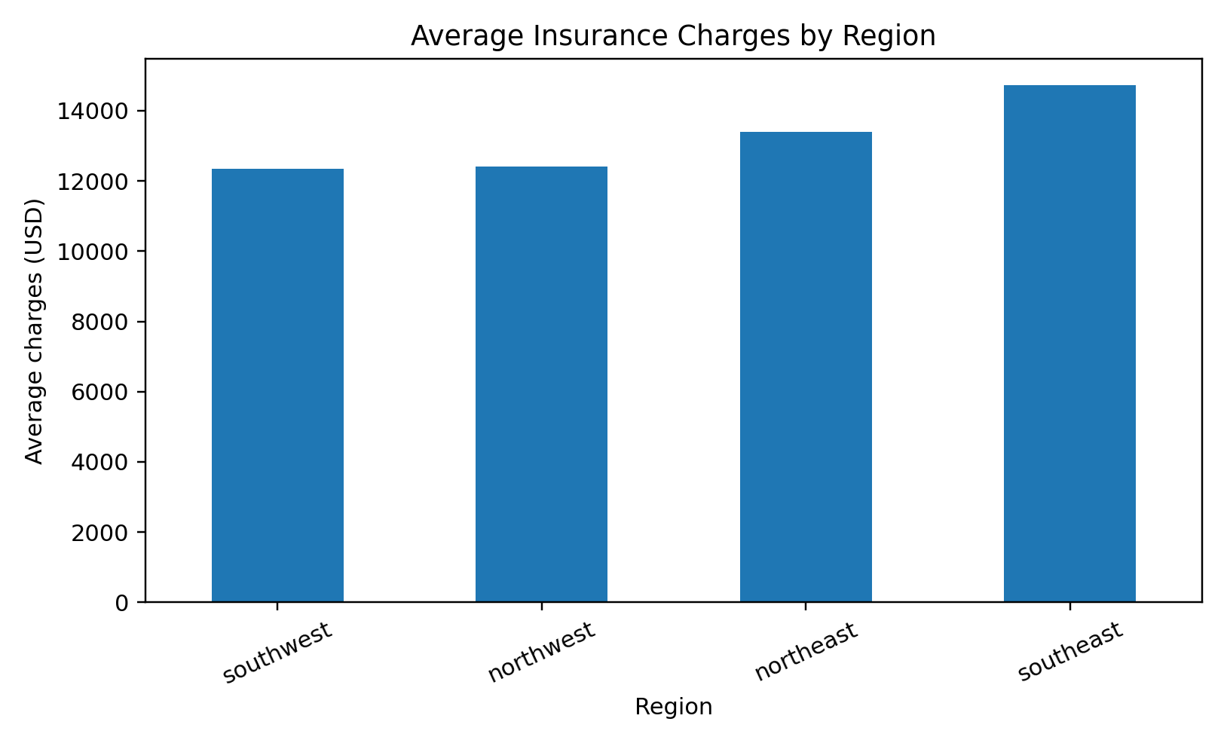
Figure 5. Average charges by region. Regional differences should be interpreted alongside other predictors rather than as evidence of a causal effect.

6. Hypothesis Testing
Research question: Do mean insurance charges differ between smokers and non-smokers?
Null hypothesis (H0): The population mean charges are equal for smokers and non-smokers.
Alternative hypothesis (H1): The population mean charges differ between smokers and non-smokers.
A Welch two-sample t-test was selected because it compares two independent group means without assuming equal population variances. The sample mean for smokers is $32,050.23; the sample mean for non-smokers is $8,434.27. The observed mean difference (smoker minus non-smoker) is $23,615.96. The test statistic is 32.75 and the p-value is 5.89e-103. At the 5% significance level, the null hypothesis is rejected; the sample provides strong evidence of a difference in mean charges.
A statistically significant result does not prove smoking alone causes the difference. Other variables and potential confounding factors may contribute.

7. Correlation Analysis
Pearson correlation between age and charges is 0.299; between BMI and charges it is 0.198. Correlation describes linear association between numeric variables and does not establish causation. Categorical variables are assessed through group comparisons and are included as factors in the regression.
The exact numeric correlation matrix is also provided as a CSV output.

8. Predictive Model and Validation
A multiple linear regression model is used because charges is continuous. The model includes age, sex, BMI, children, smoking status and region. R's lm() function automatically treats factor predictors as categorical variables and estimates the corresponding coefficients relative to reference levels.
The data are split into 80% training and 20% testing records using a fixed random seed. The model is fitted on training data and evaluated on held-out data. Five-fold cross-validation is also run to estimate how performance varies across different folds. The R script creates the official R outputs when run locally.
Metric | Result (reference analysis) | Interpretation
Test MAE | $4,181.19 | Average absolute prediction error; lower is better.
Test RMSE | $5,796.28 | Penalizes larger errors more heavily; lower is better.
Test R-squared | 0.784 | Proportion of test-set variation explained by predictions; closer to 1 is better.
Five-fold cross-validation reference results: mean RMSE $6,077.23 (SD $287.22), mean MAE $4,203.41, and mean R-squared 0.740. These reference figures are calculated with a deterministic Python implementation to give the report concrete initial results; the submitted R script independently fits and reports the model using R's functions, so small metric differences can occur because of split and implementation details.
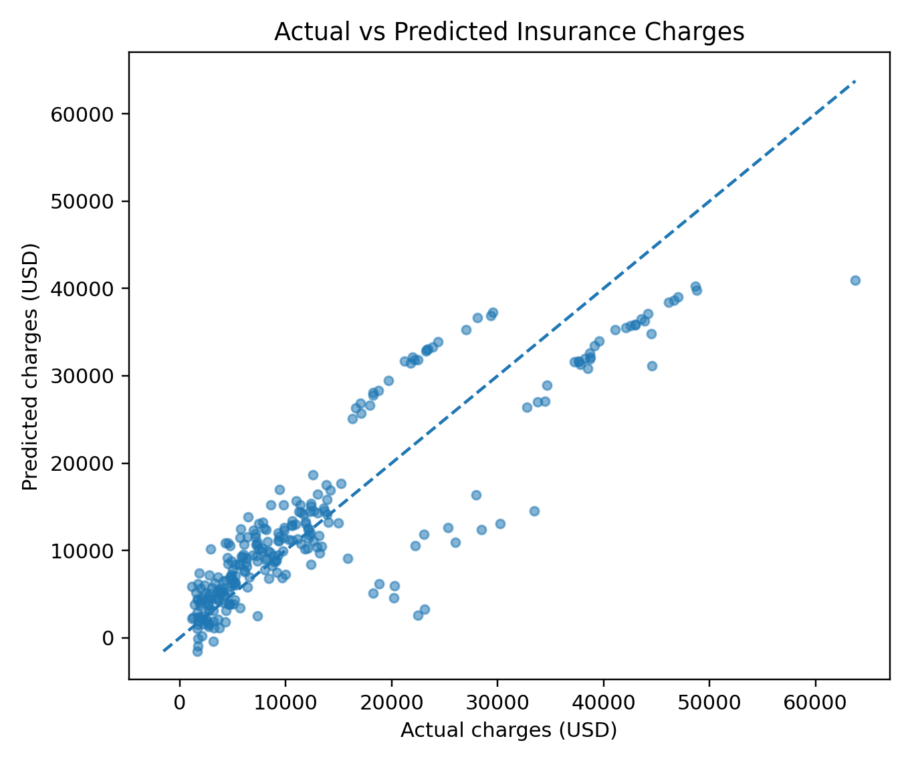
Figure 6. Actual versus predicted charges for the held-out test records. Points closer to the dashed diagonal indicate more accurate predictions.

9. Model Diagnostics
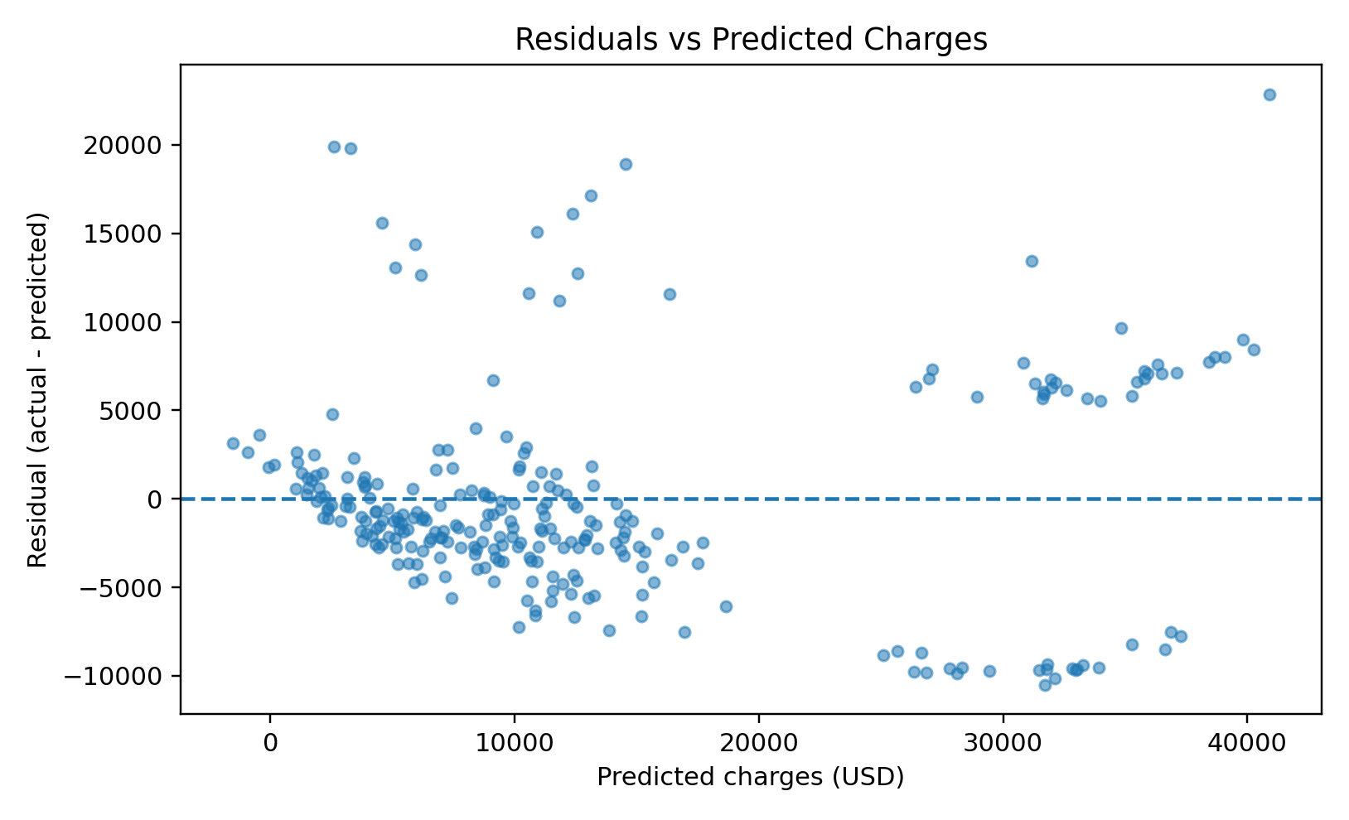
Figure 7. Residuals versus predicted charges. A desirable pattern is random scatter around zero. Curvature or a funnel shape can indicate non-linearity or unequal residual variance.
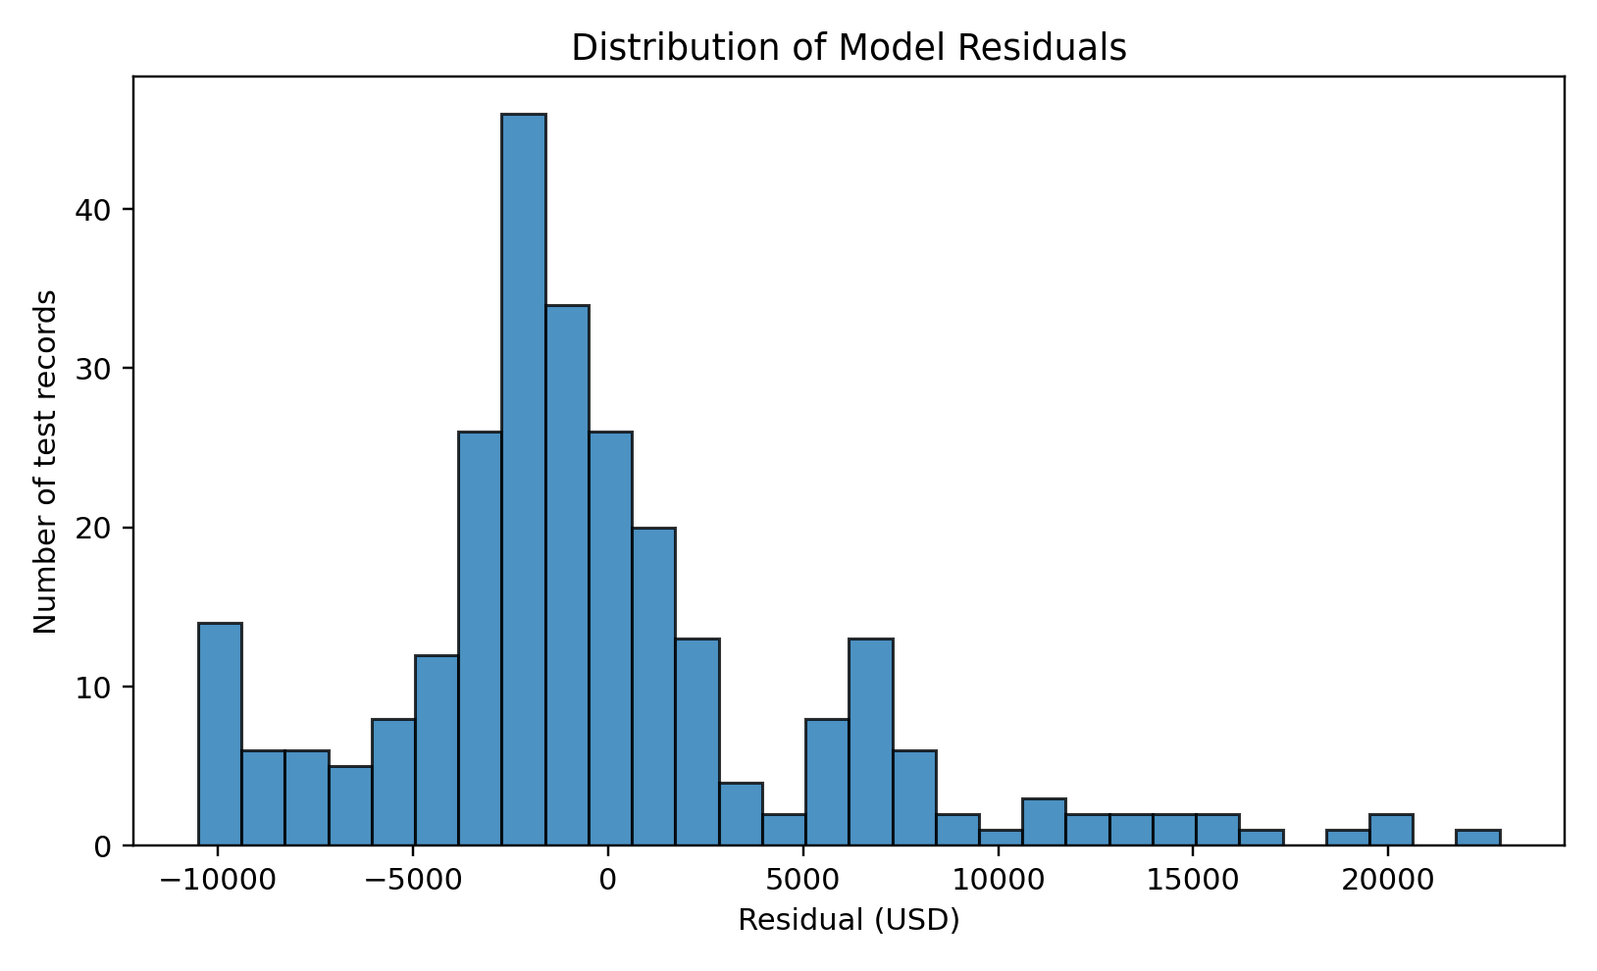
Figure 8. Residual distribution. Residual normality is mainly relevant to classical inference; prediction quality should be judged using held-out metrics and diagnostics together.
The standard R diagnostic plots are generated by plot(model). Review residuals versus fitted values, the normal Q-Q plot, scale-location and residuals versus leverage. Insurance charges include high-cost observations, so residuals may be non-normal and prediction errors may be larger for extreme cases. The script also runs an optional Shapiro-Wilk check; its p-value should not be interpreted in isolation.

10. Strengths, Limitations and Improvements
- Strength: the dataset is structured, public, and has a clear continuous target variable.
- Strength: the workflow combines descriptive analysis, formal hypothesis testing, regression and validation.
- Limitation: the dataset is observational and cannot establish causal relationships.
- Limitation: a linear model may not fully capture non-linear effects or interactions, especially between BMI and smoking status.
- Limitation: the dataset may not represent all countries, insurers, time periods or customer populations.
- Improvement: test interaction terms such as smoker × BMI and compare with regularized regression or tree-based models.
- Improvement: consider log-transforming charges or using robust regression if residual diagnostics show strong skew or heteroscedasticity.
- Improvement: retain a final untouched test set when comparing many model variants to reduce overfitting to evaluation results.

11. Conclusion
This analysis demonstrates an end-to-end statistical modeling workflow using the public insurance dataset. The descriptive results show substantial variation in billed charges, and the Welch t-test identifies a clear difference in average charges by smoking status (p = 5.89e-103). Multiple linear regression provides a useful baseline for predicting charges from the available features. Model metrics and diagnostic plots are necessary to understand both predictive accuracy and weaknesses. The results are educational and should not be used as a standalone basis for real insurance decisions.

12. Reproducibility and How to Run
- Install R from the official CRAN website and open RStudio or VS Code with an R extension.
- Extract the project ZIP and open the project root folder.
- Ensure data/insurance.csv is present.
- Run source('scripts/insurance_analysis.R') from the project root.
- Allow the script to install ggplot2, dplyr, tidyr, caret and broom if they are not installed.
- Check the outputs folder for R-generated charts, statistical tables, model metrics and diagnostics.

References
Kaggle. Medical Cost Personal Dataset. https://www.kaggle.com/datasets/mirichoi0218/insurance
R Core Team. R: A language and environment for statistical computing. https://www.r-project.org/
Wickham, H. ggplot2: Elegant Graphics for Data Analysis. https://ggplot2.tidyverse.org/
Kuhn, M. caret: Classification and Regression Training. https://topepo.github.io/caret/

