WEEK 4 FINAL PROJECT
Comprehensive Data Analysis
Reporting and Presentation
An integrated review of data cleaning, visualization, statistical analysis and predictive modelling
Submission: Week 4
Software: R / RStudio (reproducible scripts supplied)
Datasets: World Bank Fertility • ggplot2 Economics • Kaggle Medical Cost

Executive Summary
This final report brings together the work completed across Weeks 1–3 into one connected data-analysis story. Week 1 focused on cleaning country-level fertility data, Week 2 used economic time-series charts to communicate trends, and Week 3 analysed medical insurance charges and built a regression model. The purpose of Week 4 is to show how these stages connect: reliable data preparation supports useful visual analysis, and statistical modelling can add a predictive perspective when the target variable is suitable.
The Week 1 source contains 219 country records. The 2010 fertility values were checked for outliers using the 1.5×IQR rule; 4 records were flagged for review. Missing annual values for 2000–2011 were filled using the median of the corresponding year, and the cleaned dataset includes a normalized 2010 measure and fertility groups. The Week 2 report uses 574 monthly observations from July 1967 to April 2015; the previous analysis found a peak unemployment value of 15,352 thousand in October 2009 and a PCE–unemployment correlation of about 0.61. Week 3 uses the 1,338-row Kaggle insurance dataset. After removing 1 exact duplicate rows and invalid/incomplete records, 1337 observations remained for analysis. A multiple linear regression model was evaluated on a fixed 20% test sample; the independently reproduced Python validation gave MAE $4,177.05, RMSE $5,956.34, and test R² 0.807. These metrics are reported as a separate validation calculation, not as an RStudio run result.
The overall lesson is that an effective analytical report does more than list code or display attractive charts. It explains what was checked, why a method was selected, what the results mean, where uncertainty remains, and what a reader should do next. The included R workflow is designed to reproduce the analyses from the project root.

1. Introduction and Objectives
The objective of this project is to consolidate three earlier analytical tasks into one professional report. The work follows a practical sequence: inspect and prepare data, explore patterns visually, test selected relationships, build a predictive baseline, evaluate model performance, and communicate limitations and recommendations.
- Integrate the Week 1 cleaning workflow, Week 2 visual communication work, and Week 3 statistical/predictive analysis.
- Document data sources, variable meanings, quality checks, transformations, and reproducible code.
- Explain each major chart using a clear analytical question and a plain-language interpretation.
- Report statistical tests and predictive metrics without treating association as causation.
- Identify limitations and practical improvements for future analysis.

2. Project Structure and Dataset Overview
Week | Dataset | Main purpose | Key methods
1 | World Bank fertility indicator (2000–2011 analysis window) | Prepare country-level data for comparison | Missing-value review, IQR outlier flagging, median imputation, min–max normalization, grouping
2 | ggplot2::economics | Explain long-run economic patterns visually | Time-series line charts, histogram, scatter plot, decade comparison
3 | Kaggle Medical Cost Personal Dataset | Explain and predict insurance charges | Descriptive statistics, correlation, Welch t-test, multiple linear regression, holdout validation

Week 1 source file: world_bank_fertility.csv. The analysis retains Country Name and Country Code and focuses on the 2000–2011 columns. Week 2 uses the economics dataset bundled with ggplot2, so no separate CSV is needed when running the R script. Week 3 source file: insurance.csv from the Kaggle Medical Cost Personal Dataset; it contains age, sex, BMI, children, smoker, region, and charges.
Week 3 variable | Meaning | Role
age | Age in years | Predictor
sex | Recorded sex category | Categorical predictor
bmi | Body mass index | Predictor
children | Number of dependants/children | Predictor
smoker | Smoking status | Categorical predictor
region | US residential region | Categorical predictor
charges | Individual medical insurance charges (USD) | Target

3. Methodology and Data Preparation

3.1 Week 1 – Fertility data cleaning
The original file contains country identifiers, the fertility indicator metadata, and annual values across a wider period. For this project, the analysis selects the 2000–2011 period and the two country identifier fields. Missingness is summarized before imputation. Outliers in the 2010 values are flagged using the interquartile range rule; they are not automatically deleted because unusually high fertility can be a genuine country-level observation. Annual missing values are filled with the median of that year to preserve the country rows for descriptive comparison. A normalized 2010 measure is calculated using min–max scaling, and countries are grouped into low (<2), medium (2–3), and high (>3) fertility bands.
Quality item | Result / treatment
Countries in source | 219
2010 IQR lower bound | -0.997
2010 IQR upper bound | 6.462
2010 values flagged | 4
Missing-value treatment | Year-specific median imputation
Outlier treatment | Flagged and retained; interpret in context

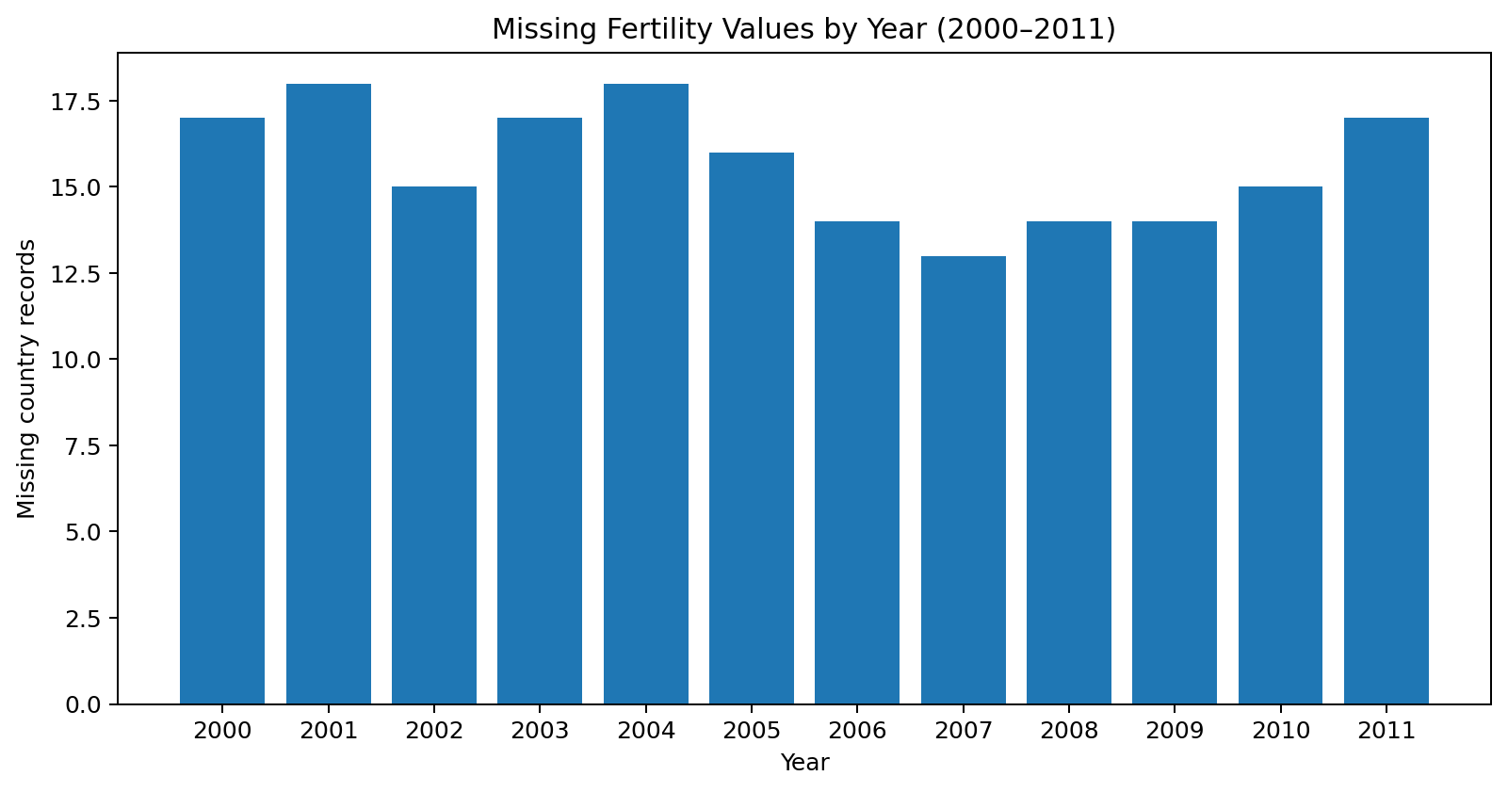
Figure 1. Missing values by year in the selected fertility period.
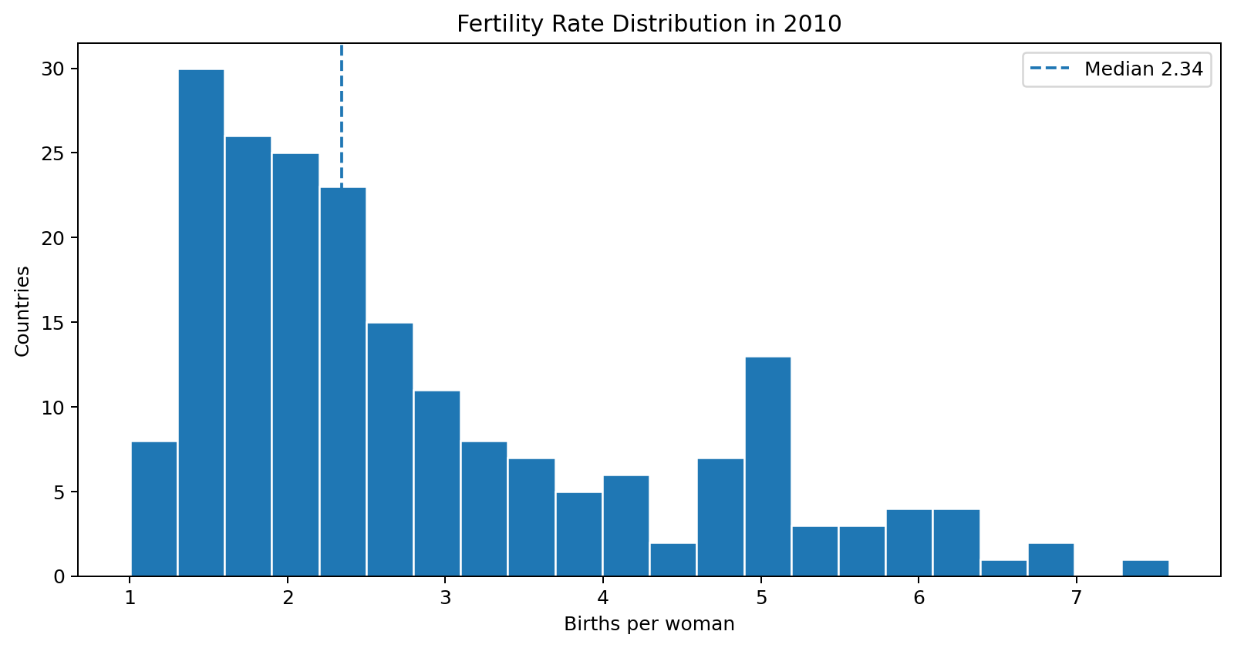
Figure 2. Distribution of observed 2010 fertility rates before imputation.
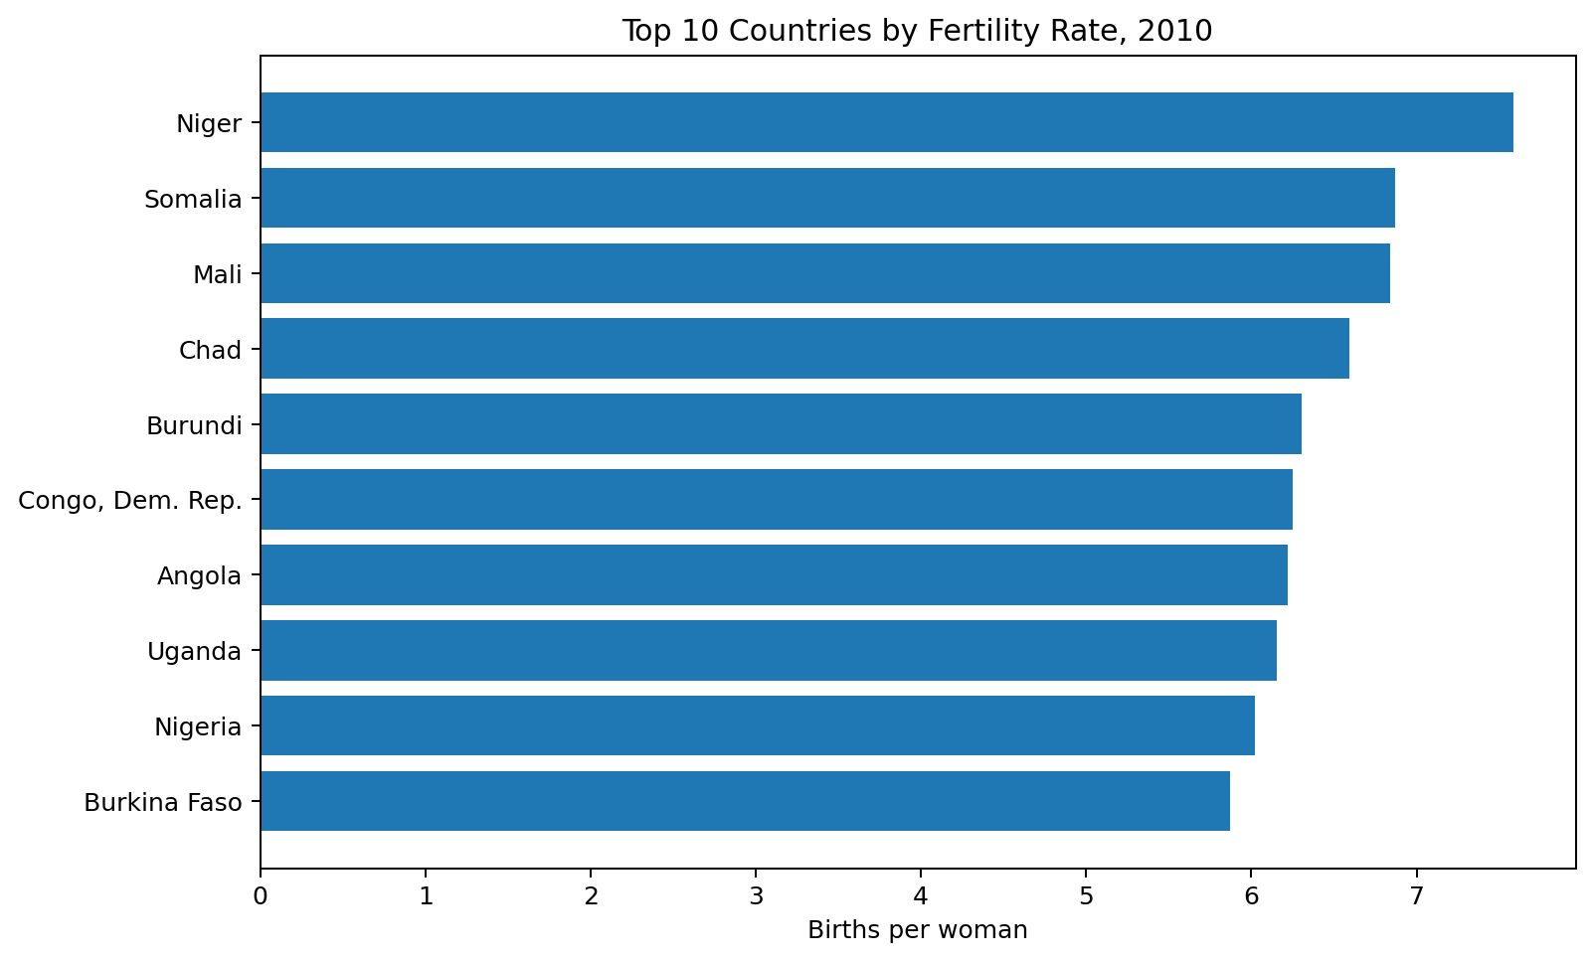
Figure 3. Ten highest 2010 fertility rates in the prepared country dataset.
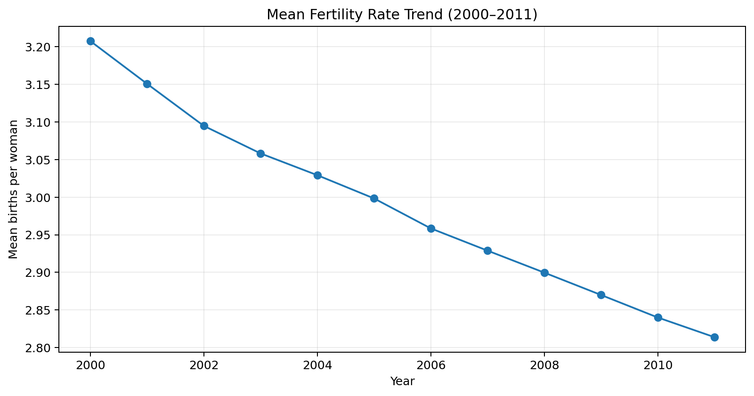
Figure 4. Mean fertility trend from 2000 to 2011 after median imputation.

3.2 Week 2 – Economics visualization
The economics dataset contains 574 monthly observations from July 1967 through April 2015. It includes date, personal consumption expenditure (PCE), population, personal savings rate, median unemployment duration, and unemployment count. The prior Week 2 workflow checked structure and missingness, derived a year and decade field, and used five chart types to answer different questions. The data were not unnecessarily transformed. PCE is nominal, so its long-run increase must not be described as inflation-adjusted real growth.
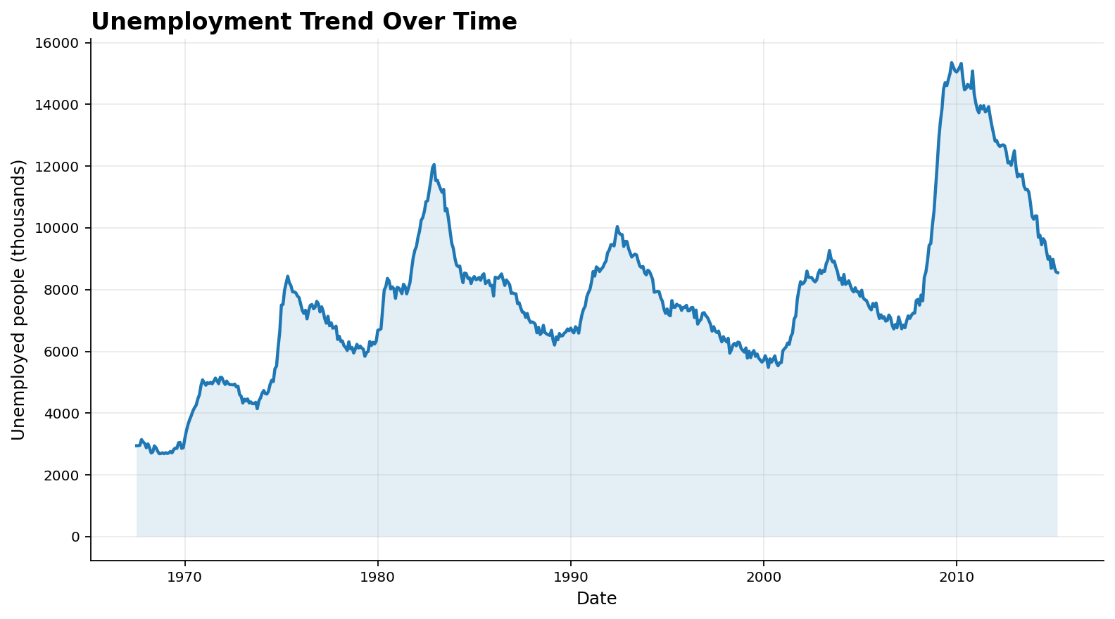
Figure 5. Monthly unemployment trend over the available period.
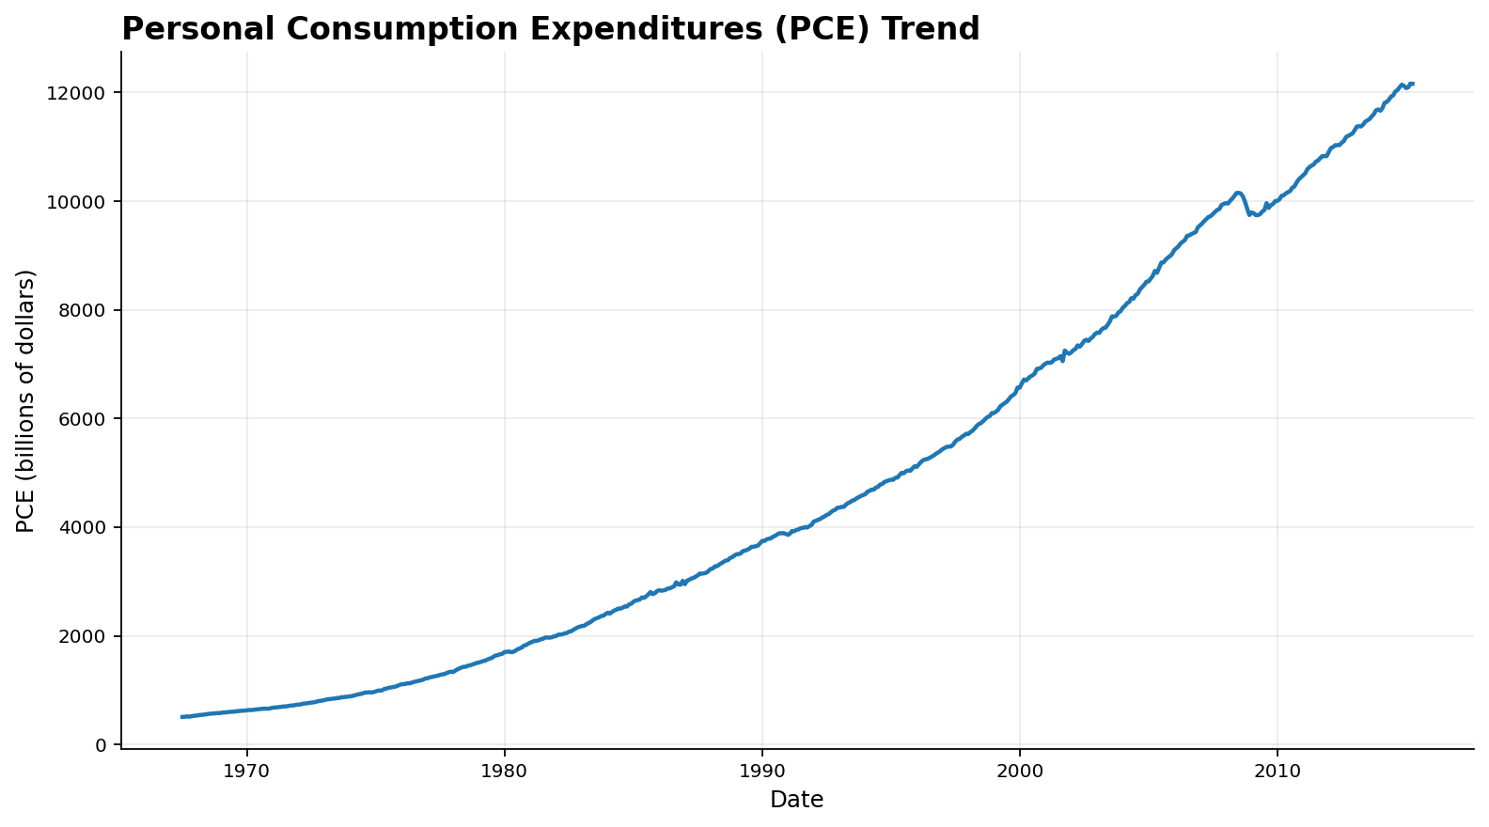
Figure 6. Long-run trend in nominal personal consumption expenditure.
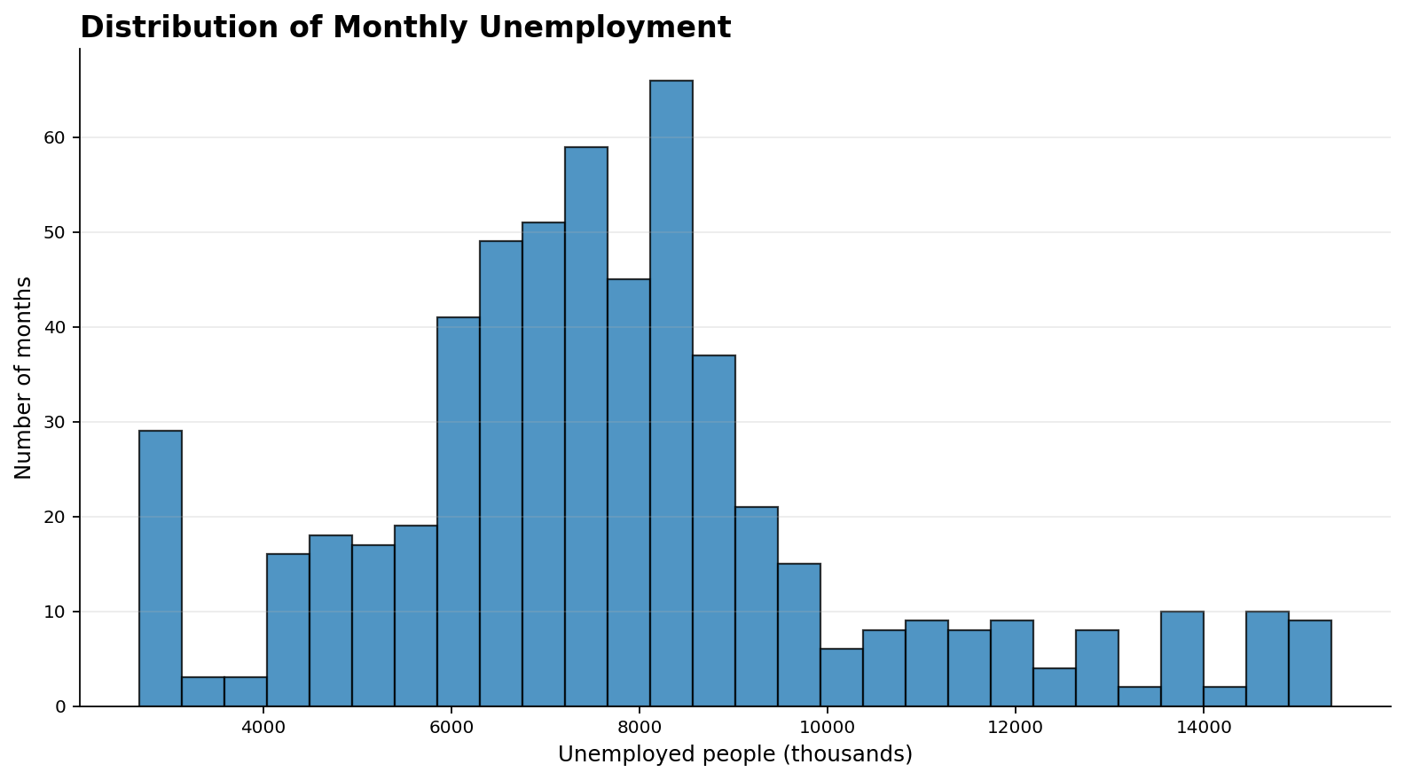
Figure 7. Distribution of monthly unemployment observations.
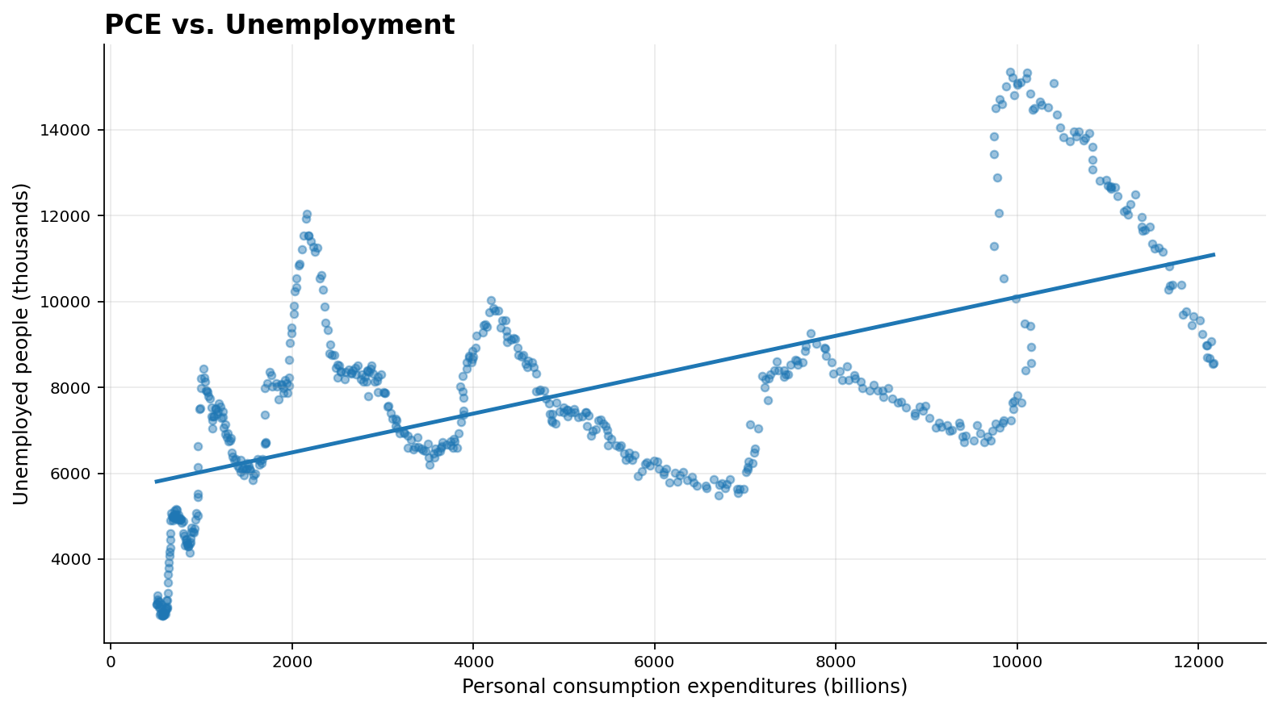
Figure 8. PCE and unemployment association; the fitted line is descriptive, not causal.
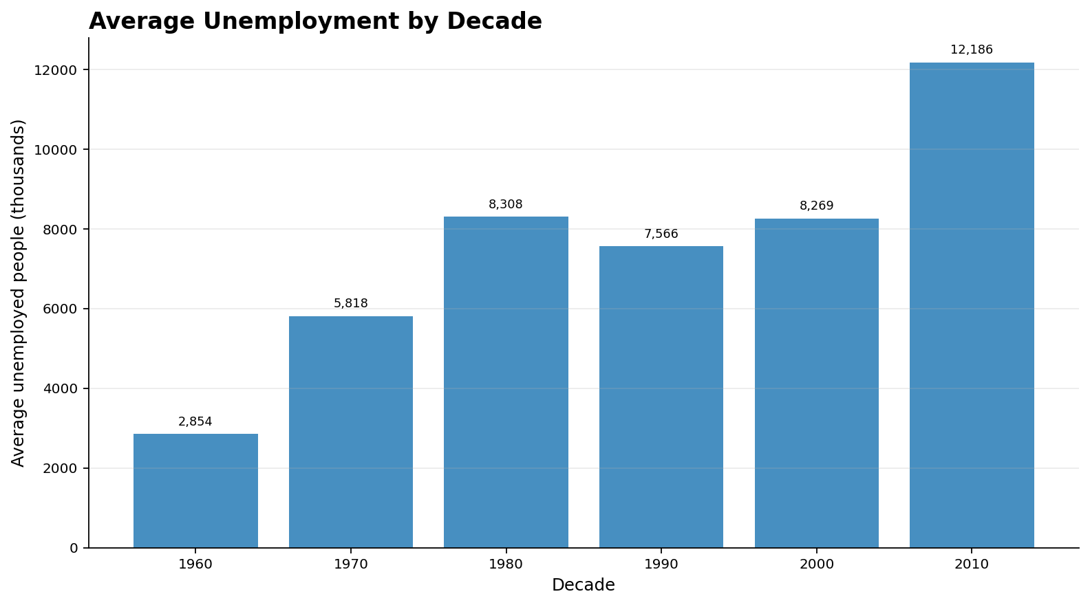
Figure 9. Average unemployment by decade; the 2010s group is only a partial decade.
The previous Week 2 analysis reported a maximum unemployment value of 15,352 thousand in October 2009, an average unemployment level of approximately 7,772 thousand, and a PCE–unemployment correlation near 0.61. Both variables move over time, so their correlation can partly reflect common time trends. It is not evidence that PCE causes unemployment.

3.3 Week 3 – Insurance data preparation
The Kaggle CSV has 1338 rows and seven expected columns. Data checks identified 0 missing cells and 1 exact duplicate rows in the supplied copy. Duplicate rows were removed, and rows with missing core fields or implausible numeric values were excluded. The resulting analysis file contains 1337 rows. Categorical values are trimmed and standardized to lowercase before modelling. No artificial values were added.
Cleaning check | Result
Original rows | 1338
Original columns | 7
Missing cells | 0
Exact duplicate rows | 1
Rows retained for analysis | 1337
Rows excluded in total | 1

4. Exploratory Analysis and Key Visual Findings

4.1 Fertility patterns
The 2010 distribution contains 204 observed country values before imputation. The median is 2.34 births per woman. The IQR method flags 4 high/low observations for review, but these remain in the cleaned file with an outlier flag. The year-level mean trend provides a broad view of change, while country-level rankings show that national patterns differ substantially. A global mean should therefore be interpreted as a summary rather than a description of every country.

4.2 Economic patterns
The Week 2 charts show cyclical unemployment movements, a long-term rise in nominal PCE, a broad distribution of unemployment levels, and a moderate positive association between PCE and unemployment in the historical sample. The decade bar chart makes broad comparison easier but has an incomplete 2010s segment because the source ends in April 2015.

4.3 Insurance charge patterns
The insurance charge distribution is right-skewed, with a relatively small number of high-cost observations. The smoker/non-smoker boxplot shows a marked difference in charge distributions. In the supplied data, the Welch two-sample test gives t=-32.74, p=6.26e-103. This is strong evidence of a difference in mean charges between the two observed groups, but it does not establish that smoking status alone causes the difference; age, BMI, and other factors may also matter. Age has a Spearman correlation of 0.534 with charges (p=3.19e-99), indicating a positive monotonic association in this sample.
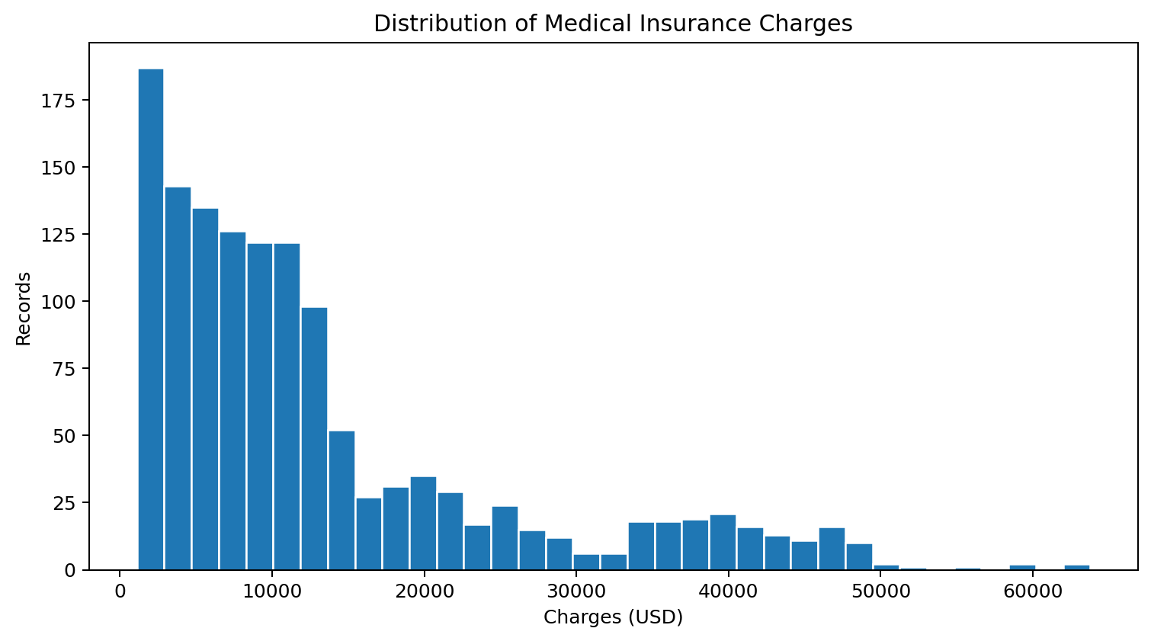
Figure 10. Insurance charge distribution.
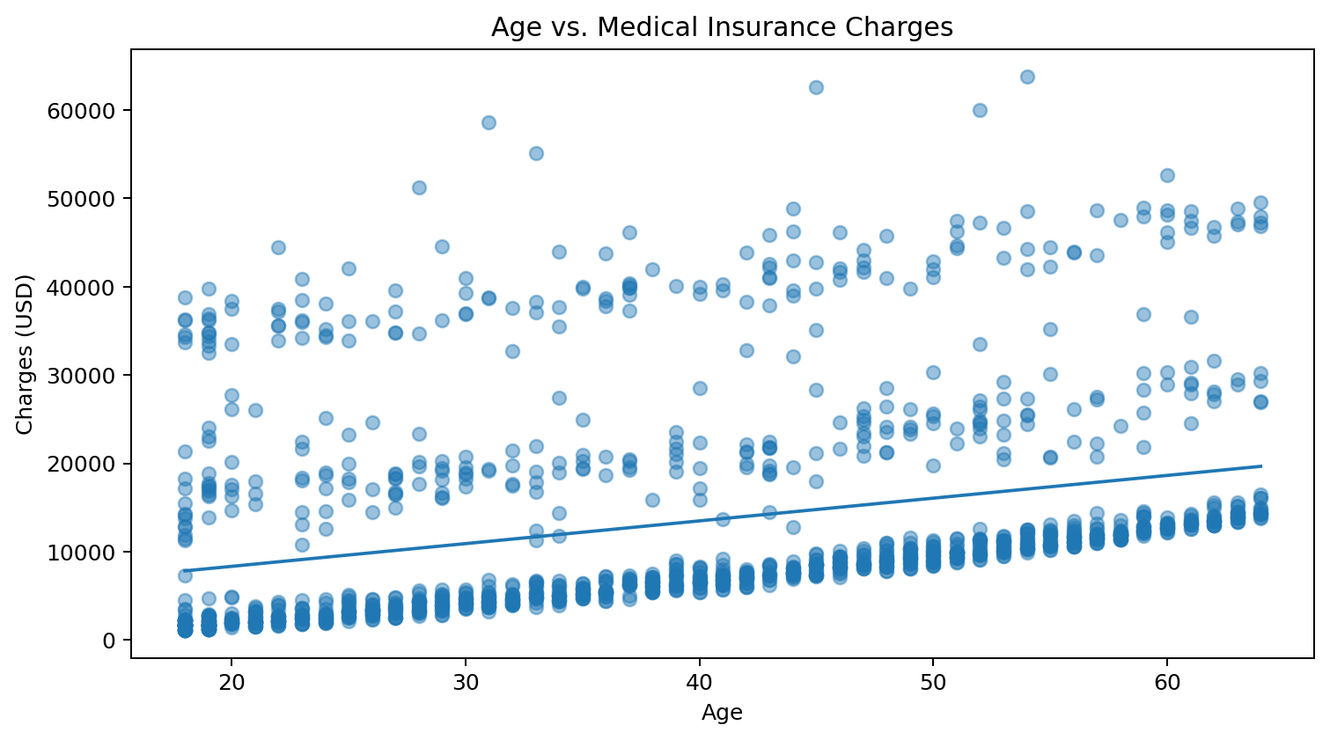
Figure 11. Age and insurance charges with a simple fitted trend.
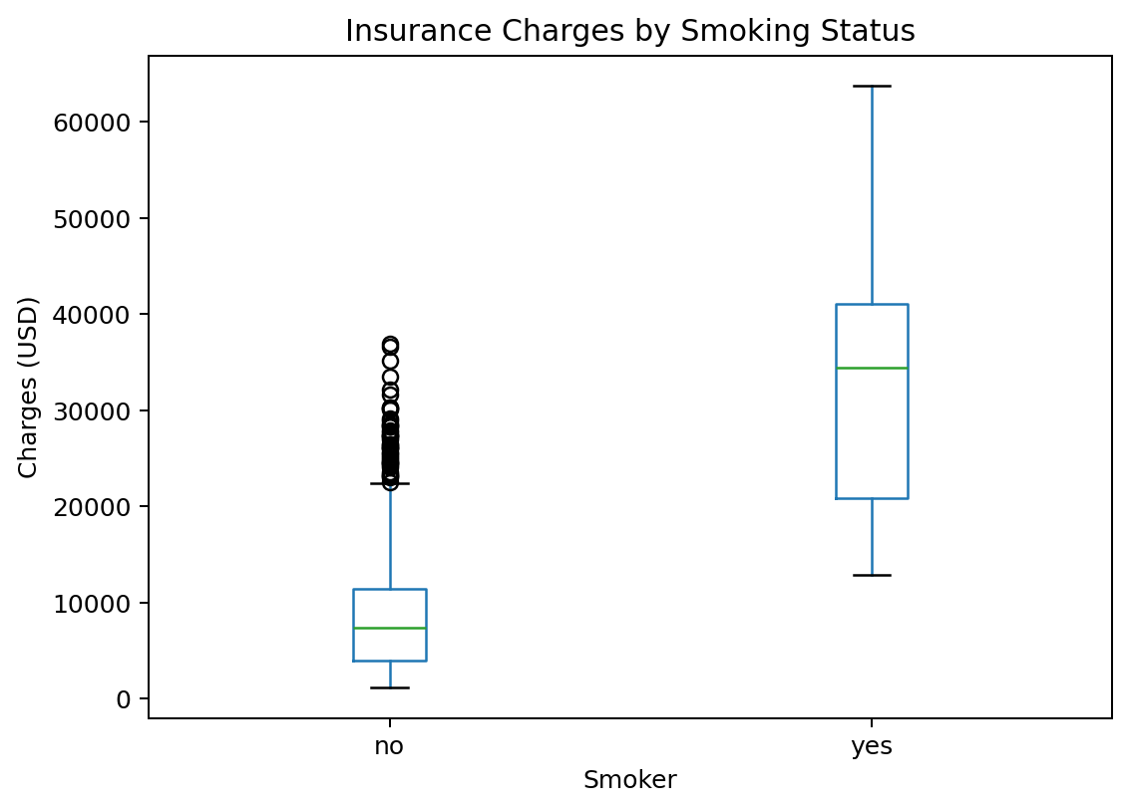
Figure 12. Charges by smoking status.
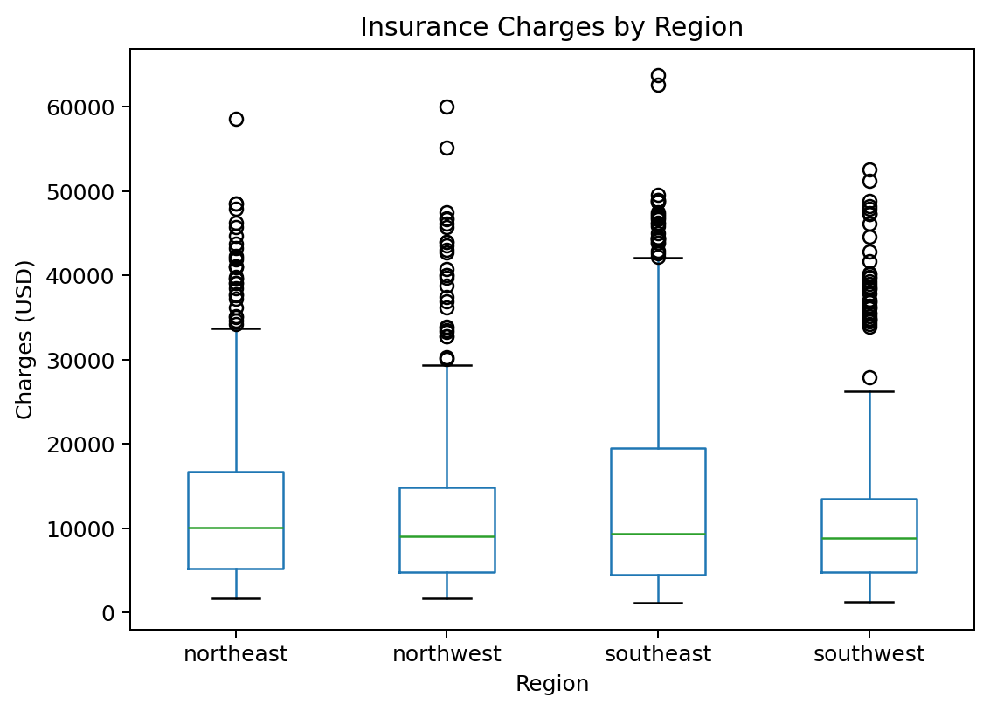
Figure 13. Charges by region.
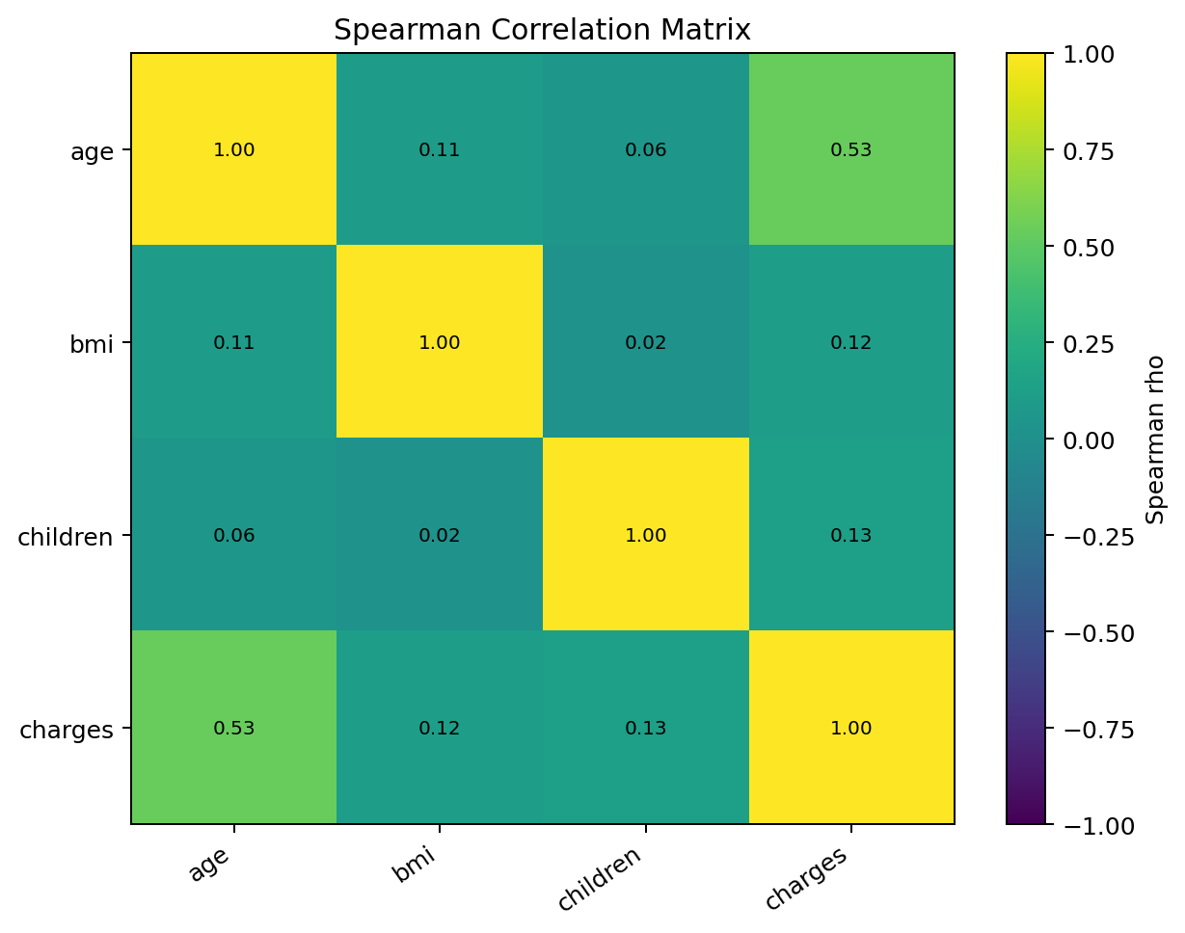
Figure 14. Spearman correlation heatmap for numeric variables.

5. Statistical Analysis and Hypothesis Testing

5.1 Smoking status and charges
H0: mean insurance charges are equal for smokers and non-smokers. H1: the two group means are different. A Welch two-sample t-test was selected because it does not require equal group variances. The Python validation on the supplied cleaned data produced the test statistic and p-value shown above. Since the p-value is below 0.05, the null hypothesis is rejected for this sample. The size and direction of the group difference should also be considered, not only statistical significance.

5.2 Age and charges
H0: age and charges have no monotonic association. H1: a monotonic association exists. Spearman correlation was used because it measures monotonic association and is less dependent on a linear relationship. The observed positive coefficient indicates that charges tend to increase with age in this dataset. This is an association, not a causal conclusion.

5.3 Regression model
A multiple linear regression model was chosen because charges are a continuous numeric target. Predictors include age, BMI, number of children, sex, smoking status, and region. Categorical variables are represented with indicator variables. The model is evaluated using a deterministic 80/20 train-test split (random seed 42).
Metric | Independent Python validation
Cleaned observations | 1337
Training observations | 1069
Test observations | 268
MAE | $4,177.05
RMSE | $5,956.34
Test R-squared | 0.807
Full-sample OLS R-squared | 0.751
Full-sample OLS adjusted R-squared | 0.749

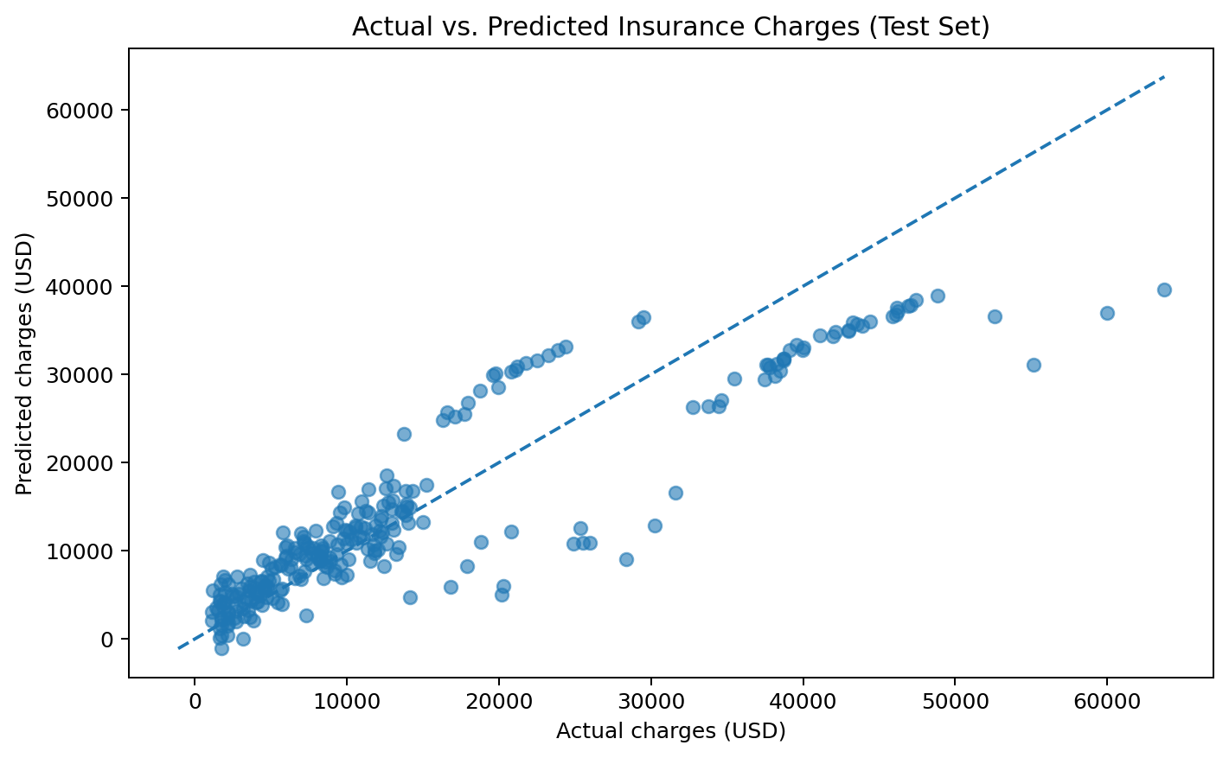
Figure 15. Actual versus predicted insurance charges for the held-out test records.
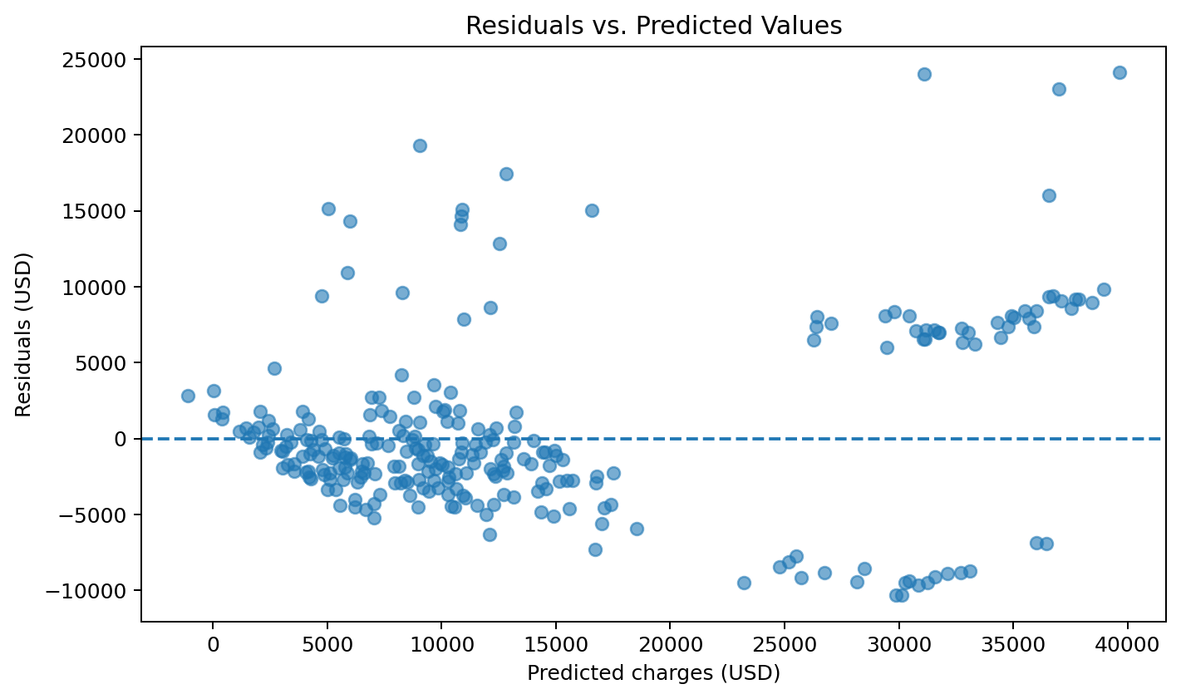
Figure 16. Residuals against predicted charges; patterns may indicate model misspecification or unequal variance.
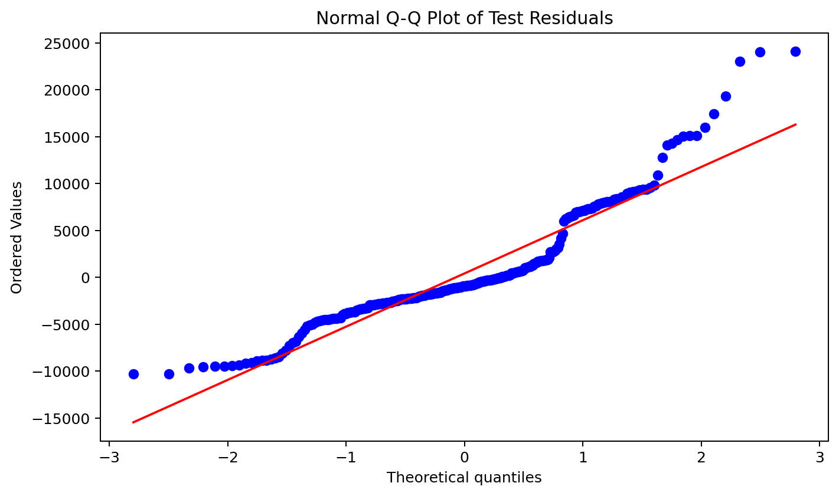
Figure 17. Normal Q–Q plot of test residuals.
The test R² of 0.807 means that the model explains approximately 80.7% of the variation in held-out charges under this split. MAE is the average absolute prediction error, while RMSE penalizes larger errors more heavily. The metrics show useful predictive information but also substantial unexplained variation. Insurance charges are highly variable, and a simple linear model may not capture interactions or nonlinear effects. The R² values above come from an independent Python validation; the included R script writes its own R results when run in RStudio, and those values may differ slightly because of implementation details.

6. Discussion and Integrated Insights
- Cleaning decisions must be transparent. Missing values, duplicates, and outlier flags should be reported so readers can understand how the analysis sample was formed.
- Charts should answer a question. Time-series lines show movement, histograms show distributions, boxplots compare groups, and scatter plots show associations.
- Statistical significance is not the same as practical importance. A small p-value should be read together with effect size, context, and limitations.
- Predictive performance must be checked on data not used to fit the model. The holdout metrics provide a more realistic view than training fit alone.
- The three datasets describe different subject areas and units. They are integrated as a learning workflow, not merged into one table or treated as if they describe the same population.

7. Challenges, Solutions and Limitations
Challenge | How it was handled | Remaining limitation
Missing fertility values | Reported missingness and used year-specific medians | Median imputation reduces variability and may bias distribution summaries
Extreme fertility values | Flagged using 1.5×IQR and retained | IQR flags are statistical indicators, not proof of data errors
Long historical economics series | Used line, histogram, scatter and decade charts | Dataset ends in 2015; nominal PCE is not inflation-adjusted
Insurance charges are skewed | Used descriptive plots, Welch test and regression diagnostics | Linear regression may not capture nonlinearities or interactions
R execution not available in build environment | Included a reproducible R master script and validation outputs | RStudio execution and screenshots still need to be completed locally

8. Recommendations and Future Directions
- Keep a data dictionary and source link beside every dataset so future users can verify definitions and provenance.
- For fertility analysis, compare results with and without imputation and consider robust summaries when country distributions are skewed.
- For economic analysis, use inflation-adjusted PCE and more recent data before making current policy or business claims.
- For insurance modelling, test log-transformed charges, interaction terms (especially smoking status with BMI), and nonlinear models such as random forests or gradient boosting.
- Use repeated cross-validation and report confidence intervals for model metrics before selecting a model for operational use.
- Capture genuine RStudio screenshots after running the master script and include the R console output, generated charts, and session information in the final portal evidence.

9. Conclusion
This project demonstrates a complete data-analysis workflow across three different datasets. Week 1 shows how careful cleaning and transparent treatment of missing values support reliable country comparisons. Week 2 demonstrates how suitable visualizations make long-term economic patterns easier to understand. Week 3 adds formal statistical tests and a predictive regression model, while showing why validation and diagnostics are essential. The most important lesson is to connect every technical step to a clear question and explain results in context. The supplied folder contains the source datasets, cleaned data, previous Week 2 charts, reproducible R scripts, analysis tables, diagnostic plots, and project documentation. Before submission, the master R script must be run in RStudio and its execution evidence checked.

10. Reproducibility, References and Appendix
Run the project from the root folder. Open RStudio, set the working directory to the extracted Week4_Comprehensive_Data_Analysis folder, then run: source("02_R_Scripts/Week4_Complete_Analysis.R"). The script checks required columns, creates output folders, writes cleaned data, statistical tables, visualizations, diagnostics, and session information. Install packages only if prompted.
- Kaggle. Medical Cost Personal Dataset. https://www.kaggle.com/datasets/mirichoi0218/insurance
- World Bank. Fertility rate, total (births per woman), indicator SP.DYN.TFRT.IN. https://data.worldbank.org/indicator/SP.DYN.TFRT.IN
- ggplot2 documentation. US economic time series (economics dataset). https://ggplot2.tidyverse.org/reference/economics.html
- Federal Reserve Bank of St. Louis. FRED economic data. https://fred.stlouisfed.org/
- R Core Team. R: A Language and Environment for Statistical Computing. https://www.r-project.org/
Appendix A – Main project files: 01_Datasets/ contains source CSV files; 02_R_Scripts/ contains the master and earlier-week scripts; 03_Cleaned_Data/ contains prepared datasets; 04_Visualizations/ contains charts; 05_Statistical_Results/ contains exported tables; 06_Model_Diagnostics/ contains regression diagnostic visuals and predictions; 07_Execution_Logs/ contains validation notes and, after R execution, the R session information.

