Organization

Network Report

# Course

**Data communication and computer networks**

# GROUP MEMBERS

Mohsin Siddiqui (18B-023-SE)

# OVERVIEW

Computer networking nowadays, is an essential part in business sector as well.

In such big scale companies like Coca Cola, computer networking plays a vital role in doing their routine work effectively within less time. It saves a lot of time as compared to traditional methods. Daily work reports and other reports as well as any kind of data can be transferred from one department to another, from an employee to its manager, from one department’s manager to another effectively and easily.

# PROJECT OBJECTIVES

To make the daily work of such big scale companies easy and effective. We have designed this network through which such companies may perform these tasks in an effective manner.

Our network for organization includes the division into the following eight departments:

1. Commercial Dept
2. Sales Dept
3. Supply Chain Dept
4. Finance Dept
5. Purchasing Dept
6. Legal & External Communication Dept
7. HR Dept
8. IT Dept

Each department serves as a separate level itself. Every department has a certain number of employees (Nodes) who report to their own respective manager. Similarly, every department has a manager as well. Manager of one department can interact with manager of other departments and employees of its own department but can not interact with employees of another department. Similarly, employees of a department can interact with each other and with their manager but can not interact with any other department’s manager neither their employees.

# NETWORK ANALYSIS

It is in a separate file named, Design of the network.

# DESIGN

# Physical Design

## 

# Logical Design

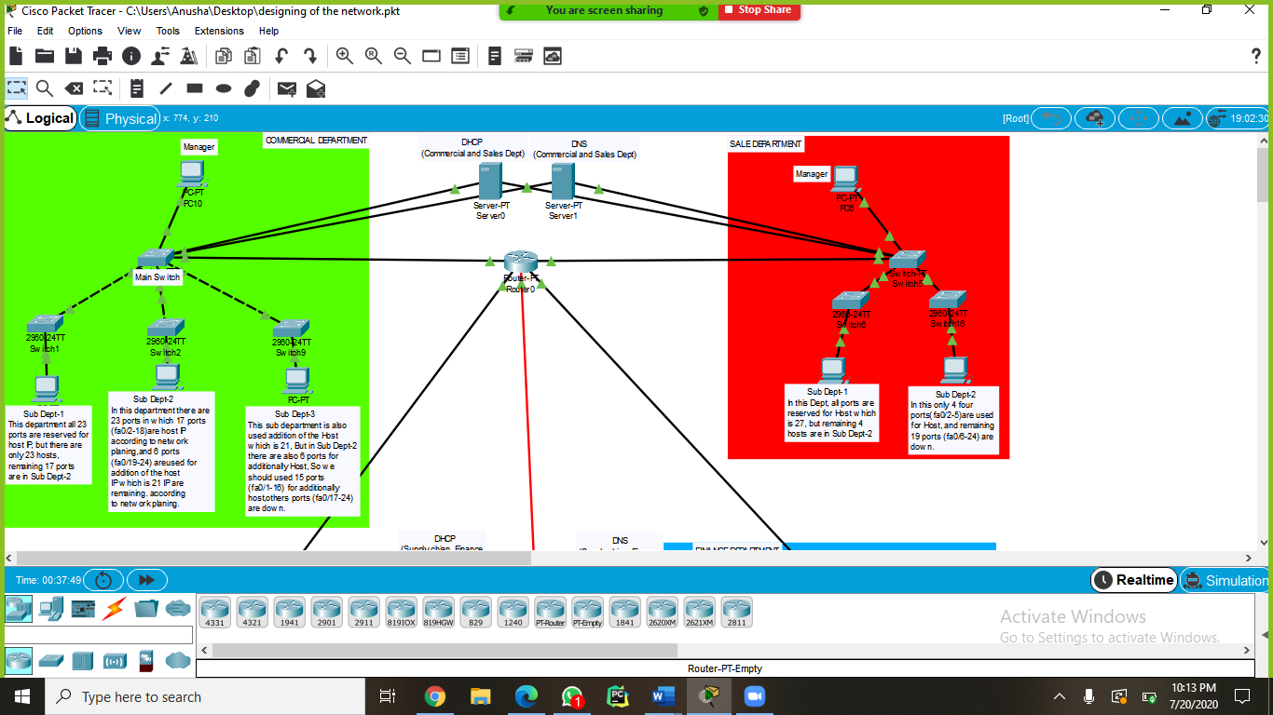

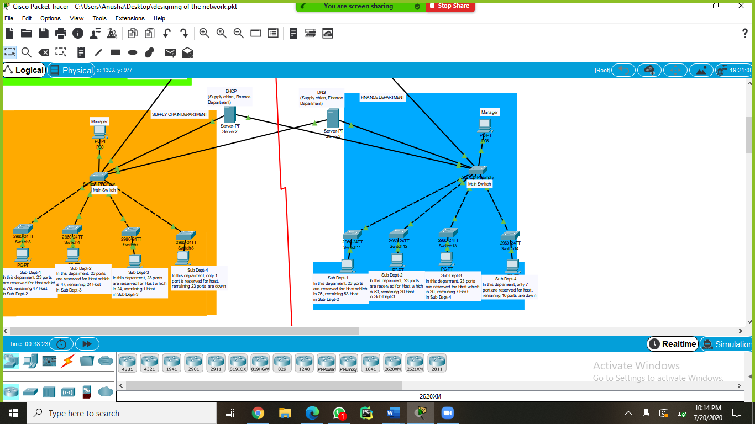

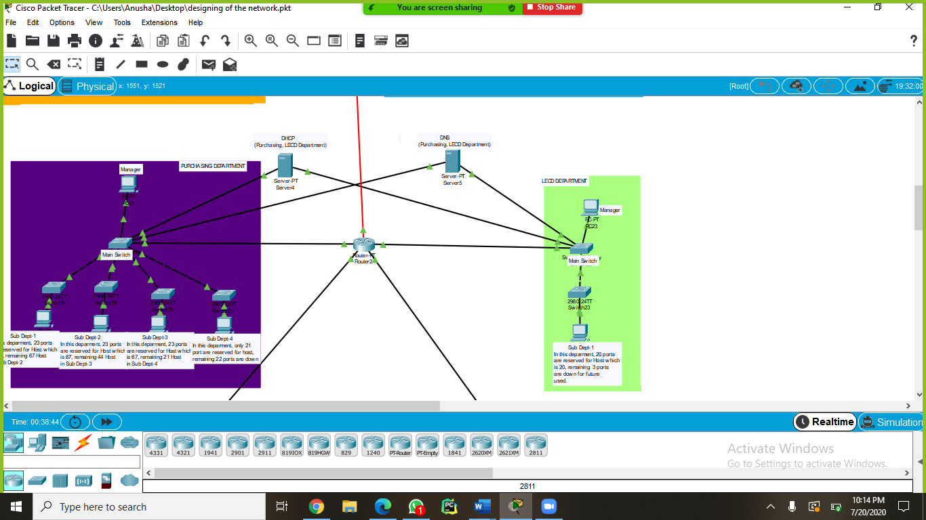

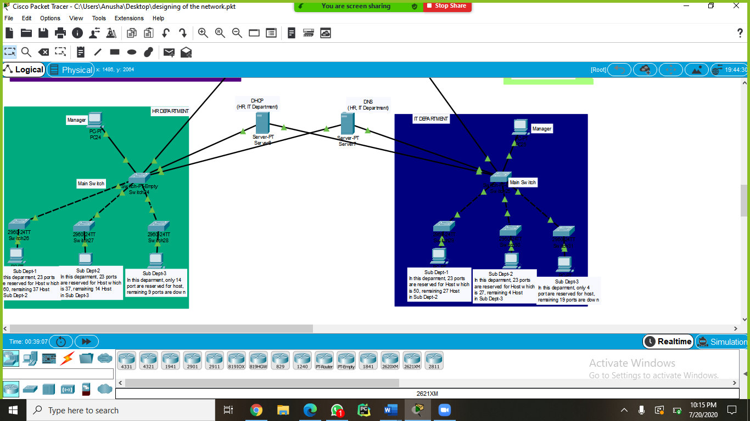

# CAPITAL AND OPERATING REQUIREMENTS

# Estimated Cost

* 8 servers
* 2 routers
* 456 Pcs
* 8 PT switches (8 ports)
* 24 switches (24 ports)

# IMPLEMENTATION PLAN

For the implementation we have used star topology as shown in Figure. A



Figure. A

In our network, every department is a LAN in such a way we have used LANs (Local Area Network) and is communicating to another LAN via a router, which is the central device in the network. Since we are using Star topology where devices are connected to a central device, which is a router in our case. If any issue occurs in the router and causes it to turn down, there will be chances of failure in connectivity. Other ways, if any LAN turns down due to any issue, then it will suspend out from the network and will not affect any other LAN.

# Conclusion

We design the network of Coca Cola organization, in which 8 departments are present and each department must contain 1 main switch, 1 DHCP, 1 DNS and 1 interface of main routers. The sub departments of each main department depend on the ports of the switches, and each switch contain 23 ports for host. The network was designed with the help of Star Topology. We used Subnetting according to the host requirement of each 8 main departments.

# Future Work

For Future, there is a flexibility of adding more users (employees) in every department. There are shutdown empty places in switches of every department for that purpose, or more switches can also be added to add more than the flexibility limit.

# References

[https://en.organizationvietnam.com/careers/departments](https://en.cocacolavietnam.com/careers/departments)