1. INTRODUCTION

With growing developments in the field of mechatronics and mathematic modelling, robotics has come a long way. From an iron piece that could move only a few inches, there are now machines capable of jumping from high-rise buildings, detecting landmines, performing operations and troubleshooting.

The very mention of a ‘robot’ reminds one of the Terminators/ Cyborgs with their menacing steel bodies and reddened eyes, which are out to destroy the world.

From the early Stark Trek days to the current cybernetics agents in Matrix and X-Men, these agents have time and reminded us of the holocaust, and with the emergence of new found technologies the fears are just confounding.

2. HISTORY OF SWARM ROBOTS

The term ‘robot’ got prominence way back in the 1950s when Karl Capek in his play Rossum’s Universal Robots denoted the birth of a superior race that had intelligence similar to that of humans.

Later on Issac Asimov introduced his laws of robots and finally Eric Elenberger, who is considered as the father of robotics, introduced real time robots to the world.

Meaning of Robotics

Robotics means the study and application of robot technology.

Robotics is a branch of engineering that involves conception, design, manufacture, and operation of machines assigned for specific high precision and repetitive tasks.

Definition of a 'robot'

"A reprogrammable, multifunctional manipulator designed to move material,

parts, tools, or specialized devices through various programmed motions for the performance

of a variety of tasks"

3. LAWS OF SWARM ROBOTICS

Popular science fiction writer Isaac Asimov created the Three Laws of Robotics:

- A robot must not injure a human being or, through inaction, allow a human being come to harm.
- A robot must always obey orders given to it by a human being, except where it would conflict

  - A robot must protect its own existence, except except where it would the first law conflict with the first or second law

4.SWARM ROBOTICS - TYPES OF ROBOTS

- Mobile Robots
- Rolling Robots
- Walking Robots
- Stationary Robots
- Autonomous Robots
- Remote-control Robots

Ask a number of people to describe a robot and most of them will answer they look like a human. Interestingly a robot that looks like a human is probably the most difficult robot to make. Is is usually a waste of time and not the most sensible thing to model a robot after a human being. A robot needs to be above all functional and designed with qualities that suits its primary tasks. It depends on the task at hand whether the robot is big, small, able to move or nailed to the ground. Each and every task means different qualities, form and function, a robot needs to be designed with the task in mind.

Mobile Robots

Mobile robots are able to move, usually they perform task such as search areas. A prime example is the Mars Explorer, specifically designed to roam the mars surface.

Mobile robots are a great help to such collapsed building for survivor’s Mobile robots are used for task where people cannot go. Either because it is too dangerous of because people cannot reach the area that needs to be searched.

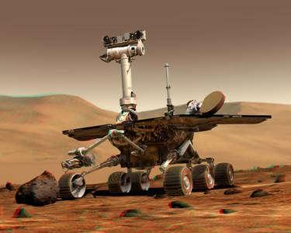

Fig 4.1 Mobile Robots

Mobile robots can be divided in two categories:

Rolling Robots

Rolling robots have wheels to move around. These are the type of robots that can quickly and easily search move around. However they are only useful in flat areas, rocky terrains give them a hard time. Flat terrains are their territory.
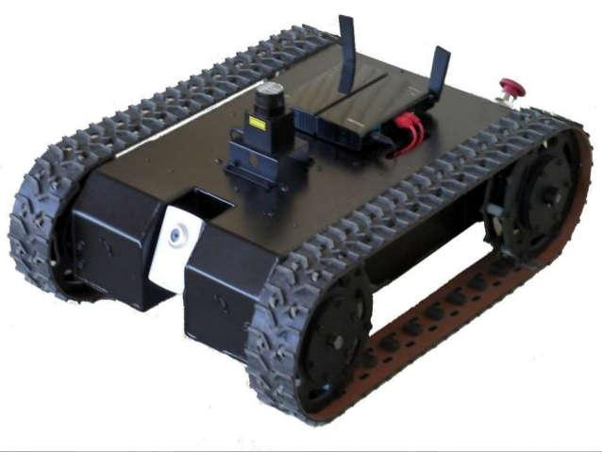

Fig 4.2 Rolling Robots

Walking Robots

Robots on legs are usually brought in when the terrain is rocky and difficult to enter with wheels. Robots have a hard time shifting balance and keep them from tumbling. That’s why most robots with have at least 4 of them, usually they have 6 legs or more. Even when they lift one or more legs they still keep their balance. Development of legged robots is often modeled after insects or crawfish..

Stationary Robots

Robots are not only used to explore areas or imitate a human being. Most robots perform repeating tasks without ever moving an inch. Most robots are ‘working’ in industry settings. Especially dull and repeating tasks are suitable for robots.

A robot never grows tired, it will perform its duty day and night without ever complaining. In case the tasks at hand are done, the robots will be reprogrammed to perform other tasks.

Autonomous Robots
Autonomous robots are self-supporting or in other words self-contained. In a way they rely on their own ‘brains’.

Autonomous robots run a program that give them the opportunity to decide on the action to perform depending on their surroundings. At times these robots even learn new behavior. They start out with a short routine and adapt this routine to be more successful at the task they perform. The most successful routine will be repeated as such their behavior is shaped. Autonomous robots can learn to walk or avoid obstacles they find in their way. Think about a six legged robot, at first the legs move ad random, after a little while the robot adjust its program and performs a pattern which enables it to move in a direction.

An autonomous robot is despite its autonomous not a very clever or intelligent unit. The memory and brain capacity is usually limited, an autonomous robot can be compared to an insect in that respect.

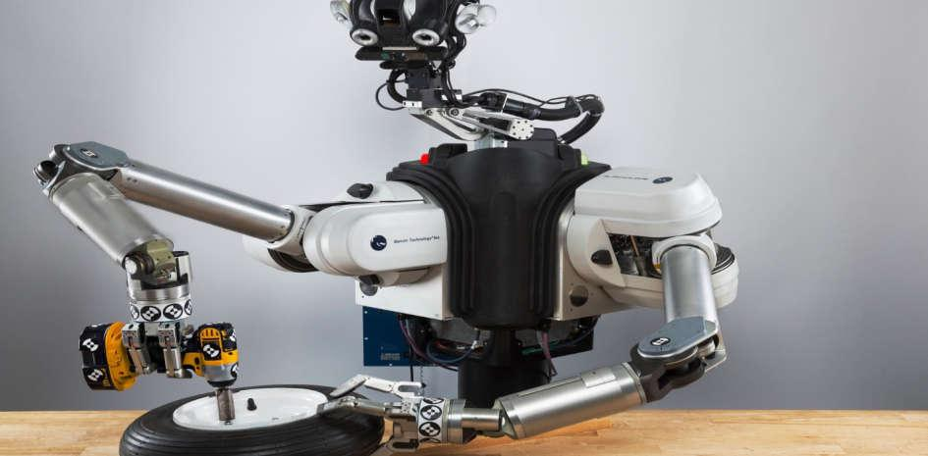

Fig 4.3 Manufacturing Robots

In case a robot needs to perform more complicated yet undetermined tasks an autonomous robot is not the right choice.

Complicated tasks are still best performed by human beings with real brainpower. A person can guide a robot by remote control. A person can perform difficult and usually dangerous tasks without being at the spot where the tasks are performed. To detonate a bomb, it is safer to send the robot to the danger area.

Robots are often modeled after nature. A lot of BEAM robots look remarkably like insects. Insects are easy to build in mechanical form. Not just the mechanics are in inspiration also the limited behavior can easily be programmed in a limited amount of memory and processing power.

Electronics
Like all robots they also contain electronics. Without electronic circuits the engines cannot be controlled. Lots of Beam Robots also use solar power as their main source of energy.

Aesthetics

A BEAM Robot should look nice and attractive. BEAM robots have no printed circuits with some parts but an appealing and original appearance.

Mechanics

In contrast with expensive big robots BEAM robots are cheap, simple, built out of recycled material and running on solar energy.

- Structure

- Power source

- Actuation

- Sensing

- Manipulation

- Locomotion

Power source

- Suitable power supply is needed to run the motors and associated circuitry

- Typical power requirement ranges from 3V to 24V DC

- 220V AC supply must be modified to suit the needs of our machine

- Batteries can also be used to run robots

- Robots are driven by different motors :-
- DC Motors

- Stepper Motors o Servo Motors

Actuation

Actuators are the "muscles" of a robot, the parts which convert stored energy into movement.

The most popular actuators are electric motors.

Manipulation

- Robots, which must work in the real world, require some way to manipulate objects; pick up, modify, destroy, or otherwise have an effect. Thus the 'hands' of a robot are often referred to as end effectors, while the arm is referred to as a manipulator.

- Some manipulators are:

Locomotion

- It is concerned with the motion of the robot.
- Robot contains different types of drives:-

- Differential drive
- Car type
- Skid steer drive
- Synchronous drive
- Pivot drive
- Articulated drive
- Pivot drive

5. APPLICATIONS

1. Rob surgery

Robots are increasingly being used during certain types of microsurgery. This lets surgeons perform delicate procedures that would otherwise be too fine for human hands.
The surgeon can control a surgery from a terminal in a room or at times several miles away from the patient while robots go on with their job. Assisted with tactile/feedback sensors, the surgeon can ‘feel’ the tissues underneath the robot instruments.

- Robots in danger zones

Robots form an important part of landmines and bomb detection squads in many
Countries. Besides such land combining operations, the robots go deep down the earth’s crust where temperatures are unbearable, also search for buried treasures in the deepest of oceans, and sometimes work in nuclear reactors. The very purpose of deploying robots is to shield humans from hazards.
However, in most of the robots used, the robots operator controls it from a safe distance and guides the fully armed robot to the danger zone.

3. AIBO----the robot pup

When one thinks about robots, AIBO is the name that comes across everyone’s mind. AIBO can express emotions of happiness, sadness, anger, surprise, etc. and definitively makes a wonderful companion.
This robot pup responds to your voice commands with flashing lights and sounds. The newer versions promise more interaction and far better responses with the sensors corresponding to the senses of humans and animals.

6. PROBLEMS WITH SWARM ROBOTS

Yes, there are problems. As with any machine, robots can even cause disaster. They are powerful machines that we allow to control certain things. When something goes wrong, terrible things can happen. Luckily, this is rare because robotic systems are designed with many safety features that limit the harm they can do.

There is also the problem of evil people using robots for evil purposes. This is true today with other forms of technology such as weapons, and biological material. Of course, robots could be used in future wars.

This could be good or bad. If humans perform their aggressive acts by sending machines out to fight other machines that would be better than sending humans out to fight other humans. Teams of robots could be used to defend a country against attacks while limiting human casualties. Could future wars really just be a video game that drives robots.

Either way, human nature is the flawed component that's here to stay.

The Impact of Robotics on Society

Since robots are used mainly in manufacturing, we see their impact in the products we use every day. Ususally this results in a cheaper product. Robots are also used in cases where it can do a better job than a human such as surgery where high precision is a benefit. Moreover, robots are used in exploration in dangerous places such as in volcanos that allows us to learn without endangering ourselves.

7. ADVANTAGES AND DISADVANTAGES

Advantages

- You can send them to very dangerous places

- You can make them do you're job for you

- They are more accurate than humans Eg no shaking when in a very important surgery, puts every screw in fabricating a car etc.

- Can do jobs 24/7

- Can guard without being tired just keep doing the same thing 24/7

- No need of nutrients

- You can programme them to make them do exactly what you want them to do

- They cannot harm you unless they are programmed to

- can work without doubts Eg when you think "what do i do now"?

- They can lift very heavy things

Disadvantages

- You need to get people trained to fix them if anything wrong happens

- Need a very intelligent crew

- They can ruin people’s lives Eg Take their job away from them

- They are very expensive to make

- You need the right materials to make them, that could be very rare

- If you make a very amazing robot with amazing quality and it brakes, it might be very hard to fix

- They can be very hard to programme

- They can reproduce but it could cost money for the materials

- You need highly trained people to make them

- They cannot recharge themselves

8. CONCLUSION

Today we find most Robots working for people in industries, factories, warehouses and laboratories. Robots are useful in many ways. For instance, it boosts economy because businesses need to be efficient to keep up with the industry competition. Therefore, having Robots help business owners to be competitive, because Robots can do jobs better and faster than humans. Yet Robots cannot perform every job; today Robots role includes assisting research and industry. Finally as the technology improves, there will be new ways to use Robots which will bring new hopes and new potentials.

9. REFERENCES

1. T. Hayashi, M. Sonehara, T. Shima and Y. Kawano: Development of Bin Picking Robotics using 3-D object recognition, Journal of IHI Technologies Vol. 48 No.1 pp.7-11

2. "Japan looks to a robot future". msnbc.com. Retrieved 17 April 2015.

3. http://www.worldrobotics.org/uploads/media/2011_Executive_Summary.pdf

