 | JSPM University Pune  Faculty of Science and Technology  School of Computational Sciences  TY B.Tech CSE- Sem-VI, 2025-26
Experiment No: 10 |  | Date: / /
Aim: Gas detection using MQ135/MQ2 and ESP32.
OBJECTIVE: The main objective of this experiment is,
- To interface Gas Detecting Sensor with ESP32.

APPRATUS: ESP32, Arduino IDE, Breadboard, Resistors, Gas Detecting sensor MQ- 135/MQ-2, connecting wires, supply source, Display.

DESCRIPTION:
The MQ-2 sensor is a versatile gas sensor capable of detecting a wide range of gases including alcohol, carbon monoxide, hydrogen, isobutene, liquefied petroleum gas, methane, propane, and smoke. It is popular among beginners due to its low cost and easy-to-use features.
The MQ-2 sensor works on the principle of resistance changes in the presence of different gases. When the target gas comes in contact with the heated MOS (Metal Oxide Semiconductor) material, it undergoes oxidation or reduction reactions that change the resistance of the MOS material. It is noteworthy that the MQ2 gas sensor is capable of detecting multiple gases, but lacks the ability to differentiate between them. This is a common characteristic of most gas sensors. The sensor has a built-in potentiometer that allows you to adjust the sensor digital output (D0) threshold. When the concentration of gas in the air exceeds a certain threshold value, the resistance of the sensor changes.
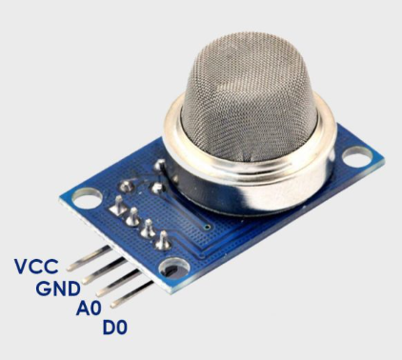
INTERFACING DIAGRAM:

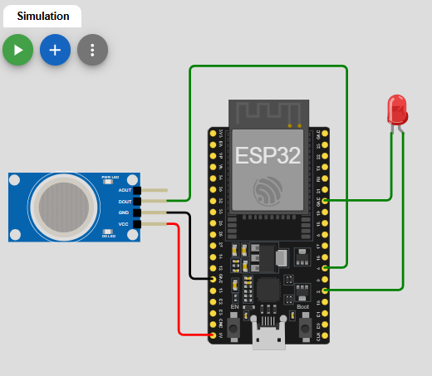

PROCEDURE:
- Give the connections to the ESP32 board as shown in the connection diagram.
- Open Arduino IDE in the computer
- Create new file → New
- Type your program and Save it in appropriate location in your computer.
- Compile your program by clicking Verify option in the menu.
- Once the program compiled successfully, connect the esp32 to the computer using USB cable.
- After connecting, go to Tools →Board → Select Arduino AVR board option.
- After selecting board, go to Tools →Port → Select Arduino Uno COM port 3 (name may appear differently for other computers).

PROGRAM:
RESULTS:
ANALYSIS AND INTERFERENCE:

SAMPLE VIVA-VOCE QUESTIONS:
  - What is the Principle of MQ2 Gas sensor?
  - What is the function of a gas sensor?
  - How do you interface a gas sensor?
  - What is the range of a gas sensor?
  - Is MQ2 Gas Sensor is Analog Sensor? If yes then why?

