 | JSPM University Pune  Faculty of Science and Technology  School of Computational Sciences  TY B.Tech CSE- Sem-VI, 2025-26
Experiment No: 11 |  | Date: / /
Aim: Servomotor (SG-90) control using ESP32.
OBJECTIVE: The main objective of this experiment is,
- Servomotor (SG-90) control using ESP32.

APPRATUS: ESP32 Board, Servo Motor (SG-90), Jumper Wires, Breadboard

DESCRIPTION:
Servo motors are geared DC motors that have an integrated servomechanism with a feedback loop to allow precise positioning of the motor shaft. A high gear ratio allows a small servo to have an impressive torque rating.
Most servos are limited in rotation to either 180 or 270 degrees, with 180-degree servo motors being more common. There are specially modified servo motors that can rotate beyond 360-degrees, but we won’t be working with those today.
Servo motors come in a wide range of sizes and can be controlled either with an analog PWM signal or with a digital I/O signal.
A very common and inexpensive servo motor is the SG90. It’s a small plastic-gear servo that has become a standard for experimenting and is also used in a lot of RC hobby applications. It has a “cousin”, the MG90, which has similar specifications but uses metal gears.
The SG90, like most servo motors, can be powered from 5-6 volts, so servo motors are great for battery-powered applications.

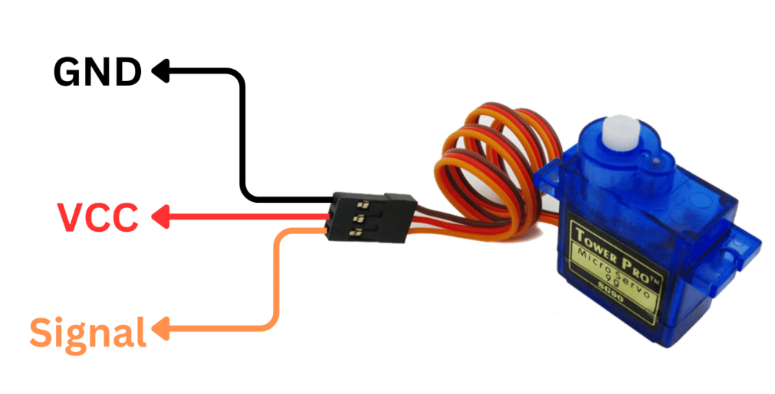

INTERFACING DIAGRAM:

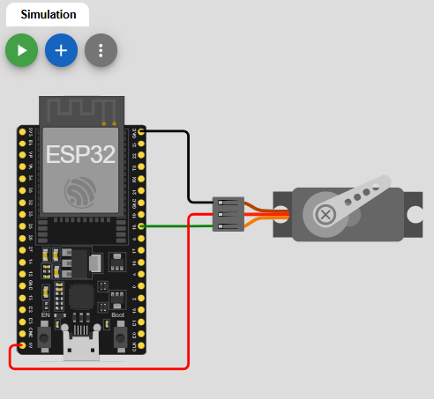

PROCEDURE:
- Give the connections to the ESP32 board as shown in the connection diagram.
- Open Arduino IDE in the computer
- Create new file → New
- Type your program and Save it in appropriate location in your computer.
- Compile your program by clicking Verify option in the menu.
- Once the program compiled successfully, connect the esp32 to the computer using USB cable.
- After connecting, go to Tools → Board → Select Arduino AVR board option.
- After selecting board, go to Tools→ Port →Select Arduino Uno COM port3 (name may appear differently for other computers).

PROGRAM:
RESULTS:
CONCLUSION:

SAMPLEVIVA-VOCEQUESTIONS:
- What is a servomotor?
- How does a servo motor work?
- How the SG-90 servo is motor connected to the ESP32?
- How can we control the position of the servo motor using the ESP32?
- What is the range of motion for the SG-90 serpvo motor?

