 | JSPM University Pune  Faculty of Science and Technology  School of Computational Sciences  TY B.Tech CSE- Sem-VI, 2025-26
Experiment No: 6 |  | Date: / /
Aim : Smart lighting system using LDR and ESP32
OBJECTIVE: The main objective of this experiment is,
  - To read LDR data and print on the Serial Monitor
  - To interface LDR with LED.
APPRATUS: Arduino UNO Board, ESP32, LED, LDR, Jumper wires, Breadboard.

DESCRIPTION:
LDR (Light Dependent Resistor) as the name states is a special type of resistor that works on the photoconductivity principle means that resistance changes according to the intensity of light. Its resistance decreases with an increase in the intensity of light.
It is often used as a light sensor, light meter, Automatic street light, and in areas where we need to have light sensitivity. LDR is also known as a Light Sensor. LDR are usually available in 5mm, 8mm, 12mm, and 25mm dimensions
Two metal contacts are placed on both ends of the Zig-Zag shape these metal contacts help in creating a connection with the LDRs. Now, a transparent coating is applied on the top so that the zig- zag- shaped photosensitive material gets protected and as the coating is transparent the LDR will be able to capture light from the outer environment for its working.

INTERFACING DIAGRAM:
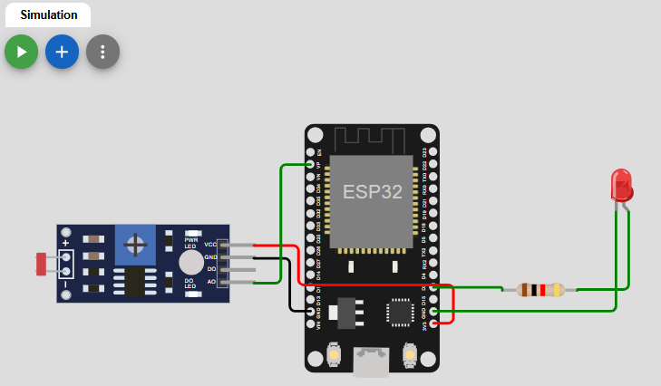
PROCEDURE:
- Connect one leg of the LDR to an analog input pin, for example, GPIO 34 (A0).
- Connect the other leg of the LDR to the 3.3V supply.
- You may need to add a resistor (e.g., 10kΩ) to create a voltage divider if your LDR doesn't have a built-in one or if your project requires it, connecting the resistor between the LDR and the ESP32's ground.

PROGRAM:
RESULTS:
CONCLUSION:

SAMPLE VIVA-VOCE QUESTIONS:
- What is LDR?
- Which type of sensor is LDR ?
- Why LDR is used?

