 | JSPM University Pune  Faculty of Science and Technology  School of Computational Sciences  TY B.Tech CSE- Sem-VI, 2025-26
Experiment No: 7 |  | Date: / /
Aim : Motion Detection using PIR Sensor and ESP32

OBJECTIVE: The main objective of this experiment is,
A. To read the digital sensor value and display the sensor value in serial monitor.

APPRATUS: Arduino IDE, ESP32, Breadboard, Resistors, PIR sensor, connecting wires, supply source, Display

DESCRIPTION:
PIR stands for Passive Infrared Sensor. It is called passive sensor because it does not emit the IR rays. It only receives the IR rays. PIR sensor allows detecting or sensing the motion. It is small, Inexpensive and low power device. It is non-wearable device for that reason they are commonly found in appliances and gadgets used in homes or businesses. It is having 3 pin structure where,

o Pin 1 is Vcc (+5v)
o Pin 2 is Output
o Pin 3 is ground

PIR sensor can detect animal/human movement in a requirement range. For Indoor passive infrared Detection distances range from 25 cm to 20 m. For Outdoor passive infrared, the detection distance ranges from 10 meters to 150 meters. It detects infrared radiation from the environment. Once there is infrared radiation from the human body particle with temperature, focusing on the optical system causes the device to generate a sudden electrical signal.

INTERFACING DIAGRAM:
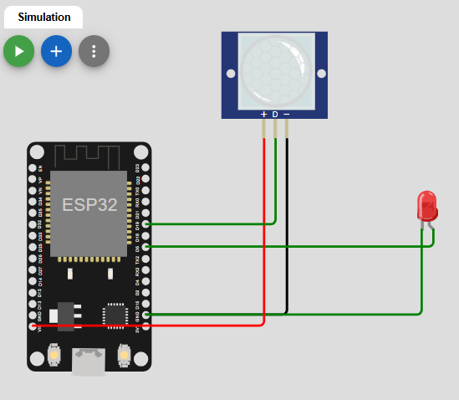
PROCEDURE:
- Give the connections to the ESP32 board as shown in the connection diagram.
- Open Arduino IDE in the computer
- Create new file → New
- Type your program and Save it in appropriate location in your computer.
- Compile your program by clicking Verify option in the menu.
- Once the program compiled successfully, connect the Arduino board to the computer using USB cable.
- After connecting, go to Tools →Board → Select Arduino AVR board option.
- After selecting board, go to Tools →Port → Select Arduino Uno COM port 3 (name may appear differently for other computers).

PROGRAM:
RESULTS:
ANALYSIS AND INTERFERENCE:

SAMPLE VIVA-VOCE QUESTIONS:
- What is the working principle of PIR sensor?
- How do you interface a PIR sensor with ESP32?
- What is the main function of PIR sensor?
- What is the range of PIR sensor in Arduino?
- State applications where PIR sensors can be used.

