 | JSPM University Pune  Faculty of Science and Technology  School of Computational Sciences  TY B.Tech CSE- Sem-VI, 2025-26
Experiment No: 8 |  | Date: / /
Aim: Temperature measurement using thermistor-LM35/DHT11 and ESP32.
OBJECTIVE: The main objective of this experiment is
A. To interface Temperature measurement using thermistor and ESP32
APPRATUS: ESP32, Arduino IDE, Breadboard, Resistors, Thermistor, connecting wires, supply source, Display.
DESCRIPTION:
A thermistor is a type of temperature sensor that changes its resistance with temperature variations. Specifically, we will be using an NTC (Negative Temperature Coefficient) thermistor, which has a higher resistance at lower temperatures and lower resistance at higher temperatures. By measuring the resistance of the thermistor, we can determine the temperature. The thermistor is connected to the Arduino UNO using two wires. One end of the thermistor is connected to the 5V pin of the Arduino, and the other end is connected to an analog input pin (e.g., A0). Additionally, a resistor (typically 10k ohms) is connected in parallel with the thermistor, with one end connected to the analog input pin and the other end connected to ground.

INTERFACING DIAGRAM:
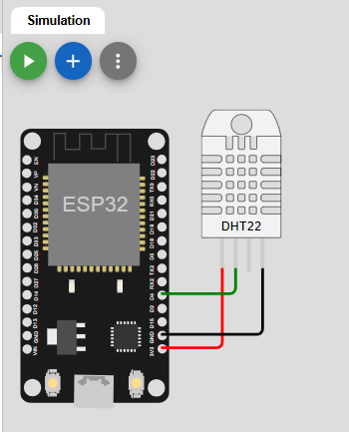
PROCEDURE:
- Give the connections to the ESP32 board as shown in the connection diagram.
- Open Arduino IDE in the computer
- Create new file → New
- Type your program and Save it in appropriate location in your computer.
- Compile your program by clicking Verify option in the menu.
- Once the program compiled successfully, connect the esp32 to the computer using USB cable.
- After connecting, go to Tools →Board → Select Arduino AVR board option.
- After selecting board, go to Tools →Port → Select Arduino Uno COM port 3 (name may appear differently for other computers).

PROGRAM:
RESULTS:
ANALYSIS AND INTERFERENCE:

SAMPLE VIVA-VOCE QUESTIONS:
- What is a thermistor?
- How is the thermistor connected to the ESP32?
- How can we convert the analog reading from the thermistor into temperature values?
- How can we improve the accuracy of temperature measurements using the thermistor and ESP32?
- What are some applications of temperature measurement using a thermistor and ESP32?

