 | JSPM University Pune  Faculty of Science and Technology  School of Computational Sciences  TY B.Tech CSE- Sem-VI, 2025-26
Experiment No: 9 |  | Date: / /
Aim: Distance measurement using SR-04 and ESP32.
OBJECTIVE: The main objective of this experiment is,
A.To Interface an Ultrasonic sensor to measure distance
APPRATUS: Arduino IDE, ESP32, Breadboard, Resistors, Ultrasonic sensor SR-04, connecting wires, supply source, Display.

DESCRIPTION:
Ultrasonic sensors work by emitting high-frequency sound waves and measuring the time it takes for the sound to reflect off an object and return to the sensor. This "time of flight" is then used with the known speed of sound to accurately calculate the distance to the object, similar to echolocation used by bats and dolphins.

INTERFACING DIAGRAM:
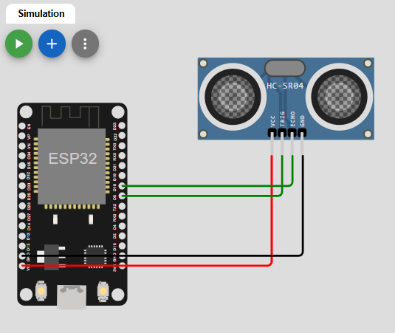
PROCEDURE:
- Give the connections to the ESP32 board as shown in the connection diagram.
- Open Arduino IDE in the computer
- Create new file → New
- Type your program and Save it in appropriate location in your computer.
- Compile your program by clicking Verify option in the menu.
- Once the program compiled successfully, connect the esp32 to the computer using USB cable.
- After connecting, go to Tools →Board → Select Arduino AVR board option.
- After selecting board, go to Tools →Port → Select Arduino Uno COM port 3 (name may appear differently for other computers).

PROGRAM:
RESULTS:
ANALYSIS AND INTERFERENCE:

SAMPLE VIVA-VOCE QUESTIONS:
- What is the purpose of the SR-04 ultrasonic sensor in this experiment?
- What is the formula used to calculate the distance using the SR-04 ultrasonic sensor?
- What is the purpose of the trigPin and echoPin connections in the SR-04 ultrasonic sensor?
- How does the SR-04 ultrasonic sensor measure distance?
- How is the SR-04 ultrasonic sensor connected to the ESP32?
- What is the maximum range of the SR-04 ultrasonic sensor?
- How can the accuracy of distance measurement be improved with the SR-04 ultrasonic sensor?

