EXP – 7:
Initial data:
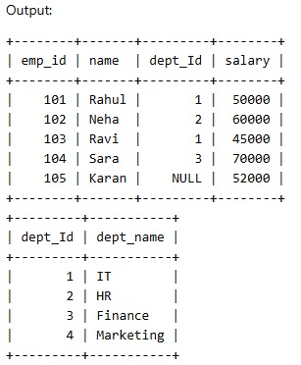

INNER JOIN:
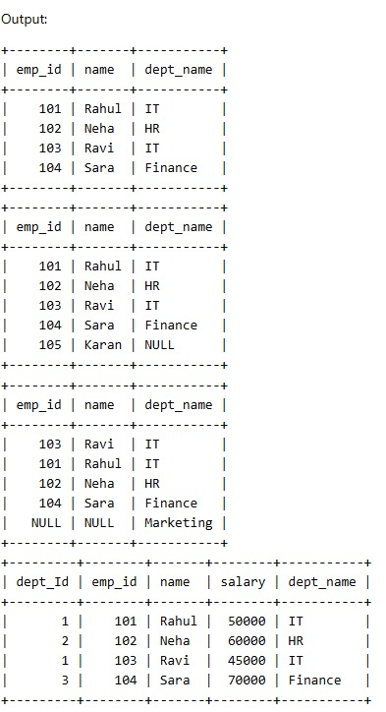

LEFT OUTER JOIN:


RIGHT OUTER JOIN:


NATURAL JOIN:


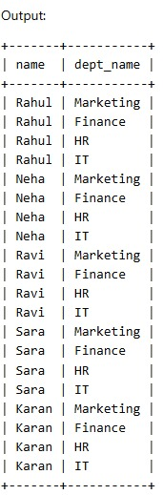
CROSS JOIN:

EXP – 8:
Initial data:
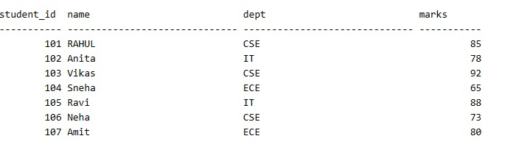

SUBQUERY Eg.1:
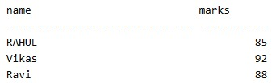

SUBQUERY Eg.2:
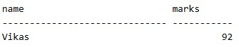

NESTED QUERY Eg.1:
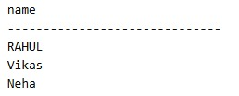

NESTED QUERY Eg.2:
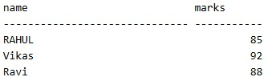

CREATE VIEW:
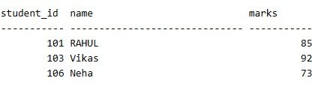

VIEW FOR HIGH SCORING STUDENTS:
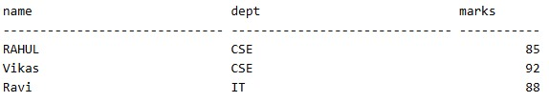

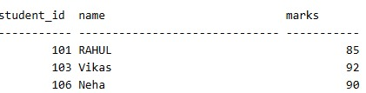
UPDATE VIEW:

