Federated Edge AI: LoRA and Differential Privacy
Technical Analysis Report
Siddhartha Mukherjee
Applied Research Topics in Deep Learning - Week 9
Case Study 9: Federated Edge AI | Date: 31 May 2026

Introduction
This report studies a small federated learning system for healthcare. Three edge clients each hold private patient vital-sign data and never share the raw data. They train one shared DistilBERT model using three ideas: federated learning, LoRA (train only small adapters), and differential privacy (add noise to protect each patient). Vitals are turned into short text and labelled Normal, Warning, or Critical, with non-IID data across clients. All numbers come from running the notebook. Section A covers the base run (Q1 to Q10), Section B the five experiments (Q11 to Q15), and Section C deployment advice.

Section A: System Analysis (Q1 to Q10)
Metric | Value (base run: 3 clients, 5 rounds)
Baseline accuracy (random, 1/3) | 0.333
Final global accuracy | 0.400 (+0.067)
Trainable / total parameters | 666,627 / 67,622,406
LoRA parameter reduction | 99.01%
Privacy per client (epsilon) | approx. 9.98 (delta = 0.001)
Full model / LoRA update size | 270.49 MB / 2.67 MB
Communication saving | 99.01%
Avg training time | 4.99 s per client per round
Edge inference latency | 6.70 ms per sample
Peak memory | approx. 952 MB (just under 1 GB)
Table 1. Main metrics from the base run.

Q1. Accuracy vs baseline
Baseline (random over 3 classes) is 0.333. After 5 rounds the model reached 0.400, a +0.067 gain. Accuracy is low by design: ~40 training samples per client, only 5 rounds, small LoRA rank, and privacy noise. The goal is to study behaviour, not high accuracy.

Q2. LoRA parameter reduction
LoRA freezes the base model and trains tiny adapters: 666,627 of 67,622,406 parameters, a 99.01% reduction. Only about 1% of the model is trained, keeping training cheap.

Q3. Privacy budget
Each client used Opacus DP with epsilon = 10.0 and delta = 0.001. All three spent about epsilon = 9.98, nearly the full budget, with DP active on every client. Lower epsilon means stronger privacy but more noise.

Q4. Communication savings
Sending the full model is 270.49 MB; sending only LoRA adapters is 2.67 MB, a 99.01% saving. This is a big benefit on slow or costly edge networks.

Q5. Training time
Local training took about 4.99 s per client per round, so the full run finished in roughly 75 s. LoRA keeps training light.

Q6. DP guarantees
DP gives a formal (epsilon, delta) guarantee: one patient's record barely changes the result, so membership inference is hard. This supports HIPAA and GDPR. The cost is that noise lowers accuracy.

Q7. Privacy-utility trade-off
Smaller epsilon means more noise, more privacy, and less accuracy. Q11 proves it: epsilon 10 to 1 dropped accuracy from 0.400 to 0.267, which is below the random baseline.

Q8. Edge inference latency
One sample was predicted in about 6.70 ms, over 100 readings per second. This is fast enough for real-time edge monitoring.

Q9. Memory and feasibility
Peak memory was about 952 MB (just under 1 GB), which fits 4 to 8 GB devices such as phones or edge boards. Deployment is feasible; very tiny microcontrollers are too small.

Q10. Overall score
Score: 6 of 10. Strong on efficiency (99.01% fewer parameters, 99.01% less data) and privacy (real guarantee, full budget spent). Speed and memory are good. The only weak point is accuracy (0.400), caused by tiny data and noise. More data and rounds would raise it.

Section B: Experimental Results (Q11 to Q15)
Each experiment changed one setting and re-ran the whole system. Table 2 and Figure 1 compare the results. (Because the dataset is tiny, results vary between runs, so small differences should be read with care.)
Experiment | Final acc | Improve | Trainable params | LoRA reduction | Avg eps | Avg time (s)
Base (eps=10, r=4) | 0.400 | +0.067 | 666,627 | 99.01% | 9.98 | 4.99
Q11 eps=1.0 | 0.267 | -0.067 | 666,627 | 99.01% | 0.96 | 1.21
Q12 r=16 | 0.400 | +0.067 | 887,811 | 98.69% | 9.98 | 4.94
Q13 2 clients, 8 rounds | 0.500 | +0.167 | 666,627 | 99.01% | 9.96 | 5.89
Q14 3 epochs, lr=5e-4 | 0.400 | +0.067 | 666,627 | 99.01% | 9.96 | 6.04
Q15 samples=25 | 0.600 | +0.267 | 666,627 | 99.01% | 9.97 | 8.22
Table 2. Five experiments compared with the base run.
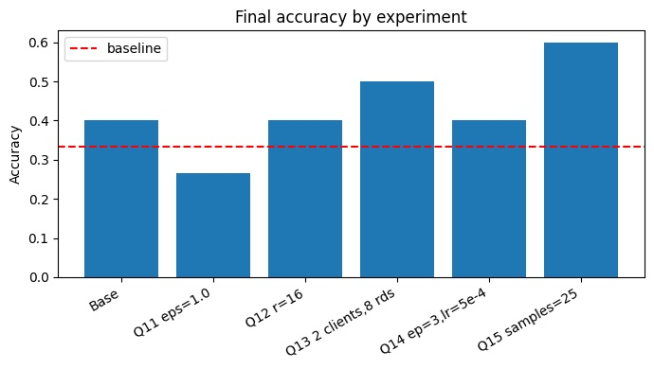
Figure 1. Final accuracy by experiment (red line = random baseline 0.333).

Q11. Privacy impact (epsilon 10 to 1)
Stronger privacy added much more noise. Accuracy fell from 0.400 to 0.267, below the random baseline, and privacy spent dropped to about 0.96. This is the clearest privacy-utility trade-off: heavy privacy at this small scale removed the model's usefulness.

Q12. LoRA rank (4 to 16)
A bigger rank raised trainable parameters from 666,627 to 887,811 (reduction 98.69%), so updates grew a little. But accuracy stayed at 0.400, no gain in this run. With such tiny data, extra capacity did not help and only added cost. Rank should be raised only when there is enough data to use it.

Q13. Federated scale (3 clients to 2, 5 rounds to 8)
Two clients with 8 rounds raised accuracy from 0.400 to 0.500. The extra rounds gave the model more chances to learn and average updates, which helped more than the number of clients. So more communication rounds matter most at this scale.

Q14. Training intensity (1 epoch to 3, lr 1e-3 to 5e-4)
Three local epochs with a smaller learning rate kept accuracy at 0.400, no gain, while training time rose to about 6.04 s per client per round. Privacy stayed near the full budget. So more local training spent more time and privacy without improving accuracy here.

Q15. Data constraints (50 samples to 25)
This is the final maintained config. Accuracy was 0.600, which looks odd for less data. The reason is high variance: the test set is tiny (~5 per client), so one prediction shifts accuracy a lot. It is not proof that less data is better.

Section C: Synthesis and Recommendations
Settings should match the goal. Three scenarios are recommended below.

High-security medical
Privacy first, to meet HIPAA and GDPR. Use small epsilon (about 1.0). Because strong privacy lowers accuracy (Q11 fell to 0.267), add more data and more rounds (Q13) to recover. Keep DP on for all clients.
- Small epsilon, DP on everywhere; offset accuracy loss with more data and rounds.

Resource-constrained IoT
Efficiency first. Keep LoRA rank small (r = 4) so updates stay tiny (2.67 MB) and memory stays near 1 GB. Use few local epochs to save battery. Some privacy noise is acceptable.
- Small rank, few epochs; gain ~99% less data, low memory, fast inference (6.70 ms).

Performance-critical
Accuracy and speed first. More rounds helped most (Q13 reached 0.500), so favour more communication rounds. Use a higher epsilon so noise does not hurt accuracy, and only raise LoRA rank or local epochs when there is enough data to benefit, since both added cost without gains in this small-data run.
- More rounds, higher epsilon; raise rank/epochs only with enough data.

Conclusion
The system ran end to end and showed the core ideas clearly. LoRA cut parameters and communication by about 99%, DP gave a real privacy guarantee, and inference was fast with low memory. Accuracy was low due to tiny data and noise, but the experiments revealed the key trade-offs. The best configuration depends on the goal: privacy for medical, efficiency for IoT, accuracy for performance-critical systems.

