Case Study 8
Web Scraping to Vector Database
Applied Research Topics in Deep Learning
Student: Siddhartha Mukherjee
Date: May 2026

1. Pipeline Summary
This project builds a complete RAG (Retrieval-Augmented Generation) pipeline. It takes text from websites, turns it into numbers (vectors), stores them in a database, and then lets you search by meaning instead of just keywords. Here is what each step does:
- Scrape: Download the web page HTML using Python’s requests library. A polite 1-second delay is used between requests to avoid overloading servers.
- Clean: Remove scripts, styles, navigation, and footer elements using BeautifulSoup. Only visible text is kept.
- Chunk: Split the cleaned text into smaller pieces of 1000 characters with 200-character overlap so no context is lost between chunks.
- Embed: Convert each text chunk into a 384-dimension vector using the all-MiniLM-L6-v2 SentenceTransformer model.
- Store: Save all vectors with metadata (source URL, domain, chunk index) into a ChromaDB collection using cosine distance.
- Search: Run semantic search queries that find content by meaning, not just matching words.

2. URL Selection Rationale
I chose three URLs from different domains with different types of content to test how well the system handles variety:
# | Website | Domain | Why I Chose It
1 | Wikipedia: Natural Language Processing | en.wikipedia.org | Long educational article about NLP, directly related to this course. Lots of structured text.
2 | Python Official Tutorial | docs.python.org | Technical documentation with code examples. Tests how the system handles mixed content types.
3 | Project Gutenberg: Alice in Wonderland | www.gutenberg.org | Classic public-domain literature. Different writing style to test content diversity.
All three URLs are publicly accessible, in English, text-heavy, from different domains, and allow scraping. This gives a good mix: educational, technical, and literary content.
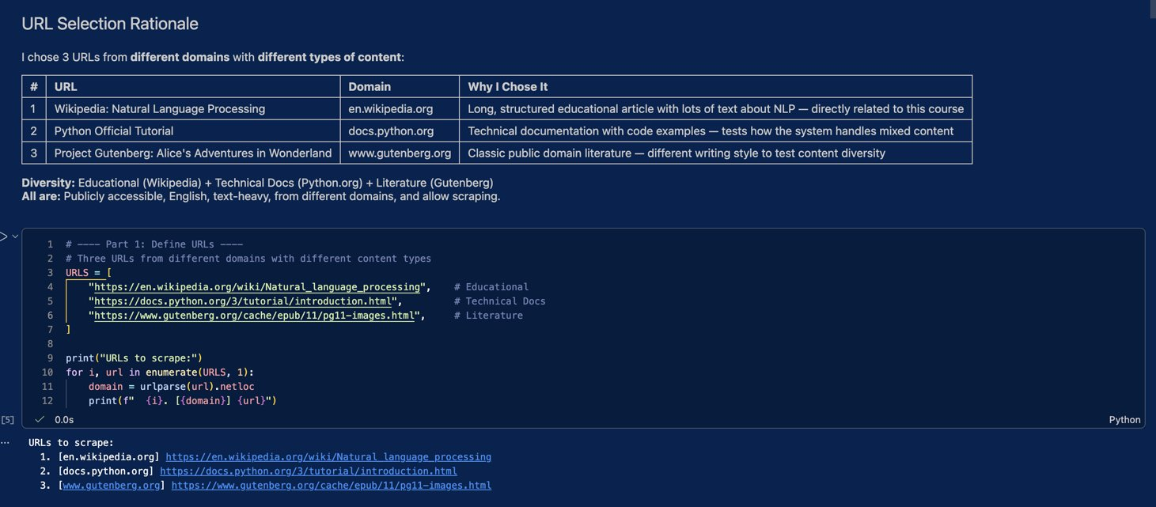
Figure 1: URL selection and code in notebook

3. Results Analysis

3.1 Environment Setup
All three Docker containers (chromadb-server, ollama, open-webui) were started and running successfully:
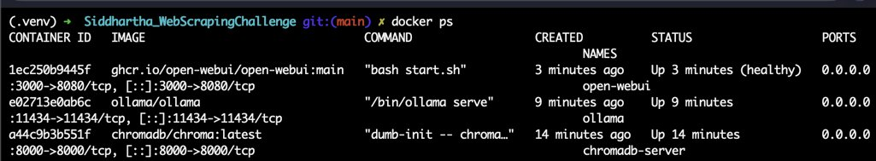
Figure 2: Docker containers running (docker ps output)
ChromaDB heartbeat was verified through the browser:
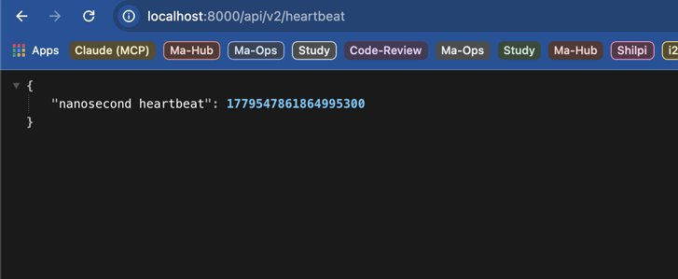
Figure 3: ChromaDB heartbeat response in browser

3.2 Scraping and Chunking Results
All 3 URLs were scraped without errors:
Source | Text Extracted | Chunks Created
en.wikipedia.org | 52,199 characters | 66 chunks
docs.python.org | 18,248 characters | 23 chunks
www.gutenberg.org | 162,100 characters | 203 chunks
TOTAL | 232,547 characters | 292 chunks (≥ 50 required)
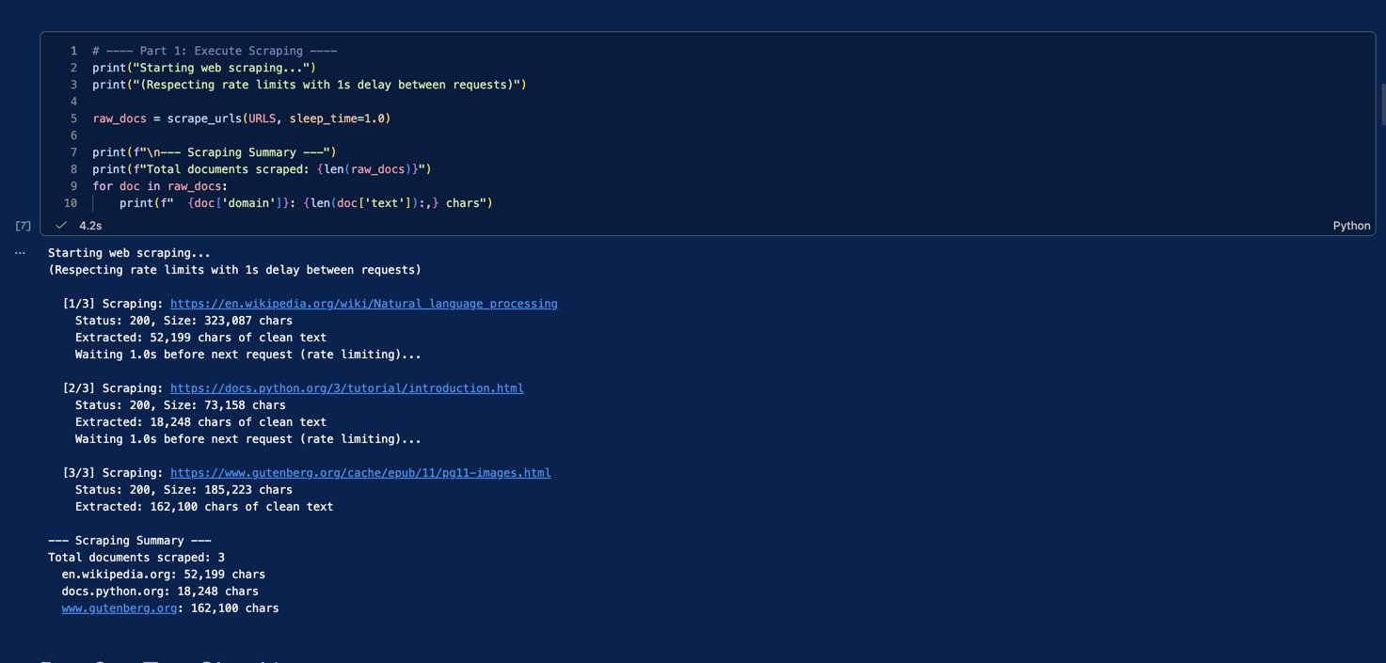
Figure 4: Scraping output showing all 3 URLs scraped successfully
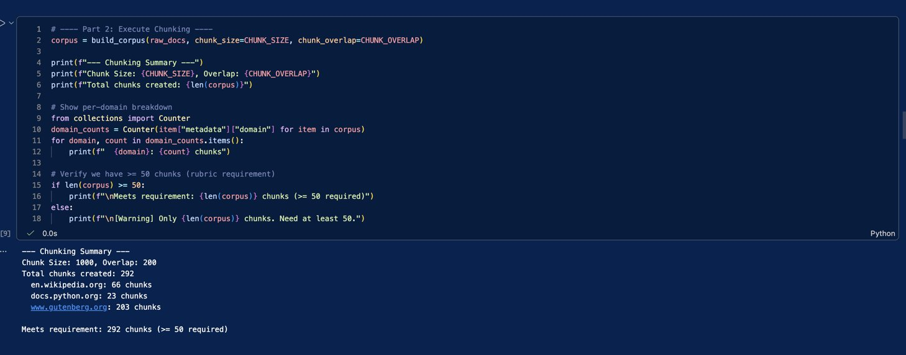
Figure 5: Chunking summary — 292 chunks across 3 domains

3.3 Embeddings and Storage
The embedding model (all-MiniLM-L6-v2) converted each chunk into a 384-dimensional vector. All 292 vectors were stored in ChromaDB successfully.
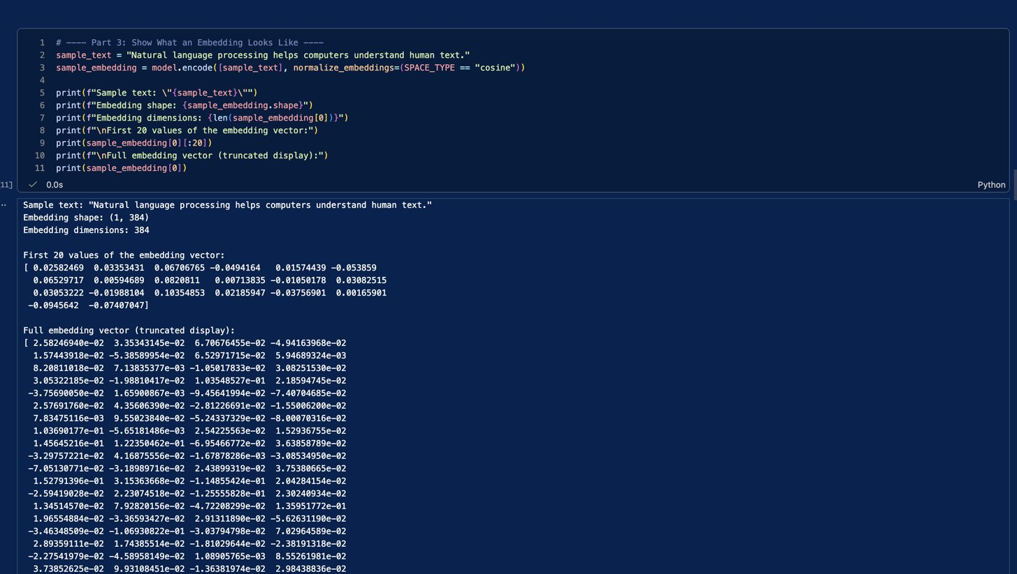
Figure 6: Embedding output showing 384 dimensions and sample vector values
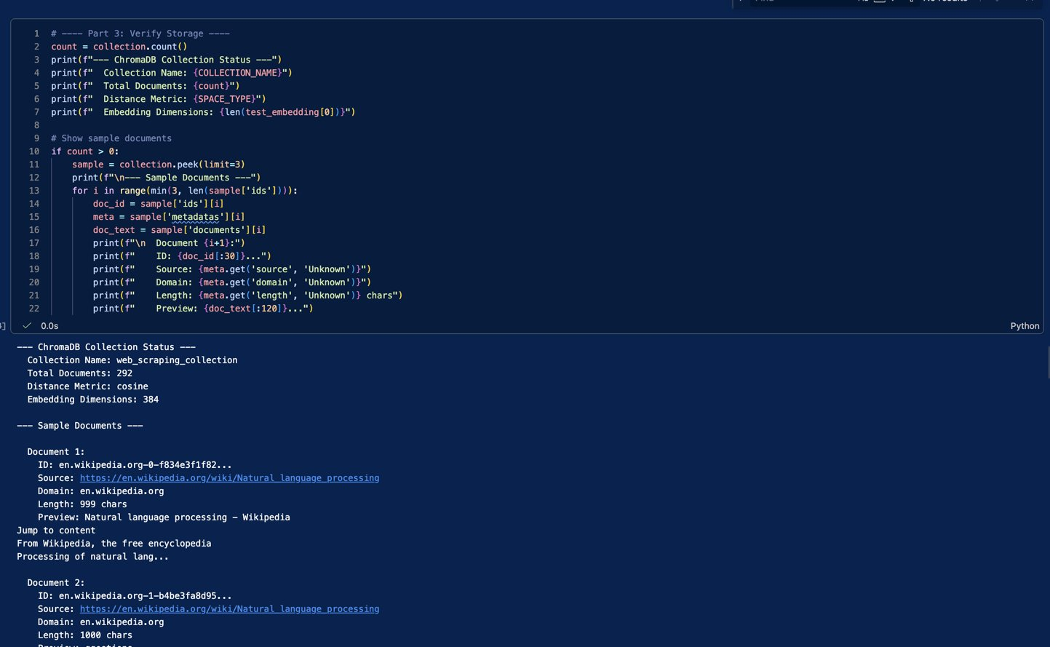
Figure 7: ChromaDB collection status — 292 documents stored with metadata

3.4 Semantic Search Results
I ran three semantic search queries. Each one was designed to match a different source:
- Query 1: "How do machines understand and process human language?" — Top result came from Wikipedia (NLP article) with distance 0.4555. Correct match.
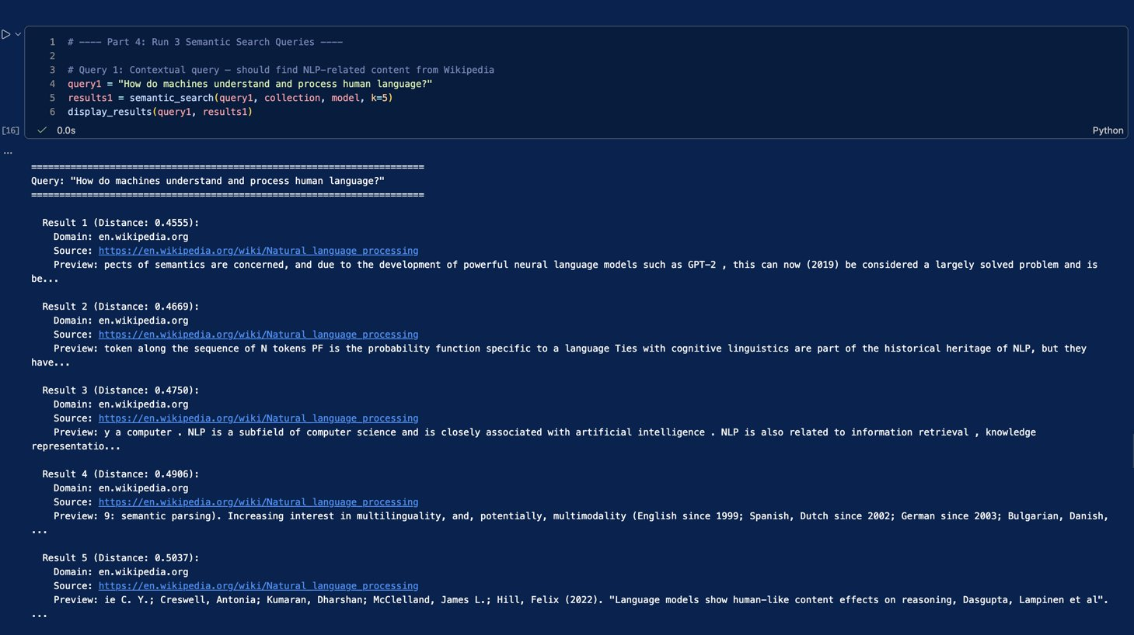
Figure 8: Search Query 1 results — NLP query matches Wikipedia content
- Query 2: "How to use strings and numbers in Python programming" — Top result came from Python docs with distance 0.3506. Correct match.
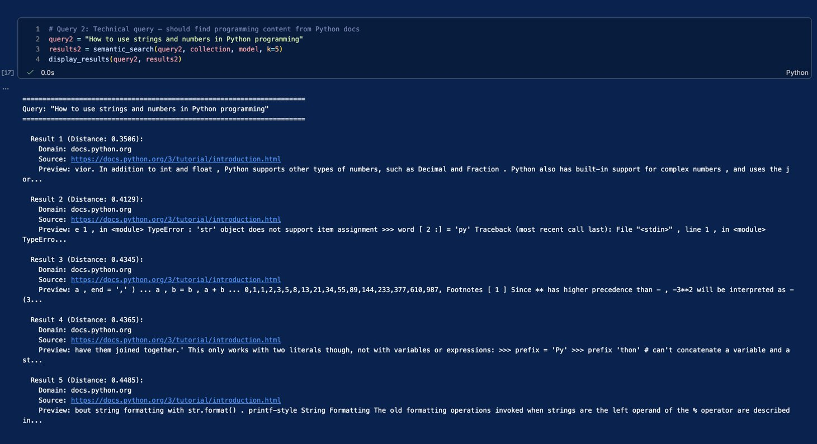
Figure 9: Search Query 2 results — Python query matches docs.python.org
- Query 3: "A curious girl falling down a rabbit hole into a strange world" — Top result came from Gutenberg (Alice in Wonderland) with distance 0.3480. Correct match.
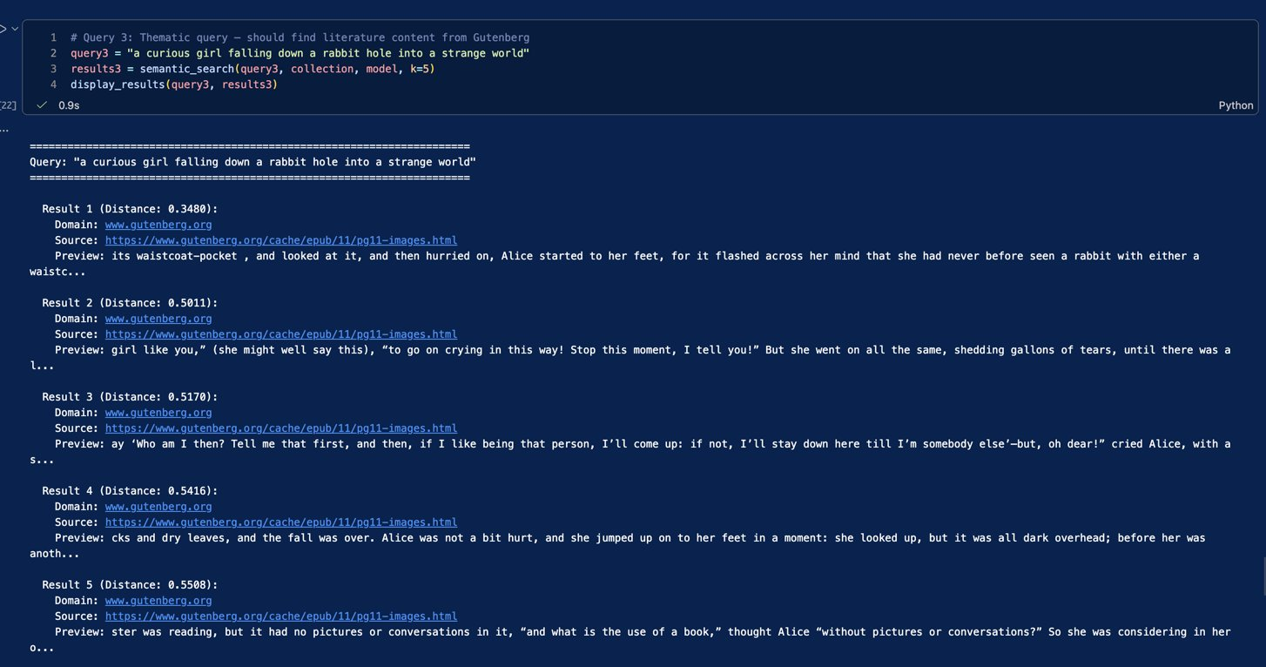
Figure 10: Search Query 3 results — literature query matches Gutenberg
I also compared contextual vs keyword queries. The contextual query gave better (lower) distance scores than the keyword query, showing that the embedding model understands meaning better when you write in natural language.

3.5 Chunk Size Experiment
I tested three different chunk size settings to see how they affect search quality:
Setting | Chunks | Avg Distance | Best Distance
Small (500/100) | 583 | 0.4854 | 0.4651
Medium (1000/200) | 292 | 0.4901 | 0.4680
Large (2000/400) | 147 | 0.5245 | 0.5014
Smaller chunks gave slightly better (lower) distance scores because each chunk is more focused on one topic. However, they create many more chunks which uses more storage. Large chunks have more context but mix multiple topics, making matches less precise. The medium setting (1000/200) gives a good balance between search quality and storage. This is why I kept 1000/200 as the default.
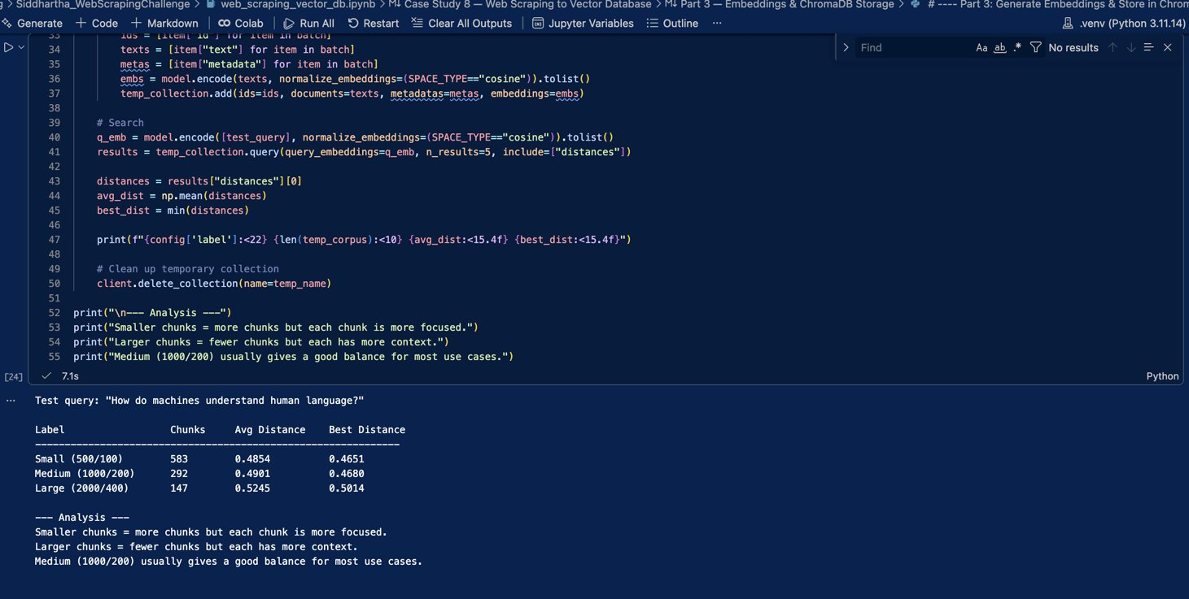
Figure 11: Chunk size experiment comparison

4. Challenges and Mitigations
- Docker setup: Getting all three Docker containers (ChromaDB, Ollama, OpenWebUI) to run at the same time needed enough RAM. I made sure Docker had at least 4GB allocated in its settings.
- Large content from Gutenberg: The Alice in Wonderland page had ~162K characters, creating 203 chunks. This meant Gutenberg dominated the database. In a real project, you might want to balance content from each source.
- Noisy HTML: Some scraped pages included navigation menus, cookie notices, and footer text mixed with the main content. The cleaning function removes most of this, but a few irrelevant lines may still appear.
- Embedding model loading: The first time loading the SentenceTransformer model took extra time because it downloads the model weights. After the first run it loads from cache.

5. Ethical Considerations
- robots.txt: All three websites allow scraping of the pages I used. Wikipedia and Gutenberg are open-access. Python docs are publicly available documentation.
- Rate limiting: The scraper waits 1 second between each request to avoid putting load on the servers.
- Educational use only: All content is scraped for learning purposes only, not for commercial use or redistribution.
- Attribution: Source URLs are stored as metadata with every chunk, so the original source is always tracked.

6. Conclusion
This project successfully built an end-to-end RAG pipeline. I scraped 3 websites, created 292 text chunks, generated 384-dimensional embeddings, and stored everything in ChromaDB. The semantic search works well — each query correctly found content from the right source. The chunk size experiment showed that medium-sized chunks (1000 characters) offer the best balance between precision and context. This pipeline forms a solid foundation for building AI-powered search and chatbot applications.
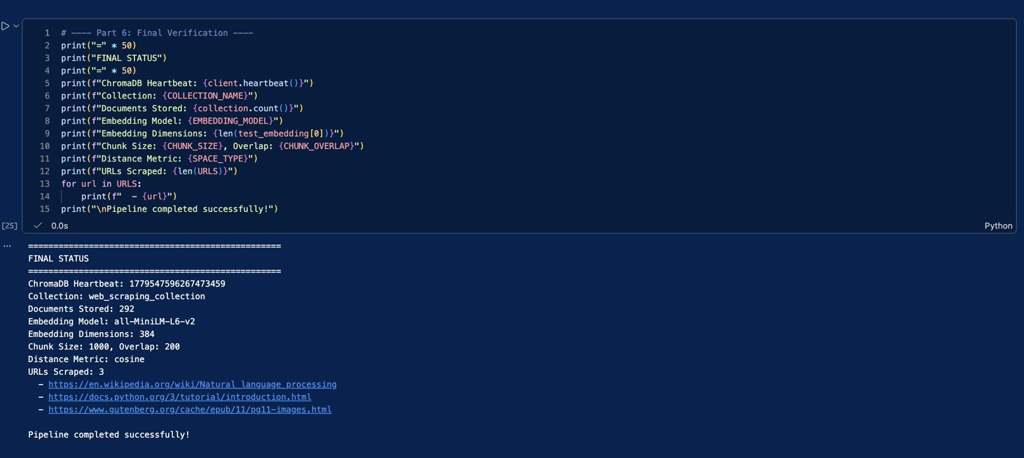
Figure 12: Final pipeline status — all systems verified

