Siddhesh Singh

23070521150

Practical 07

Write and execute PL/SQL function to print /return binary equivalent of decimal number.

# Introduction

A PL/SQL function is a subprogram that computes and returns a value. It helps in reusability, modular programming, and efficient database operations.

# Key Concepts Used in This Program

* Functions in PL/SQL: A function must have a return type and return a value.
* Loops in PL/SQL: We use loops to repeatedly divide the decimal number by 2 to obtain its binary equivalent.
* String Operations: We build the binary number as a string.

# PL/SQL Function to Convert Decimal to Binary Steps to Convert Decimal to Binary in PL/SQL

* 1. Take a decimal number as input.
  2. Use a LOOP to repeatedly divide the number by 2.
  3. Store the remainders (0 or 1) in reverse order.
  4. Return the final binary string.

# PL/SQL Function Code

CREATE OR REPLACE FUNCTION decimal_to_binary(n IN NUMBER) RETURN VARCHAR2 IS

binary_result VARCHAR2(100) := ''; -- Variable to store the binary equivalent

num NUMBER := n; -- Copy of the input number remainder NUMBER; -- Stores remainder after division

## BEGIN

-- Check for zero case IF num = 0 THEN

## RETURN '0'; END IF;

-- Loop to convert decimal to binary WHILE num > 0 LOOP

remainder := MOD(num, 2); -- Get remainder when divided

by 2

binary_result := remainder || binary_result; -- Build

binary string in reverse

num := TRUNC(num / 2); -- Reduce number by dividing by

2

## END LOOP;

RETURN binary_result; -- Return final binary value END decimal_to_binary;

/

# How to Execute the Function

**Call the Function Using PL/SQL Block**

## DECLARE

decimal_num NUMBER := 10; -- Example decimal number binary_value VARCHAR2(100);

## BEGIN

binary_value := decimal_to_binary(decimal_num); DBMS_OUTPUT.PUT_LINE('Binary equivalent of ' || decimal_num

|| ' is: ' || binary_value); END;

/

# Expected Output:

**Binary equivalent of 10 is: 1010**

# Explanation of the Code

|  |  |
| --- | --- |
| **Step** | **Description** |
| Function Creation | Defines decimal_to_binary function with input n  (decimal number). |
| Binary Result Variable | Stores the binary representation as a string. |
| Loop Execution | Repeatedly divides num by 2, storing remainders. |

|  |  |
| --- | --- |
| String Concatenation | Builds binary number in reverse order. |
| Return Statement | Returns the final binary string. |

**Task**

1. Modify the function to display step-by-step conversion while calculating binary.

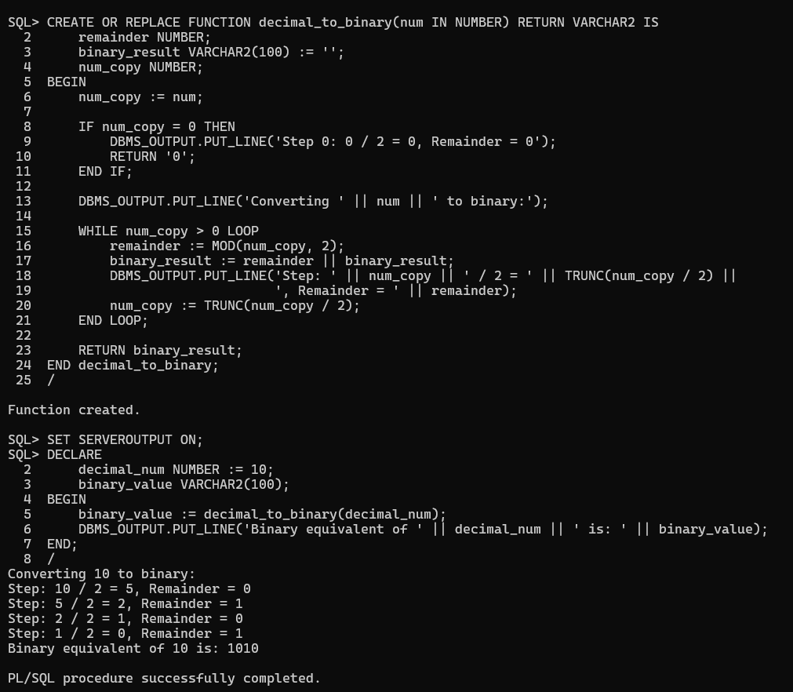

1. Write a PL/SQL block to accept user input for the decimal number and call the function.

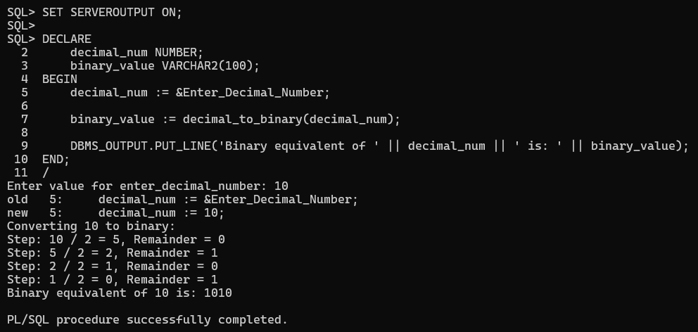

1. Modify the function to store binary values in a table (binary_conversions).

