# Siddhesh Singh

# 23070521150

# Subquery Tasks

1. Find the **highest-spending customer** in 2024.

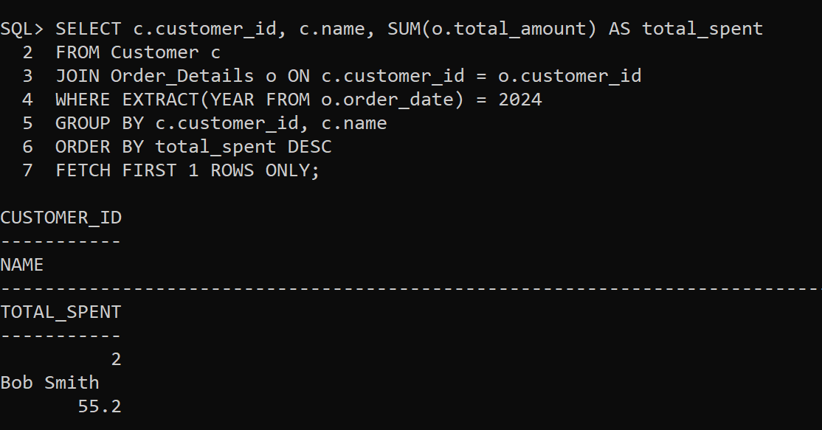

1. Retrieve the **most ordered product** based on quantity.

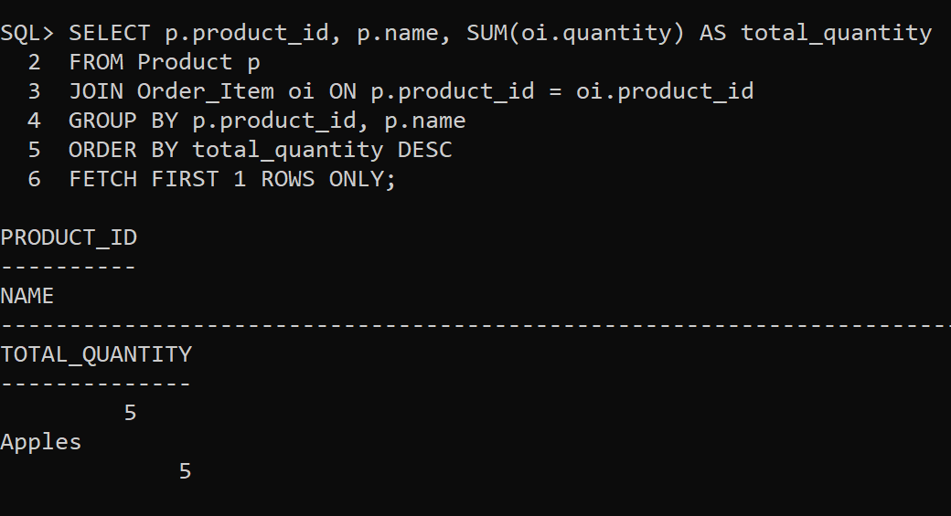

1. Find employees who **earn more than the lowest-paid manager**.

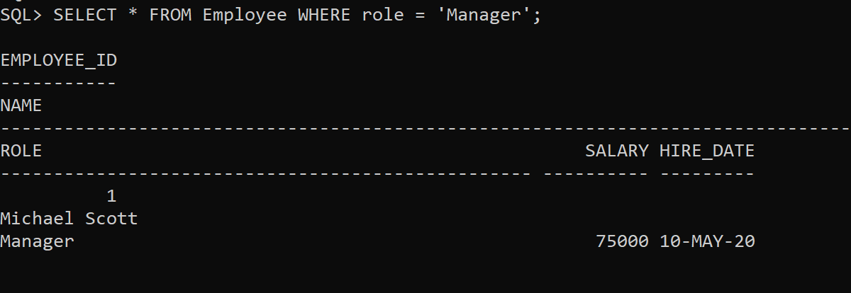

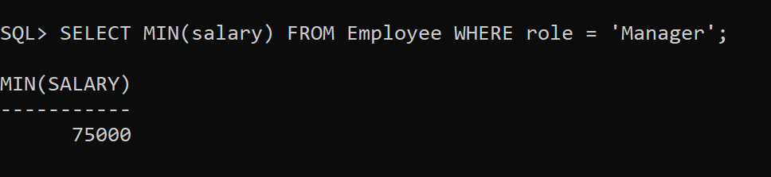

1. Retrieve customers who **placed orders only in 2023 but not in 2024**.

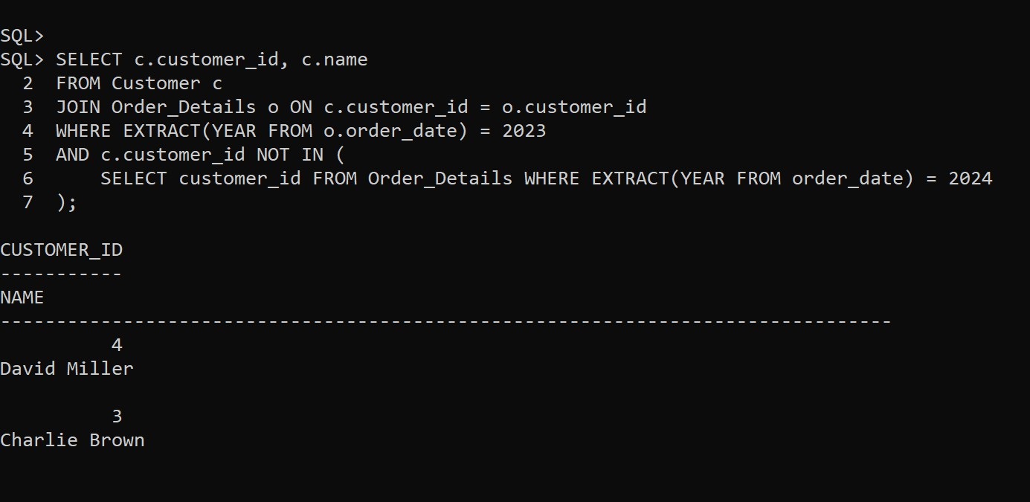

1. Find the **total revenue generated in February 2024**.

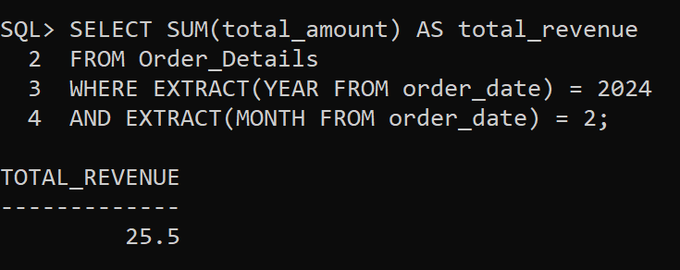

# Joins Tasks

1. Find the **top 3 customers** with the **highest total spending**.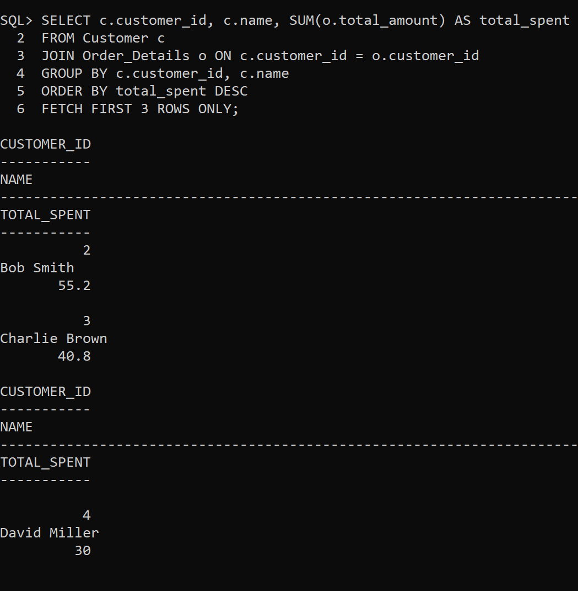
2. Retrieve **employee names** along with the **total revenue generated from their assigned orders**.

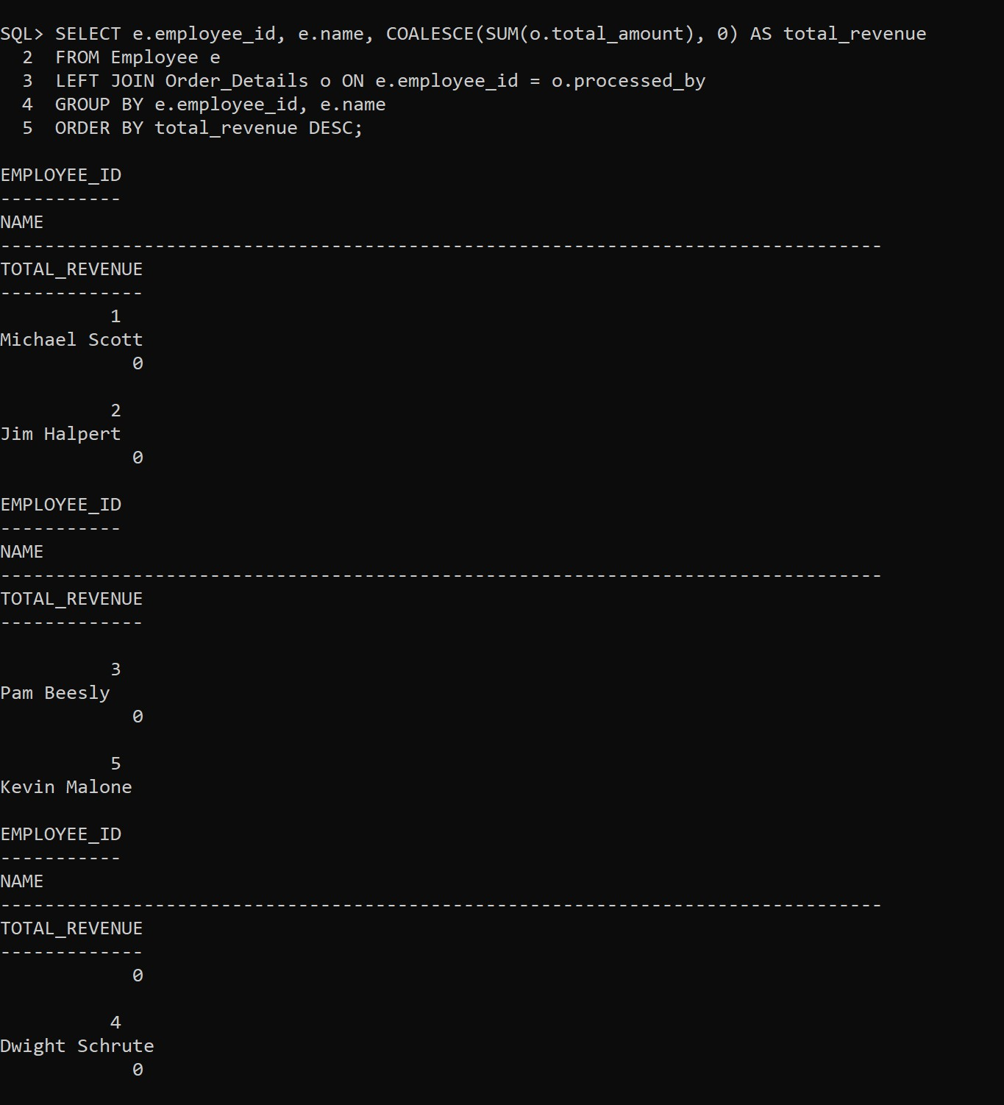

1. Show the **most ordered product category** and its total quantity sold.
2. Retrieve employees who **earn more than their colleagues** using a **SELF JOIN**.
3. Find employees who **work under the same manager** using a **SELF JOIN**.

