## MNIST with Docker

Siddhant Patny (sp5331)

Instructions:

* Steps: Create a Vagrant File with Docker Preinstalled
* Run MNIST inside Docker on the virtual box

Report:

Docker is popular tool to build images, create containers for different applications or deployments and use volumes to mount and persist user data.

For this assignment, I created a virtualbox VM using vagrant with the vagrantfile provided in this repo [1] as the base. I increased memory using the vagrant plug-in [2]. I also changed the base image for docker to the tiny python 3.6 container. This enabled the image to be smaller than a larger Ubuntu container. The VM ran with the latest 64-bit version of Ubuntu with docker and IBM Cloud CLI installed.

Once the VM was ready. I could ssh into it. I added the code and dockerfile to the VM directory and built the docker image. The MNIST code was cloned from the pytorch-cli repository [3]. The docker container installed the requirements using pip and had the final layer of the code. This allowed for easy upgrade as the final layer of the code changes the most. We build this and give it a new tag (mnist-train) as the code downloaded the MNIST dataset, trained the model and saved the saved the model state in a file (mnist_cnn.pt). Optionally, I also pushed the image to my docker hub using docker login and docker tag (image id) (tag name). Since the image is large (2.3GB) because of the pytorch dependencies (in the second to last layer), this could take some time. The image can be found it siddpatny/mnist-train.

Once the image was built, I could run the container and see the training output on the terminal as shown in the image below. This process of containerizing was convenient and efficient as I could load the VM or a new VM with the container image by specifying the docker image and it would set up the container with the dependencies installed and run the training with a few simple steps. Since the code was currently running on a VM in my local machine. It was much slower than running it on a cloud provider or HPC cluster. However on an old system which I have been using for years with multiple environments, it enabled me to isolate this application in the container and install the dependencies and run the train, with very little configuration and no conflict with other projects.

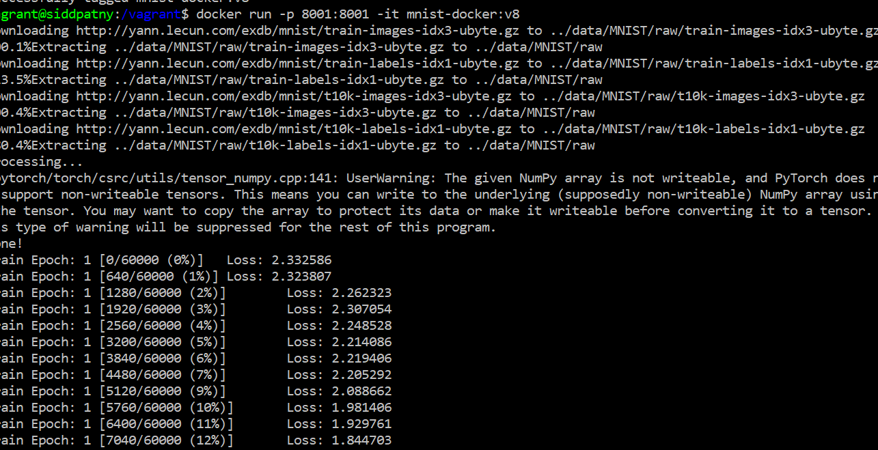

References

1. <https://github.com/ihchung/cloudml/tree/master/vg-ibmcloud>
2. <https://github.com/sprotheroe/vagrant-disksize>
3. <https://github.com/nyuspring2020/pytorch-cli>