CardioSentinel: A Multi-Model Federated Framework for ECG-Based Heart Disease Detection
Siddhi Salunkhe (23BDS0243) and Sanvi Saket (23BDS0210)
Abstract— Automatic interpretation of the 12-lead electrocardiogram (ECG) can speed up the detection of myocardial infarction, ischaemic changes, conduction disturbances and hypertrophy, but the deep networks that perform best are trained on centrally pooled data, whereas hospitals cannot share patient records. Federated learning removes this constraint, yet common methods average model parameters over many rounds and therefore force every institution to train the same architecture, and few ECG studies explain their predictions or state when a finding should be referred. This paper proposes CardioSentinel, a one-shot federated model in which four clients train structurally different networks (a 1D CNN, a 1D ResNet, a BiLSTM and a CNN-LSTM) on disjoint, patient-separated data, calibrate them with a temperature, and share only class probabilities with a server that combines them with weights on the probability simplex. Equal, learned static and per-patient dynamic weights are selected by patient-grouped cross-validation with a parsimony margin. Experiments use 21,388 records of PTB-XL for multi-label classification of five superclasses, with 80% of the data for training, 10% for validation and an untouched 10% for testing, over three seeds. The federated model achieves a macro AUROC of 0.905, a macro F1 of 70.7% and a label-wise accuracy of 86.9%, improves on the best single client in every seed (+0.009 to +0.012 AUROC, paired bootstrap), and comes within 0.004 AUROC of a centrally trained model and within 0.002 of FedAvg, which needs 20 rounds and a shared architecture. Integrated Gradients localise the evidence in leads and waveform segments, and per-finding triage decides 53.7% of findings automatically at 0.937 precision. Most of the benefit of pooling ECG data is thus obtained without exchanging data, parameters or architectures.
Index Terms— Electrocardiogram, federated learning, ensemble learning, multi-label classification, PTB-XL, explainable artificial intelligence, calibration.

I. Introduction
Cardiovascular diseases remain the leading cause of death worldwide, and the Global Burden of Disease study estimated that their prevalence has almost doubled between 1990 and 2019 [1]. The 12-lead electrocardiogram (ECG) is the first-line, low-cost and non-invasive test for most of these conditions: it is recorded in primary care, emergency departments and wards, and a single ten-second recording can reveal myocardial infarction (MI), ischaemic ST/T changes (STTC), conduction disturbances (CD) and ventricular hypertrophy (HYP). Because a large fraction of ECGs is acquired where no cardiologist is present, reliable automatic interpretation directly affects how quickly a patient with an acute finding is identified and referred.
Problem definition. In current practice the ECG is interpreted visually by a physician, often supported by rule-based software built into the electrocardiograph. Visual reading is subjective and depends on training and workload, and the built-in algorithms are known to produce frequent errors, especially for non-sinus rhythms and subtle morphological changes, so their statements have to be over-read by an expert [2]. A single ECG can, moreover, carry several co-existing diagnoses, which makes the task inherently multi-label rather than a choice between mutually exclusive classes. In this work the problem is therefore formulated as the multi-label prediction of the five diagnostic superclasses NORM, MI, STTC, CD and HYP from the raw 12-lead signal.
Deep learning has substantially changed automatic ECG analysis. Convolutional and recurrent networks have reached cardiologist-level performance on single-lead ambulatory recordings [3] and on large 12-lead cohorts [4], and the public PTB-XL dataset [5] has enabled reproducible benchmarks in which ResNet, Inception and LSTM models reach macro areas under the ROC curve (AUROC) between 0.921 and 0.930 on the superdiagnostic task [6]. Subsequent work has added self-supervised pretraining [7], [8], state space models and patient metadata [9], and ECG–text multimodal learning [10], [11]. Three gaps nevertheless remain. First, almost all of these models are trained on centrally pooled data, whereas in practice ECG archives are held by separate hospitals that cannot share patient records. Second, the federated learning (FL) methods that address this constraint [12], [13], such as FedAvg [14], FedProx [15] and SCAFFOLD [16], average model parameters and therefore require every site to train the same architecture over many communication rounds. Third, the clinical use of such models requires explanations and an explicit statement of when the model should not decide on its own, which most ECG studies do not provide [17].
Motivation and novelty. This paper studies a setting in which several institutions each own a disjoint, patient-separated share of the training data and are free to choose their own network architecture. Instead of averaging parameters, each institution trains its model once, calibrates it, and contributes only its predicted class probabilities to a central gate, which combines them as P(y∣x)=i​wiPi(y∣x) with weights on the probability simplex. This one-shot, prediction-level form of federation needs a single communication step per query, places no constraint on the client architectures, and never moves raw ECGs or parameters between sites. The question addressed is deliberately conservative: whether the aggregated model is better than the best individual client, and how close it comes to a model trained on all data pooled together. The weighting scheme itself is selected on validation data with a rule that prefers the simplest combiner unless a more complex one is clearly better, and the final model is evaluated once on the held-out PTB-XL test fold over three random seeds.
The major contributions of this work are as follows.
- One-shot federated aggregation of heterogeneous clients: Four clients train structurally different networks (a 1D CNN, a 1D ResNet, a BiLSTM and a CNN-LSTM) on disjoint, patient-level shares of PTB-XL, and only calibrated probabilities are exchanged, so no parameter averaging and no common architecture are required.
- Calibrated simplex gate with parsimony-first selection: Equal weights, learned static weights and a per-patient dynamic gate are fitted on patient-grouped cross-validation predictions, and a more complex combiner is adopted only if it improves the validation macro AUROC by at least 0.002.
- Rigorous multi-seed evaluation against strong references: Over three seeds the selected gate reaches a test macro AUROC of 0.905 and improves on the best single client in every seed (paired bootstrap), and it is compared with traditional classifiers on 172 hand-crafted features and with FedAvg, FedProx, SCAFFOLD and FedNova on the same partitions, remaining within 0.002 AUROC of FedAvg with a single communication round.
- Client-level ablation and attribution: All 15 client subsets are evaluated and the contribution of each institution is quantified with Shapley values, showing why learned weights that discard weaker clients lose to equal weighting.
- Explainability and safe automation: Integrated Gradients attribute each superclass prediction to leads and time, and per-finding rule-in/rule-out bands fitted on validation data automate 53.7% of findings with a precision of 0.937 and an accuracy of 0.967 while referring the remaining findings to a cardiologist.
The rest of this paper is organized as follows. Section II reviews recent unimodal, multimodal, federated and explainable approaches to ECG and clinical classification. Section III describes the proposed model, including preprocessing, the client networks, the federated aggregation and the explainability methods. Section IV presents the dataset, the experimental setup, the comparisons, the ablation experiments, the federated and class-wise analyses and the explainability results. Section V concludes the paper and outlines future work.

II. Related Work
This section reviews peer-reviewed studies published between 2022 and 2026 that are closest to the present work. They are grouped into unimodal deep-learning approaches for the ECG, multimodal approaches, federated-learning approaches and explainable approaches. The reported figures are those stated by the respective authors on their own datasets and splits; they are therefore not directly comparable with each other, and the metric is named whenever it is not accuracy. Table I summarises the review.

A. Unimodal ML/DL Approaches
Mehari and Strodthoff (2022) [7] proposed adapting contrastive predictive coding, SimCLR, BYOL and SwAV to 12-lead ECGs from PTB-XL and achieved a macro AUROC of 94.18% on the 71-statement task after self-supervised pretraining and fine-tuning, but the gain over supervised training was about one percentage point and the pretraining relied on pooling several large public corpora at one site. Na et al. (2024) [8] proposed ST-MEM, a spatio-temporal masked auto-encoder, using PTB-XL for evaluation on the five diagnostic superclasses and achieved 82.5% accuracy and a macro AUROC of 93.3% after fine-tuning, but the method requires large-scale centralised pretraining and does not explain its decisions. Mehari and Strodthoff (2023) [9] proposed structured state space (S4) models for the raw 12-lead signal and achieved a macro AUROC of 94.17% on the PTB-XL 71-statement task from the signal alone, but the model was trained on a single pooled dataset and its comparison with convolutional baselines was limited to centralised training. Together these studies establish strong single-site baselines, yet each assumes that all training records can be gathered in one place.

B. Multimodal Approaches
Mehari and Strodthoff (2023) [9] also proposed fusing basic demographic metadata with the ECG representation of a pretrained S4 model on PTB-XL and achieved a macro AUROC of 94.63%, but the metadata improved the result by only 0.18 percentage points and the fusion was again centralised. Li et al. (2023) [10] proposed METS, which aligns ECG signals with automatically generated reports through a frozen language model, using PTB-XL and achieved 84.2% zero-shot accuracy on the superclass task, but its macro F1 of 65.7% remained below the 77.6% of a supervised ResNet-18 reported in the same study. Liu et al. (2024) [11] proposed MERL, an ECG–report multimodal pretraining method with test-time clinical-knowledge prompts, using MIMIC-ECG for pretraining and six public datasets for evaluation and achieved an average zero-shot AUROC of 75.2%, but zero-shot performance stays well below supervised fine-tuning and the method needs paired free-text reports for every training ECG. Palakayala et al. (2025) [18] proposed HAMF, a hierarchical attention-based fusion of MRI, gait and speech for Parkinson’s disease, using PPMI, PhysioNet and voice repositories and achieved 94.2% accuracy, but the modalities were compiled from different cohorts rather than acquired from the same patients and the model was trained centrally. These studies show that additional modalities can help, but also that every modality must be available for each patient at one site.

C. Federated Learning Approaches
Raza et al. (2022) [19] proposed a federated transfer-learning framework with a convolutional auto-encoder and an explanation module, using the MIT-BIH arrhythmia database and achieved 98.9% accuracy on clean signals (94.5% on noisy signals), but the evaluation used five-fold cross-validation on beats of a 48-record database rather than patient-level 12-lead diagnosis. Goto et al. (2022) [20] proposed multinational FL for ECG and echocardiogram models across three hospitals in the United States and Japan and achieved AUROCs of 90%–96% on internal test sets and 93% on an external site for hypertrophic cardiomyopathy, but all sites trained the same architecture and the task was a single binary diagnosis. Quan et al. (2025) [21] proposed FedOcw, which optimises client-specific aggregation weights in every round, using five multilingual speech corpora for Parkinson’s disease and achieved 74.81% accuracy in the Spanish–Italian scenario, outperforming FedAvg, FedProx, SCAFFOLD and FedNova, but the method still averages parameters of an identical network over 100 rounds. Sathi et al. (2025) [22] proposed explainable FL on ECG fiducial features with SHAP and LIME, using the MIT-BIH, European ST-T and Fantasia databases and achieved 92.3% accuracy, but the clients shared one model family and the reported accuracies vary between sections of the study. In all of these studies the clients are required to train the same model and to communicate repeatedly.

D. Explainable AI Approaches
Jahmunah et al. (2022) [23] proposed DenseNet and CNN models with Grad-CAM, using the PTB diagnostic database to separate healthy subjects from ten MI locations and achieved accuracies above 95%, but the data came from a small cohort and the heat maps were assessed only qualitatively. Wagner et al. (2024) [17] proposed a set of building blocks for auditing ECG models, comparing local attributions with concept-based global analyses on PTB-XL, and reported that saliency was the only attribution method that passed all of their sanity checks, but the study focuses on the explanation methods and does not propose a new classifier. Pantelidis et al. (2025) [24] proposed ECG-XPLAIM, an inception-style 1D CNN with Grad-CAM trained on MIMIC-IV and externally validated on PTB-XL, and achieved a macro AUROC of 98% for conduction disturbances, but the model addresses selected arrhythmias and its sensitivity for long-QT detection was only 69.1%. Explainability is increasingly expected, yet it is rarely combined with a privacy-preserving training scheme or with a mechanism that decides which predictions should be referred to a clinician.
TABLE I. Summary of related work (reported figures are the authors’ own; metric named when not accuracy)
Ref | Author & Year | Dataset / Modality | Model / Method | Accuracy (%) | Limitation
[7] | Mehari & Strodthoff, 2022 | PTB-XL; 12-lead ECG | CPC self-supervised pretraining + LSTM | 94.18 (macro AUROC) | Centralised pretraining on pooled corpora
[8] | Na et al., 2024 | PTB-XL superclasses; ECG | ST-MEM masked auto-encoder | 82.5 (AUROC 93.3) | Large centralised pretraining; no explanations
[9] | Mehari & Strodthoff, 2023 | PTB-XL; ECG (+ metadata) | S4 state space model | 94.17 / 94.63 (macro AUROC) | Single site; metadata adds 0.18 points
[10] | Li et al., 2023 | PTB-XL; ECG + report text | METS, frozen language model | 84.2 (zero-shot) | F1 65.7 below supervised ResNet-18
[11] | Liu et al., 2024 | MIMIC-ECG + 6 datasets; ECG + text | MERL multimodal pretraining | 75.2 (avg. zero-shot AUROC) | Needs paired reports; below fine-tuning
[18] | Palakayala et al., 2025 | PPMI, PhysioNet, voice; MRI, gait, speech | HAMF hierarchical attention fusion | 94.2 | Modalities from different cohorts; centralised
[19] | Raza et al., 2022 | MIT-BIH; single-lead beats | Federated transfer learning + XAI | 98.9 (clean), 94.5 (noisy) | Beat-level task; same model on all clients
[20] | Goto et al., 2022 | 4 hospitals; ECG, echo | Multinational FL | 90–96 (AUROC) | Binary task; homogeneous architectures
[21] | Quan et al., 2025 | 5 speech corpora | FedOcw optimised client weights | 74.81 | 100 rounds of parameter averaging
[22] | Sathi et al., 2025 | MIT-BIH, ST-T, Fantasia; fiducial features | Explainable FL with SHAP/LIME | 92.3 | Hand-crafted features; inconsistent reporting
[23] | Jahmunah et al., 2022 | PTB; 12-lead ECG | DenseNet/CNN + Grad-CAM | $>$95 | Small cohort; qualitative heat maps
[17] | Wagner et al., 2024 | PTB-XL; 12-lead ECG | Attribution sanity checks, concept analysis | – (not reported) | Explanation study, no new classifier
[24] | Pantelidis et al., 2025 | MIMIC-IV $→$ PTB-XL; ECG | ECG-XPLAIM 1D CNN + Grad-CAM | 98 (macro AUROC, CD) | Selected arrhythmias; LQT sensitivity 69.1
This work | – | PTB-XL superclasses; 12-lead ECG | One-shot federated gate over 4 heterogeneous clients | 86.9 (label-wise); AUROC 90.5 | See Section IV-H

E. Research Gap
The reviewed studies reveal three gaps that motivate this work. Single-site ECG models achieve high AUROC but assume that all records can be pooled. Federated methods remove this assumption but average parameters, so every institution must adopt the same architecture and participate in many synchronised rounds. Explainable models, finally, are seldom combined with privacy-preserving training or with an explicit rule for deferring uncertain findings. The proposed model addresses these gaps by letting each institution train its own architecture once, combining only calibrated probabilities through a validated simplex gate, explaining the combined prediction with attributions on the raw signal, and reporting automatically only those findings for which the validated precision and recall reach the clinical target.

III. Proposed Model
The proposed model, CardioSentinel, classifies a 10-s, 12-lead ECG into the five PTB-XL diagnostic superclasses with a privacy-preserving, one-shot federated scheme. The training records are divided into four disjoint, patient-separated partitions that play the role of four institutions. Each client preprocesses its own recordings identically, trains its own network architecture locally, and calibrates it with a single temperature. The central server never receives signals or parameters; it receives only the calibrated class probabilities of the clients and combines them with weights constrained to the probability simplex. The weighting rule, the per-class decision thresholds and an optional triage band are all fitted on a separate validation fold, and the combined prediction is explained with Integrated Gradients and with Shapley values over clients. The six subsections below describe the architecture, the preprocessing, the features, the classification task, the federated protocol and the explainability methods.

A. Architecture
Fig. 1 shows the architecture. The data block at the bottom holds the PTB-XL records, already split by the official stratified folds into four client partitions, a validation fold and a test fold. The pre-processing block applies the same signal pipeline at every client (Section III-B). The feature analysis stage is performed inside each client network, which learns its own representation of the 12 leads (Section III-C). Each of the four local client models ends in its own classifier head, marked C in the figure, that outputs five logits; these are converted into calibrated probabilities with a per-client temperature. The federated server combines the four probability vectors with the simplex weights $w_{i}$ into the global model output, the classification block turns the global probabilities into five binary decisions with per-class thresholds and, optionally, into automatic-or-referred triage decisions, and the explainability block attributes the global output to leads and time.
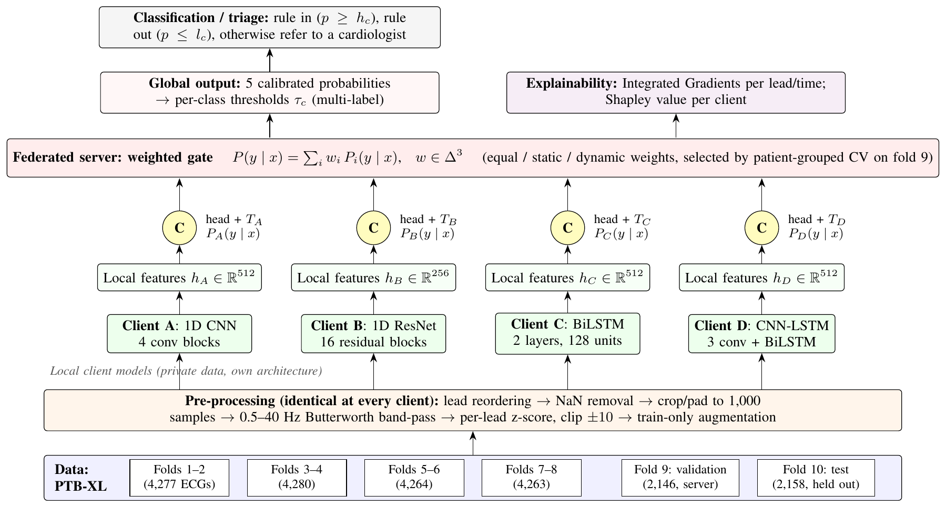
Fig. 1. Architecture of the proposed CardioSentinel model. Four clients hold disjoint, patient-separated PTB-XL partitions, apply the same pre-processing, learn their own features with different network architectures and expose only calibrated probabilities through their classifier heads (C). The server combines the probabilities on the simplex, thresholds them per class and explains the global output.
Model progression. The four clients were deliberately chosen to span the main families of ECG networks, from purely convolutional to purely recurrent, so that their errors are as diverse as possible. Client A is a plain 1D CNN with four blocks of a 7-tap convolution (no bias), batch normalisation, ReLU and max-pooling by two, with 32, 64, 128 and 256 channels. For an input $x∈R^{12×1000}$ each block computes
$$h^{(l+1)}={MaxPool}_{2}\left(ReLU(BN(W^{(l)}*h^{(l)}))\right), (1)$$
and the final feature map is summarised by concatenated global average and global max pooling, AM(h)=[1Tt​ht; maxtht]. Client B is a 1D ResNet [25] with a 7-tap, 64-channel stem and stages of 64, 128, 256 and 256 channels containing 3, 4, 6 and 3 residual blocks with 5-tap kernels, in which the last batch normalisation of each block is initialised to zero so that each block starts as the identity, $h^{(l+1)}=ReLU(F(h^{(l)})+S(h^{(l)}))$. Client C is a two-layer bidirectional LSTM [26], [27] with 128 hidden units per direction that reads the 1,000 time steps directly; each direction updates
$$i_{t}=σ(W_{i}x_{t}+U_{i}h_{t−1}+b_{i}),$$
$$f_{t}=σ(W_{f}x_{t}+U_{f}h_{t−1}+b_{f}),$$
$$o_{t}=σ(W_{o}x_{t}+U_{o}h_{t−1}+b_{o}),$$
$$g_{t}=tanh(W_{c}x_{t}+U_{c}h_{t−1}+b_{c}),$$
$$c_{t}=f_{t}⊙c_{t−1}+i_{t}⊙g_{t}, h_{t}=o_{t}⊙tanh(c_{t}), (2)$$
and the forward and backward states are concatenated and pooled with $AM(⋅)$. Client D is a CNN-LSTM hybrid in which three convolutional blocks (32, 64 and 128 channels) shorten the sequence from 1,000 to 125 steps before a one-layer BiLSTM with 128 hidden units, so that local wave morphology is captured by the convolutions and rhythm context by the recurrence. All clients share the same head, $Linear(d​→​256)​→​ReLU​→​Dropout(0.3)​→​Linear(256​→​5)$, and the same training recipe, so that only the architecture and the data differ. On the held-out test fold this progression moves the macro AUROC from 0.882–0.888 for the convolutional clients to 0.894 for the BiLSTM and 0.896 for the CNN-LSTM, and the federated gate over all four reaches 0.905 (Section IV-C). An attention-based client was not part of the study.
Algorithm 1 summarises the complete method, from preprocessing to the explained, triaged prediction.
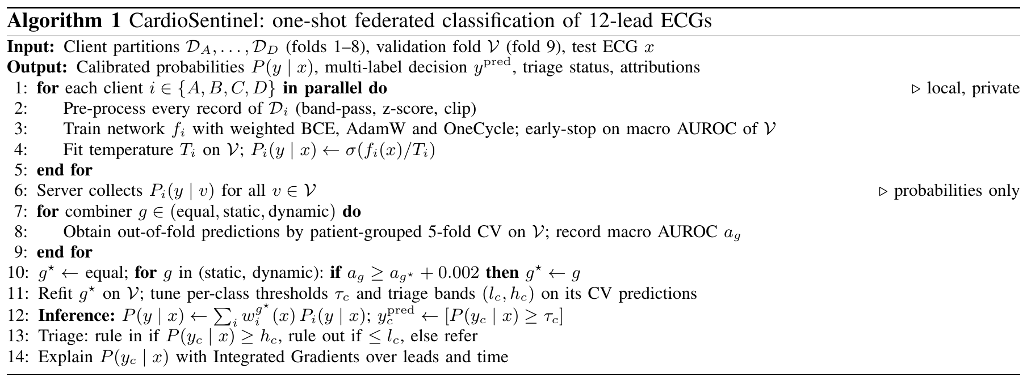

B. Preprocessing
All preprocessing steps are listed in Table II. They are implemented once and executed identically by every client, so no client-specific normalisation statistics are needed and no information crosses client boundaries.
Label encoding and cleaning. Each record’s SCP-ECG statements are mapped to the diagnostic_class column of scp_statements.csv, keeping only the 44 statements flagged as diagnostic, and encoded as a multi-hot vector over (NORM, MI, STTC, CD, HYP). Records without any diagnostic superclass cannot be labelled and are removed, which reduces the 21,799 records to 21,388. No other record is excluded.
Signal cleaning. The 100-Hz waveforms are read with the WFDB library and reordered to I, II, III, aVR, aVL, aVF, V1–V6, matching lead names case-insensitively. Non-finite samples are replaced by zero, and every signal is cropped or zero-padded to exactly 1,000 samples. Baseline wander and high-frequency noise are removed with a third-order Butterworth band-pass filter between 0.5 and 40 Hz applied forwards and backwards, so that the filter introduces no phase shift. The filtered signals are stored in millivolts without normalisation.
Normalisation. At load time each lead of each recording is z-scored with its own mean and standard deviation, $x_{ℓt}^{norm}=(x_{ℓt}−μ_{ℓ})/σ_{ℓ}$, clipped to $[−10,10]$, and a lead whose standard deviation is below ${10}^{−6}$ is set to zero. Because the statistics are per-recording, the normalisation needs no shared population statistics, which is essential in the federated setting.
Augmentation and class balancing. During training only, each signal is multiplied by a random amplitude factor in $[0.9,1.1]$, white Gaussian noise is added at a signal-to-noise ratio drawn from 20–30 dB, a sinusoidal baseline wander of 0.1–0.5 Hz with an amplitude of 0.05–0.3 standard deviations is added to every lead, and each lead is zeroed with probability 0.05. Class imbalance is handled in the loss rather than by resampling: the positive term of each class is weighted by the ratio of negatives to positives in the client’s training data (Section III-D). Modality alignment is not required because a single modality is used, but all leads are aligned in time by construction.
TABLE II. Pre-processing steps and parameters
Step | Method and parameters
Label encoding | SCP codes $→$ 5 diagnostic superclasses (44 diagnostic statements); multi-hot
Record cleaning | Remove records without a superclass (21,799 $→$ 21,388)
Lead order | I, II, III, aVR, aVL, aVF, V1–V6
Missing values | NaN/$±∞$ $→$ 0
Length | 100 Hz, crop/zero-pad to 1,000 samples (10 s)
Filtering | Butterworth band-pass 0.5–40 Hz, order 3, zero-phase
Normalisation | Per-lead, per-record z-score; clip to $±10$; flat lead $→$ 0
Augmentation (train) | Amplitude $×U(0.9,1.1)$; noise SNR $U(20,30)$ dB; wander 0.1–0.5 Hz, amp. $U(0.05,0.3)$; lead dropout $p=0.05$
Class balancing | BCE positive weight $=\#\text{neg}/\#\text{pos}$ per class

C. Feature Analysis
No hand-crafted features are extracted. Every client learns its features end-to-end from the normalised 12-lead signal, and the four architectures look at the signal in complementary ways, as summarised in Table III. The convolutional clients extract local morphological features (QRS complexes, ST segments and T waves) whose receptive field grows with depth; the BiLSTM integrates the whole 10-s recording in both directions and is sensitive to rhythm and to the temporal relation between beats; the CNN-LSTM first compresses local morphology into 125 steps and then models their sequence. All clients summarise the time axis with concatenated average and max pooling, which preserves both the typical and the most extreme activation of each feature channel.
The correlation structure of the input explains why a lead-wise model is appropriate. The 12 leads are not independent: the limb leads are linear combinations of two measured potentials, and neighbouring precordial leads view the heart from similar angles. Fig. 2 shows the mean Pearson correlation between the normalised leads over 17,083 training recordings (one recording with a flat lead was skipped). The leads facing the left ventricle form one strongly correlated group: I, II, V4, V5 and V6 correlate with each other at $r=0.62$–$0.92$, and aVR mirrors them ($r=−0.69$ to $−0.90$). The inferior leads III and aVF form a second group ($r=0.74$), anti-correlated with aVL ($r=−0.72$ for III), whereas the right precordial leads V1–V3 are only weakly related to the lateral group (for example $r=0.02$ between V2 and V5). Much of the 12-lead input is therefore redundant, while V1–V3 and the inferior leads carry largely separate information. Feature selection is left to the networks, and lead dropout during training discourages them from relying on a single lead.
Fusion is performed at the decision level. Feature-level fusion of the client embeddings $h_{i}$ would require the clients to transmit internal representations of every patient and to agree on a common embedding space, which both weakens privacy and is not meaningful for networks of different design. Each client therefore maps its own features to calibrated class probabilities, and only these are fused (Section III-E).
TABLE III. Learned features per client
Client | Feature extractor | Pooled dim. | Main signal property
A | 4 conv blocks, k=7, 32–256 ch. | 512 | Local wave morphology
B | ResNet, 16 blocks, k=5, 64–256 ch. | 512$→$256 | Hierarchical morphology
C | 2-layer BiLSTM, 128 units, 1,000 steps | 512 | Rhythm, beat-to-beat context
D | 3 conv blocks + BiLSTM, 125 steps | 512 | Morphology and rhythm
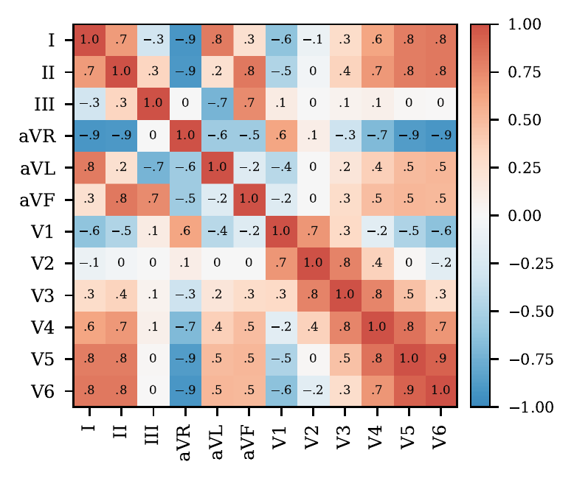
Fig. 2. Mean Pearson correlation between the 12 normalised leads over the training folds 1–8.

D. Classification and Regression
Classification. The task is multi-label: a recording can belong to several superclasses at once, and in PTB-XL 24.1% of the retained records carry more than one superclass. The output layer of each client therefore has five independent logits $z_{ic}$, and a sigmoid rather than a softmax gives the class probabilities. Each client minimises the class-weighted binary cross-entropy
$$\begin{aligned}L_{i}=−\frac{1}{5N}\sum_{n=1}^{N}{\sum_{c=1}^{5}{[}}&β_{c} y_{nc}logσ(z_{nc}) \\ &+(1−y_{nc})log\left(1−σ(z_{nc})\right)], (3)\end{aligned}$$
with $β_{c}=N_{c}^{−}/N_{c}^{+}$ computed from the client’s own training labels. After training, a single temperature $T_{i}$ is fitted on the validation fold by minimising the same loss without weights over $σ(z/T_{i})$ [28], which rescales the confidence of the client without changing its ranking. The final binary decision for class $c$ is $y_{c}^{pred}=[P(y_{c}∣x)≥τ_{c}]$, where $τ_{c}$ is the threshold that maximises the F1-score of class $c$ on the validation predictions.
Regression. The PTB-XL superclass task does not provide a continuous target such as a severity score, so no regression head was trained and no regression metric (MAE, RMSE, $R^{2}$) is reported. The only continuous quantities produced by the model are the calibrated probabilities, which are used as graded risk scores by the triage rule: for each class a rule-in threshold $h_{c}$ and a rule-out threshold $l_{c}$ are fitted on validation data, findings with $l_{c}<P<h_{c}$ are referred to a cardiologist, and coverage is always reported together with the precision and recall of the automatically decided findings.

E. Federated Learning
Clients and data split. The $K=4$ clients receive the official PTB-XL training folds in pairs: A folds 1–2, B folds 3–4, C folds 5–6 and D folds 7–8, i.e. about 4,270 records each. The folds were constructed by the dataset authors so that all records of a patient lie in one fold and the label distribution is similar across folds [5]; the partition is therefore patient-disjoint and approximately IID with respect to the labels, and the heterogeneity of the federation lies in the models: every client trains a different architecture with a different number of parameters (0.44M to 6.73M). Fold 9 is held by the server as a validation set, and fold 10 is the untouched test set.
Local training and communication. Each client trains once, for up to 50 local epochs with early stopping, and then fits its temperature. Federation therefore takes a single round: there is no repeated exchange of parameters and no synchronisation between clients during training. At fitting and inference time the server sends an ECG to the clients and receives one calibrated 5-dimensional probability vector from each, i.e. 20 numbers per ECG. In the experiments reported here all parties were simulated on one machine, but no step of the method requires a client to reveal its data, parameters or architecture. Fig. 3 shows the workflow and Algorithm 2 the protocol.
Aggregation rule. Parameter-averaging methods such as FedAvg [14] update a shared model as $θ_{t+1}=\sum_{k=1}^{K}{\frac{n_{k}}{n}}θ_{k}^{t+1}$, which is only defined when all clients share the same parameter space. CardioSentinel instead aggregates the calibrated predictions,
$$\begin{aligned}P(y∣x)&=\sum_{i=1}^{K}{w_{i}}(x) P_{i}(y∣x), \\ w_{i}(x)&≥0, \sum_{i=1}^{K}{w_{i}}(x)=1, (4)\end{aligned}$$
with the weights parameterised by a softmax so that the simplex constraint holds by construction. This prediction-level aggregation is related to one-shot FL with ensembles of local models [29] and to distillation-based schemes that also admit heterogeneous client models [30], [31]; unlike the latter, it needs neither a public transfer dataset nor a distillation step, because the calibrated mixture itself is the global model. Three combiners of increasing complexity are considered. Equal weights use $w_{i}=1/K$ and learn nothing. Static weights learn one global logit per client, $w=softmax(θ)$, by minimising the binary cross-entropy of $P(y∣x)$ on the validation data with full-batch Adam (learning rate 0.05, 500 steps). The dynamic gate is a per-patient mixture of experts [32]: an MLP takes the 20 client probabilities and the four mean binary entropies Hi=−15c​[piclogpic+(1−pic)log(1−pic)], passes them through a 32-unit ReLU layer with dropout 0.2 and outputs $w(x)=softmax(⋅)$; its last layer is initialised to zero so that it starts from equal weights, and it is trained with AdamW and early stopping on a patient-grouped 20% inner hold-out. All three are evaluated by patient-grouped five-fold cross-validation inside the validation fold, and the selection rule of Algorithm 1 adopts a more complex combiner only if its cross-validated macro AUROC exceeds that of the current choice by at least 0.002. This rule was fixed before the multi-seed test evaluation.
Privacy benefit. Raw ECGs, patient identifiers, model parameters, gradients and internal embeddings never leave a client. The server observes only five calibrated probabilities per client and ECG, which is the information a clinical decision-support service would return anyway. The scheme does not by itself provide formal guarantees such as differential privacy, and the server must hold a labelled validation set to fit the gate.
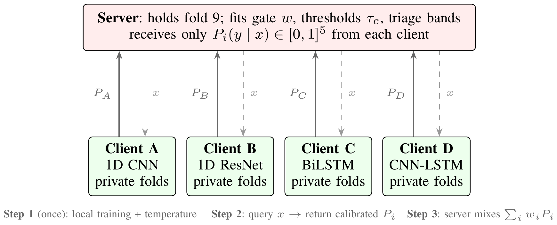
Fig. 3. Federated workflow. Clients train once on private data; afterwards the server sends an ECG $x$ (dashed) and receives calibrated probabilities (solid). No parameters or raw training data are exchanged.
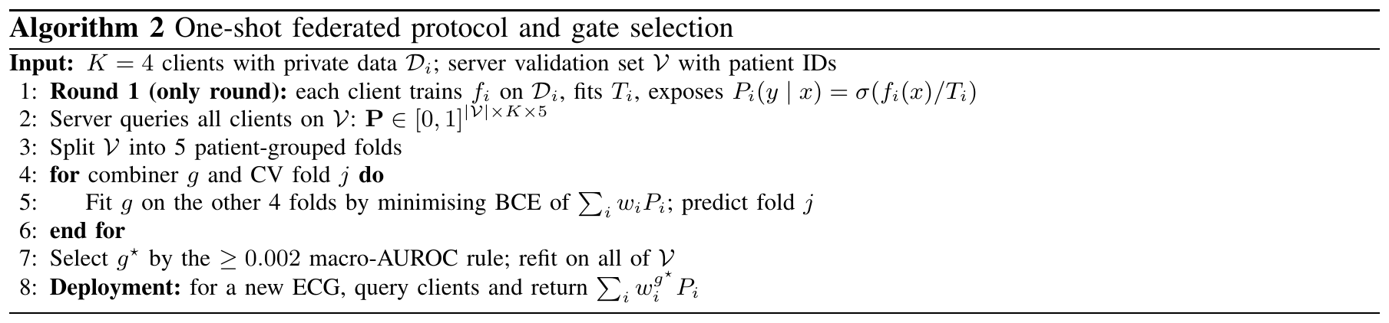

F. Explainable AI
Two complementary explanations are produced for the global model, one at the level of the input signal and one at the level of the federation.
Signal-level attributions. Because the global output of Eq. (4) with equal weights is a differentiable function of the input, Fc(x)=1Ki​σ(zic(x)/Ti), it can be explained with Integrated Gradients (IG) [33]. For class $c$ and a baseline $x^{′}$, the attribution of input sample $(ℓ,t)$ is
$${IG}_{ℓt}(x)=(x_{ℓt}−x_{ℓt}^{′})\int_{0}^{1}{\frac{∂F_{c}\left(x^{′}+α(x−x^{′})\right)}{∂x_{ℓt}}} dα, (5)$$
approximated with a 32-step Riemann sum. The baseline is the all-zero signal, which after per-lead z-scoring corresponds to every lead resting at its own mean. IG satisfies completeness, i.e. the attributions sum to $F_{c}(x)−F_{c}(x^{′})$, and is computed on the whole gate rather than on a single client. Global lead importance for class $c$ is the share of t​|IGℓt| falling on each lead, averaged over the positive validation records of that class; local explanations show $|{IG}_{ℓt}|$ along time for the leads with the largest share. The faithfulness of the attributions is checked with a deletion test: the $k$ leads with the largest attribution are set to zero and the drop in $F_{c}$ is compared with that obtained when $k$ random leads are removed. Gradient methods were preferred over Grad-CAM [34] because two of the four clients have no convolutional feature map at the output, and over sampling-based SHAP [35] because of the 12,000-dimensional input.
Federation-level attributions. The contribution of each institution to the global macro AUROC $v(S)$ of an equal-weight sub-federation $S⊆\{A,B,C,D\}$ is quantified with the Shapley value [36],
ϕi=S⊆K\{i}​|S|! (K−|S|−1)!K!v(S∪{i})−v(S), (6)
with $v(∅)=0.5$, the AUROC of an uninformative ranking. The 15 non-empty subsets are evaluated exactly, so no sampling approximation is needed. All explanations are computed on validation (fold 9) records or on subset results that were already part of the evaluation; the test fold is not used to generate them.

IV. Results and Analysis

A. Dataset Description
All experiments use PTB-XL v1.0.3 [5], an open-access (CC BY 4.0) collection distributed through PhysioNet [37]. It contains 21,799 clinical 12-lead ECGs of 10 s from 18,869 patients, recorded with Schiller devices and annotated with SCP-ECG statements by up to two cardiologists; the 100-Hz version of the waveforms is used here. As described in Section III-B, 411 records without a diagnostic superclass were removed, leaving 21,388 records from 18,617 patients. The mean age of the retained patients is 59.4 $±$ 16.8 years (ages above 89 are stored as a placeholder in PTB-XL and were excluded from this mean), and 48.1% of the records belong to female patients. The labels are the five diagnostic superclasses: normal ECG (NORM), myocardial infarction (MI), ST/T change (STTC), conduction disturbance (CD) and hypertrophy (HYP). Because a recording may carry several superclasses, the mean number of labels per record is 1.30 and 24.1% of the records are multi-label.
The official stratified folds of PTB-XL were used without modification, which guarantees that all recordings of a patient lie in a single fold. Folds 1–8 (17,084 records, 80%) form the training data and are divided among the four clients, fold 9 (2,146 records, 10%) is the validation set used for early stopping, calibration, thresholds and the gate, and fold 10 (2,158 records from 1,877 patients, 10%) is the test set. The split is therefore 80/10/10 rather than 80/20: the separate validation fold prevents any model or gate choice from being tuned on the test data. Table IV lists the records, patients and class counts of every partition, and Fig. 4 shows the class distribution. NORM is the most frequent superclass (44.5% of records) and HYP the rarest (12.4%), and the class proportions of the four clients differ by less than one percentage point.
TABLE IV. Dataset details: records, patients and positive labels per partition (prevalence in % in parentheses)
Partition | Folds | Records | Patients | NORM | MI | STTC | CD | HYP
Client A | 1, 2 | 4,277 | 3,676 | 1,907 | 1,087 | 1,050 | 966 | 527
Client B | 3, 4 | 4,280 | 3,722 | 1,918 | 1,079 | 1,042 | 981 | 525
Client C | 5, 6 | 4,264 | 3,725 | 1,869 | 1,125 | 1,060 | 990 | 535
Client D | 7, 8 | 4,263 | 3,700 | 1,902 | 1,088 | 1,034 | 970 | 532
Train | 1–8 | 17,084 | 14,823 | 7,596 (44.5) | 4,379 (25.6) | 4,186 (24.5) | 3,907 (22.9) | 2,119 (12.4)
Validation | 9 | 2,146 | 1,917 | 955 (44.5) | 540 (25.2) | 528 (24.6) | 495 (23.1) | 268 (12.5)
Test | 10 | 2,158 | 1,877 | 963 (44.6) | 550 (25.5) | 521 (24.1) | 496 (23.0) | 262 (12.1)
Total | 1–10 | 21,388 | 18,617 | 9,514 (44.5) | 5,469 (25.6) | 5,235 (24.5) | 4,898 (22.9) | 2,649 (12.4)
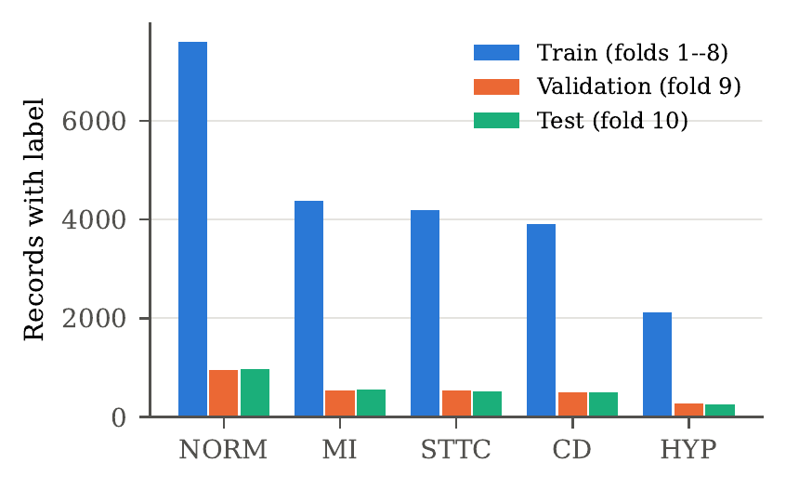
Fig. 4. Number of records carrying each diagnostic superclass in the training, validation and test folds (multi-label, so a record can be counted in several classes).

B. Experimental Setup
All networks were implemented in PyTorch [38] and trained on an Apple M1 MacBook Air with 8 GB of unified memory using the Metal (MPS) backend, under macOS, Python 3.11.17 and PyTorch 2.14.1. Mixed precision was not used. A mean training epoch took 26.8 s for Client A, 38.5 s for Client B, 65.4 s for Client C and 28.2 s for Client D. Every experiment was repeated with the random seeds 42, 43 and 44, and results are reported as mean $±$ standard deviation over the three seeds. Table V lists all hyperparameters; they are identical for every client so that only the architecture and the data differ.
TABLE V. Hyperparameters
Parameter | Value
Input | $12×1000$ (10 s at 100 Hz)
Number of clients | 4 (A, B, C, D), 2 PTB-XL folds each
Communication rounds | 1 (one-shot; probabilities only)
Local epochs | up to 50; early stopping, patience 8
Early-stopping criterion | macro AUROC on fold 9
Batch size | 128
Optimizer | AdamW [39], weight decay ${10}^{−2}$
Learning rate | ${10}^{−3}$, OneCycle schedule [40]
Loss | BCE with logits, positive weight $N_{c}^{−}/N_{c}^{+}$
Gradient clipping | global norm 1.0
Head | Linear 256, ReLU, dropout 0.3, Linear 5
Activation | ReLU (BiLSTM: sigmoid/tanh gates)
Calibration | 1 temperature per client, LBFGS on fold 9
Aggregation | equal / static / dynamic gate; selection by 5-fold patient-grouped CV, margin 0.002
Static gate | 4 weights, Adam lr 0.05, 500 steps
Dynamic gate | MLP 24–32–4, dropout 0.2, AdamW lr ${10}^{−3}$, $≤$300 epochs, patience 30
Thresholds | per class, max. F1 on fold 9
Bootstrap | 1,000 resamples (95% CI, paired)
Seeds | 42, 43, 44
Because the task is multi-label, every metric is first computed per class from that class’s confusion counts $TP_{c}$, $FP_{c}$, $FN_{c}$ and $TN_{c}$ on the $N$ test records, and then macro-averaged over the five classes:
$${Precision}_{c}=\frac{TP_{c}}{TP_{c}+FP_{c}}, {Recall}_{c}=\frac{TP_{c}}{TP_{c}+FN_{c}}, (7)$$
$${Specificity}_{c}=\frac{TN_{c}}{TN_{c}+FP_{c}}, (8)$$
$${F1}_{c}=\frac{2 {Precision}_{c} {Recall}_{c}}{{Precision}_{c}+{Recall}_{c}}, (9)$$
$${Acc}_{\text{label}}=\frac{1}{5}\sum_{c=1}^{5}{\frac{TP_{c}+TN_{c}}{N}}, (10)$$
$${Acc}_{\text{exact}}=\frac{1}{N}\sum_{n=1}^{N}{\left[y_{n}^{pred}=y_{n}\right]}. (11)$$
Label-wise accuracy (reported as “Acc.”) counts every one of the five decisions per record, whereas exact-match accuracy requires all five decisions of a record to be correct. The area under the ROC curve is ${AUROC}_{c}=\int_{0}^{1}{{TPR}_{c}} d {FPR}_{c}$, the probability that a random positive is ranked above a random negative, and is threshold-free; AUPRC is the area under the precision–recall curve. Macro AUROC is the primary metric, because it is insensitive to the decision thresholds and to class prevalence, and its 95% confidence interval is obtained with 1,000 bootstrap resamples of the test records [41]. Differences between two models are assessed with a paired bootstrap on the same resamples. Regression metrics (MAE, RMSE, $R^{2}$) do not apply because the task has no continuous target (Section III-D).

C. Comparison of Performance Metrics With Traditional Machine Learning Models and Unimodal Models
Table VI compares the proposed model with the individual deep clients, with the two learned aggregation variants and with a centrally trained reference. All rows were evaluated once on the same test fold with thresholds chosen on fold 9. The traditional classifiers use 172 hand-crafted features computed from the filtered, un-normalised signal: per-lead amplitude statistics (standard deviation, minimum, maximum, range, skewness, kurtosis, mean absolute slope), relative spectral power in the 0.5–5, 5–15 and 15–40 Hz bands, heart rate and RR-interval variability from R peaks detected in lead II, and per-lead median R, S, ST and T amplitudes around those peaks. They were trained on the pooled folds 1–8, Platt-scaled on fold 9 and thresholded on fold 9 like the deep models; Random Forest and XGBoost were run with the three seeds, while logistic regression, the RBF SVM and KNN are deterministic.
TABLE VI. Comparison with traditional machine-learning models, the individual deep clients and the aggregation variants on the PTB-XL test fold (mean $±$ SD over 3 seeds; Acc. = label-wise accuracy; Prec., Rec., F1, AUROC and AUPRC are macro averages over the five superclasses)
Model | Params | Acc. (%) | Prec. (%) | Rec. (%) | F1 (%) | AUROC | AUPRC
Traditional machine learning (172 hand-crafted features, pooled folds 1–8)
Logistic Regression | – | 84.4 $±$ 0.0 | 65.3 $±$ 0.0 | 71.7 $±$ 0.0 | 68.2 $±$ 0.0 | 0.880 $±$ 0.000 | 0.724 $±$ 0.000
SVM (RBF) | – | 85.8 $±$ 0.0 | 67.3 $±$ 0.0 | 74.5 $±$ 0.0 | 70.6 $±$ 0.0 | 0.898 $±$ 0.000 | 0.772 $±$ 0.000
Random Forest | – | 86.2 $±$ 0.2 | 69.1 $±$ 0.8 | 74.0 $±$ 1.2 | 71.2 $±$ 0.2 | 0.902 $±$ 0.001 | 0.778 $±$ 0.001
KNN | – | 82.2 $±$ 0.0 | 60.8 $±$ 0.0 | 68.9 $±$ 0.0 | 64.4 $±$ 0.0 | 0.859 $±$ 0.000 | 0.700 $±$ 0.000
XGBoost | – | 86.8 $±$ 0.0 | 69.7 $±$ 0.2 | 76.3 $±$ 0.5 | 72.6 $±$ 0.2 | 0.909 $±$ 0.002 | 0.789 $±$ 0.003
Single deep clients (25% of training data each)
Client A: 1D CNN | 0.44M | 84.8 $±$ 0.2 | 64.6 $±$ 0.6 | 72.6 $±$ 0.8 | 68.0 $±$ 0.3 | 0.888 $±$ 0.002 | 0.738 $±$ 0.005
Client B: 1D ResNet | 6.73M | 84.0 $±$ 0.8 | 63.0 $±$ 1.3 | 73.4 $±$ 1.8 | 67.2 $±$ 0.4 | 0.882 $±$ 0.002 | 0.721 $±$ 0.005
Client C: BiLSTM | 0.67M | 85.5 $±$ 0.3 | 66.2 $±$ 1.2 | 73.3 $±$ 0.5 | 69.2 $±$ 0.3 | 0.894 $±$ 0.000 | 0.745 $±$ 0.003
Client D: CNN-LSTM | 0.47M | 85.7 $±$ 0.8 | 67.0 $±$ 2.8 | 72.2 $±$ 3.1 | 69.0 $±$ 0.1 | 0.896 $±$ 0.001 | 0.749 $±$ 0.006
Aggregation of the four clients
Static learned weights | 4 | 86.6 $±$ 0.3 | 68.5 $±$ 0.9 | 72.8 $±$ 0.8 | 70.3 $±$ 0.3 | 0.903 $±$ 0.001 | 0.764 $±$ 0.004
Dynamic gate | $≈$1k | 86.4 $±$ 0.3 | 68.1 $±$ 1.2 | 72.9 $±$ 1.3 | 70.2 $±$ 0.1 | 0.901 $±$ 0.001 | 0.759 $±$ 0.002
Proposed (equal-weight gate) | 8.31M | 86.9 $±$ 0.2 | 69.8 $±$ 0.9 | 72.5 $±$ 2.1 | 70.7 $±$ 0.6 | 0.905 $±$ 0.000 | 0.767 $±$ 0.002
Centralised reference (data pooled, not federated)
CNN-LSTM on folds 1–8 | 0.47M | 86.4 $±$ 0.7 | 68.5 $±$ 1.2 | 74.0 $±$ 0.6 | 70.7 $±$ 0.8 | 0.909 $±$ 0.001 | 0.774 $±$ 0.002
The four deep clients, each trained on only a quarter of the training data, reach test macro AUROCs between 0.882 (Client B, 1D ResNet) and 0.896 (Client D, CNN-LSTM). The recurrent clients rank best: the BiLSTM (0.894) and the CNN-LSTM (0.896) outperform both convolutional clients, and the ResNet, despite having the most parameters (6.73M), is the weakest, which is consistent with its early stopping after 13.7 epochs on average (Table XIV) and indicates over-fitting on 4,280 records. The proposed equal-weight gate raises the macro AUROC to 0.905 $±$ 0.000, the label-wise accuracy to 86.9% (from at most 85.7%), the macro F1 to 70.7% (from at most 69.2%) and the macro precision to 69.8% (from at most 67.0%), while keeping the recall (72.5%) at the level of the clients. Its AUPRC of 0.767 is also the highest among the federated models. A CNN-LSTM trained centrally on all eight training folds, which is not possible when the data cannot be pooled, attains 0.909 $±$ 0.001 macro AUROC and the same macro F1 of 70.7%; the federated gate therefore recovers about 70% of the AUROC lost by splitting the data (0.896 $→$ 0.905 of the 0.896 $→$ 0.909 gap) and is tied with the pooled model in F1. As an external reference for feature-based learning on the same test fold, the wavelet-feature neural network of [6] reported a superdiagnostic macro AUROC of 0.874.
The traditional classifiers turn out to be strong baselines. Trained on all pooled data, XGBoost reaches a macro AUROC of 0.909 $±$ 0.002 and a macro F1 of 72.6%, and Random Forest 0.902 and 71.2%, so the best of them matches the pooled CNN-LSTM in AUROC and exceeds both it and the federated gate in F1; KNN (0.859) and logistic regression (0.880) are clearly weaker. The amplitude features are the likely reason: they keep the absolute voltages that the per-recording z-scoring of the deep models removes, and these voltages define hypertrophy. The comparison is, however, not a federated one, because these models see four times as much data as each client. Table VII therefore trains the same classifiers on a single client’s two folds. Under this restriction XGBoost reaches 0.898 on average and Random Forest 0.893–0.895, i.e. the level of the best deep clients (0.894–0.896), and every locally trained model, traditional or deep, remains below the federated gate (0.905).
TABLE VII. Traditional classifiers trained locally (one client’s folds; mean $±$ SD over clients A–D, seed 42) or on pooled data (mean $±$ SD over 3 seeds), compared with the best deep clients (test fold)
 | Local (one client, mean of A–D) |  | Pooled (folds 1–8)
2-3(l)4-5 Model | AUROC | F1 (%) | AUROC | F1 (%)
Logistic Regression | 0.870 $±$ 0.001 | 67.0 $±$ 0.1 | 0.880 $±$ 0.000 | 68.2 $±$ 0.0
SVM (RBF) | 0.886 $±$ 0.002 | 68.8 $±$ 0.3 | 0.898 $±$ 0.000 | 70.6 $±$ 0.0
Random Forest | 0.894 $±$ 0.001 | 69.8 $±$ 0.2 | 0.902 $±$ 0.001 | 71.2 $±$ 0.2
KNN | 0.847 $±$ 0.004 | 63.3 $±$ 0.6 | 0.859 $±$ 0.000 | 64.4 $±$ 0.0
XGBoost | 0.898 $±$ 0.002 | 70.4 $±$ 0.4 | 0.909 $±$ 0.002 | 72.6 $±$ 0.2
Deep client C (BiLSTM) | 0.894 $±$ 0.000 | 69.2 $±$ 0.3 | – | –
Deep client D (CNN-LSTM) | 0.896 $±$ 0.001 | 69.0 $±$ 0.1 | – | –
The study uses a single input modality, the 12-lead ECG, so a comparison of unimodal and multimodal models in the strict sense is not possible. Table VIII instead contrasts each single-architecture client with the federated combination of all four, per superclass. The gate achieves the highest AUROC in every class, and its largest gain over the best client is observed for the hardest class, HYP (0.828 versus at most 0.809). This indicates that the clients make partly independent errors that the combination averages out, the same mechanism that motivates multimodal fusion, but obtained here from architectural rather than modal diversity.
TABLE VIII. Single clients versus the federated gate: test AUROC per superclass (mean of 3 seeds; best in bold)
Model | NORM | MI | STTC | CD | HYP | Macro
Client A (1D CNN) | 0.926 | 0.891 | 0.925 | 0.900 | 0.798 | 0.888
Client B (1D ResNet) | 0.922 | 0.877 | 0.918 | 0.884 | 0.808 | 0.882
Client C (BiLSTM) | 0.931 | 0.901 | 0.926 | 0.902 | 0.809 | 0.894
Client D (CNN-LSTM) | 0.933 | 0.906 | 0.923 | 0.909 | 0.808 | 0.896
Proposed | 0.938 | 0.912 | 0.933 | 0.914 | 0.828 | 0.905
The gain over the best single client is statistically significant. In a paired bootstrap on the test fold, the macro AUROC of the gate exceeds that of the best client chosen on fold 9 by +0.012 [+0.009, +0.016] for seed 42 (Client C), +0.011 [+0.007, +0.014] for seed 43 (Client C) and +0.009 [+0.005, +0.013] for seed 44 (Client D), so every confidence interval lies above zero. The macro F1 improves by +0.018 [+0.009, +0.028], +0.010 [$−$0.001, +0.021] and +0.024 [+0.014, +0.034], respectively, with the interval excluding zero in two of the three seeds. Fig. 5 summarises the macro AUROC of all models.
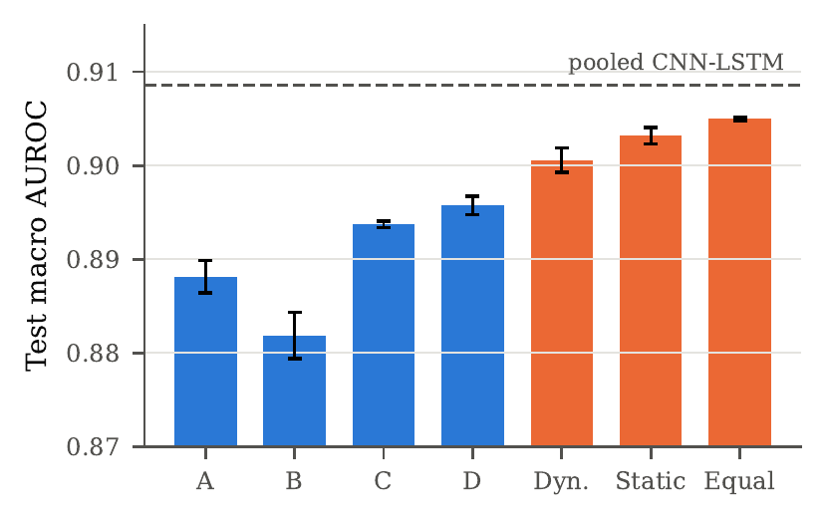
Fig. 5. Test macro AUROC of the four clients and the three aggregation variants (mean $±$ SD over 3 seeds). The dashed line marks the centrally trained CNN-LSTM.

D. Ablation Experiments

1) Modality Ablation Experiment
Since the ECG is the only modality, the input-source ablation was carried out over the participating institutions: every one of the 15 non-empty subsets of $\{A,B,C,D\}$ was combined with equal weights and evaluated on fold 9 (cross-validated) and on the test fold. The results, ordered by the number of clients, are given in Table IX, and Table X converts them into a Shapley value per client.
TABLE IX. Client-subset ablation (equal-weight gate; mean over 3 seeds, test SD shown)
#Clients | Subset | Fold-9 CV AUROC | Test AUROC | $Δ$ vs. ABCD
4 | ABCD | 0.909 | 0.905 $±$ 0.000 | 0.000
3 | ACD | 0.908 | 0.905 $±$ 0.000 | 0.000
3 | BCD | 0.908 | 0.904 $±$ 0.001 | -0.001
3 | ABC | 0.906 | 0.901 $±$ 0.000 | -0.004
3 | ABD | 0.905 | 0.902 $±$ 0.001 | -0.003
2 | CD | 0.907 | 0.903 $±$ 0.001 | -0.002
2 | AC | 0.905 | 0.900 $±$ 0.000 | -0.005
2 | AD | 0.904 | 0.901 $±$ 0.001 | -0.004
2 | BC | 0.903 | 0.898 $±$ 0.001 | -0.007
2 | BD | 0.903 | 0.900 $±$ 0.001 | -0.005
2 | AB | 0.899 | 0.895 $±$ 0.001 | -0.010
1 | C | 0.900 | 0.894 $±$ 0.000 | -0.011
1 | D | 0.898 | 0.896 $±$ 0.001 | -0.009
1 | A | 0.893 | 0.888 $±$ 0.002 | -0.017
1 | B | 0.886 | 0.882 $±$ 0.003 | -0.023
The full federation ABCD is the best configuration on both splits (fold 9: 0.909; test: 0.905). Every two-client combination outperforms every single client on the test fold, so most of the gain comes from combining heterogeneous models at all, and adding clients yields diminishing returns (single: at most 0.896; pairs: at most 0.903; triples: at most 0.905). Removing the recurrent clients hurts most: dropping D lowers the test AUROC by 0.004 and dropping C by 0.003, whereas dropping A or B costs at most 0.001. The Shapley values in Table X confirm this ranking (C and D largest, B smallest), but they also show that the four contributions are of the same order (0.097–0.105 on the test fold). This explains why equal weighting works well: the learned static weights assign almost nothing to Client A (0.001 on average), although its marginal contribution to the federation is comparable to that of the other clients.
TABLE X. Shapley value $ϕ_{i}$ of each client for the macro AUROC of the equal-weight federation ($v(∅)=0.5$) and the mean learned static weight
Client | Architecture | $ϕ$ (fold 9) | $ϕ$ (test) | Static weight $w_{i}$
A | 1D CNN | 0.1009 | 0.0998 | 0.001
B | 1D ResNet | 0.0980 | 0.0971 | 0.042
C | BiLSTM | 0.1055 | 0.1033 | 0.549
D | CNN-LSTM | 0.1043 | 0.1047 | 0.407
Sum | – | 0.4087 | 0.4050 | 1.000

2) Feature Fusion Module Ablation Experiments
Table XI compares the three fusion strategies of Section III-E: equal weights, learned static weights and the dynamic per-patient gate. All three are late (decision-level) fusion strategies, because the clients do not share embeddings; early or feature-level fusion is excluded by the privacy constraint. The validation columns are the patient-grouped cross-validated values used for selection, and the test columns were obtained afterwards.
TABLE XI. Ablation of the fusion strategy (fold-9 CV values used for selection; test values mean $±$ SD over 3 seeds)
Fusion strategy | CV AUROC | CV BCE | Test AUROC | Test F1 (%) | Exact match (%)
Equal weights (selected) | 0.909 | 0.372 | 0.905 $±$ 0.000 | 70.7 $±$ 0.6 | 58.1 $±$ 0.7
Static learned weights | 0.907 | 0.346 | 0.903 $±$ 0.001 | 70.3 $±$ 0.3 | 57.0 $±$ 1.5
Dynamic per-patient gate | 0.904 | 0.338 | 0.901 $±$ 0.001 | 70.2 $±$ 0.1 | 56.8 $±$ 0.7
Equal weights achieve the highest cross-validated macro AUROC (0.909) and were selected in all three seeds; learned static weights (0.907) and the dynamic gate (0.904) did not reach the required margin. The learned combiners achieve a lower cross-validated binary cross-entropy (0.346 and 0.338 versus 0.372), i.e. they produce better-calibrated probabilities, but they do so by concentrating the weight on Clients C and D (Fig. 6), which sacrifices the diversity contributed by A and B and lowers the ranking quality. The dynamic gate never outperformed the simpler combiners: its per-patient weights differ little from the static ones (mean test weights 0.002, 0.092, 0.532 and 0.374 for A–D), because all clients receive the same ECG and there is little patient-specific information about which client to trust. The same ordering holds on the test fold (0.905, 0.903 and 0.901), so the selection made on validation data was confirmed.
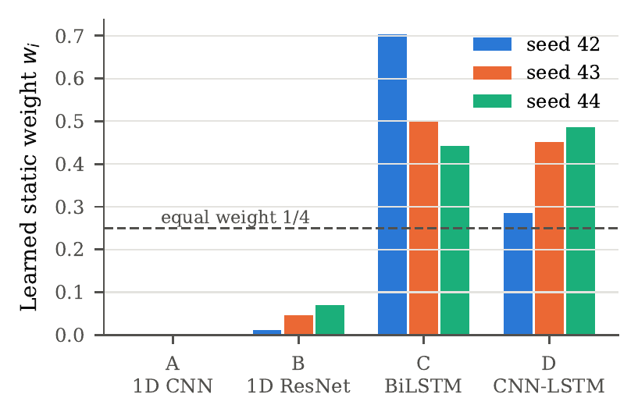
Fig. 6. Static aggregation weights learned on fold 9 for each seed. The dashed line marks the equal weight 1/4 used by the selected gate.

3) Ablation Study on Activation Function and Optimizer
The choice of activation function and optimizer was examined on Client D (CNN-LSTM, folds 7–8, seed 42), keeping every other element of the recipe fixed, including the OneCycle schedule with a maximum learning rate of ${10}^{−3}$, early stopping on fold 9 and the class-weighted loss. To avoid any tuning on the test data, the ablations were evaluated on fold 9 only. In the activation ablation the ReLU of the convolutional blocks and of the classification head was replaced, while the gates of the LSTM were left unchanged. Tables XII and XIII report the best fold-9 macro AUROC, the epoch at which it was reached, the number of epochs before early stopping and the training loss at the selected epoch.
TABLE XII. Activation-function ablation (Client D, CNN-LSTM, seed 42; fold-9 macro AUROC)
Activation | Fold-9 AUROC | Best / run epochs | Train loss
ReLU (used) | 0.898 | 23 / 31 | 0.444
LeakyReLU | 0.898 | 24 / 32 | 0.423
ELU | 0.895 | 14 / 22 | 0.547
GELU | 0.896 | 14 / 22 | 0.534
Tanh | 0.894 | 19 / 27 | 0.484

TABLE XIII. Optimizer ablation (Client D, CNN-LSTM, seed 42; fold-9 macro AUROC; maximum learning rate ${10}^{−3}$ for all optimizers)
Optimizer | Fold-9 AUROC | Best / run epochs | Train loss
AdamW (used) | 0.898 | 23 / 31 | 0.444
Adam [42] | 0.898 | 20 / 28 | 0.480
SGD (momentum 0.9) | 0.786 | 30 / 38 | 1.014
RMSprop (momentum 0.9) | 0.855 | 3 / 11 | 0.724
ReLU and LeakyReLU perform identically (0.898), and they also train longest before early stopping (23 and 24 epochs to the best model), reaching the lowest training losses (0.444 and 0.423). The smooth activations GELU (0.896) and ELU (0.895) converge faster, with their best epoch at 14, but to a slightly lower AUROC, and the saturating tanh is the weakest (0.894). The differences are at most 0.004 AUROC, so the activation function is not a decisive design factor for this model, and the ReLU used for all clients is among the best choices.
The optimizer matters much more. AdamW and Adam reach the same AUROC (0.898), which shows that the decoupled weight decay neither helped nor hurt at this data size. SGD with momentum is clearly inferior (0.786): with the same maximum learning rate of ${10}^{−3}$ it was still improving slowly when it stopped after 38 epochs, with a training loss of 1.014, so it would need a much larger learning rate or longer training. RMSprop reached its best AUROC of 0.855 already at epoch 3 and did not improve afterwards, which indicates unstable optimisation with this learning rate and momentum. Adaptive moment-based optimizers are therefore the appropriate choice for the clients, and the configuration used in this work (ReLU with AdamW) is confirmed by both ablations.

E. Federated Learning Results Analysis

1) Client-wise Training Accuracy and Loss
Because the federation consists of a single round, the training dynamics of the system are those of the four local trainings. Fig. 7 shows, for seed 42, the validation macro AUROC (the early-stopping criterion, used here in place of accuracy because the label-wise accuracy depends on thresholds that are fitted only after training) and the weighted training loss of every client over its local epochs, and Table XIV summarises all three seeds.
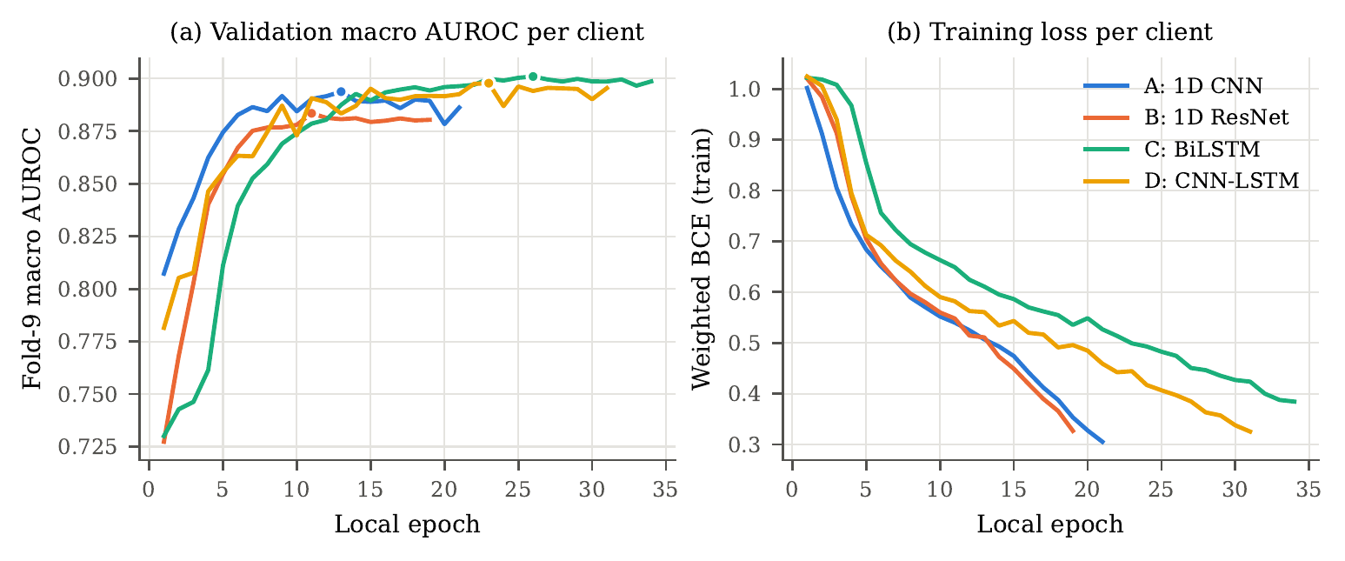
Fig. 7. Local training of the four clients (seed 42): (a) fold-9 macro AUROC per epoch, with the selected epoch marked by a dot; (b) class-weighted training BCE per epoch. Each curve ends when early stopping (patience 8) was triggered.
TABLE XIV. Client-wise training summary (mean over 3 seeds; loss and AUROC mean $±$ SD at the selected epoch)
Model | $n_{\text{train}}$ | Epochs run | Best epoch | Train loss | Fold-9 AUROC | $T_{i}$
Client A | 4,277 | 20.7 | 12.7 | 0.510 $±$ 0.036 | 0.893 $±$ 0.001 | 1.74 $±$ 0.22
Client B | 4,280 | 21.7 | 13.7 | 0.479 $±$ 0.079 | 0.886 $±$ 0.002 | 1.52 $±$ 0.15
Client C | 4,264 | 35.0 | 27.0 | 0.466 $±$ 0.017 | 0.900 $±$ 0.001 | 1.25 $±$ 0.09
Client D | 4,263 | 30.7 | 22.7 | 0.450 $±$ 0.024 | 0.898 $±$ 0.001 | 1.35 $±$ 0.06
Pooled (folds 1–8) | 17,084 | 31.0 | 23.0 | 0.452 $±$ 0.037 | 0.914 $±$ 0.002 | 1.31 $±$ 0.08
The convolutional clients converge fastest: Client A reaches its best validation AUROC after 12.7 epochs and Client B after 13.7 epochs on average, after which the validation AUROC stagnates or decreases while the training loss keeps falling, the typical sign of over-fitting on a small local dataset. The recurrent clients learn more slowly at the start (Client C stays below 0.80 for the first four epochs in Fig. 7a) but keep improving for longer, with best epochs of 27.0 (C) and 22.7 (D), and they end with the highest validation AUROCs (0.900 and 0.898). The fitted temperatures are all larger than one (1.25–1.74 on average), i.e. every client is over-confident after training with the class-weighted loss, and calibration is therefore needed before probabilities from different clients can be averaged meaningfully.

2) Global Model (Server) Test Accuracy and Loss
The server performs no iterative training, so there are no communication rounds over which a server accuracy or loss could converge. The closest analogue is the behaviour of the global model as client contributions are added. Fig. 8 plots the macro AUROC of the equal-weight global model against the number of aggregated clients, both on fold 9 and on the test fold. Both curves rise monotonically and flatten after three clients: the mean over all subsets increases from 0.890 with one client to 0.900 with two, 0.903 with three and 0.905 with four on the test fold. The gap between the fold-9 and the test curves remains small (0.004 for the full federation), which shows that the validation-based selection did not over-fit the gate. In terms of loss, the selected gate has a cross-validated binary cross-entropy of 0.372 on fold 9 and a test binary cross-entropy of 0.376 $±$ 0.008; the learned static (0.349 $±$ 0.004) and dynamic (0.343 $±$ 0.005) gates have lower test losses, mirroring their better calibration on fold 9 (Table XI), but a lower AUROC.
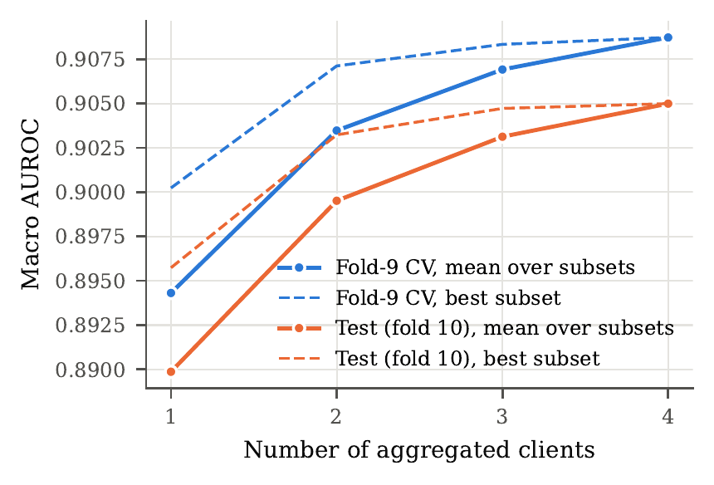
Fig. 8. Macro AUROC of the global (server) model as a function of the number of aggregated clients, averaged over all subsets of that size (solid) and for the best subset (dashed).

3) Comparison with Other Federated Learning Frameworks
Parameter-averaging frameworks cannot combine the heterogeneous clients of CardioSentinel, so they were evaluated with one shared architecture, the CNN-LSTM of Client D, on exactly the same four client partitions. FedAvg [14], FedProx [15] ($μ=0.01$), SCAFFOLD [16] (control variates, option II) and FedNova [43] (updates normalised by the number of local steps) were run for 20 communication rounds of one local epoch each, with the client recipe of Section IV-B (AdamW, learning rate ${10}^{−3}$, batch 128, class-weighted loss, augmentation, gradient clipping) and aggregation weights $n_{k}/n$. The round with the best fold-9 macro AUROC was kept, calibrated and thresholded on fold 9, and evaluated once on the test fold. Because of the computational cost these runs use seed 42 only, so Table XV reports seed-42 values for every row, and Fig. 9 shows the convergence.
TABLE XV. Comparison with federated-learning frameworks on the same four client partitions (seed 42; test fold unless stated). ªPatient-grouped CV on fold 9.
Method | Rounds | Same arch. | Fold-9 AUROC | Test AUROC | F1 (%) | Acc. (%)
Local only (best client, D) | 0 | – | 0.898 | 0.895 | 68.9 | 85.0
FedAvg [14] | 20/20 | yes | 0.911 | 0.907 | 71.8 | 87.2
FedProx ($μ=0.01$) [15] | 20/20 | yes | 0.910 | 0.906 | 71.4 | 86.9
SCAFFOLD [16] | 1/20 | yes | 0.850 | 0.842 | 62.4 | 80.6
FedNova [43] | 20/20 | yes | 0.911 | 0.907 | 71.5 | 86.8
Proposed (one-shot gate) | 1 | no | 0.908ª | 0.905 | 70.9 | 86.8
Centralised (pooled data) | – | – | 0.916 | 0.909 | 69.6 | 85.5
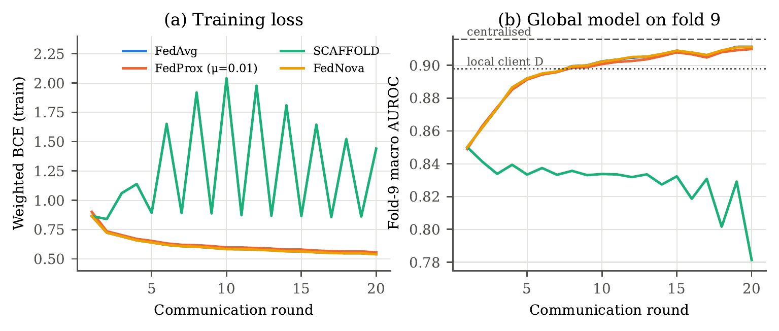
Fig. 9. Convergence of the parameter-averaging frameworks (shared CNN-LSTM, seed 42): (a) training loss averaged over clients; (b) fold-9 macro AUROC of the global model, with the local-only Client D and the centrally trained CNN-LSTM as references.
Accuracy. FedAvg and FedNova reach a test macro AUROC of 0.907 and FedProx 0.906, slightly above the proposed one-shot gate (0.905) and close to centralised training (0.909). They also achieve a higher macro F1 (71.4%–71.8% versus 70.9%). With identical clients and many communication rounds, parameter averaging thus remains marginally more accurate than prediction-level aggregation; the difference to the proposed model (0.002 AUROC) is, however, smaller than the gain of either approach over local training (0.895 for Client D in this seed). SCAFFOLD failed in this configuration: its best global model was the one after the first round (test AUROC 0.842), and its training loss oscillated between about 0.8 and 2.0 in subsequent rounds. The control-variate correction assumes plain SGD local steps of size $η$, and combined with the adaptive AdamW updates used here it over-corrects the client drift; with SGD local training it may behave differently.
Stability and convergence speed. FedAvg, FedProx and FedNova converge smoothly and almost identically (Fig. 9): they pass the local-only reference of 0.898 on fold 9 at round 8, exceed 0.90 at round 10 and are still improving slightly at round 20, so more rounds could add a little more. FedNova coincides with FedAvg because all four clients perform the same number of local steps (33 per epoch), in which case its normalisation has no effect; the proximal term of FedProx is unnecessary when the label distributions of the clients are as similar as here. The cost of this accuracy is communication and coordination: 20 synchronised rounds, each exchanging the full set of 0.47M parameters with every client, and the requirement that all institutions train the same network. The proposed model needs a single round, exchanges only five probabilities per client and query, and lets every institution keep its own architecture, at a cost of about 0.002 AUROC in this setting.

F. Class-wise Analysis

1) Confusion Matrix
Fig. 10 shows the per-class confusion matrices of the proposed model on the 2,158 test records for seed 42, at the thresholds chosen on fold 9 (0.42 for NORM, 0.62 for MI and STTC and 0.64 for CD and HYP), and Fig. 11 the corresponding ROC curves. Because the task is multi-label, each superclass has its own $2×2$ matrix.
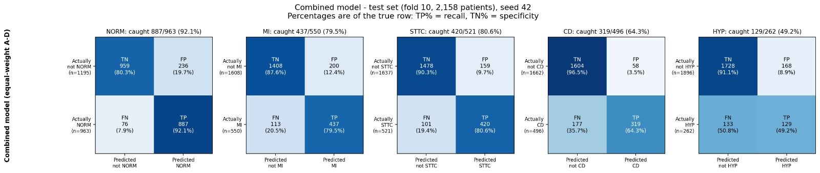
Fig. 10. Per-class confusion matrices of the proposed model on the test fold (seed 42); counts and row-normalised rates (TP% = recall, TN% = specificity).
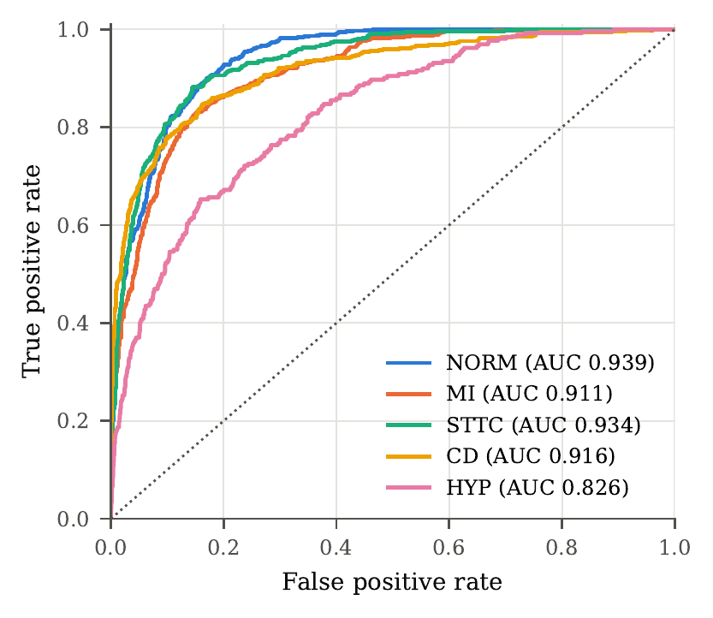
Fig. 11. ROC curves of the proposed model on the test fold for the five superclasses (seed 42).
NORM is detected most reliably: 887 of its 963 positives are found (recall 0.92), at the cost of 236 false positives, which reflects the low NORM threshold that favours sensitivity. For STTC and MI the model identifies 420 of 521 and 437 of 550 positives, with 159 and 200 false positives respectively. CD is predicted conservatively: only 58 false positives occur, but 177 of the 496 positives are missed. HYP is the most difficult class, with 129 true positives, 133 false negatives and 168 false positives; hypertrophy criteria rely on voltage amplitudes, which the per-recording z-scoring partly removes, and HYP frequently co-occurs with STTC and CD, so its ECG changes overlap with those of other classes. The ROC curves confirm this ranking, with the HYP curve clearly below the others.
Compared with the four clients, each at its own fold-9 thresholds (seed 42), for MI the gate both finds the most positives (437 against 408–431) and raises the fewest false alarms (200 against 226–258). For CD it trades recall for precision: the clients find 314–355 positives with 110–163 false positives, the gate 319 with only 58. The gain of the combination is therefore mainly in precision, in line with Table VI, where the macro precision rises from at most 67.0% to 69.8% while the recall stays at the level of the clients.

2) Class-wise Performance Table
Table XVI reports precision, recall, F1-score and AUROC per superclass, averaged over the three seeds, together with the macro and support-weighted averages.
TABLE XVI. Class-wise performance of the proposed model on the test fold (mean of 3 seeds)
Class | Precision | Recall | F1-score | AUROC | Support
NORM | 0.782 | 0.930 | 0.850 | 0.938 | 963
MI | 0.724 | 0.730 | 0.725 | 0.912 | 550
STTC | 0.745 | 0.792 | 0.768 | 0.933 | 521
CD | 0.800 | 0.682 | 0.735 | 0.914 | 496
HYP | 0.439 | 0.490 | 0.461 | 0.828 | 262
Macro avg. | 0.698 | 0.725 | 0.707 | 0.905 | 2792
Weighted avg. | 0.735 | 0.780 | 0.753 | 0.917 | 2792
NORM (F1 0.850) and STTC (0.768) are the best-recognised superclasses, followed by CD (0.735) and MI (0.725). HYP remains clearly weaker (F1 0.461, AUROC 0.828), and because it is also the rarest class it pulls the macro F1 (0.707) below the support-weighted F1 (0.753). The AUROC of every class except HYP exceeds 0.91, so the ranking quality is high and the lower F1 values of MI and CD are largely a matter of operating point.
Fig. 12 gives the confusion matrices averaged over the three seeds. Summed over the five classes, the model makes 2,177 true-positive and 7,198 true-negative decisions out of 10,790 (2,158 ECGs $×$ 5 classes), a label-wise accuracy of 0.869 with a micro-averaged precision of 0.731 and recall of 0.780; the 615 false negatives are dominated by HYP (134), CD (158) and MI (148).
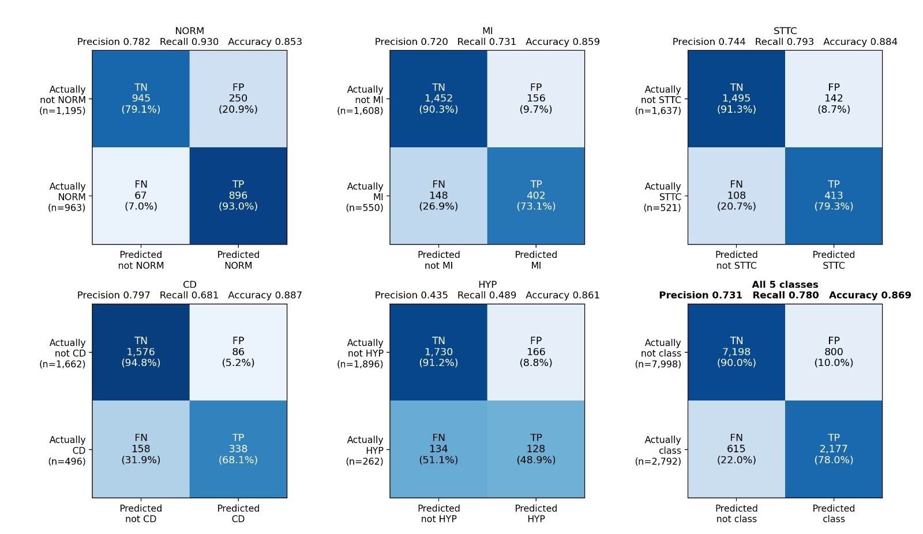
Fig. 12. Per-class confusion matrices of the proposed model on the test fold (fold 10, 2,158 ECGs), mean counts over seeds 42, 43 and 44; percentages are of the true row. The last panel sums the five classes (2,158 ECGs $×$ 5 decisions = 10,790).
Per-finding triage. When the clinical requirement is a precision and recall of at least 0.90, no global threshold can satisfy it for all classes. Applying the rule-in/rule-out bands fitted on fold 9 (Section III-D) to the test fold, 53.7% of all findings are decided automatically, with a macro precision of 0.937, a macro recall of 0.908 over the automated classes and an accuracy of 0.967; 17.8% of the ECGs are decided completely without referral. NORM, MI and CD were automated in all seeds, STTC in one of three seeds, and HYP only in rule-out mode, so every possible HYP finding is referred. Not every target was met: the test recall of CD was 0.880.

G. Explainable Results
The explanations were computed for the selected equal-weight gate of seed 42 on 300 randomly drawn validation (fold-9) records, which contain 131 NORM, 81 MI, 65 STTC, 80 CD and 31 HYP positives; the test fold was not used. Fig. 13 shows the global lead importance, i.e. the share of the absolute Integrated-Gradients attribution falling on each lead, averaged over the positive records of each class. Under a uniform distribution every lead would receive 8.3%.
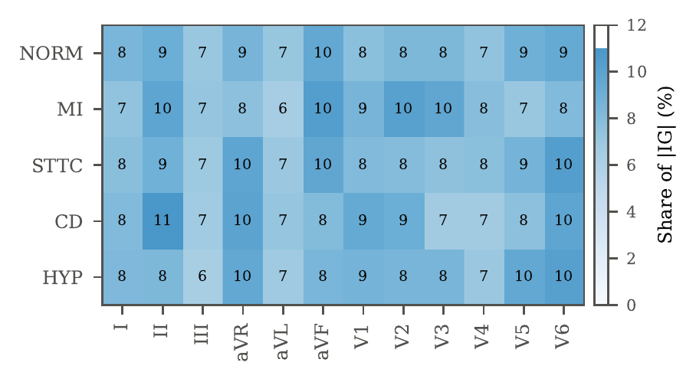
Fig. 13. Global explanation: share of the absolute Integrated-Gradients attribution per lead (%) for the positive validation records of each superclass (seed 42, equal-weight gate).
The attributions are spread over all twelve leads (no lead receives more than 11.0%), which is consistent with the redundancy of the leads shown in Fig. 2 and with training under lead dropout. Within this spread the emphasis follows the expected anatomy. For MI the largest shares fall on aVF (10.3%), V2 (10.1%), II (9.8%) and V3 (9.7%), i.e. on the inferior and anteroseptal leads that record the most frequent infarct locations. For HYP the largest shares fall on V6 (10.3%), V5 and aVR (9.6% each) and V1 (8.6%), the leads used by the classical voltage criteria for left ventricular hypertrophy, which combine the S wave in V1 with the R wave in V5 or V6. For CD the model relies most on II (11.0%), aVR (9.9%), V6 (9.8%) and V1 (9.4%); V1 and V6 are the leads in which right and left bundle branch blocks are recognised. STTC is attributed mainly to the lateral and inferior leads V6 (10.3%), aVR (9.8%) and aVF (9.7%). In every class, leads III and aVL are among the four least-attributed leads (6.2%–7.2%); both are linear combinations of I and II, so they add little independent information.
Local explanations. Fig. 14 shows the two validation records predicted with the highest confidence for MI and for STTC, with the three leads that carry the largest attribution and the attribution magnitude along time. Record 5927 (label MI) is classified as MI with probability 0.99, and its attribution concentrates on V2, V3 and V4. These leads show deep, predominantly negative QRS complexes, the pattern of an anterior infarction, and the attribution peaks at each QRS complex rather than in the baseline between beats. Record 14758 (labels STTC and HYP) receives P(STTC) = 0.98 and P(HYP) = 0.85, so both of its labels are recovered; for STTC the attribution falls on V2, V1 and aVF and again peaks at the QRS complexes and the adjoining ST segments of the beats. In both cases the attribution is locked to the beats and falls on the waveform segments a cardiologist would inspect, not on the baseline between beats; two examples cannot, however, establish this for all records.
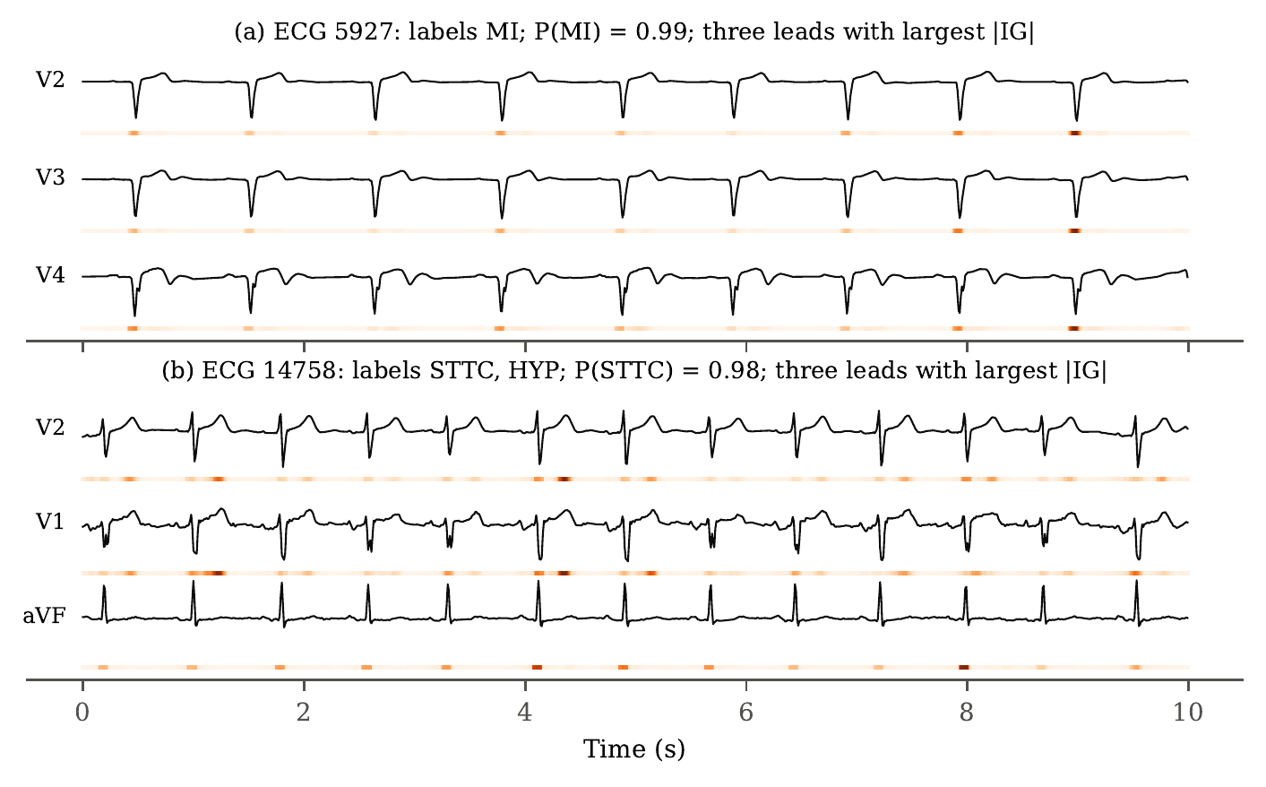
Fig. 14. Local explanations for the most confident true-positive (a) MI and (b) STTC validation records. For each record the three leads with the largest total attribution are shown; the colour strip below each trace encodes $|IG|$ over time (darker = larger), smoothed over 90 ms.
Faithfulness. Table XVII reports the deletion test. For NORM, MI and CD, removing the lead with the largest attribution lowers the mean predicted probability more than removing a random lead (NORM: $−$0.028 versus $−$0.019; MI: $−$0.030 versus $−$0.006; CD: $−$0.043 versus $−$0.012), and removing the three most important leads lowers it substantially more than removing three random leads (NORM: $−$0.135 versus $−$0.074; MI: $−$0.057 versus $−$0.006; CD: $−$0.070 versus $−$0.009). For these classes the attributions therefore identify leads on which the prediction actually depends. For STTC and HYP, in contrast, neither targeted nor random deletion changes the probability appreciably (STTC: 0.764 intact, 0.765–0.772 after deletion; HYP: 0.620 intact, 0.613–0.627 after deletion). The evidence for these two classes is distributed redundantly over many leads, so lead-level attributions should not be read as identifying a single decisive lead.
TABLE XVII. Deletion test: mean gate probability of the true class after zeroing the $k$ leads with the largest IG attribution or $k$ random leads (fold-9 positives, seed 42)
 |  |  | Top-$k$ IG leads removed |  | Random $k$ leads removed
4-5(l)6-7 Class | $n$ | Mean $p$ (intact) | $k=1$ | $k=3$ | $k=1$ | $k=3$
NORM | 131 | 0.741 | 0.713 | 0.606 | 0.722 | 0.667
MI | 81 | 0.750 | 0.720 | 0.693 | 0.744 | 0.744
STTC | 65 | 0.764 | 0.765 | 0.772 | 0.764 | 0.771
CD | 80 | 0.758 | 0.715 | 0.688 | 0.746 | 0.749
HYP | 31 | 0.620 | 0.626 | 0.621 | 0.627 | 0.613
Federation-level explanation. At the level of the institutions, the Shapley values in Table X show that the four clients contribute comparably to the AUROC of the federation (0.097–0.105 on the test fold), with the recurrent clients C and D contributing most. Together with the signal-level attributions, this gives a clinician two complementary views: which leads and waveform segments drove a finding, and which participating sites the global model relied on. These explanations are post hoc and were not yet reviewed by cardiologists, and IG with a zero baseline, like every attribution method, depends on the choice of baseline.

H. Comparison with State-of-the-Art and Discussion
Table XVIII compares the proposed model with published results on the PTB-XL superclass task. The models of [6] were trained centrally on the same folds 1–8 and tested on the same fold 10, and they are therefore the most directly comparable; the other entries use the same superclass labels but different training protocols.
TABLE XVIII. Comparison with state-of-the-art results on the PTB-XL five-superclass task
Method | Training data | Macro AUROC | Acc. (%)
Wavelet + NN [6] | pooled | 0.874 | –
inception1d [6] | pooled | 0.921 | –
LSTM (bidir.) [6] | pooled | 0.921 | –
xresnet1d101 [6] | pooled | 0.928 | –
resnet1d_wang [6] | pooled | 0.930 | –
Ensemble [6] | pooled | 0.934 | –
ST-MEM [8] | pooled + pretrain | 0.933 | 82.5
METS, zero-shot [10] | pooled + text | – | 84.2
Pooled CNN-LSTM (ours) | pooled | 0.909 | 86.4 (label)
XGBoost, 172 features (ours) | pooled | 0.909 | 86.8 (label)
FedAvg, CNN-LSTM (ours, seed 42) | 4 sites, 20 rounds | 0.907 | 87.2 (label)
Proposed (federated) | 4 sites, 1 round | 0.905 | 86.9 (label)
The proposed model does not exceed the best centrally trained models: its macro AUROC of 0.905 is 0.016–0.029 below the centrally trained deep networks and the ensemble of [6]. Part of this gap is attributable to the data restriction, since each client sees only 25% of the training records, and part to the training recipe, since our own pooled CNN-LSTM reaches 0.909 rather than 0.92–0.93; the recipe (100 Hz input, no test-time augmentation, no external pretraining) was kept fixed for all models to isolate the effect of federation. The accuracies in Table XVIII are not directly comparable either, because ST-MEM and METS report accuracy under their own definitions, whereas the label-wise accuracy of this work averages the five binary decisions.
Strengths. The main strength of the approach is that it delivers most of the benefit of pooling the data without moving any record or parameter: the federated gate recovers about 70% of the AUROC lost by splitting the data and ties the pooled CNN-LSTM in macro F1, with one communication step and freely chosen architectures. It outperforms every model that can be trained at a single site, including XGBoost on hand-crafted features (0.898 on average), and comes within 0.002 AUROC of FedAvg, which needs twenty synchronised rounds and a common architecture. The improvement over the best institution is statistically significant in every seed, the results are highly reproducible (the SD of the gate’s macro AUROC over seeds is below 0.001), and all modelling choices, including the aggregation rule, were made on validation data before a single evaluation on the test fold. The triage rule converts the model into a tool that decides about half of all findings automatically at a precision above 0.93, while stating explicitly which findings require a cardiologist.
Limitations. First, the four clients are simulated partitions of one dataset from one hospital system with near-identical label distributions, so the benefits of the method under real inter-site shifts (different devices, populations and label practices) remain to be shown. Second, fold 9 is used for early stopping, calibration, thresholds and the gate, so validation figures are optimistic; only the test-fold figures are unbiased. Third, the learned gates did not improve on equal weighting, which suggests that the per-patient gate lacks informative inputs when all clients see the same signal. Fourth, HYP remains poorly recognised, and the bootstrap confidence intervals resample records rather than patients (the test fold contains 2,158 records from 1,877 patients). Fifth, two baselines are stronger than the proposed model: parameter averaging with a shared CNN-LSTM (FedAvg and FedNova, 0.907) and, without any federation, XGBoost on hand-crafted features trained on the pooled data (0.909, macro F1 72.6%). The latter shows that absolute amplitude features, which the deep clients do not see, carry information that the current gate cannot exploit; adding a feature-based client to the federation is an obvious extension. Finally, the federated baselines and the activation and optimizer ablations were run with a single seed, and the triage and explanation analyses use seed 42.
Why federation helps. The federation helps for two reasons. It enlarges the effective training set without data sharing: no single client can learn from more than a quarter of the records, but the gate combines models that together have seen all of them. And because the clients use different architectures, their errors are only partly correlated, so averaging their calibrated probabilities reduces variance in the same way as a deep ensemble [44], [45]: every pair of clients already outperforms every single client, even though no client was trained to complement the others.

V. Conclusion and Future Work
This paper presented CardioSentinel, a privacy-preserving, one-shot federated model for the multi-label classification of 12-lead ECGs into the five PTB-XL diagnostic superclasses. Four clients trained a 1D CNN, a 1D ResNet, a BiLSTM and a CNN-LSTM on disjoint, patient-separated quarters of the training data, calibrated them, and shared only their class probabilities with a server that combines them on the probability simplex. A parsimony-first selection on patient-grouped validation predictions chose equal weighting over learned static weights and a per-patient dynamic gate in all three seeds. On the untouched test fold the federated model reached a macro AUROC of 0.905 $±$ 0.000, a macro F1 of 70.7% and a label-wise accuracy of 86.9%, improved on the best single client in every seed (+0.009 to +0.012 AUROC, paired bootstrap), and came within 0.004 AUROC of a model trained on all data pooled together while matching its macro F1. It outperformed every model trainable at a single site, including hand-crafted-feature XGBoost, whereas FedAvg with a shared CNN-LSTM was 0.002 AUROC better after 20 rounds and pooled-data XGBoost 0.004 better; the proposed scheme therefore trades a small loss in accuracy for a single communication round and a free choice of architecture. Client-subset ablations and Shapley values showed that every institution contributes, which is why equal weighting outperformed learned weights that discard the weaker clients. Integrated Gradients attributed the predictions to leads and waveform segments, and per-finding triage bands automated 53.7% of the findings at a precision of 0.937 and an accuracy of 0.967 while referring the remainder to a cardiologist.
Future work will follow four directions. First, the method will be evaluated on genuinely heterogeneous institutions with different devices, populations and label distributions, where the diversity of the clients and the need for a learned gate are expected to be larger. Second, a client trained on hand-crafted amplitude features, such as the XGBoost model that reached 0.909 AUROC on pooled data, will be added to the federation, and the parameter-averaging baselines will be repeated over several seeds and with longer training. Third, the gate will receive inputs that actually differ between clients, such as additional modalities or site metadata, so that per-patient weighting can become informative, and formal guarantees such as differential privacy on the shared probabilities will be studied. Fourth, the recognition of hypertrophy will be improved, for example by restoring absolute voltage information that per-recording normalisation removes, and the explanations will be validated with cardiologists.

References
[1] G. A. Roth, G. A. Mensah, C. O. Johnson et al., “Global burden of cardiovascular diseases and risk factors, 1990–2019: Update from the GBD 2019 study,” Journal of the American College of Cardiology, vol. 76, no. 25, pp. 2982–3021, 2020.
[2] J. Schläpfer and H. J. Wellens, “Computer-interpreted electrocardiograms: Benefits and limitations,” Journal of the American College of Cardiology, vol. 70, no. 9, pp. 1183–1192, 2017.
[3] A. Y. Hannun, P. Rajpurkar, M. Haghpanahi, G. H. Tison, C. Bourn, M. P. Turakhia, and A. Y. Ng, “Cardiologist-level arrhythmia detection and classification in ambulatory electrocardiograms using a deep neural network,” Nature Medicine, vol. 25, no. 1, pp. 65–69, 2019.
[4] A. H. Ribeiro, M. H. Ribeiro, G. M. M. Paixão et al., “Automatic diagnosis of the 12-lead ECG using a deep neural network,” Nature Communications, vol. 11, p. 1760, 2020.
[5] P. Wagner, N. Strodthoff, R.-D. Bousseljot, D. Kreiseler, F. I. Lunze, W. Samek, and T. Schaeffter, “PTB-XL, a large publicly available electrocardiography dataset,” Scientific Data, vol. 7, p. 154, 2020.
[6] N. Strodthoff, P. Wagner, T. Schaeffter, and W. Samek, “Deep learning for ECG analysis: Benchmarks and insights from PTB-XL,” IEEE Journal of Biomedical and Health Informatics, vol. 25, no. 5, pp. 1519–1528, 2021.
[7] T. Mehari and N. Strodthoff, “Self-supervised representation learning from 12-lead ECG data,” Computers in Biology and Medicine, vol. 141, p. 105114, 2022.
[8] Y. Na, M. Park, Y. Tae, and S. Joo, “Guiding masked representation learning to capture spatio-temporal relationship of electrocardiogram,” in Proc. International Conference on Learning Representations (ICLR), 2024.
[9] T. Mehari and N. Strodthoff, “Towards quantitative precision for ECG analysis: Leveraging state space models, self-supervision and patient metadata,” IEEE Journal of Biomedical and Health Informatics, vol. 27, no. 11, pp. 5326–5334, 2023.
[10] J. Li, C. Liu, S. Cheng, R. Arcucci, and S. Hong, “Frozen language model helps ECG zero-shot learning,” in Proc. Medical Imaging with Deep Learning (MIDL), ser. PMLR, vol. 227, 2023.
[11] C. Liu, Z. Wan, C. Ouyang, A. Shah, W. Bai, and R. Arcucci, “Zero-shot ECG classification with multimodal learning and test-time clinical knowledge enhancement,” in Proc. International Conference on Machine Learning (ICML), ser. PMLR, vol. 235, 2024.
[12] N. Rieke, J. Hancox, W. Li et al., “The future of digital health with federated learning,” npj Digital Medicine, vol. 3, p. 119, 2020.
[13] P. Kairouz, H. B. McMahan et al., “Advances and open problems in federated learning,” Foundations and Trends in Machine Learning, vol. 14, no. 1–2, pp. 1–210, 2021.
[14] B. McMahan, E. Moore, D. Ramage, S. Hampson, and B. A. y. Arcas, “Communication-efficient learning of deep networks from decentralized data,” in Proc. International Conference on Artificial Intelligence and Statistics (AISTATS), ser. PMLR, vol. 54, 2017, pp. 1273–1282.
[15] T. Li, A. K. Sahu, M. Zaheer, M. Sanjabi, A. Talwalkar, and V. Smith, “Federated optimization in heterogeneous networks,” in Proc. Machine Learning and Systems (MLSys), vol. 2, 2020, pp. 429–450.
[16] S. P. Karimireddy, S. Kale, M. Mohri, S. Reddi, S. Stich, and A. T. Suresh, “SCAFFOLD: Stochastic controlled averaging for federated learning,” in Proc. International Conference on Machine Learning (ICML), ser. PMLR, vol. 119, 2020, pp. 5132–5143.
[17] P. Wagner, T. Mehari, W. Haverkamp, and N. Strodthoff, “Explaining deep learning for ECG analysis: Building blocks for auditing and knowledge discovery,” Computers in Biology and Medicine, vol. 176, p. 108525, 2024.
[18] A. R. Palakayala, P. Kuppusamy, D. Kothandaraman, G. Archana, and J. Gera, “HAMF: A novel hierarchical attention-based multi-modal fusion model for Parkinson’s disease classification and severity prediction,” IEEE Access, vol. 13, pp. 81 252–81 278, 2025.
[19] A. Raza, K. P. Tran, L. Koehl, and S. Li, “Designing ECG monitoring healthcare system with federated transfer learning and explainable AI,” Knowledge-Based Systems, vol. 236, p. 107763, 2022.
[20] S. Goto, D. Solanki, J. E. John, R. Yagi, M. Homilius, G. Ichihara, Y. Katsumata, H. K. Gaggin, Y. Itabashi, C. A. MacRae, and R. C. Deo, “Multinational federated learning approach to train ECG and echocardiogram models for hypertrophic cardiomyopathy detection,” Circulation, vol. 146, no. 10, pp. 755–769, 2022.
[21] C. Quan, Z. Chen, K. Ren, and Z. Luo, “FedOcw: optimized federated learning for cross-lingual speech-based Parkinson’s disease detection,” npj Digital Medicine, vol. 8, p. 357, 2025.
[22] T. A. Sathi, R. Jany, A. K. M. Azad, S. A. Alyami, N. Alotaibi, I. Hussain, and M. A. Hossain, “Explainable federated learning for multi-class heart disease diagnosis via ECG fiducial features,” Diagnostics, vol. 15, no. 24, p. 3110, 2025.
[23] V. Jahmunah, E. Y. K. Ng, R.-S. Tan, S. L. Oh, and U. R. Acharya, “Explainable detection of myocardial infarction using deep learning models with Grad-CAM technique on ECG signals,” Computers in Biology and Medicine, vol. 146, p. 105550, 2022.
[24] P. Pantelidis, S. Ruipérez-Campillo, J. E. Vogt, A. Antonopoulos, I. Gialamas, G. E. Zakynthinos, M. Spartalis, P. Dilaveris, J. Millet, T. G. Papaioannou, E. Oikonomou, and G. Siasos, “ECG-XPLAIM: eXPlainable locally-adaptive artificial intelligence model for arrhythmia detection from large-scale electrocardiogram data,” Frontiers in Cardiovascular Medicine, vol. 12, p. 1659971, 2025.
[25] K. He, X. Zhang, S. Ren, and J. Sun, “Deep residual learning for image recognition,” in Proc. IEEE Conference on Computer Vision and Pattern Recognition (CVPR), 2016, pp. 770–778.
[26] S. Hochreiter and J. Schmidhuber, “Long short-term memory,” Neural Computation, vol. 9, no. 8, pp. 1735–1780, 1997.
[27] M. Schuster and K. K. Paliwal, “Bidirectional recurrent neural networks,” IEEE Transactions on Signal Processing, vol. 45, no. 11, pp. 2673–2681, 1997.
[28] C. Guo, G. Pleiss, Y. Sun, and K. Q. Weinberger, “On calibration of modern neural networks,” in Proc. International Conference on Machine Learning (ICML), ser. PMLR, vol. 70, 2017, pp. 1321–1330.
[29] N. Guha, A. Talwalkar, and V. Smith, “One-shot federated learning,” arXiv:1902.11175, 2019.
[30] D. Li and J. Wang, “FedMD: Heterogenous federated learning via model distillation,” arXiv:1910.03581, 2019.
[31] T. Lin, L. Kong, S. U. Stich, and M. Jaggi, “Ensemble distillation for robust model fusion in federated learning,” in Advances in Neural Information Processing Systems (NeurIPS), vol. 33, 2020, pp. 2351–2363.
[32] R. A. Jacobs, M. I. Jordan, S. J. Nowlan, and G. E. Hinton, “Adaptive mixtures of local experts,” Neural Computation, vol. 3, no. 1, pp. 79–87, 1991.
[33] M. Sundararajan, A. Taly, and Q. Yan, “Axiomatic attribution for deep networks,” in Proc. International Conference on Machine Learning (ICML), ser. PMLR, vol. 70, 2017, pp. 3319–3328.
[34] R. R. Selvaraju, M. Cogswell, A. Das, R. Vedantam, D. Parikh, and D. Batra, “Grad-CAM: Visual explanations from deep networks via gradient-based localization,” in Proc. IEEE International Conference on Computer Vision (ICCV), 2017, pp. 618–626.
[35] S. M. Lundberg and S.-I. Lee, “A unified approach to interpreting model predictions,” in Advances in Neural Information Processing Systems (NeurIPS), vol. 30, 2017, pp. 4765–4774.
[36] L. S. Shapley, “A value for n-person games,” in Contributions to the Theory of Games II, ser. Annals of Mathematics Studies.Princeton University Press, 1953, vol. 28, pp. 307–317.
[37] A. L. Goldberger, L. A. N. Amaral, L. Glass et al., “PhysioBank, PhysioToolkit, and PhysioNet: Components of a new research resource for complex physiologic signals,” Circulation, vol. 101, no. 23, pp. e215–e220, 2000.
[38] A. Paszke, S. Gross, F. Massa et al., “PyTorch: An imperative style, high-performance deep learning library,” in Advances in Neural Information Processing Systems (NeurIPS), vol. 32, 2019, pp. 8024–8035.
[39] I. Loshchilov and F. Hutter, “Decoupled weight decay regularization,” in Proc. International Conference on Learning Representations (ICLR), 2019.
[40] L. N. Smith and N. Topin, “Super-convergence: Very fast training of neural networks using large learning rates,” in Proc. SPIE Artificial Intelligence and Machine Learning for Multi-Domain Operations Applications, vol. 11006, 2019, p. 1100612.
[41] B. Efron and R. J. Tibshirani, An Introduction to the Bootstrap.New York: Chapman & Hall, 1993.
[42] D. P. Kingma and J. Ba, “Adam: A method for stochastic optimization,” in Proc. International Conference on Learning Representations (ICLR), 2015.
[43] J. Wang, Q. Liu, H. Liang, G. Joshi, and H. V. Poor, “Tackling the objective inconsistency problem in heterogeneous federated optimization,” in Advances in Neural Information Processing Systems (NeurIPS), vol. 33, 2020, pp. 7611–7623.
[44] B. Lakshminarayanan, A. Pritzel, and C. Blundell, “Simple and scalable predictive uncertainty estimation using deep ensembles,” in Advances in Neural Information Processing Systems (NeurIPS), vol. 30, 2017, pp. 6402–6413.
[45] T. G. Dietterich, “Ensemble methods in machine learning,” in Multiple Classifier Systems (MCS), ser. Lecture Notes in Computer Science, vol. 1857.Springer, 2000, pp. 1–15.

