

**TRIBHUVAN UNIVERSITY**

**Faculty of Humanities and Social Sciences**

**One Stop for Trekking Solution**

**A Project Proposal**

Submitted to

Department of Computer Application

Janamaitri Multiple Campus

**In partial fulfillment of the requirements for the BCA (Bachelors in Computer Application)**

Submitted by

**Laxmi Thami**

(Registration No: )

**Siddhartha Shakya**

(Registration No: 6-2-263-29-2021)

Under the Supervision of

**Kamal Tamrakar**



**TRIBHUVAN UNIVERSITY**

**Faculty of Humanities and Social Sciences**

**Janamaitri Multiple Campus**

**Kuleshwor, Kathmandu.**

## Supervisor’s Recommendation

I hereby recommend that this project has been prepared under my supervision by Laxmi Thami (Registration No:) and Siddhartha shakya (Registration No: 6-2-263-29-2021) entitled " **One Stop for Trekking Solution"** in partial fulfillment of the requirements for the Bachelor's degree of BCA (Bachelor of Computer Application) is recommended for the final evaluation.

**………………………………..**

**Kamal Tamrakar**

Supervisor



**TRIBHUVAN UNIVERSITY**

**Faculty of Humanities and Social Sciences**

**Janamaitri Multiple Campus**

**Kuleshwor, Kathmandu.**

## Letter of approval

This is to certify that this project prepared by Laxmi Thami (Registration No:) and Siddhartha shakya (Registration No: 6-2-263-29-2021) entitled " **One Stop for Trekking Solution"** in partial fulfillment of the requirements for the bachelor's degree of BCA (Bachelor of Computer Application) has been evaluated. In our opinion it is satisfactory in the scope and quality as a project for the required degree.

|  |  |
| --- | --- |
| **Signature of Supervisor**  **……………………………..**  Kamal Tamrakar  (Supervisor) | **Signature of HOD/ Coordinator**  **………………………………**  Kamal Tamrakar  (HOD/Coordinator) |
| **Signature of Internal Examiner**  **………………………………..**  Internal Examiner | **Signature of External Examiner**  **………………………………..**  External Examiner |

## Table of Contents

Supervisor’s Recommendation ii

Letter of approval iii

Table of Contents iv

Abbreviation v

List of Figures v

Abstract vi

1. Introduction 5

2. Problem Statement 5

3. Objectives 6

4. Literature Review 6

5. Methodology 7

A. Requirement Identification 7

i. Study of Existing System 7

ii. Requirement Collection 7

Functional Requirements 8

Non-Functional Requirements 8

B. Feasibility Study 9

i. Technical Feasibility 9

ii. Operational Feasibility 9

iii. Economic Feasibility 10

C. High-level Design of System 11

# Abbreviation

CRUD: Create, Read, Update, Delete

DFD: Data Flow Diagram

# List of Figures

|  |  |  |
| --- | --- | --- |
| **Figure no** | **Figure details** | **Page no.** |
| Fig. 1 | Waterfall model | 7 |
| Fig. 2 |  |  |
| Fig. 3 |  |  |
| Fig. 4 |  |  |
| Fig. 5 |  |  |

# Abstract

One Stop Trekking Solution is a comprehensive and user-friendly platform dedicated to catering to the needs of trekking enthusiasts, adventure seekers, and outdoor enthusiasts in Nepal. This website aims to provide a one-stop solution for all trekking-related requirements, offering a wide range of premium trekking gear, equipment, and services. Everything a hiker might possibly need is available, including clothing, boots, sleeping bags, tents, and accessories.

To assist customers in making informed decisions, Our Solution provides expert recommendations and reviews for various products. This ensures that customers can choose the most suitable gear for their specific trekking requirements. Beyond just selling equipment, the website offers curated trekking packages and experiences.

Security is a top priority, and it employs robust encryption protocols to ensure the safety of online transactions. Customers can confidently make purchases, knowing that their personal and financial information is secure. We are committed to providing excellent customer support. Users can reach out to a dedicated support team for assistance with product inquiries, order tracking, and any other concerns.

This site stands out as a premier e-commerce platform, not only offering top-notch trekking gear but also providing a holistic experience for outdoor enthusiasts in Nepal. Whether customers are gearing up for their next trek or seeking expert advice, this website serves as the go-to destination for all things related to trekking in the breathtaking landscapes of Nepal

**One Stop for Trekking Solution**

## Introduction

This proposal outlines the development of a unique e-commerce website catering to the booming trekking market in Nepal. Leveraging Nepal's unparalleled trekking landscape and rich cultural heritage, the website will offer a one-stop destination for adventurous travelers seeking a curated selection of trekking gear, personalized recommendations, and local expertise. By using CRUD, we will achieve Following functionality.

* **Users**: Registering accounts, viewing variety of products as well as make online payment.
* **Products**: Adding new gear, apparel, and resources to the website inventory.
* **Reviews** and Ratings: Allowing users to share feedback on products and experiences.

## Problem Statement

Nepal boasts some of the world's most awe-inspiring treks, from the legendary Everest Base Camp to the mystical Annapurna Circuit. Yet, trekkers often face challenges finding reliable information, accessing suitable gear, and connecting with authentic local experiences. Existing platforms lack specialization in Nepal and fail to capture the essence of its distinct trekking culture.

**Curated Gear Selection:** Partnering with local Nepali brands and renowned international manufacturers, we will offer a carefully chosen inventory of trekking gear designed specifically for Nepal's diverse terrains and weather conditions.

**Personalized Recommendations:** An interactive platform will guide users through a selection process based on their experience, trekking goals, and budget, recommending ideal gear combinations and local guides.

**Cultural Immersion**: Dedicated sections will showcase cultural experiences, homestays, and locally run businesses, encouraging responsible tourism and supporting local communities.

## **Objectives**

The primary objectives of developing the Our Website are as follows:

1. **Local Product Showcase:**

Highlight Nepali-made trekking gear, clothing, and accessories to promote local businesses. Provide a platform for local artisans to showcase traditional craftsmanship.

1. **Customizable Packages:**

Allow users to create and customize their trekking gear packages based on their preferences and specific trekking routes.

1. **Technology Stack:**

Our proposed technology stack will be chosen to provide a scalable and secure platform, considering the unique needs of the Nepali market.

## Literature Review

To guarantee a reliable, effective, and user-friendly solution, we will commit to a thorough process when developing the web application for trekking equipment. The approach covers a range of phases, from preliminary planning to implementation, to cater to the requirements of both international and Nepali trekkers and climbers.

It is important to do a comprehensive analysis of the current systems prior to initiating the creation of the Trekking equipment e-commerce web Application. An examination of any existing websites and solutions is part of this. Through an analysis of the current system's advantages and disadvantages, we are able to pinpoint areas in need of development as well as the features that are essential to the web application's success.

Following a thorough analysis of the current web application, the following stage is to gather specific needs from other comparable websites. These may include comparable trekking goods, user interfaces, login processes, and end users. In order to learn more about these users’ individual requirements and expectations, requirement collecting and speaking with them through surveys and interviews.

# Methodology

## Requirement Identification

### Study of Existing System

* **Market Research and Analysis:**

To comprehend the present trends, needs, and rivalry in Nepal's trekking equipment and adventure tourism sectors, we will carry out in-depth market research. Examine consumer inclinations, rival products, and market gaps to mold the product line and services.

* **Limitations:**

Examine the current hiking marketing system in more detail to learn about its shortcomings in relation to a number of areas, including the demands and desires of customers and the system for managing items. In addition to lacking characteristics

* **Area of Improvements:**

Genuine goods, a user-friendly layout with less advertisements, and well-curated content for hikers and trekkers

### Requirement Collection

To obtain information about the particular requirements and expectations of the target audience, conduct interviews with trekking enthusiasts, adventure trip operators, and subject matter experts. This data is essential for customizing the product offerings and designing enticing hiking packages. As well as Form alliances and joint ventures with respectable vendors and well-known brands in the hiking and outdoor equipment sector. Reach arrangements for the provision of premium goods, guaranteeing a varied and superior inventory for the clients.

## Functional Requirements

* It should be possible for users to register on the website using just their password and username.
* Following completion, the user can explore the home page and view a variety of trekking and hiking items. They can also access other features like product searching and cart details.
* The consumer will see another page with purchase and add to cart buttons after picking their preferred product. This page will describe the product they have chosen.
* When the user selects the "buy" button, a number of payment choices are displayed. A popup window will appear to finish the transaction.

## Non-Functional Requirements

* With clear labeling and directions, the user interface should be simple to use and intuitive.
* To provide a seamless user experience, response times for search queries and page loading should be minimized.
* Sensitive information, such user passwords, should be protected with data encryption.
* The website needs to be built with ease of scalability in mind, able to handle a rising number of users and products.

## Feasibility Study

### Technical Feasibility

The technical feasibility study will determine whether our suggested trekking e-commerce website is compatible with already-existing websites of a similar nature. HTML will be used to create the Web application, together with CSS for the graphical user interface and PHP Mysql for database connectivity. By ensuring platform independence, the system may be adjusted to work in a variety of operating conditions.

We will also evaluate the technological viability in terms of performance and scalability. The application can be scaled as the volume of data increases thanks to the selected technologies, and responsive user experience will be ensured through optimizations.

**Languages:** HTML and CSS will be our main programming languages. These languages allow us to create extremely responsive, flexible, and interactive website.

**Database:** Since MySQL offers a scalable and dependable option for storing data about various hiking equipment and user information, we will utilize it as the backend database management system.

**Scalability:** With scalability in mind, the architecture will be created such that the system can manage an increasing number of Products and transactions without experiencing performance issues.

Utilizing well-known and extensively used languages guarantees a reliable and expandable solution. The web application will also have an extendable and modular architecture to support upgrades and enhancements in the future.

### Operational Feasibility

Operational Feasibility is centered on creating highly adaptable and user-friendly websites that capture the variety of Nepal's terrain using the right tools and equipment. Our software seeks to expedite processes associated with browsing and purchasing different types of equipment. The smooth navigation menu and dynamic user interface is an important operating feature.

**Operational Factors:**

* Interfaces that are simple to use for viewing products.
* Seamless navigation and quick access to CRUD functions.
* Effective ordering, changing, and purchasing system.

Potential end users will participate in usability testing of the web application to make sure it satisfies operational needs and improves the general effectiveness of product management.

### Economic Feasibility

Economic Feasibility examines the financial elements of deploying Trekking equipment web application. The costs of growth and upkeep will be thoroughly examined, with attention given to the typical budgets of both foreign and Nepalese citizens, as well as other expenses and product pricing.

## High-level Design of System

Our approach to building the hiking and trekking equipment e-commerce website is focused on building a stable and intuitive platform that allows hikers and trekkers to effectively handle a variety of gear and items categorized into different categories guarantee a smooth and simple user experience

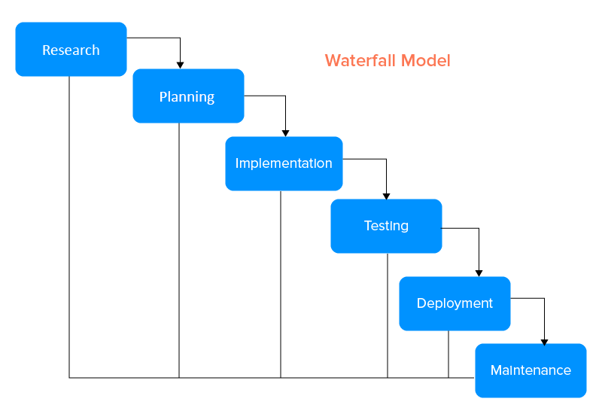When developing the website, we'll follow the waterfall Model. Because this project has clear objectives, detailed documentation, and well-understood technology, so waterfall model is best suited.

Figure 1 - Waterfall model