Siddhant Shah
9/18/2018
COMS 4187
Assignment 1

1. a.

The author claims he is uncertain whether he can configure the computer so as to block all remote access. Additionally, Apple may send a system update that updates the login configurations.

b.

An obvious reason to have a strong password even with those expected usage characteristics is the threat of break-ins and burglaries. With a weak password, one’s own data is more susceptible to being recovered when the device itself is taken into someone else’s custody.

2.

The 2 developments were the development of FTP and Java.

3.

Air gapped systems are generally needed for traditional computer networks, even when they are air gapped from the rest of the internet. One of the main advantages of having anti-virus software on all access points is that it prevents viruses from spreading in the network if they are somehow introduced. In that direction, the air gap does not mean much if the gapped system runs with instructions and code that can be simulated on the outside, since an enemy actor can still design a virus and supply it through some physical port.

For embedded systems, the hacker might not have knowledge of how the instructions are written, and the embedded system may just be a single unit. Anti-virus software may also have to customized to run on an embedded system. For these reasons, it may make more sense to not run anti-virus software on an embedded system.

4.
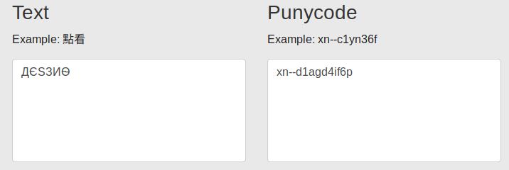
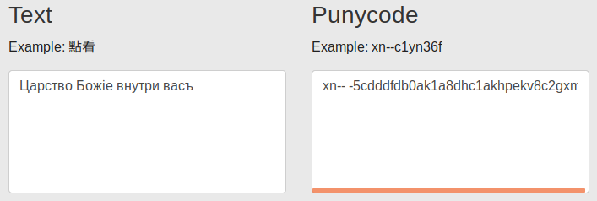
5.

Note: This depends on ASLR being disabled and being compiled with no canaries.

HW1a Input:
aaaaaaaaaaaaaaaaaaaaaaaaaaaaaaaa�UUV

HW1a Output:

Congratulations!
You have entered in the secret function!

HW1b Input:
aaaaaaaaaaaaaaaaaaaaaaaaaaaaaaaa�UUV

HW1b Output:
You entered: aaaaaaaaaaaaaaaaaaa

