Overview
The BGP Route Reflector IPv4 Route Scale methodology measures the time it takes for a DUT route reflector to re-advertise a collection of IPv4 routes. Routes used by this methodology are configured in the methodology itself.
Routes may originate from either client or non-client peers, and are expected to be reflected as follows:
- A route from a Non-Client peer: reflect to all Clients only
- A route from a Client peer: reflect to all Clients and Non-Clients

Topology
The topology for this methodology, is shown in the diagram below, consists of
- A route reflector, which is the device under test
- Multiple PE client routers, simulated by Spirent TestCenter port(s)
- Multiple PE non-client routers, simulated by Spirent TestCenter ports

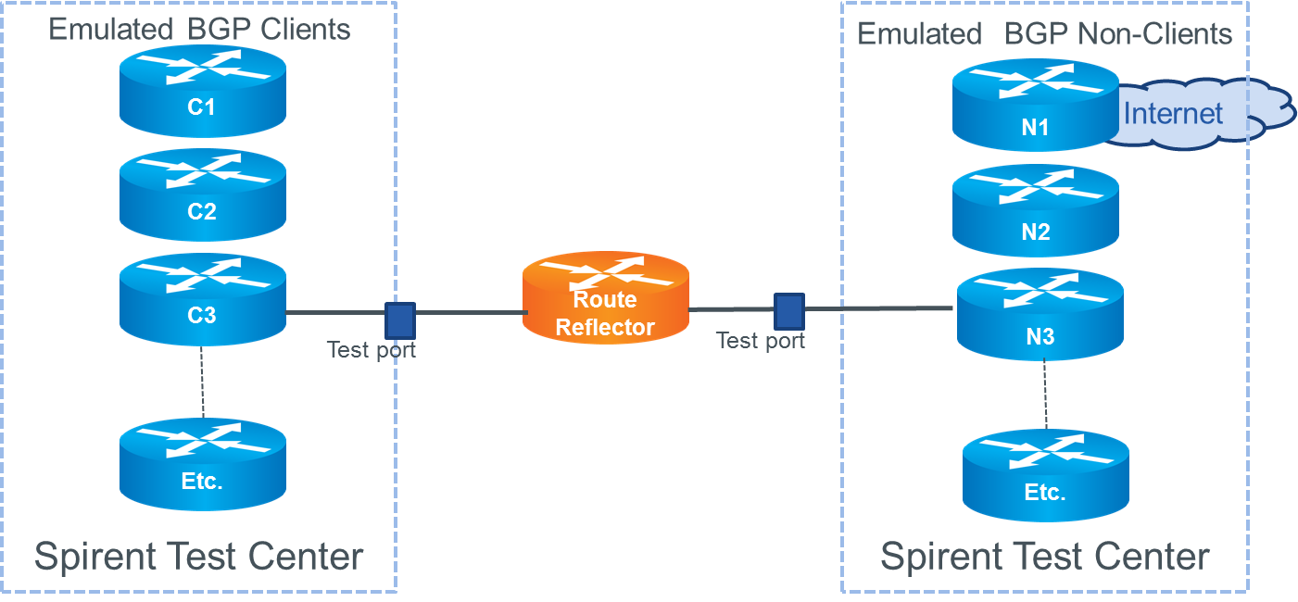

Test Steps
The steps in this methodology are as follows:
- All i-BGP peers are brought up simultaneously
- Start to advertise routes from all client and non-client peers on STC test ports
- The DUT/Route Reflector should reflect all advertised routes.
- Receive the re-advertised routes is indeed received on each simulated client and non-client emulating STC test port.
- Verify that the received routes are
  - At least as many as expected
  - Not greater than the expected tolerance
  - Received within the specified time limit
- The test passes if all of the above conditions are met; otherwise the test fails.
- Stop all BGP sessions

Resources
IETF RFCs
- RFC 1966: BGP Route Reflection An alternative to full mesh IBGP
- RFC 4456: BGP Route Reflection An Alternative to Full Mesh Internal BGP (IBGP)
Wikipedia
- BGP Article
- Route Reflector Article

Acronyms
BGP Border Gateway Protocol
DUT Device Under Test

