Overview
DHCP Prefix Delegation is an IPv6 technology that assigns network address prefixes to client networks. The DHCP-PD over PPPoE Setup Rate methodology determines the maximum DHCP subscriber setup rate supported by a DUT for a given number of DHCP clients.
In this methodology, Spirent TestCenter emulates multiple DHCP-PD clients which request prefixes from the DUT. Each setup attempt consists of first establishing a PPPoE session, followed by a prefix request. The methodology starts with attempts at a minimum rate; if successful, the rate is increased until either the attempted set up rate cannot be achieved, or the maximum configured set up rate is achieved. For highest achieved set up rate, if selected, traffic is sent from the traffic endpoint ports to the DHCP Clients, after the DHCP sessions are established.
This methodology works with IPv4, IPv6, or both. The methodology can also work with single or stacked (QinQ) VLANs.

Topology
The topology for this methodology is shown in the diagram below, consists of:
- A DHCP Client Port Group, where Spirent TestCenter ports emulating multiple PPPoE Clients
- The SUT, which is an access device, potentially including a DHCP/PPP server
- A DHCP Server/Traffic Endpoint port group
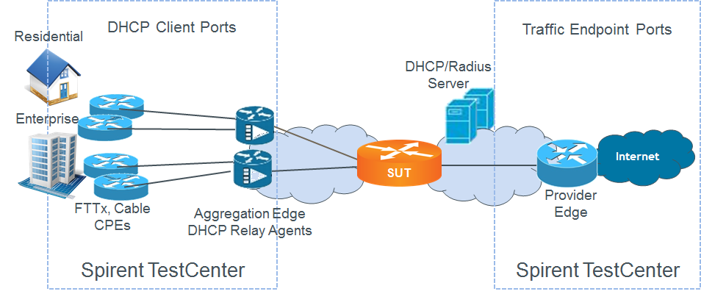

Test Steps
The steps in this methodology are as follows:
- Perform a binary search to find out the maximum rate at which prefixes can be delegated, with each step being as follows:
  - Establish a PPP session
  - Request a prefix to be delegated
- Send traffic from the traffic endpoint ports, through the SUT, to the DHCP client ports.
- The test passes if,
  - the achieved prefix delegation rate is greater than or equal to the configured threshold, within the configured tolerance, and
  - traffic is received at greater than or equal to the configured threshold rate on all receive test ports

Resources
IETF RFCs
- RFC 2131: Dynamic Host Configuration Protocol
- RFC 2132: DHCP Options and BOOTP Vendor Extensions
- RFC 2516: PPP over Ethernet
- RFC 3315: Dynamic Host Configuration Protocol for IPv6 (DHCPv6)
- RFC 3633: IPv6 Prefix Options for Dynamic Host Configuration Protocol (DHCP) version 6
- RFC 3736: Stateless Dynamic Host Configuration Protocol (DHCP) Service for IPv6
- RFC 4649: Dynamic Host Configuration Protocol for IPv6 (DHCPv6) Relay Agent Remote-ID Option
- RFC 6422: Relay-Supplied DHCP Options
- RFC 6925: DHCPv4 Relay Agent Identifier Sub-Option
- RFC 7618: Dynamic Allocation of Shared IPv4 Addresses
Wikipedia
- DHCP Article

Acronyms
BNG Broadband Network Gateway
BRAS Broadband Remote Access Server
DHCP Dynamic Host Configuration Protocol
DUT Device Under Test
PD Prefix Delegation
PPP Point-to-Point Protocol

