Overview
The DHCP Setup Rate methodology determines the maximum DHCP subscriber setup rate supported by a DUT for a given maximum number of DHCP sessions.
In this methodology, Spirent TestCenter emulates multiple DHCP clients which establish sessions with a DHCP server, which can be the DUT or a Spirent TestCenter port. The methodology starts by attempting to establish DHCP sessions at a minimum rate; if successful, the rate is increased until either the attempted set up rate cannot be achieved, or the maximum configured set up rate is achieved. For highest achieved set up rate, bidirectional traffic is sent between the DHCP Server to the DHCP Clients, after the DHCP sessions are established.
This methodology works with IPv4, IPv6, or both. The methodology can also work with single or stacked (QinQ) VLANs.

Topology
The topology for this methodology is shown in the diagram below, consists of:
- A DHCP Client Port Group, where Spirent TestCenter ports emulating multiple PPPoE Clients
- The DUT, which can be a Broadband Network Gateway (BNG), or a DHCP Relay Agent
- A DHCP Server/Traffic Endpoint port group
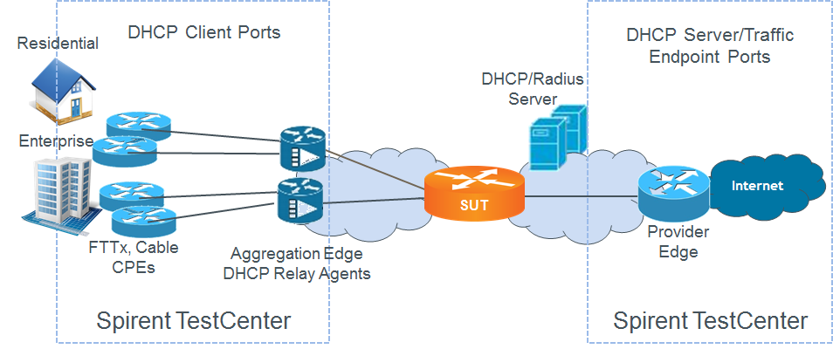

Test Steps
The steps in this methodology are as follows:
- Search Phase
  - Perform a binary search to find out the maximum rate at which DHCP sessions can be established.
  - Record the highest session rate
  - Create a full mesh traffic configuration between the DHCP Clients and Internet hosts emulated by STC on the DHCP Server side of DUT.
  - Send traffic, if configured.
- Stability Phase
  - Repeat the steps below the same number of times as the configured Stability Repeat Count
  - Establish a number of DHCP sessions supported by DUT for the given session rate.
  - Create a full mesh traffic configuration between the DHCP Clients and Internet hosts emulated by STC on the DHCP Server side of DUT.
  - Send traffic, if configured.
- The test passes if,
  - the achieved DHCP session rate in both the Search Phase and the Stability Phase are greater than or equal to the configured Session Rate Threshold, within the configured tolerance, and
  - at least one test (traffic) packets is received on each of the test ports

Resources
IETF RFCs
- RFC 2131: Dynamic Host Configuration Protocol
- RFC 2132: DHCP Options and BOOTP Vendor Extensions
- RFC 3315: Dynamic Host Configuration Protocol for IPv6 (DHCPv6)
- RFC 3633: IPv6 Prefix Options for Dynamic Host Configuration Protocol (DHCP) version 6
- RFC 3736: Stateless Dynamic Host Configuration Protocol (DHCP) Service for IPv6
- RFC 4649: Dynamic Host Configuration Protocol for IPv6 (DHCPv6) Relay Agent Remote-ID Option
- RFC 6422: Relay-Supplied DHCP Options
- RFC 6925: DHCPv4 Relay Agent Identifier Sub-Option
- RFC 7618: Dynamic Allocation of Shared IPv4 Addresses
Wikipedia
- DHCP Article

Acronyms
BNG Broadband Network Gateway
BRAS Broadband Remote Access Server
DHCP Dynamic Host Configuration Protocol
DUT Device Under Test

