Overview
The L3 QoS DSCP IPv4 Validation Methodology validates QoS operation using the Differentiated Services Code Point (DSCP) in IPv4 packet headers. DSCP is defined in RFC2474. The test will create situations in which there is traffic congestion at one or more egress ports. The test validates that the System Under Test (SUT) properly prioritizes the appropriate flows and delivers on its QoS guarantees. The test has multiple iterations, one per desired frame size.
The test presents the SUT with traffic at every DSCP level as shown in Table 1 below. The traffic is sent to multiple ingress ports on the SUT. The traffic loads are controlled such that one or more egress ports on the SUT experience congestion. When congestion occurs, the SUT will drop frames. The test will validate that the higher-priority traffic will continue to be delivered per the QoS requirements and that lower-priority traffic will experience degradation and drops.
Table 1 - QoS Analysis Values by DSCP
DSCP | Max Jitter (usec) | Max Latency (usec) | Max Loss (Frames) | Max Duplicates (Frames) | Max Reordered (Frames) | Max Late (Frames)
EF | 0 | 1 | 0 | 0 | 0 | 0
AF31 | 0 | 2 | 0 | 0 | 0 | 0
AF21 | 2 | 5 | 0 | 1 | 1 | 1
BE | Any | Any | Any | Any | Any | Any

Topology
The topology for this methodology is shown in the diagram below, consists of the following port groups:
- Tx Load Port Group (TxLoad): Emulates source endpoints for AF31, AF21, and BE traffic (3 streams per port)
- Tx Test Port Group (TxTest): Emulates source endpoints for EF traffic (1 stream per port)
- Rx Port Group (Rx): Emulates destination endpoints for EF, AF31, AF21, and BE traffic (4 streams per port)
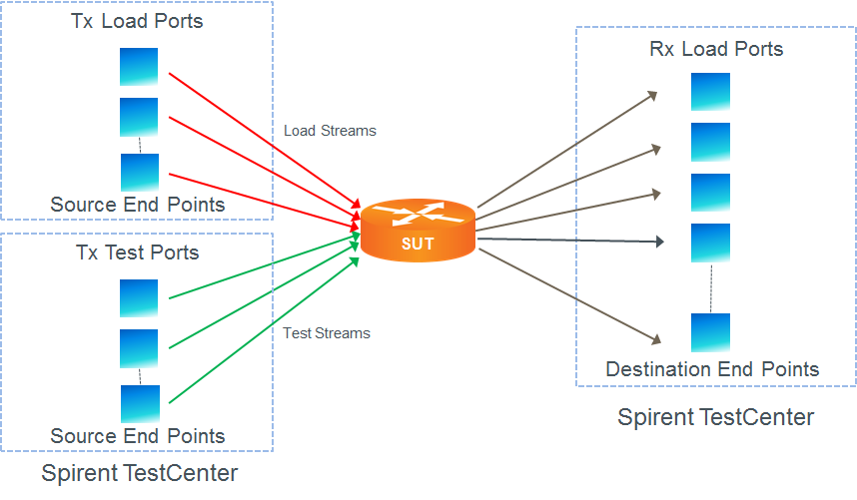
Traffic is unidirectional. Each traffic stream will originate on devices at either Tx Load ports or Tx Test ports. All traffic streams will terminate on devices at RX.
The Tx Load is configured such that it delivers a constant 3/4 (75% of Rx line rate) saturation load to Rx. As Tx Test is increased in steps of 1/4 (25% of Rx line rate) saturation load to Rx we expect to see the SUT drop traffic from the lowest priority levels. For example, when Tx Load is providing 75% Rx saturation and Tx Test is providing 50% Rx saturation we expect BE (and only BE) traffic to be dropped by the SUT.
Test configuration is simplified if all port speeds are equal and the number of ports in each port group is the same.
The test will iterate over frame sizes. That is, for each specified frame size the test will be run. The results will include a single overall result and individual results for each iteration.

The methodology has the following main phases:
- Sanity, to validate the test setup without the presence of congestion
- Congestion iterations, to validate performance under load
- Recovery, to validate that the QoS levels will be reset to their proper values when congestion is removed.

Test Steps
- Load the configuration for the test. This includes the SUT and the testing tool.
- If learning is enabled, perform L2 learning and populate configuration as required.
- Start sanity run. This is Tx Load traffic only. Tx Test traffic is set to 0%. Run for one iteration length of time to validate test setup.
- Validate that the performance of the SUT is according to the values listed in Table 1.
- Frame Size Loop, Congestion: Here, loop through the various fixed frame sizes provided as inputs to the test.
- Load Loop, Congestion: Here, loop through iterations of successively increasing Tx Test loads, stepping through Tx Load values that present the following DSCP EF loads to the Rx ports:
1/4 (25%)
2/4 (50%)
3/4 (75%)
4/4 (100%)
- Configure the frame size and the load based on the loop values, start traffic. Run traffic for the specified duration.
- Validate that each iteration degrades only traffic from the lowest-remaining priority group while maintaining performance characteristics shown in Table 1 for the remaining priority streams. The effects of each iteration are shown below:
EF load | Degraded DSCP levels
25% | None
50% | BE
75% | BE, AF31
100% | 0-6

- To test recovery, reduce the Tx Test traffic load to 0% for an iteration length of time.
- Validate that the performance of the SUT is according to the values listed in Table 1.

IETF RFCs
- RFC 2474: Definition of the Differentiated Services Field (DS Field) in the IPv4 and IPv6 Headers
Other Resources
- Spirent Journal of Layer 2/3 QoS Pass Test Methodologies (requires registration)

Acronyms
AF Assured Forwarding
BE Best Effort
DSCP Differentiated Services Code Point
DUT Device Under Test
EF Expedited Forwarding
SUT System Under Test

