Overview
This methodology validates QoS operation using the Class of Service (CoS) bits in the frame definition specified in IEEE 802.1p and codified in the PRI field of VLAN tags as specified in IEEE 802.1Q. The test creates situations in which there are an increasing number of VLANs and a mix of PRI traffic. The test validates that the SUT properly prioritizes the appropriate flows and delivers on its QoS guarantees when supporting a large number of VLANs. The test has multiple iterations, each with a fixed frame size for all traffic.
The test presents the SUT with traffic at every PRI level shown in Table 1. The traffic will be presented to multiple ingress ports on the SUT. The traffic loads will be controlled such that one or more egress ports on the SUT experience congestion. When congestion occurs, the SUT will drop frames. The test will validate that the higher-priority traffic will continue to be delivered per QoS requirements and that lower-priority traffic will experience degradation and drops.
Table 1: Pass criteria
802.1Q PRI CoS | Min Rx/Tx BW Ratio | Max Jitter (us) | Max Latency (us) | Max Loss (frames) | Max Duplicate (frames) | Max Reordered (frames) | Max Late Frames
7 | 1 | 0 | 1 | 0 | 0 | 0 | 0
6 | 1 | 0 | 2 | 0 | 0 | 0 | 0
5 | 0.99 | 1 | 2 | 0 | 0 | 0 | 0
4 | 0.98 | 1 | 3 | 0 | 0 | 0 | 0
3 | 0.95 | 2 | 5 | 0 | 1 | 1 | 1
2 | 0.90 | 3 | 5 | 1 | 1 | 1 | 1
1 | 0.85 | 5 | 10 | 1 | 2 | 2 | 2

Topology
The topology for this methodology is shown in the diagram below, consists of the following port groups:
- Tx Load Port Group (TxLoad): Emulates source endpoints for PRI 0-6 traffic (7 streams per port)
- Tx Test Port Group (TxTest): Emulates source endpoints for PRI 7 traffic (1 stream per port)
- Rx Port Group (Rx): Emulates destination endpoints for PRI 0-7 traffic (8 streams per port)
Traffic will be unidirectional. Each traffic stream will originate on devices at either TXLoad or TXTest. All traffic streams will terminate on devices at RX.
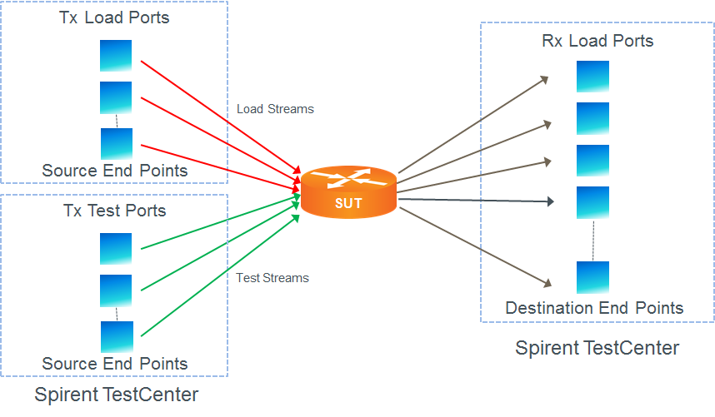
TXLoad is configured such that it delivers a constant 7/8 (87.5%) saturation load to RX. As TXTest is increased in steps of 1/8 (12.5%) saturation load to RX we expect to see the SUT drop traffic from the lowest priority levels. For example, when TXLoad is providing 87.5% RX saturation and TXTest is providing 25% RX saturation we expect PRI 0 (and only PRI 0) traffic to be dropped by the SUT.

Table 2: Device Block Configuration

The test will iterate over frame sizes. That is, for each specified frame size the test will be run. The results will include a single overall result and individual results for each iteration.

Test Steps
- Load the configuration for the test. This includes the SUT and the testing tool.
- If learning is enabled, perform L2 learning and populate configuration as required.
- Start sanity run. This is Tx Load traffic only. TxTest traffic is set to 0%. Run for one iteration length of time to validate setup.
- Validate that the performance of the SUT is according to the values listed in Table 1.
- For each frame size, perform all of the steps below.
- Loop through iterations of successively increasing TxTest loads, stepping through TxLoad values that present the following PRI 7 loads to the Rx ports:
PRI 7 Load Level
1/8 (12.5%)
2/8 (25%)
3/8 (37.5%)
4/8 (50%)
5/8 (62.5%)
6/8 (75%)
7/8 (87.5%)
8/8 (100%)

- Validate that each iteration degrades only traffic from the lowest-remaining priority group while maintaining performance characteristics shown in Table 1 for the remaining priority streams. The effects of each iteration are shown below:
PRI 7 Load Level | Degraded PRI Levels
1/8 (12.5%) | None
2/8 (25%) | 0
3/8 (37.5%) | 0-1
4/8 (50%) | 0-2
5/8 (62.5%) | 0-3
6/8 (75%) | 0-4
7/8 (87.5%) | 0-5
8/8 (100%) | 0-6

- To test recovery, reduce the TxTest traffic load to 0% for an iteration length of time.
- Pass the test if the performance of the SUT is according to the values listed in Table 1.

Standards
- IEEE 802.1Q – Virtual LANs
- IEEE 802.1p - Traffic Class Expediting and Dynamic Multicast Filtering (published in 802.1D-1998)
Other Resources
- Spirent Journal of Layer 2/3 QoS Pass Test Methodologies (requires registration)

Acronyms
DUT Device Under Test
SUT System Under Test
VLAN Virtual Local Area Network

