Overview
This methodology determines the maximum number of VLANs for which a SUT can satisfy its QoS guarantees, according to VLAN tag priority bits, as per IEEE 802.1 Q.
The test creates situations in which there are an increasing number of VLANs and a mix of PRI traffic. The test validates that the SUT properly prioritizes the appropriate flows and delivers on its QoS guarantees when supporting a large number of VLANs. The test has multiple iterations, each with a fixed frame size for all traffic.
The test presents the SUT with traffic at PRI levels 1-7 shown in Table 1. PRI level 0 traffic is uninteresting for this test because it has no constraints or requirements. The traffic loads will be controlled such that the egress ports on the SUT are loaded to line rate, but not more. This test will not introduce congestion. Traffic will be bidirectional. The test will validate that traffic at all PRI levels will continue to be delivered per QoS requirements as the number of VLANs increases to a maximum of 4094 (4096 minus two reserved values, 0 and 4095).
Table 1: Pass criteria
802.1Q PRI CoS | Min Rx/Tx BW Ratio | Max Jitter (us) | Max Latency (us) | Max Loss (frames) | Max Duplicate (frames) | Max Reordered (frames) | Max Late Frames
7 | 1 | 0 | 1 | 0 | 0 | 0 | 0
6 | 1 | 0 | 2 | 0 | 0 | 0 | 0
5 | 0.99 | 1 | 2 | 0 | 0 | 0 | 0
4 | 0.98 | 1 | 3 | 0 | 0 | 0 | 0
3 | 0.95 | 2 | 5 | 0 | 1 | 1 | 1
2 | 0.90 | 3 | 5 | 1 | 1 | 1 | 1
1 | 0.85 | 5 | 10 | 1 | 2 | 2 | 2

Topology
The topology of the test will be configured using 2 port groups, each with a minimum of 1 test port each, and each having the same number and speed of ports.
- East Port Group (EAST): Emulate endpoints for PRI 1-7 traffic
- West Port Group (WEST): Emulate endpoints for PRI 1-7 traffic
Each traffic stream will originate on devices at either EAST or WEST and terminate on devices on the other port group. This topology is shown in the figure below.
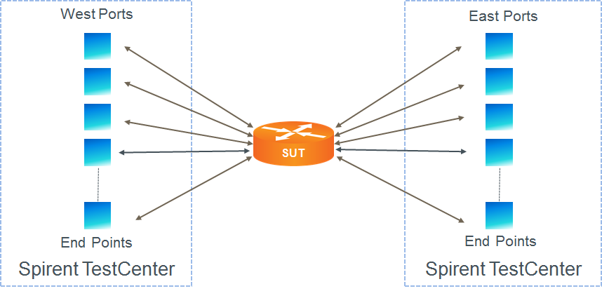
All ports have the same speed and streams will be generated from all ports. Test streams are bidirectional, paired. Test stream loads are set such that ports are operating at line rate, but not above. All test streams have the same load.
Each port will be configured with exactly 7 device blocks. Each device block will correspond to one of the PRI levels under consideration. The traffic for the device blocks will be configured as shown in table 2 below.

Table 2: Device Block Configuration
Device Block | Starting VLAN ID | NUM VLANs | Ending VLAN ID | PRI | Burst | VLAN IDs removed per iteration
1 | 1 | 585 | 585 | 1 | 1000 | 30
2 | 586 | 585 | 1170 | 2 | 500 | 30
3 | 1170 | 585 | 1755 | 3 | 10 | 30
4 | 1756 | 585 | 2340 | 4 | 7 | 30
5 | 2341 | 585 | 2825 | 5 | 5 | 30
6 | 2926 | 585 | 3510 | 6 | 3 | 30
7 | 3510* | 4094 | 4094 | 7 | 1 | 30

*Note that in Table 2 the starting VLAN ID for Device Block 7 slightly overlaps the ending VLAN ID for Device Block 6. This is necessary to achieve the maximum of 4094 VLAN IDs using a uniform number of VLANs per device block. A test without overlap can be created, but it would be unnecessarily complex to implement.
The test will iterate over frame sizes. That is, for each specified frame size the test will be run. The results will include a single overall result and individual results for each iteration.

Test Steps
- Load the configuration for the test. This includes the SUT and the testing tool.
- If learning is enabled, perform L2 learning and populate configuration as required.
- Configure the load for all streams such that the total load on each port is 100% of line rate..
- For each frame size, perform all of the steps below.
- Starting with the maximum number of VLANs, iterate over a decreasing number of VLANs..
- Configure all streams for the proper frame size. Configure all device blocks for the proper number of VLANs. Start traffic.
- Validate that the performance of the SUT is according to the values listed in Table 1.
- Validate that each iteration degrades only traffic from the lowest-remaining priority group while maintaining performance characteristics shown in Table 1
- The test passes if there are no setup errors and all frame-size iterations result in a PASS verdict by meeting the performance criteria shown in Table 1.

Standards
- IEEE 802.1Q – Virtual LANs
- IEEE 802.1p - Traffic Class Expediting and Dynamic Multicast Filtering (published in 802.1D-1998)
Other Resources
- Spirent Journal of Layer 2/3 QoS Pass Test Methodologies (requires registration)

Acronyms
DUT Device Under Test
SUT System Under Test
VLAN Virtual Local Area Network

