Overview
The Ping Methodology verifies connectivity through a DUT using ICMP messages.
With each trial, ping request (ICMP echo request) messages are sent from STC test ports in the west port group, through the DUT, to STC test ports in the east port group. After receiving ping request messages, the east port group test ports reply with ping response (ICMP echo response) messages, which are transmitted back through the DUT to the west port group test ports.
Ping test packets for this test may be defined only as IPv4. Inner and outer VLAN IDs may also be configured for each test port.

Topology
The topology for this methodology, is shown in the diagram below, consists of
- A set of ports on the “west” side of the SUT
- A sets of ports on the “east” side of the SUT
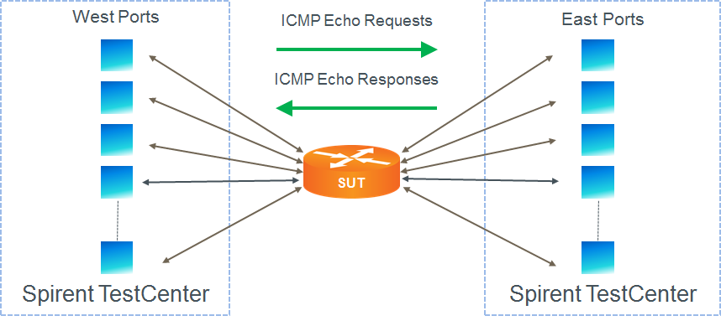

Test Steps
- For each configured port, send a ping request message with the specified ping source address to the specified ping destination address.
- For each ping request message received, reply with a ping response message
- This test passes if ping responses are received for all ping requests.

Resources
IETF RFCs
- RFC 792: Internet Control Message Protocol

Acronyms
DUT Device Under Test
SUT System Under Test

