Overview
The PPPoL2TPv2 Session Rate methodology determines the maximum rate at which PPP sessions can be established over L2TPv2 tunnels.
In this methodology, Spirent TestCenter emulates multiple PPP/L2TPv2 subscribers and Link Access Concentrators (LAC) which establish sessions with a Link Node Server (LNS), which is part of the System Under Test (SUT). The methodology starts by establishing L2TP tunnel(s) with the SUT. Then, a binary search is conducted to find the maximum rate at which PPP sessions can be established. For each attempted set-up rate, bidirectional traffic consisting of 500-byte frames is sent between the PPP Server to the PPPoE Clients, after the PPP sessions are established.
This methodology works with IPv4, IPv6, or both. The methodology can also authenticate using PAP (Password Access Protocol) or CHAP (Challenge Handshake Access Protocol)

Topology
The topology for this methodology is shown in the diagram below, consists of:
- A PPPoL2TPv2 Client Port Group, where Spirent TestCenter ports emulating multiple PPPoL2TPv2 Clients possibly being aggregated through LACs (L2TP Access Concentrators)
- The SUT, which is a router or switch with an LNS (L2TP Node Server)
- A PPP Server/Traffic Endpoint port group
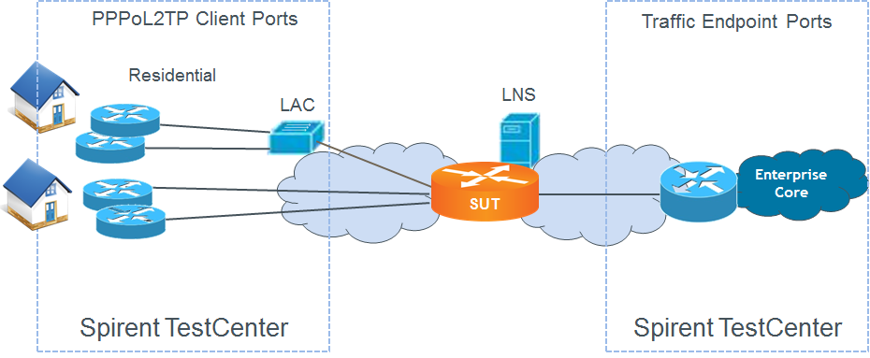

Test Steps
The steps in this methodology are as follows:
- Establish L2TP tunnel(s) from the PPPoL2TP Client Port Group to the SUT.
- Perform a binary search for the PPP session establishment rate over the L2TP tunnels.
- For each rate at which all PPP sessions are established in the previous step, send bi-directional traffic consisting of 500-byte frames across each PPP session.
- The test passes if,
  - All required L2TP tunnels are established in step one above
  - the achieved PPP session rate in both the Search Phase and the Stability Phase are greater than or equal to the configured Session Rate Threshold, within the configured tolerance, and
  - at least one test (traffic) packets is received on each of the test ports

Resources
IETF RFCs
- RFC 1332: Internet Protocol Control Protocol
- RFC 1334: PPP Authentication Protocols
- RFC 1570: LCP Extensions
- RFC 1661: The Point-to-Point Protocol
- RFC 1662: PPP in HDLC-like Framing
- RFC 1994: PPP Challenge Handshake Authentication Protocol (CHAP)
- RFC 2472: IPv6 over PPP
- RFC 2661: Layer Two Tunneling Protocol “L2TP”
Wikipedia
- L2TP Article
- PPP Article

Acronyms
CHAP Challenge Handshake Access Protocol
DUT Device Under Test
L2TP Layer 2 Tunneling protocol
LAC L2TP Access Concentrator
LNS L2TP Network Server
PAP Password Access Protocol
PPP Point-to-Point Protocol

