Overview
The PPPoE Session Rate methodology determines the maximum rate at which PPPoE sessions can be established.
In this methodology, Spirent TestCenter emulates multiple PPPoE clients which establish sessions with a PPP server, which can be the DUT or a Spirent TestCenter port. The methodology starts by attempting to establish PPP sessions at a minimum rate; if successful, the rate is increased until either the attempted set up rate cannot be achieved, or the maximum configured set up rate is achieved. For highest achieved set up rate, bidirectional traffic is sent between the PPP Server to the PPPoE Clients, after the PPP sessions are established.
This methodology works with IPv4, IPv6, or both. The methodology can also authenticate using PAP (Password Access Protocol) or CHAP (Challenge Handshake Access Protocol)

Topology
The topology for this methodology is shown in the diagram below, consists of:
- A PPPoE Client Port Group, where Spirent TestCenter ports emulating multiple PPPoE Clients
- The DUT, which can be an access controller, Broadband Remote Access Server (BRAS), or PPP relay agent
- A PPP Server/Traffic Endpoint port group
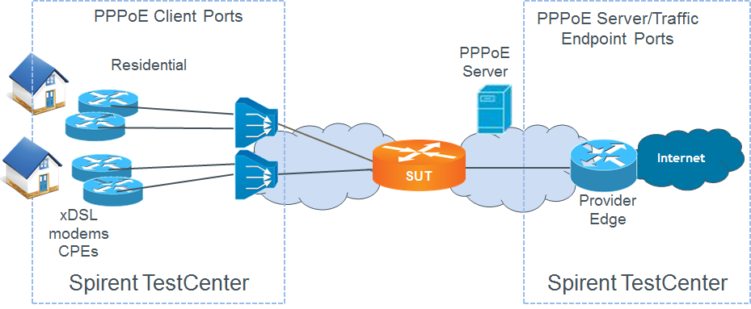

Test Steps
The steps in this methodology are as follows:
- Start all device blocks on the PPPoE Client ports.
- Wait for the PPPoE sessions to be established.
- Chart the successful setup rate for the duration of the iteration.
- Record the number of successful connections, number of failed connections, and average successful transactions to connect.
- Record Min, Max and Avg. Setup time.
- If the attempted set up rate (within the specified tolerance) is achieved, then increase the session setup rate by the increment specified in the input parameters and repeat the steps above.
- Record the last session setup rate that met the success criteria.
- Create full mesh traffic configuration between the PPPoE Clients and Internet hosts emulated by STC on the PPPoE Server side of DUT.
- Send traffic at the configured rate.
- The test passes if,
  - the achieved PPP session set up rate is greater than or equal to configured Session Rate Threshold, within the configured tolerance, and
  - at least one test (traffic) packets is received on each of the test ports

Resources
IETF RFCs
- RFC 1334: PPP Authentication Protocols
- RFC 1570: LCP Extensions
- RFC 1661: The Point-to-Point Protocol
- RFC 1994: PPP Challenge Handshake Authentication Protocol (CHAP)
- RFC 2472: IPv6 over PPP
- RFC 2516: A Method for Transmitting PPP over Ethernet
Wikipedia
- PPP Article

Acronyms
BRAS Broadband Remote Access Server
CHAP Challenge Handshake Access Protocol
DUT Device Under Test
PAP Password Access Protocol
PPP Point-to-Point Protocol

