Overview
The PPPoE Session Scale methodology determines the maximum number of PPPoE sessions a DUT can bring up at a given connection rate.
In this methodology, Spirent TestCenter emulates multiple PPPoE clients which establish sessions with a PPP server, which can be the DUT or a Spirent TestCenter port. The methodology starts by attempting to establish a minimum number of PPP sessions at a given rate; if successful, the number is increased until either the attempted number of sessions cannot be achieved, or the configured maximum number of sessions is achieved. For highest achieved number of sessions, bidirectional traffic is sent between the PPP Server to the PPPoE Clients, after the PPP sessions are established.
This methodology works with IPv4, IPv6, or both. The methodology can also authenticate using PAP (Password Access Protocol) or CHAP (Challenge Handshake Access Protocol)

Topology
The topology for this methodology is shown in the diagram below, consists of:
- A PPPoE Client Port Group, where Spirent TestCenter ports emulating multiple PPPoE Clients
- The DUT, which can be an access controller, Broadband Remote Access Server (BRAS), or PPP relay agent
- A PPP Server/Traffic Endpoint port group
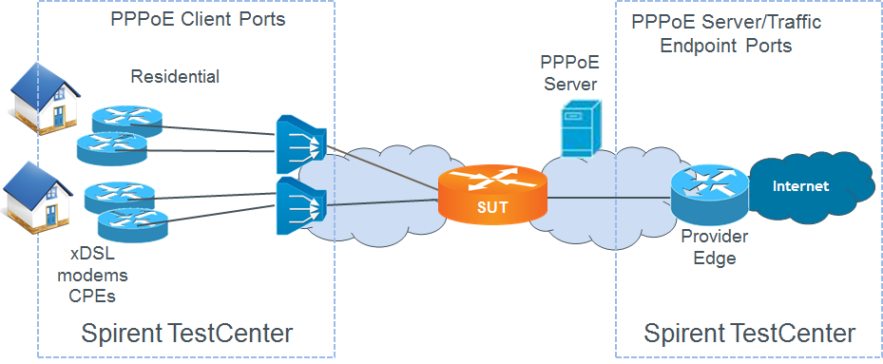

Test Steps
The steps in this methodology are as follows:
- Search Phase:
  - Perform a binary search to find out the maximum number of PPPoE sessions supported by DUT for the given session rate.
  - Record the highest session scale.
  - Create a full mesh traffic configuration between the PPPoE Clients and Internet hosts emulated by STC on the PPPoE Server side of DUT.
  - Send traffic, if configured.
- Stability Phase:
  - Repeat the steps below the same number of times as the configured Stability Repeat Count
  - Establish a number of PPPoE sessions supported by DUT for the given session rate.
  - Create a full mesh traffic configuration between the PPPoE Clients and Internet hosts emulated by STC on the PPPoE Server side of DUT.
  - Send traffic, if configured.
- The test passes if,
  - the achieved PPP session scale in both the Search Phase and the Stability Phase are greater than or equal to configured Session Count Threshold, within the configured tolerance, and
  - at least one test (traffic) packets is received on each of the test ports

Resources
IETF RFCs
- RFC 1334: PPP Authentication Protocols
- RFC 1570: LCP Extensions
- RFC 1661: The Point-to-Point Protocol
- RFC 1994: PPP Challenge Handshake Authentication Protocol (CHAP)
- RFC 2472: IPv6 over PPP
- RFC 2516: A Method for Transmitting PPP over Ethernet
Wikipedia
- PPP Article

Acronyms
BRAS Broadband Remote Access Server
CHAP Challenge Handshake Access Protocol
DUT Device Under Test
PAP Password Access Protocol
PPP Point-to-Point Protocol

