Overview
The RFC 2544 Back to Back Methodology uses a binary search to find the maximum burst size that the SUT can forward without frame loss, for different frame sizes, at a specified frame rate.
With each trial of the throughput test, bursts of test frames are sent for the specified duration. If there is any frame loss, the burst size is decreased; otherwise, the burst size is increased. The trials are repeated until the maximum burst size is found at which there is no frame loss. RFC 2544 does not specify an algorithm to implement, however the most common approach is a binary search algorithm. With the binary search algorithm, the first trial uses a configured initial burst size. If there is frame loss with a specific trial, the next trial uses a burst size calculated as the midpoint between the current burst size and the configured minimum; otherwise, the next trial uses a burst size calculated as the midpoint between the current rate and a configured maximum. The test is stopped when the difference between the burst size of the current and previous trial is less than or equal to a configured delta.
Test traffic for this test may be defined as IPv4 and/or IPv6, with or without VLAN tags. Traffic patterns may be set as pair, mesh or backbone. Traffic directions may be set as unidirectional or bi-directional.

Topology
The topology for this methodology, is shown in the diagram below, consists of
- A set of ports on the “west” side of the SUT
- A sets of ports on the “east” side of the SUT
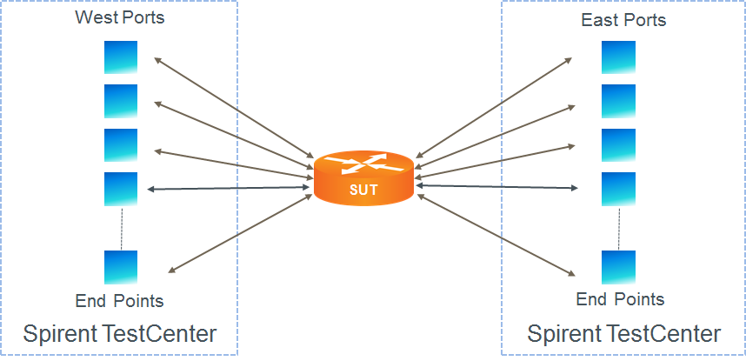

Test Steps
For each frame size, determine the maximum zero-loss burst size, as follows:
- Set burst size to the configured initial burst size.
- Send learning frames (L2 or L3).
- Send bursts of frames at the specified rate from all test ports for the configured duration.
- Determine if there is any frame loss, defined as the number of frames transmitted minus the number of frames received, across all test ports.
- If frame loss is zero, increase the burst size to the mid-point between the previous trial and the upper limit, and repeat. If not equal, decrease the burst size to the mid-point between the previous trial and the lower limit.
- Repeat steps 3 through 5 above until either the zero-loss burst size is within the specified tolerance, or the burst size is greater than or equal to the configured upper limit.
- The test passes if the maximum measured loss-less burst size is greater than the configured threshold.

Resources
IETF RFCs
- RFC 2544: Benchmarking Methodology for Internet Connected Devices

Acronyms
DUT Device Under Test
SUT System Under Test

