Overview
The RFC 2544 Frame Loss Methodology measures loss across a range of frame rates and frame sizes.
With each trial, test frames are sent at a specific frame rate and the number of frames forwarded by the DUT are counted and recorded.
Test traffic for this test may be defined as IPv4 and/or IPv6, with or without VLAN tags. Traffic patterns may be set as pair, mesh or backbone. Traffic directions may be set as unidirectional or bi-directional.

Topology
The topology for this methodology, is shown in the diagram below, consists of
- A set of ports on the “west” side of the SUT
- A sets of ports on the “east” side of the SUT
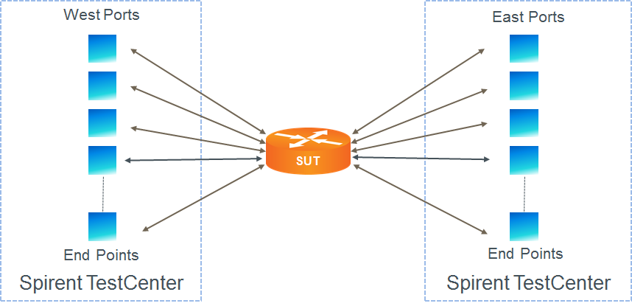

Test Steps
- For each frame size perform all of the steps below
- For each frame rate, starting at the highest rate first, perform all of the steps below.
- Send learning frames (L2 or L3).
- Send frames at the specified rate (lower limit initially; adjusted rate for subsequent trials) from all test ports for the configured trial duration.
- Calculate frame loss as the number of frames transmitted minus the number of frames received, aggregated across all test ports.

Resources
IETF RFCs
- RFC 2544: Benchmarking Methodology for Internet Connected Devices

Acronyms
DUT Device Under Test
SUT System Under Test

