Overview
The RFC 2544 Latency Methodology measures latency across a range of frame rates and frame sizes.
With each trial, test frames of the specified length are sent at a specific frame rate through the SUT, with latency of the received frames being measured and recorded.
Test traffic for this test may be defined as IPv4 and/or IPv6, with or without VLAN tags. Traffic patterns may be set as pair, mesh or backbone. Traffic directions may be set as unidirectional or bi-directional.

Topology
The topology for this methodology, is shown in the diagram below, consists of
- A set of ports on the “west” side of the SUT
- A sets of ports on the “east” side of the SUT
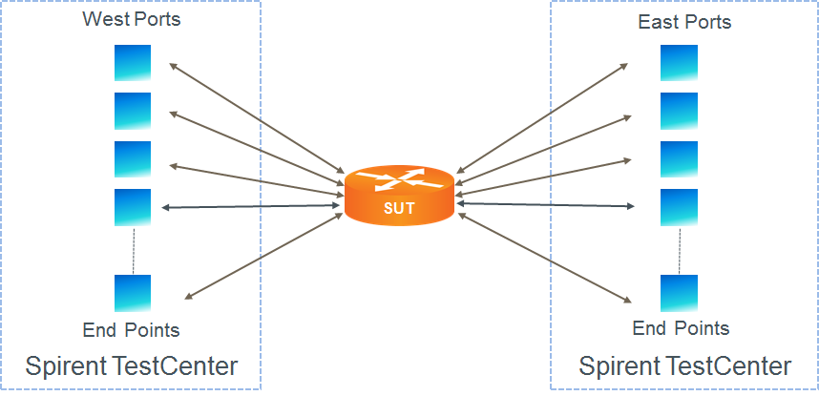

Test Steps
- For each frame size perform all of the steps below
- For each frame rate, starting at the highest rate first, perform all of the steps below.
- Send learning frames (L2 or L3).
- Send frames at the specified rate (lower limit initially; adjusted rate for subsequent trials) from all test ports for the configured trial duration.
- Calculate the latency of all received test frames on all test ports.
- The test should pass only if the maximum measured latency for all frame sizes is less than the threshold configured by the user.

Resources
IETF RFCs
- RFC 2544: Benchmarking Methodology for Internet Connected Devices

Acronyms
DUT Device Under Test
SUT System Under Test

