Overview
The RFC 2544 Throughput Methodology determines the maximum throughput at which no frames are lost for a set of frame sizes.
With each trial of the throughput test, test frames are sent at a specific frame rate and the number of frames forwarded by the SUT, are counted. If there is any frame loss, the rate is decreased; otherwise, the rate is increased. The trials are repeated until the maximum rate is found at which there is no frame loss. RFC 2544 does not specify an algorithm to implement, however the most common approach is a binary search algorithm. With the binary search algorithm, the first trial uses a configured initial frame rate (or percent utilization). If there is frame loss with a specific trial, the next trial uses a rate calculated as the midpoint between the current rate and a configured minimum; otherwise, the next trial uses a rate calculated as the midpoint between the current rate and a configured maximum. The test is stopped when the difference between the frame rate of the current and previous trial is less than or equal to a configured delta.
Test traffic for this test may be defined as IPv4 and/or IPv6, with or without VLAN tags. Traffic patterns may be set as pair, mesh or backbone. Traffic directions may be set as unidirectional or bi-directional.

Topology
The topology for this methodology, is shown in the diagram below, consists of
- A set of ports on the “west” side of the DUT
- A sets of ports on the “east” side of the DUT
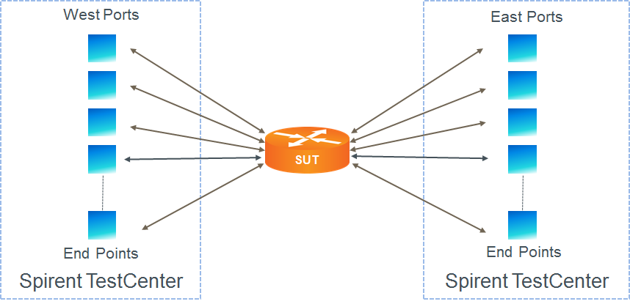

Test Steps
For each frame size, determine the maximum zero-loss throughput, as follows:
- Set traffic rate to the configured initial frame rate.
- Send learning frames (L2 or L3).
- Send frames at the specified rate (lower limit initially; adjusted rate for subsequent trials) from all test ports for the configured trial duration.
- Calculate frame loss as the number of frames transmitted minus the number of frames received, aggregated across all test ports.
- If frame loss is zero, increase the frame rate to the mid-point between the previous trial and the upper limit, and repeat. If not equal, decrease the frame rate to the mid-point between the previous trial and the lower limit.
- Repeat steps 3 through 5 above until either the zero-loss frame rate is within the specified tolerance, or the traffic rate is greater than or equal to the configured upper limit.

Resources
IETF RFCs
- RFC 2544: Benchmarking Methodology for Internet Connected Devices

Acronyms
DUT Device Under Test
SUT System Under Test

