Overview
The RFC 2889 Address Caching Capacity methodology implements section 5.7 of the RFC 2889 IETF standard for LAN switch benchmarking. The purpose of this methodology is to determine the maximum address caching capacity of a LAN switching device.
In this methodology, Spirent TestCenter ports are used to send and receive all frames. The basic algorithm of the test is to do a binary search across a range of addresses until the maximum number of addresses the SUT can handle is found. For each iteration, learning frames are initially sent from the Learning port(s), through the SUT, and on to the Test port(s); then test frames are sent from the Test port(s), back through the SUT and to the Learning port(s). If the SUT floods frames to the Monitor ports, the attempt was not successful. The attempted number of addresses is adjusted up or down depending on whether the trial was successful or not, i.e. the SUT was able to “learn” the addresses such that it could successfully forward test frames.
The methodology can work without VLANs, with single VLANs or stacked (QinQ) VLANs.

Topology
The topology for this methodology is shown in the diagram below, consists of:
- Learning ports, which transmit learning frames through the SUT
- Test Ports, which receive learning frames from the SUT, and transmit test frames through the SUT to the Learning ports
- Monitor Port(s), which potentially receive overflow frames from the SUT
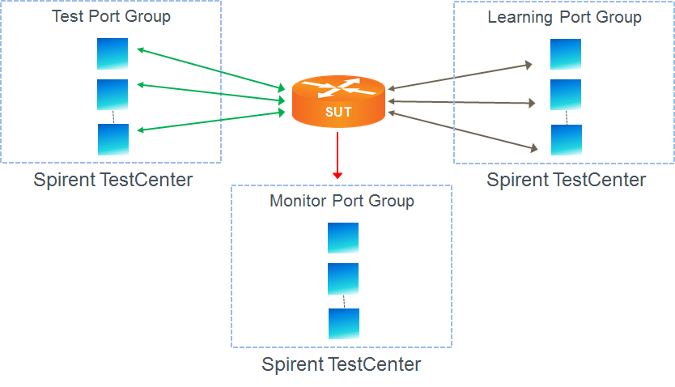

Test Steps
The steps in this methodology are as follows:
- For the configured number of trials conduct a binary search for the maximum address capacity, as follows
  - Starting at the Initial Learning Rate, send learning frames, at the configured rate, from the Learning ports to the SUT.
  - After all learning frames are sent, send test frames from the Test ports to the SUT.
  - If all test frames are successfully forwarded to the Learning ports, without broadcast frames overflowing to the Monitor port, the iteration is successful.
  - If successful, the learning rate should be increased to the mid-point between the initial learning rate and the maximum learning rate; if unsuccessful, the learning rate should be decreased to the mid-point between the initial learning rate and the minimum learning rate.
  - Wait for the specified aging time to expire so that the SUT has “forgotten” any addresses it learned in the trial.
  - Repeat steps a through d above until the measured address capacity is determined within the resolution specified in the configuration.
- The test passes if,
  - The maximum measured address capacity is greater than the Address Caching Capacity Test Criteria.

Resources
Standards
- RFC 2889

Acronyms
DUT Device Under Test
LAN Local Area Network
MAC Media Access Control
SUT System Under Test
VLAN Virtual Local Area Network

