Overview
The RFC 2889 Broadcasting Frame Forwarding methodology implements the throughput test portion of section 5.10 of the RFC 2889 IETF standard for LAN switch benchmarking. The purpose of this methodology is to determine the throughput of the SUT while forwarding broadcast frames.
In this methodology, Spirent TestCenter ports are used to send and receive all frames. The basic algorithm of the test is to generate test traffic with a broadcast address, at the intended load (ILoad) rate, from a single Source port to the SUT, which forwards the test traffic on to the Receive port(s) at the offered load (OLoad) rate. The latency through the SUT is measured. The exercise is repeated for the specified number of trials, for each frame size. The forwarding rate for all frame sizes is expected to be greater than the configured forwarding rate test criteria.
The methodology can work without VLANs, with single VLANs or stacked (QinQ) VLANs.

Topology
The topology for this methodology is shown in the diagram below, consists of:
- Source port, which sends test traffic to the SUT
- Receive Port(s), which receive test traffic from the SUT
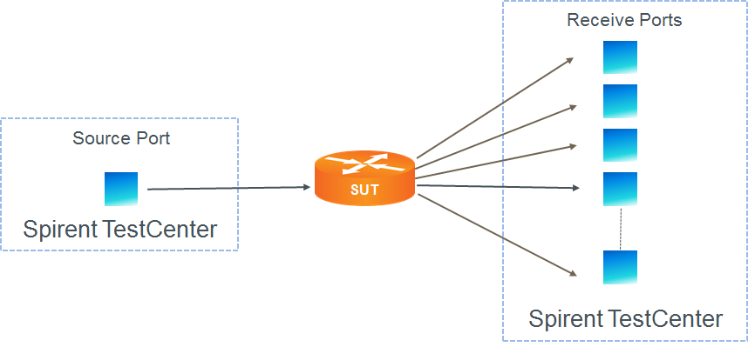

Test Steps
The steps in this methodology are as follows:
- For each of the specified frame sizes, do all of the steps below.
- For configured number of trials, do all of the steps below
- Starting at the lower limit, send traffic from the Source Port to the SUT for the configured duration
- On all Receive port(s), measure the throughput.
- If the measured throughput on all receive ports is greater than the configured threshold, increase the traffic rate to the mid-point between previous successful iteration and the upper limit; if the measured throughput is less than the configured threshold, decrease the traffic rate to the mid-point between the previous successful iteration and the lower limit.
- Repeat from step 3 onwards until the successful rate is determined within the configured resolution.
- The test passes if the highest achieved throughput is greater than or equal to the forwarding rate test criteria, within the specified resolution.

Resources
Standards
- RFC 2889

Acronyms
DUT Device Under Test
LAN Local Area Network
MAC Media Access Control
SUT System Under Test
VLAN Virtual Local Area Network

